# AttendanceRecordServiceTest

## ApplyRescanReviewFlagsAdditionalTests

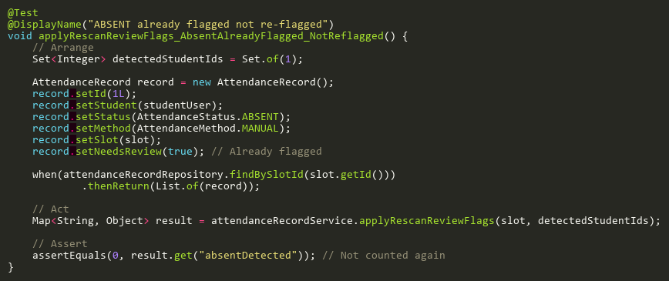

**Figure: applyRescanReviewFlags_AbsentAlreadyFlagged_NotReflagged**  
*Reference: Sheet "ARST_reviewFlags", Test Case TC03*

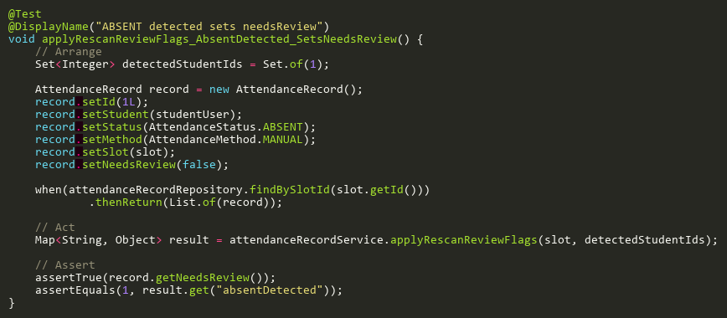

**Figure: applyRescanReviewFlags_AbsentDetected_SetsNeedsReview**  
*Reference: Sheet "ARST_reviewFlags", Test Case TC01*

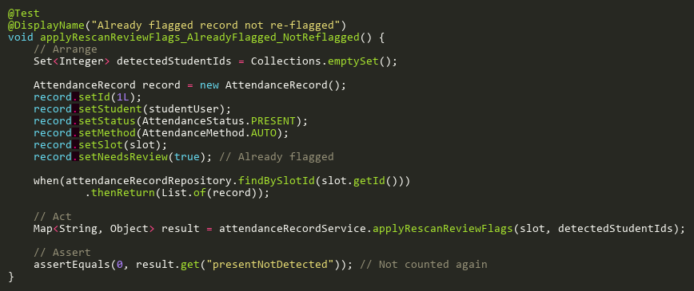

**Figure: applyRescanReviewFlags_AlreadyFlagged_NotReflagged**  
*Reference: Sheet "ARST_reviewFlags", Test Case TC02*

## EvidenceDownloadFailureTests

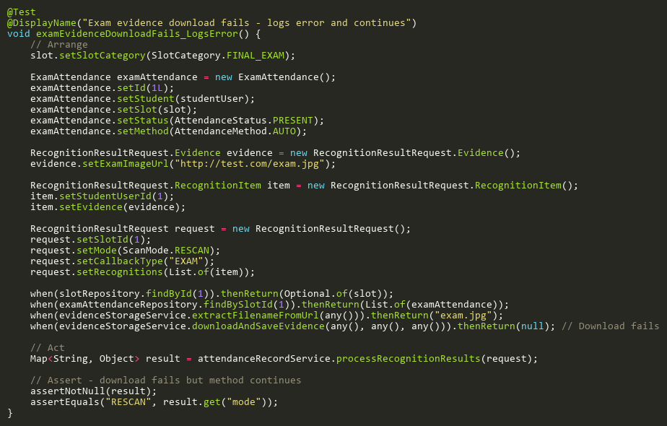

**Figure: examEvidenceDownloadFails_LogsError**  
*Reference: Sheet "ARST_evidenceFail", Test Case TC02*

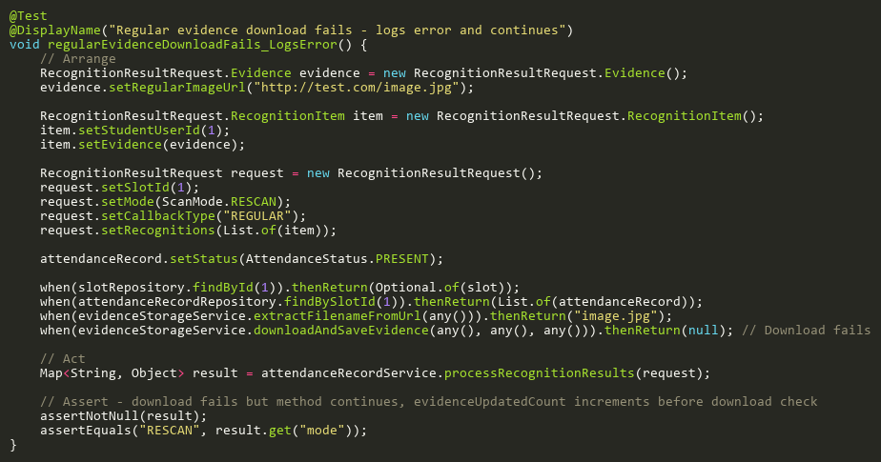

**Figure: regularEvidenceDownloadFails_LogsError**  
*Reference: Sheet "ARST_evidenceFail", Test Case TC01*

## EvidenceStorageTests

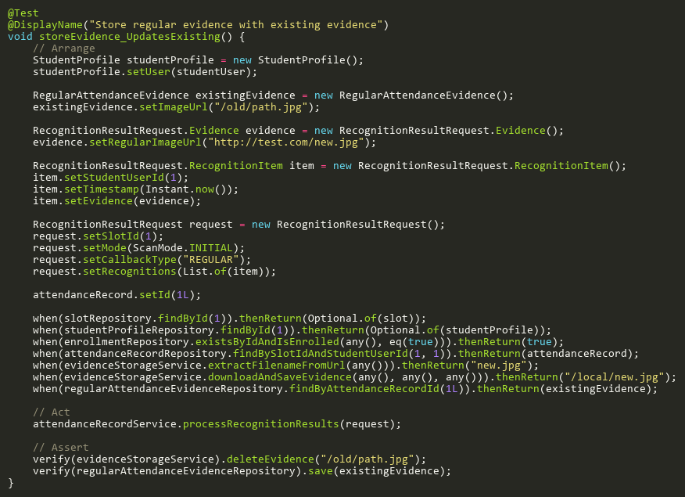

**Figure: storeEvidence_UpdatesExisting**  
*Reference: Sheet "ARST_evidenceStore", Test Case TC01*

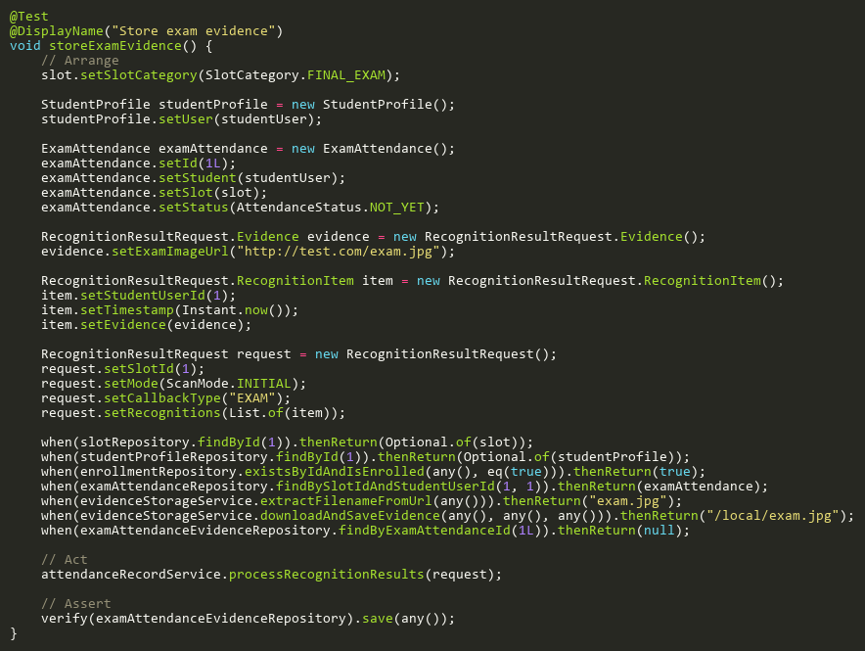

**Figure: storeExamEvidence**  
*Reference: Sheet "ARST_evidenceStore", Test Case TC02*

## ProcessExamRecognitionTests

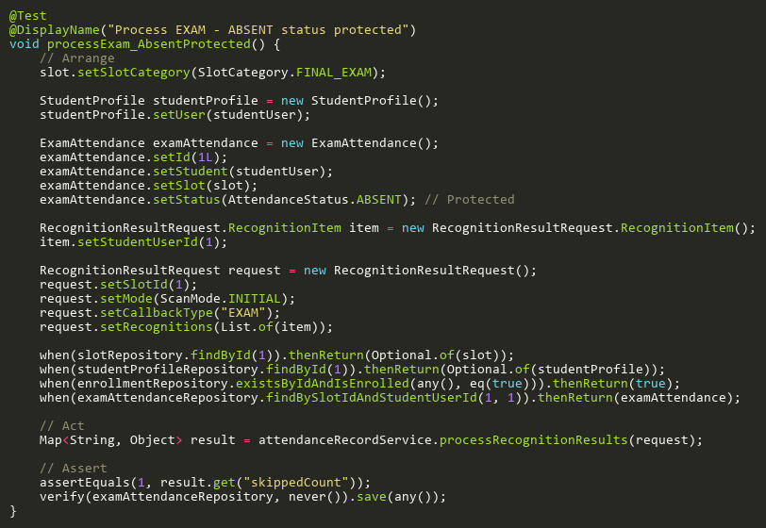

**Figure: processExam_AbsentProtected**  
*Reference: Sheet "ARST_processExam", Test Case TC02*

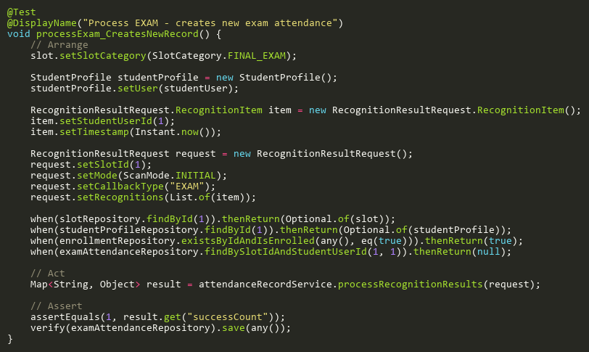

**Figure: processExam_CreatesNewRecord**  
*Reference: Sheet "ARST_processExam", Test Case TC03*

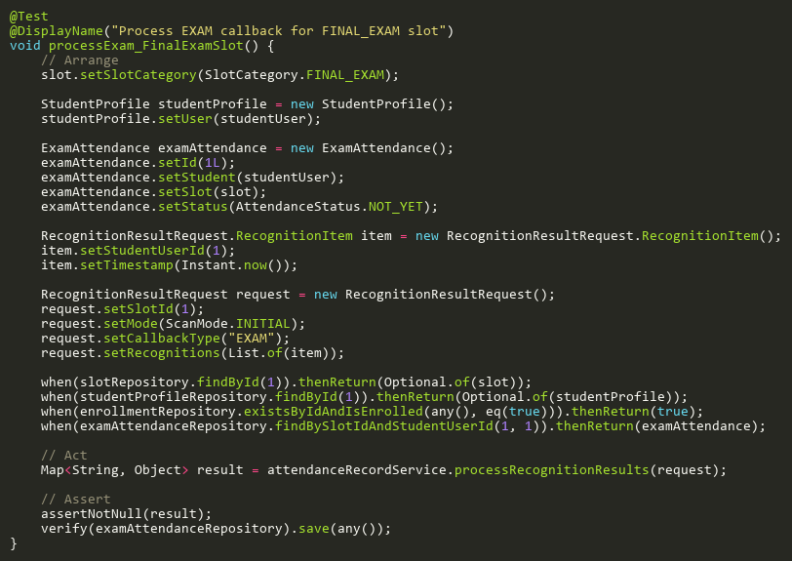

**Figure: processExam_FinalExamSlot**  
*Reference: Sheet "ARST_processExam", Test Case TC01*

## ProcessInitialRecognitionTests

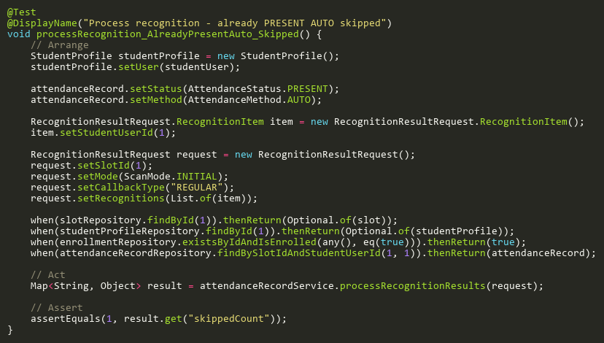

**Figure: processRecognition_AlreadyPresentAuto_Skipped**  
*Reference: Sheet "ARST_processInitial", Test Case TC03*

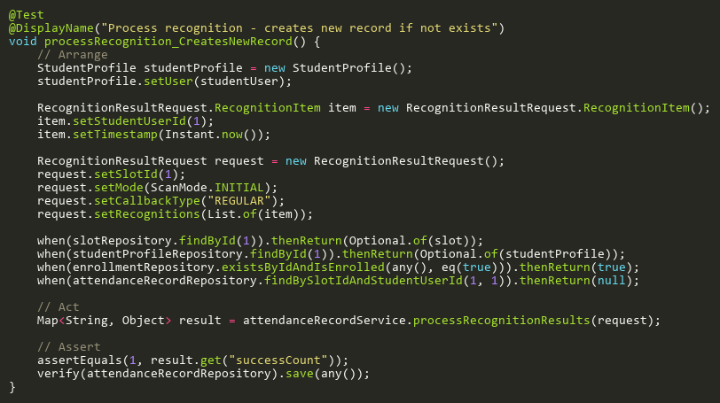

**Figure: processRecognition_CreatesNewRecord**  
*Reference: Sheet "ARST_processInitial", Test Case TC04*

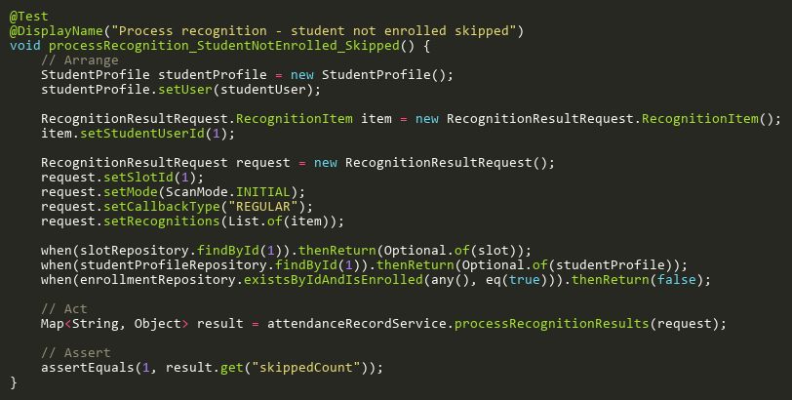

**Figure: processRecognition_StudentNotEnrolled_Skipped**  
*Reference: Sheet "ARST_processInitial", Test Case TC02*

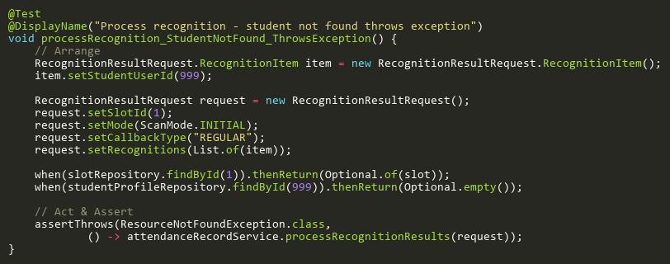

**Figure: processRecognition_StudentNotFound_ThrowsException**  
*Reference: Sheet "ARST_processInitial", Test Case TC05*

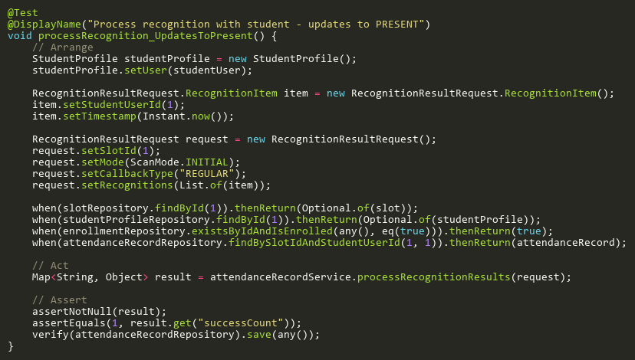

**Figure: processRecognition_UpdatesToPresent**  
*Reference: Sheet "ARST_processInitial", Test Case TC01*

## ProcessRecognitionAdditionalTests

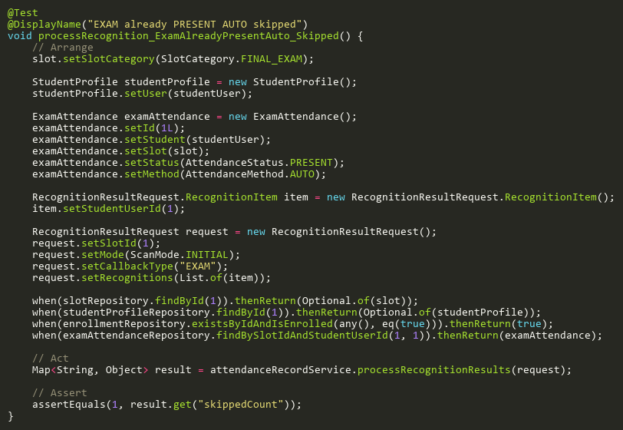

**Figure: processRecognition_ExamAlreadyPresentAuto_Skipped**  
*Reference: Sheet "ARST_processAdd", Test Case TC02*

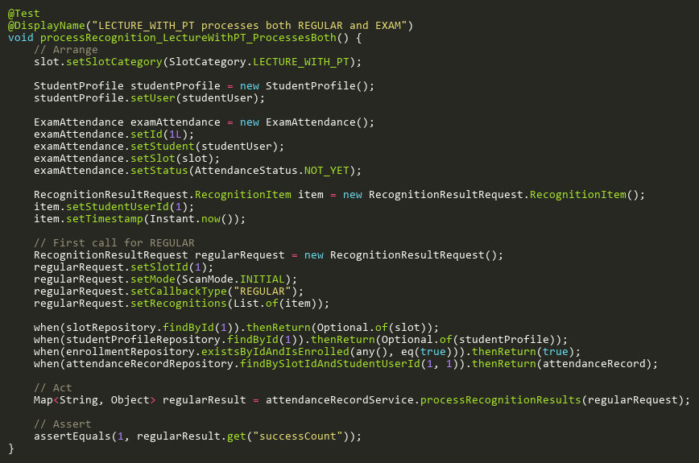

**Figure: processRecognition_LectureWithPT_ProcessesBoth**  
*Reference: Sheet "ARST_processAdd", Test Case TC03*

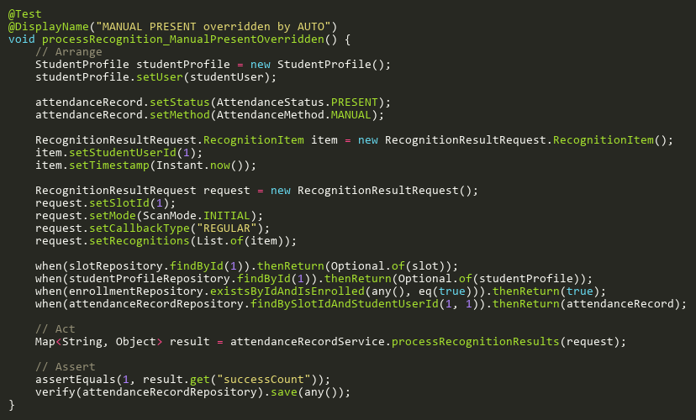

**Figure: processRecognition_ManualPresentOverridden**  
*Reference: Sheet "ARST_processAdd", Test Case TC01*

## ProcessRescanExamAdditionalTests

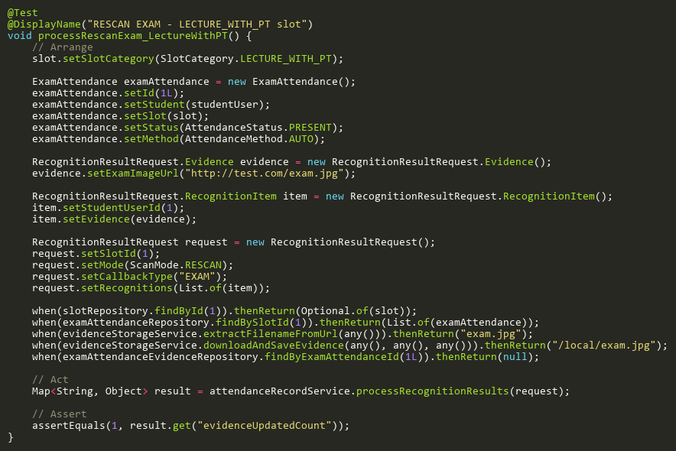

**Figure: processRescanExam_LectureWithPT**  
*Reference: Sheet "ARST_rescanExamAdd", Test Case TC04*

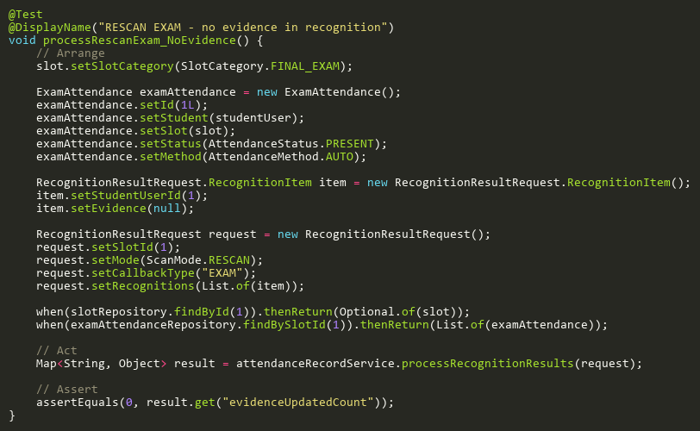

**Figure: processRescanExam_NoEvidence**  
*Reference: Sheet "ARST_rescanExamAdd", Test Case TC02*

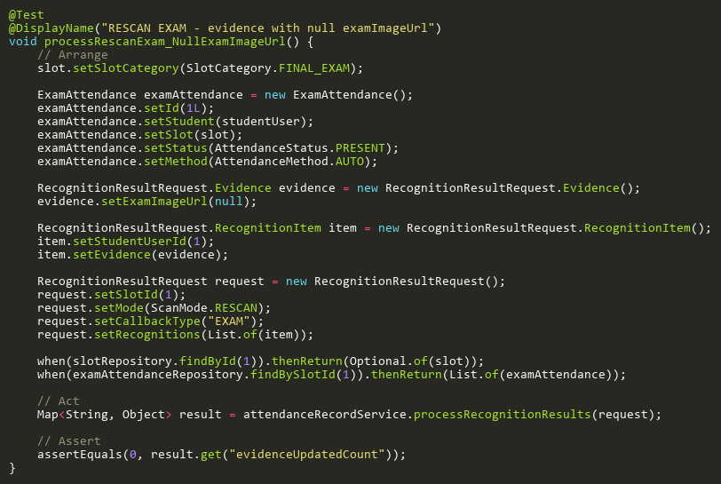

**Figure: processRescanExam_NullExamImageUrl**  
*Reference: Sheet "ARST_rescanExamAdd", Test Case TC03*

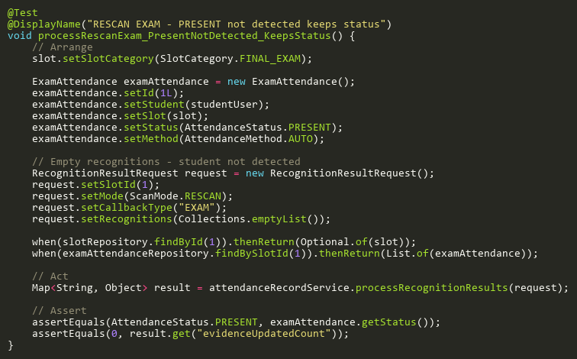

**Figure: processRescanExam_PresentNotDetected_KeepsStatus**  
*Reference: Sheet "ARST_rescanExamAdd", Test Case TC01*

## ProcessRescanExamTests

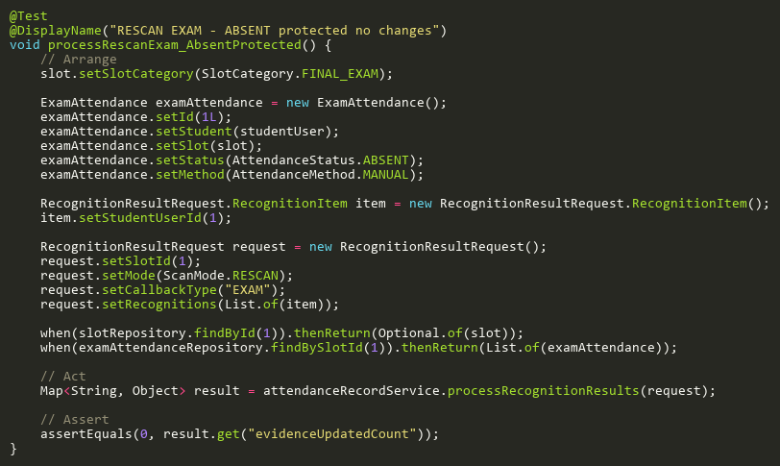

**Figure: processRescanExam_AbsentProtected**  
*Reference: Sheet "ARST_rescanExam", Test Case TC03*

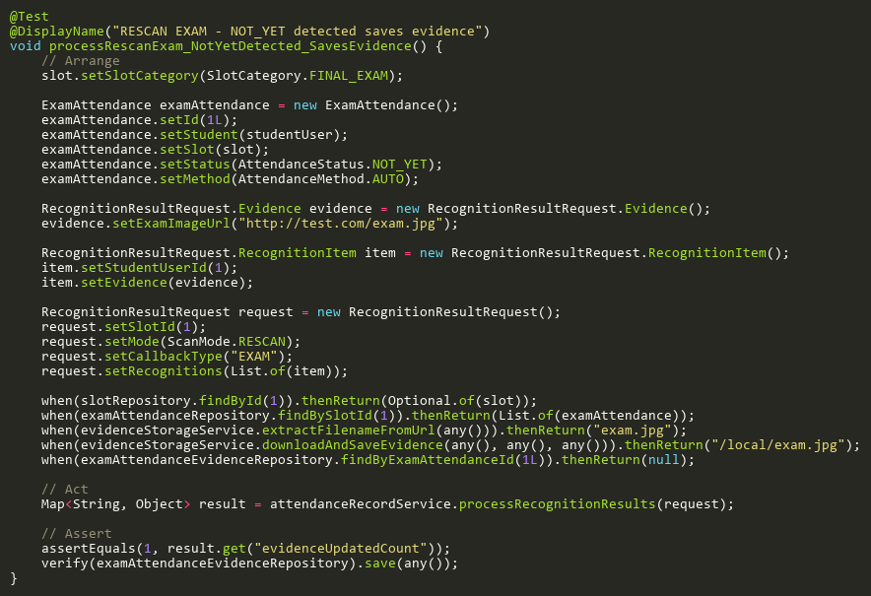

**Figure: processRescanExam_NotYetDetected_SavesEvidence**  
*Reference: Sheet "ARST_rescanExam", Test Case TC02*

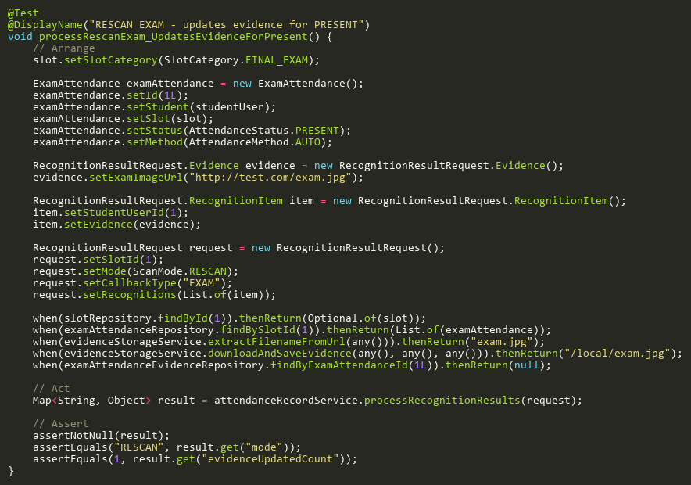

**Figure: processRescanExam_UpdatesEvidenceForPresent**  
*Reference: Sheet "ARST_rescanExam", Test Case TC01*

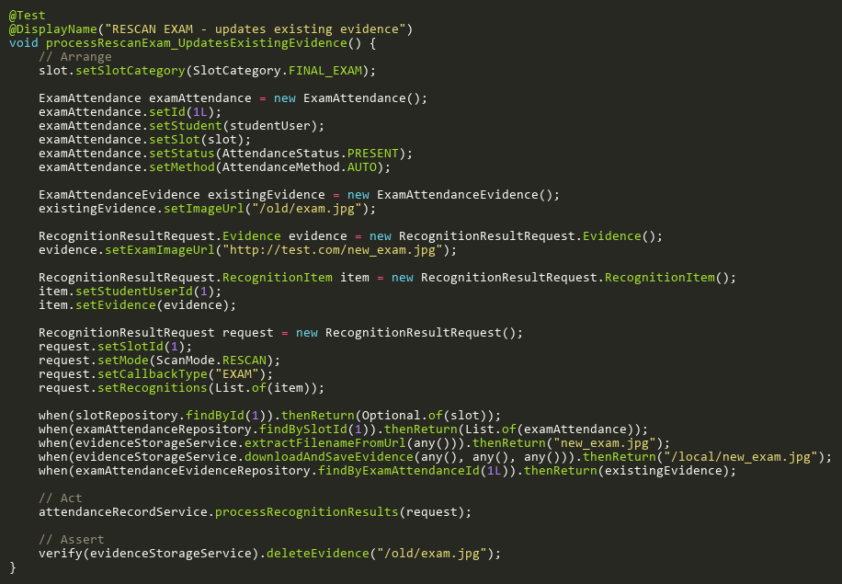

**Figure: processRescanExam_UpdatesExistingEvidence**  
*Reference: Sheet "ARST_rescanExam", Test Case TC04*

## ProcessRescanRecognitionTests

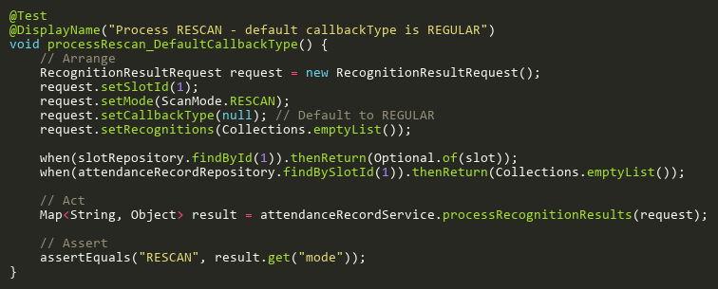

**Figure: processRescan_DefaultCallbackType**  
*Reference: Sheet "ARST_processRescan", Test Case TC02*

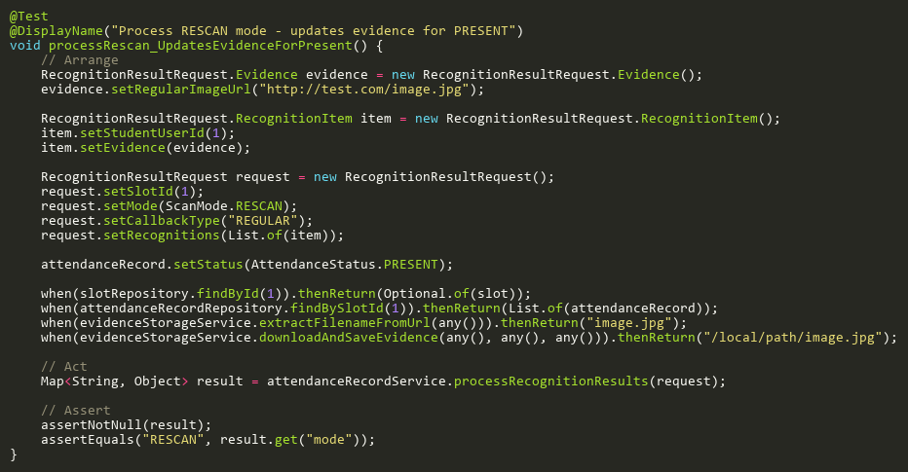

**Figure: processRescan_UpdatesEvidenceForPresent**  
*Reference: Sheet "ARST_processRescan", Test Case TC01*

## ProcessRescanRegularAdditionalTests

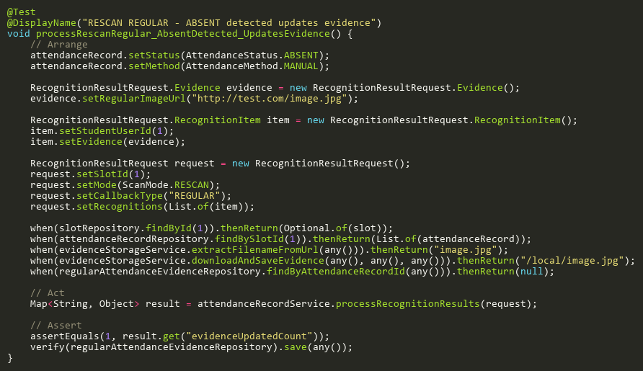

**Figure: processRescanRegular_AbsentDetected_UpdatesEvidence**  
*Reference: Sheet "ARST_rescanRegAdd", Test Case TC01*

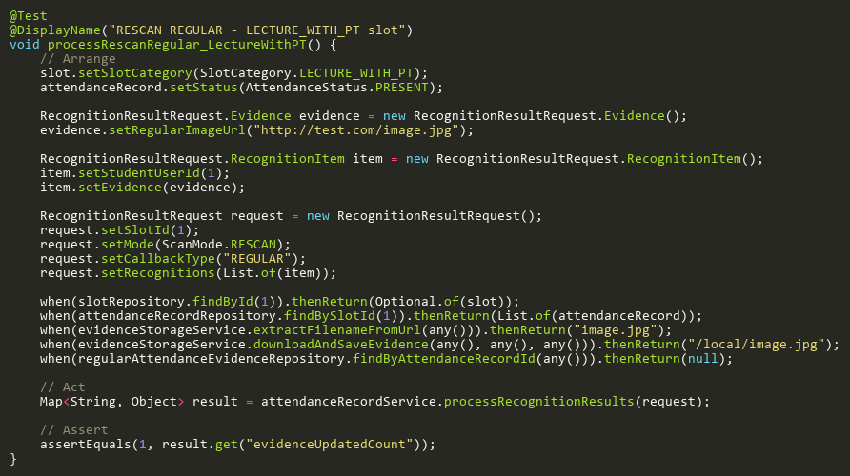

**Figure: processRescanRegular_LectureWithPT**  
*Reference: Sheet "ARST_rescanRegAdd", Test Case TC04*

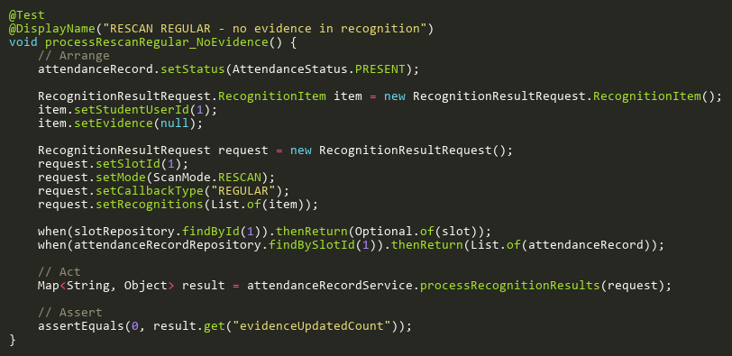

**Figure: processRescanRegular_NoEvidence**  
*Reference: Sheet "ARST_rescanRegAdd", Test Case TC05*

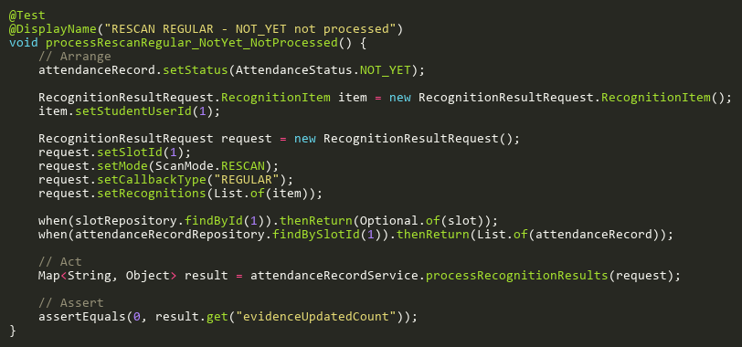

**Figure: processRescanRegular_NotYet_NotProcessed**  
*Reference: Sheet "ARST_rescanRegAdd", Test Case TC02*

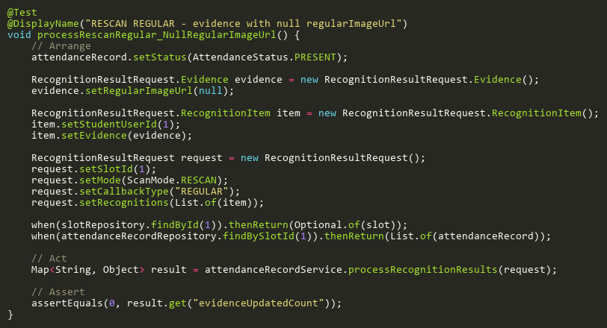

**Figure: processRescanRegular_NullRegularImageUrl**  
*Reference: Sheet "ARST_rescanRegAdd", Test Case TC06*

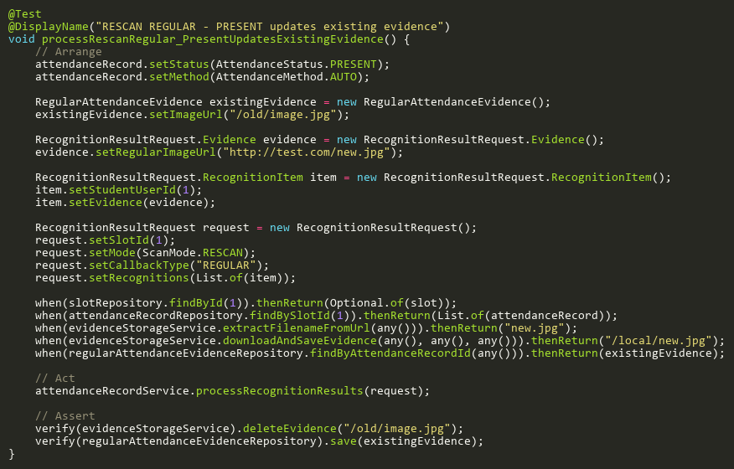

**Figure: processRescanRegular_PresentUpdatesExistingEvidence**  
*Reference: Sheet "ARST_rescanRegAdd", Test Case TC03*

## SsePublishExceptionTests

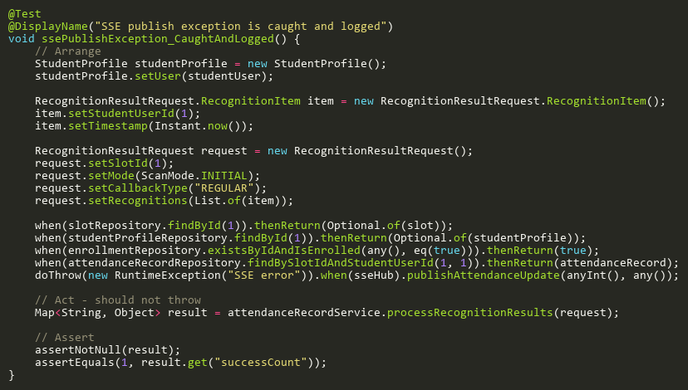

**Figure: ssePublishException_CaughtAndLogged**  
*Reference: Sheet "ARST_sseException", Test Case TC01*

## UpdateStatusAdditionalTests

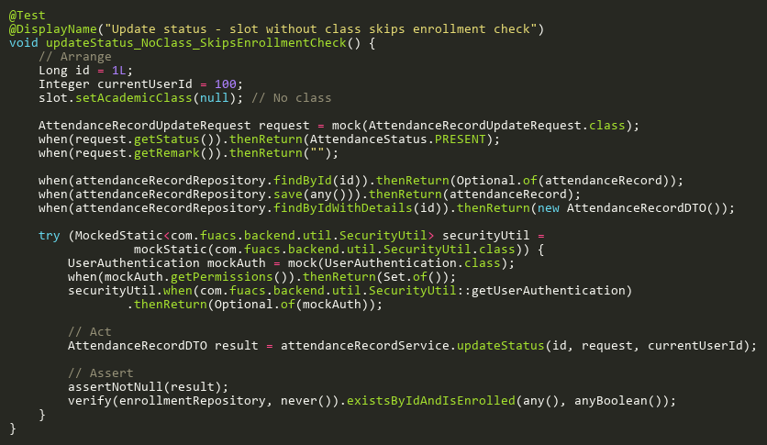

**Figure: updateStatus_NoClass_SkipsEnrollmentCheck**  
*Reference: Sheet "ARST_updateStatusAdd", Test Case TC03*

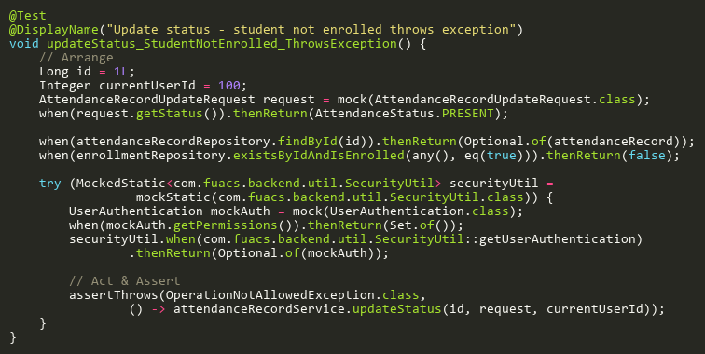

**Figure: updateStatus_StudentNotEnrolled_ThrowsException**  
*Reference: Sheet "ARST_updateStatusAdd", Test Case TC02*

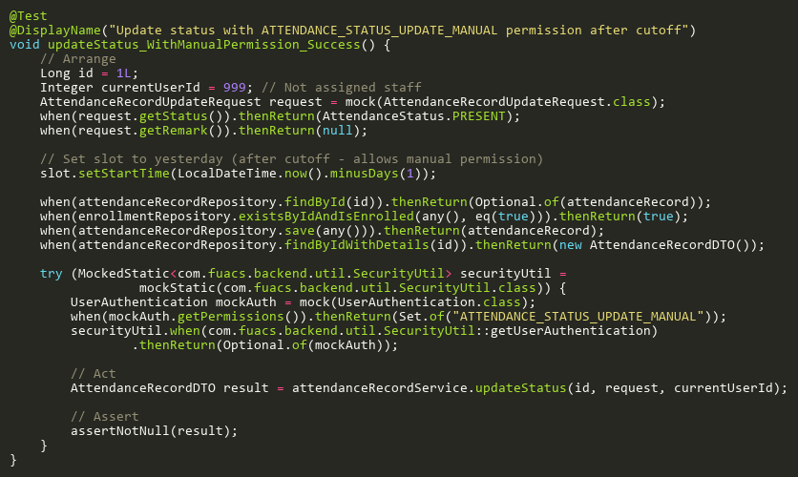

**Figure: updateStatus_WithManualPermission_Success**  
*Reference: Sheet "ARST_updateStatusAdd", Test Case TC01*

## UpdateStatusTests

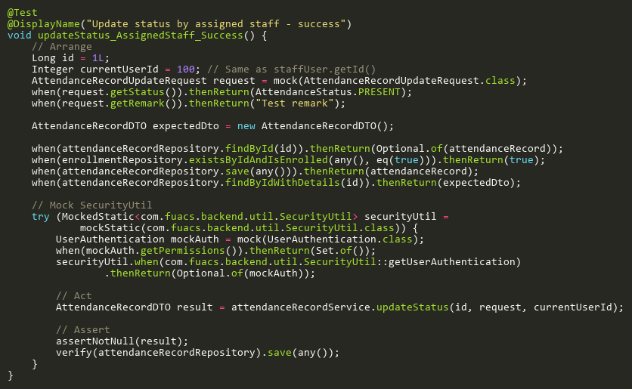

**Figure: updateStatus_AssignedStaff_Success**  
*Reference: Sheet "ARST_updateStatus", Test Case TC01*

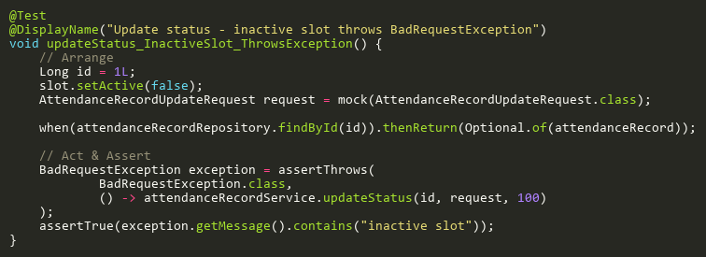

**Figure: updateStatus_InactiveSlot_ThrowsException**  
*Reference: Sheet "ARST_updateStatus", Test Case TC03*

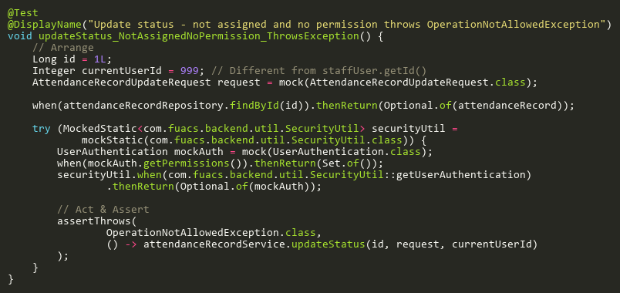

**Figure: updateStatus_NotAssignedNoPermission_ThrowsException**  
*Reference: Sheet "ARST_updateStatus", Test Case TC04*

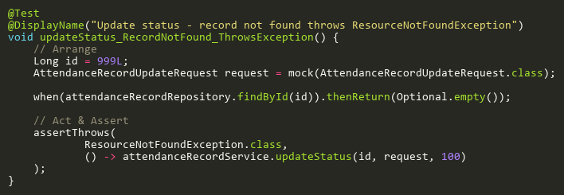

**Figure: updateStatus_RecordNotFound_ThrowsException**  
*Reference: Sheet "ARST_updateStatus", Test Case TC02*

## ValidateEditWindowTests

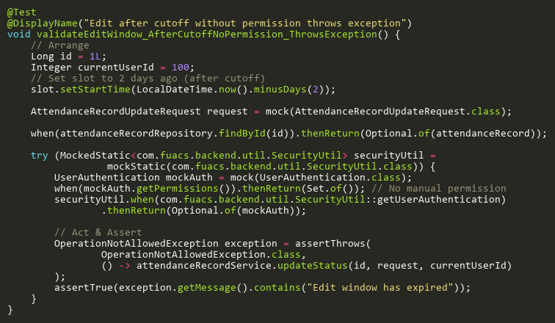

**Figure: validateEditWindow_AfterCutoffNoPermission_ThrowsException**  
*Reference: Sheet "ARST_validateEdit", Test Case TC02*

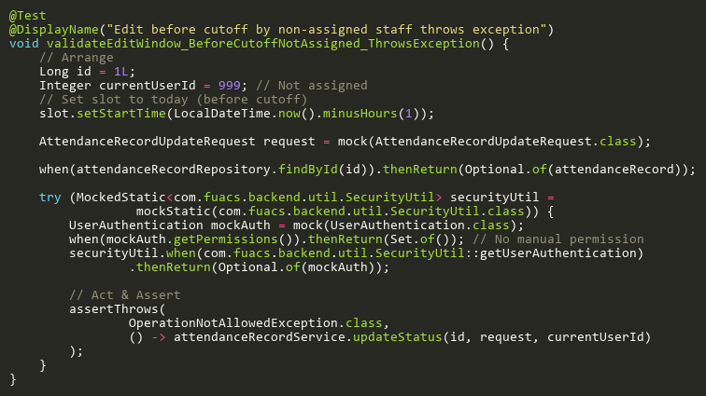

**Figure: validateEditWindow_BeforeCutoffNotAssigned_ThrowsException**  
*Reference: Sheet "ARST_validateEdit", Test Case TC03*

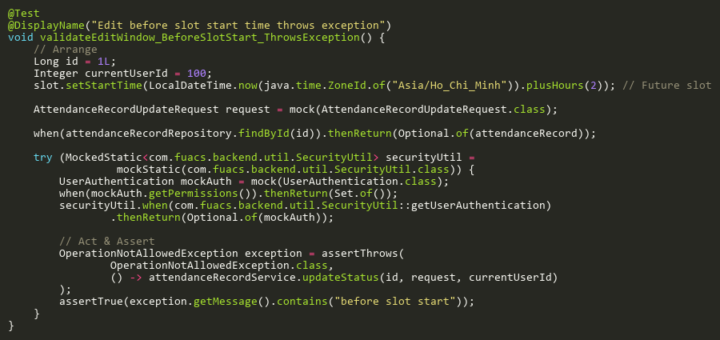

**Figure: validateEditWindow_BeforeSlotStart_ThrowsException**  
*Reference: Sheet "ARST_validateEdit", Test Case TC01*

# BulkPhotoUploadServiceTest

## ProcessBulkUploadTests

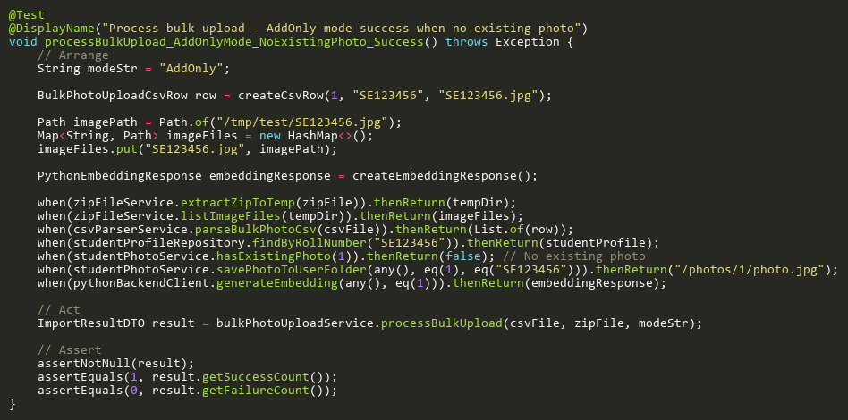

**Figure: processBulkUpload_AddOnlyMode_NoExistingPhoto_Success**  
*Reference: Sheet "BPUS_processBulkUpload", Test Case TC11*

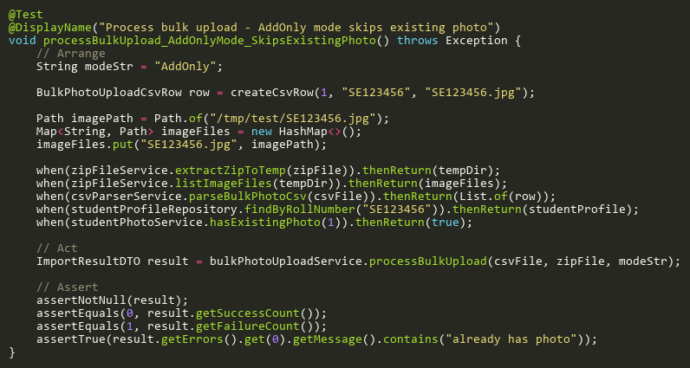

**Figure: processBulkUpload_AddOnlyMode_SkipsExistingPhoto**  
*Reference: Sheet "BPUS_processBulkUpload", Test Case TC06*

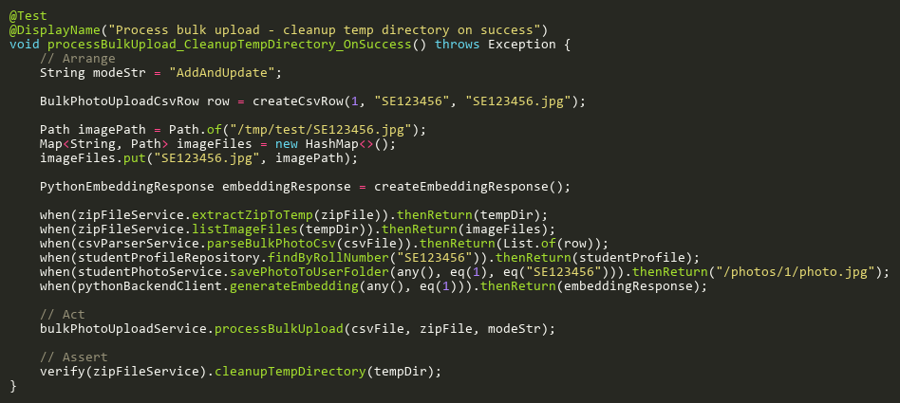

**Figure: processBulkUpload_CleanupTempDirectory_OnSuccess**  
*Reference: Sheet "BPUS_processBulkUpload", Test Case TC10*

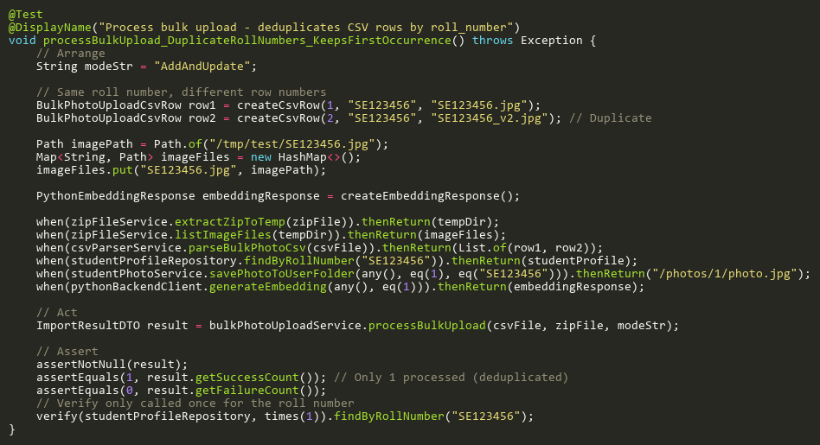

**Figure: processBulkUpload_DuplicateRollNumbers_KeepsFirstOccurrence**  
*Reference: Sheet "BPUS_processBulkUpload", Test Case TC08*

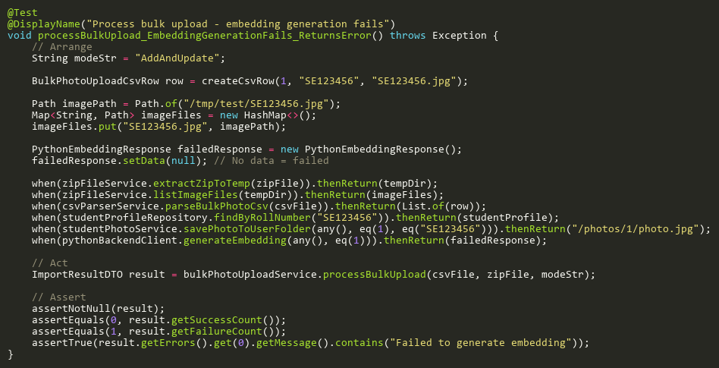

**Figure: processBulkUpload_EmbeddingGenerationFails_ReturnsError**  
*Reference: Sheet "BPUS_processBulkUpload", Test Case TC07*

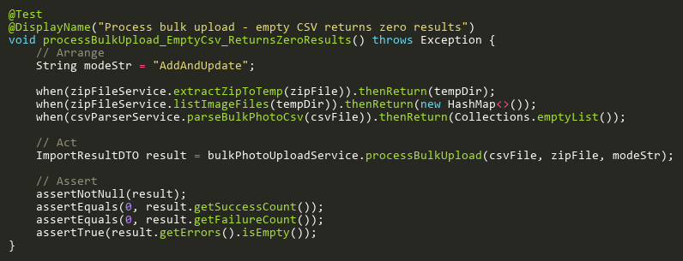

**Figure: processBulkUpload_EmptyCsv_ReturnsZeroResults**  
*Reference: Sheet "BPUS_processBulkUpload", Test Case TC12*

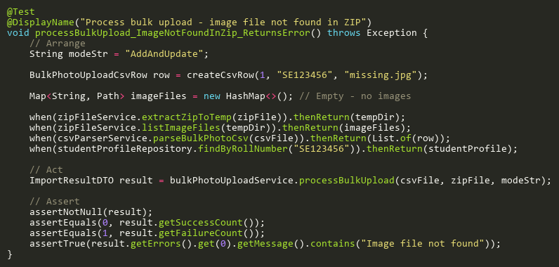

**Figure: processBulkUpload_ImageNotFoundInZip_ReturnsError**  
*Reference: Sheet "BPUS_processBulkUpload", Test Case TC05*

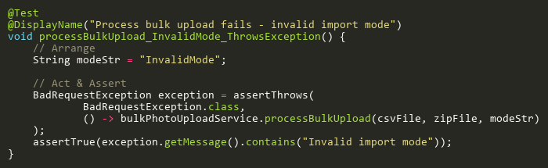

**Figure: processBulkUpload_InvalidMode_ThrowsException**  
*Reference: Sheet "BPUS_processBulkUpload", Test Case TC03*

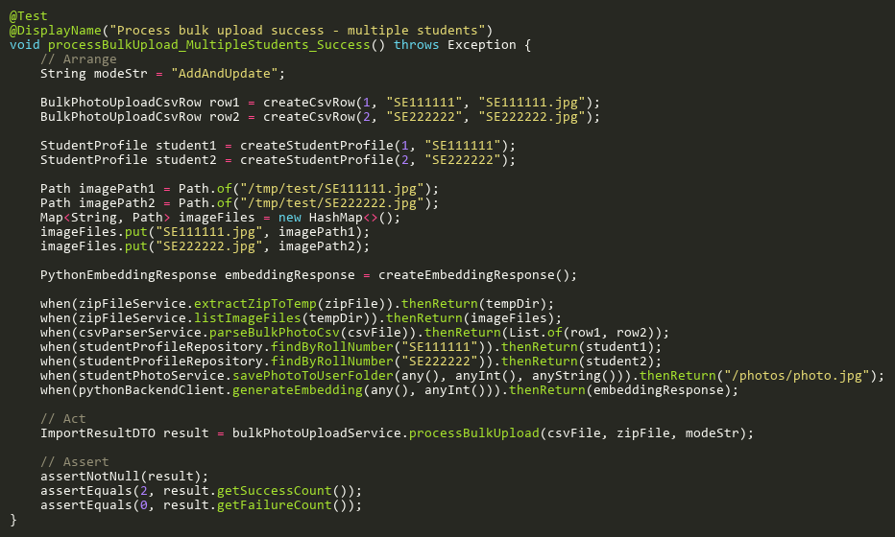

**Figure: processBulkUpload_MultipleStudents_Success**  
*Reference: Sheet "BPUS_processBulkUpload", Test Case TC02*

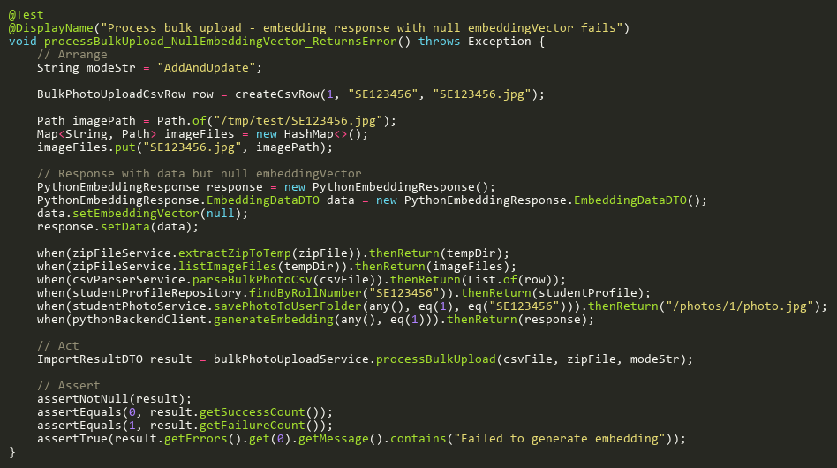

**Figure: processBulkUpload_NullEmbeddingVector_ReturnsError**  
*Reference: Sheet "BPUS_processBulkUpload", Test Case TC13*

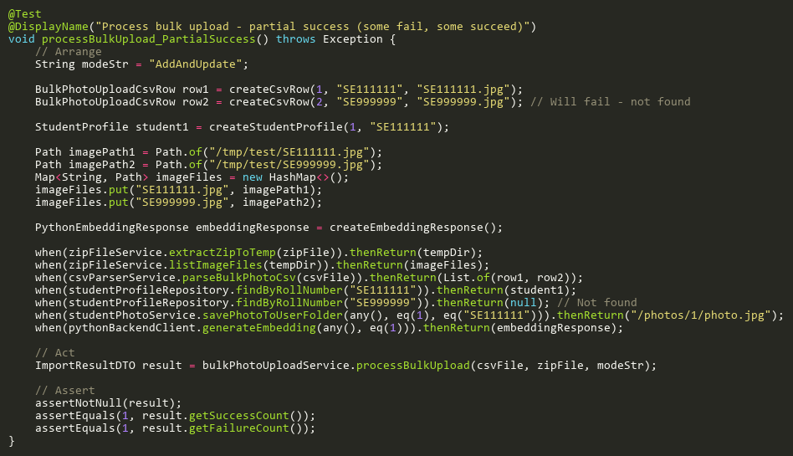

**Figure: processBulkUpload_PartialSuccess**  
*Reference: Sheet "BPUS_processBulkUpload", Test Case TC09*

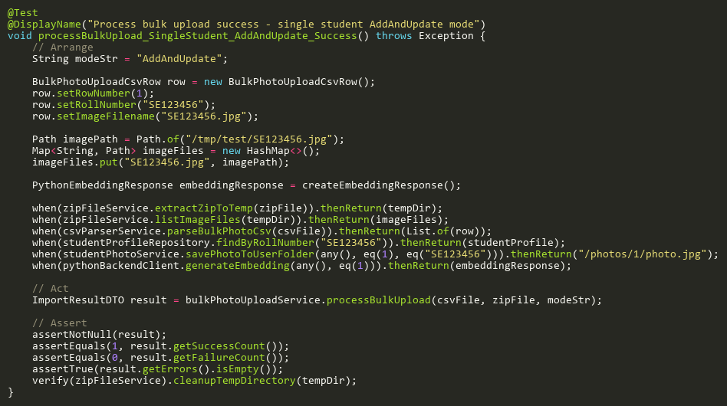

**Figure: processBulkUpload_SingleStudent_AddAndUpdate_Success**  
*Reference: Sheet "BPUS_processBulkUpload", Test Case TC01*

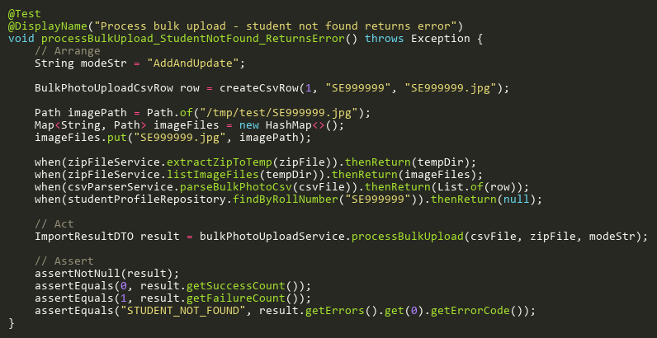

**Figure: processBulkUpload_StudentNotFound_ReturnsError**  
*Reference: Sheet "BPUS_processBulkUpload", Test Case TC04*

# CameraServiceTest

## CreateTests

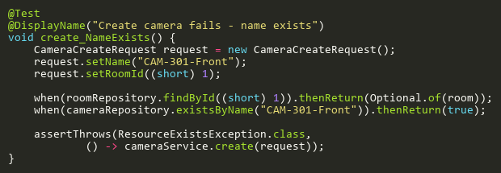

**Figure: create_NameExists**  
*Reference: Sheet "CS_create", Test Case TC03*

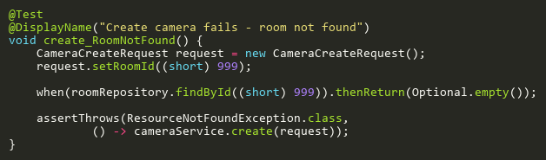

**Figure: create_RoomNotFound**  
*Reference: Sheet "CS_create", Test Case TC02*

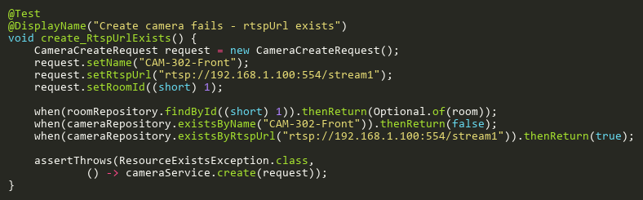

**Figure: create_RtspUrlExists**  
*Reference: Sheet "CS_create", Test Case TC04*

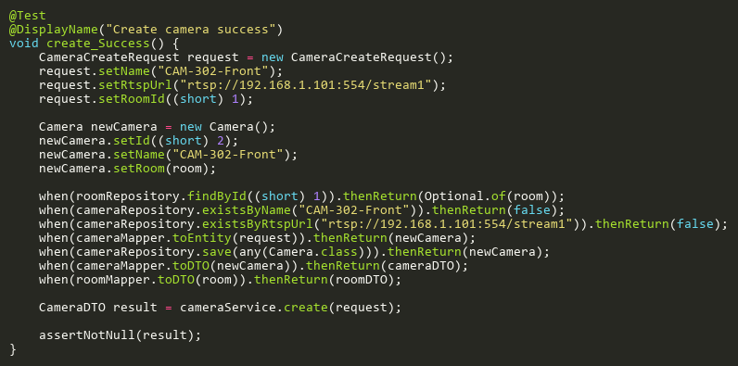

**Figure: create_Success**  
*Reference: Sheet "CS_create", Test Case TC01*

## DeleteTests

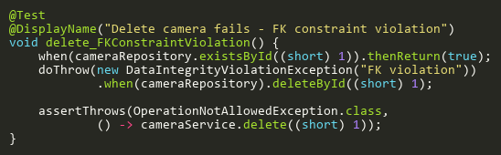

**Figure: delete_FKConstraintViolation**  
*Reference: Sheet "CS_delete", Test Case TC03*

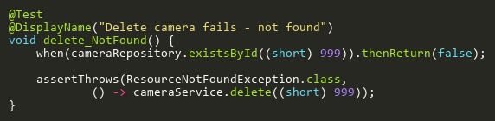

**Figure: delete_NotFound**  
*Reference: Sheet "CS_delete", Test Case TC02*

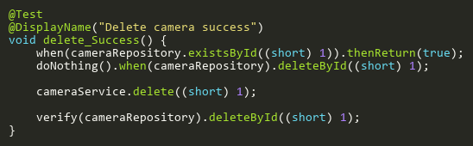

**Figure: delete_Success**  
*Reference: Sheet "CS_delete", Test Case TC01*

## FindByIdTests

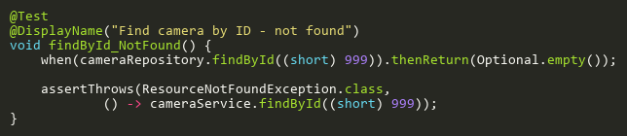

**Figure: findById_NotFound**  
*Reference: Sheet "CS_findById", Test Case TC02*

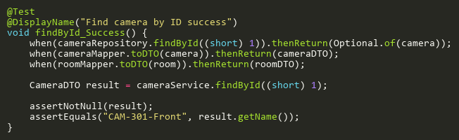

**Figure: findById_Success**  
*Reference: Sheet "CS_findById", Test Case TC01*

## TestConnectionTests

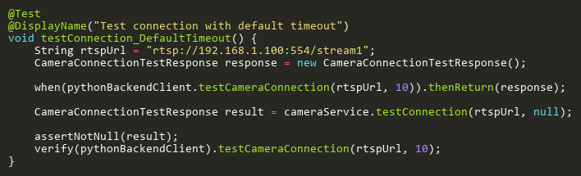

**Figure: testConnection_DefaultTimeout**  
*Reference: Sheet "CS_testConnection", Test Case TC02*

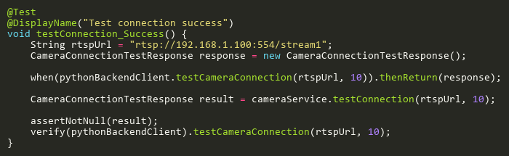

**Figure: testConnection_Success**  
*Reference: Sheet "CS_testConnection", Test Case TC01*

## UpdateTests

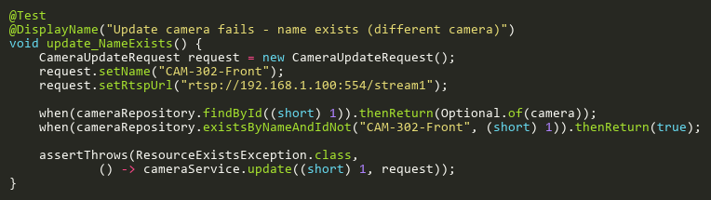

**Figure: update_NameExists**  
*Reference: Sheet "CS_update", Test Case TC03*

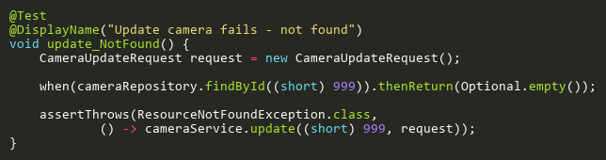

**Figure: update_NotFound**  
*Reference: Sheet "CS_update", Test Case TC02*

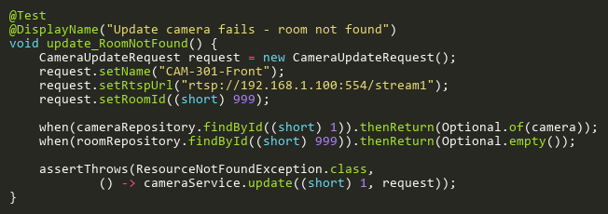

**Figure: update_RoomNotFound**  
*Reference: Sheet "CS_update", Test Case TC05*

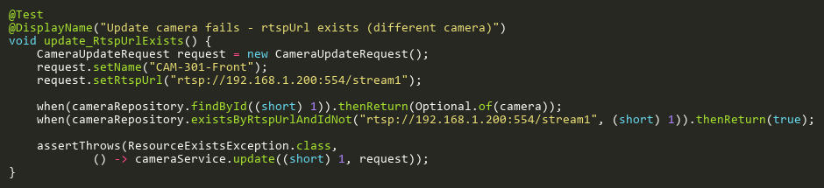

**Figure: update_RtspUrlExists**  
*Reference: Sheet "CS_update", Test Case TC04*

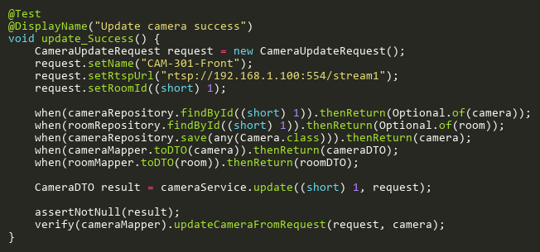

**Figure: update_Success**  
*Reference: Sheet "CS_update", Test Case TC01*

# ClassServiceTest

## CountClassesByStaffIdTests

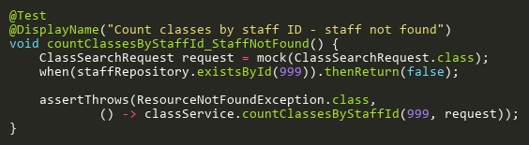

**Figure: countClassesByStaffId_StaffNotFound**  
*Reference: Sheet "CLS_countByStaffId", Test Case TC02*

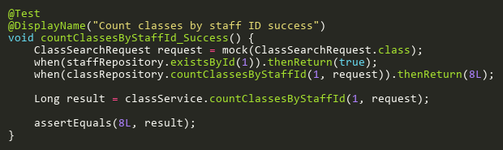

**Figure: countClassesByStaffId_Success**  
*Reference: Sheet "CLS_countByStaffId", Test Case TC01*

## CreateTests

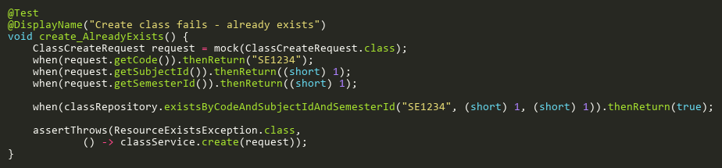

**Figure: create_AlreadyExists**  
*Reference: Sheet "CLS_create", Test Case TC02*

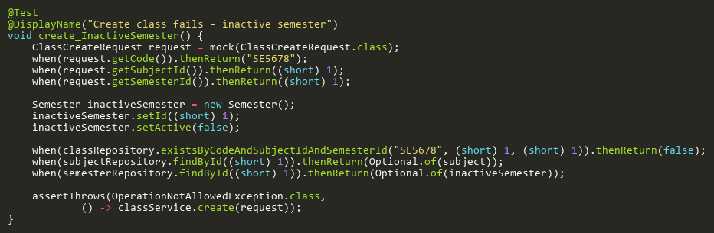

**Figure: create_InactiveSemester**  
*Reference: Sheet "CLS_create", Test Case TC06*

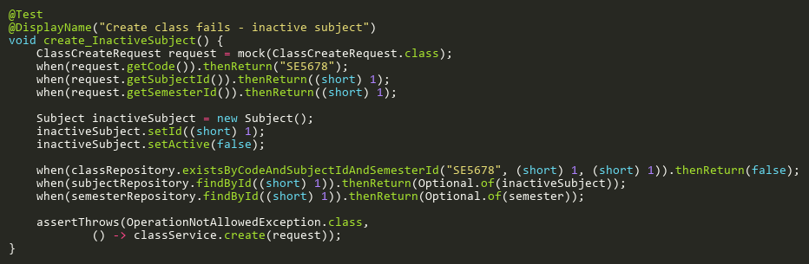

**Figure: create_InactiveSubject**  
*Reference: Sheet "CLS_create", Test Case TC05*

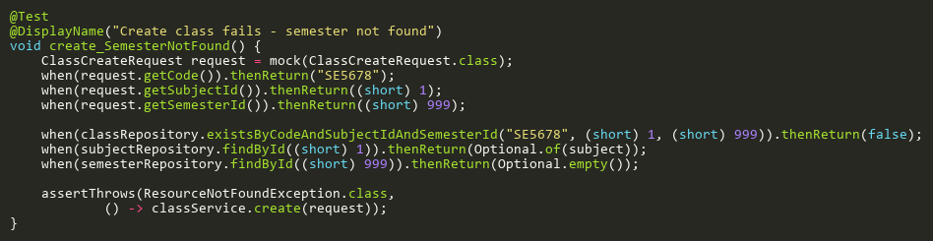

**Figure: create_SemesterNotFound**  
*Reference: Sheet "CLS_create", Test Case TC04*

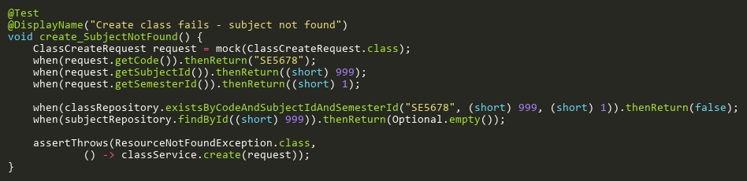

**Figure: create_SubjectNotFound**  
*Reference: Sheet "CLS_create", Test Case TC03*

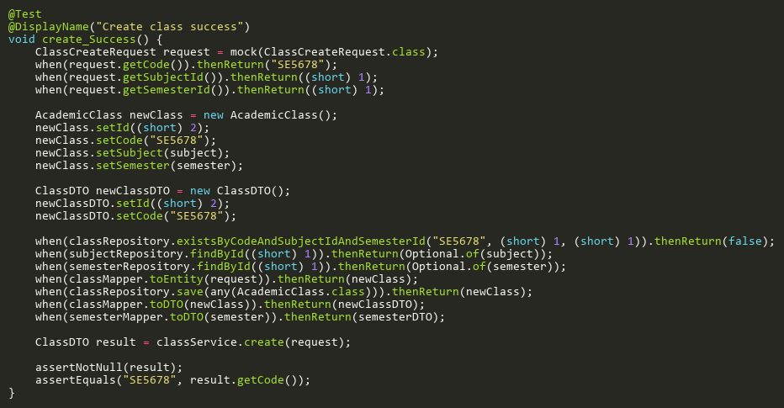

**Figure: create_Success**  
*Reference: Sheet "CLS_create", Test Case TC01*

## DeleteTests

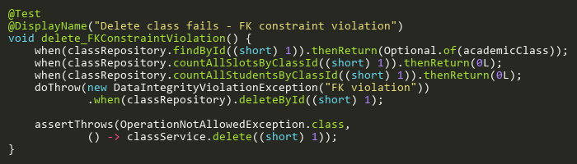

**Figure: delete_FKConstraintViolation**  
*Reference: Sheet "CLS_delete", Test Case TC05*

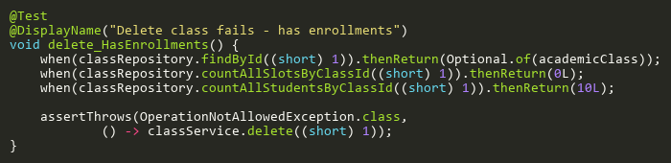

**Figure: delete_HasEnrollments**  
*Reference: Sheet "CLS_delete", Test Case TC04*

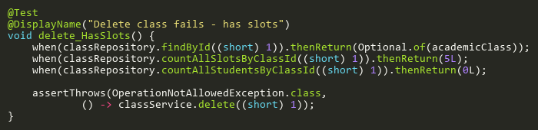

**Figure: delete_HasSlots**  
*Reference: Sheet "CLS_delete", Test Case TC03*

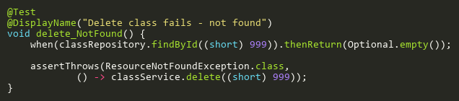

**Figure: delete_NotFound**  
*Reference: Sheet "CLS_delete", Test Case TC02*

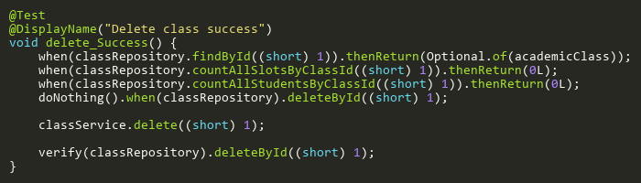

**Figure: delete_Success**  
*Reference: Sheet "CLS_delete", Test Case TC01*

## UpdateTests

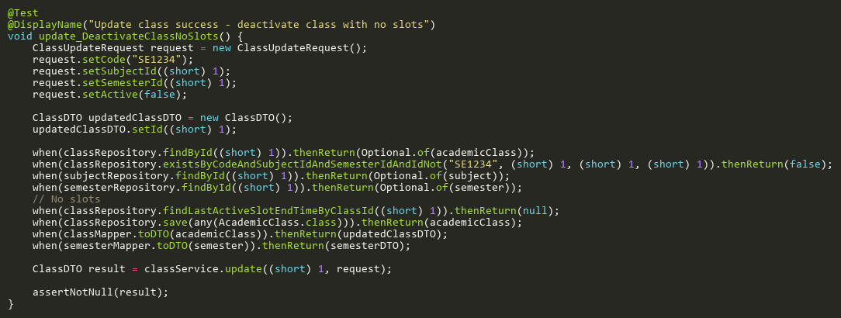

**Figure: update_DeactivateClassNoSlots**  
*Reference: Sheet "CLS_update", Test Case TC09*

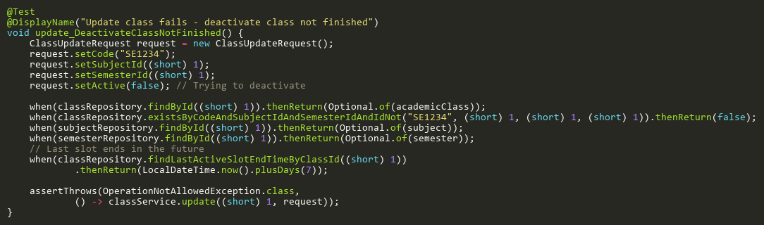

**Figure: update_DeactivateClassNotFinished**  
*Reference: Sheet "CLS_update", Test Case TC07*

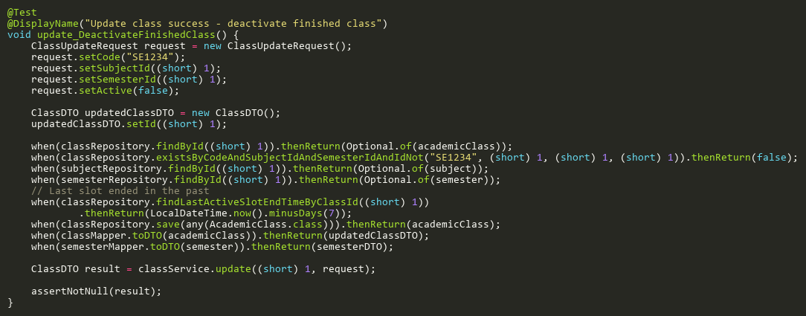

**Figure: update_DeactivateFinishedClass**  
*Reference: Sheet "CLS_update", Test Case TC08*

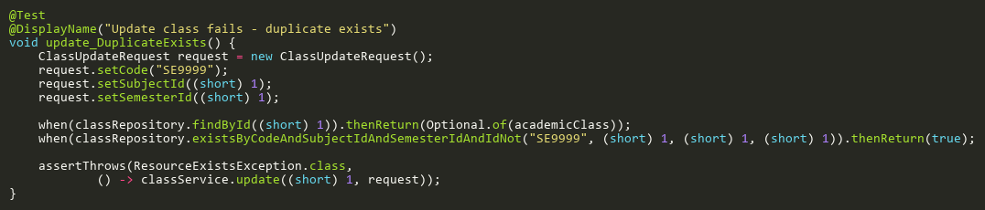

**Figure: update_DuplicateExists**  
*Reference: Sheet "CLS_update", Test Case TC03*

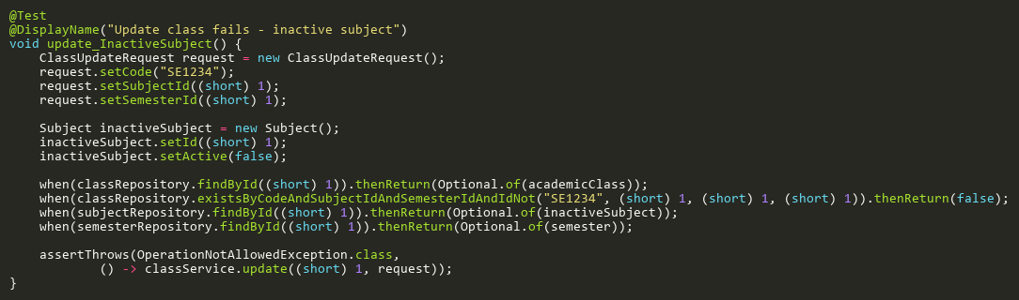

**Figure: update_InactiveSubject**  
*Reference: Sheet "CLS_update", Test Case TC06*

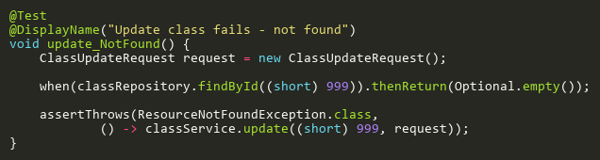

**Figure: update_NotFound**  
*Reference: Sheet "CLS_update", Test Case TC02*

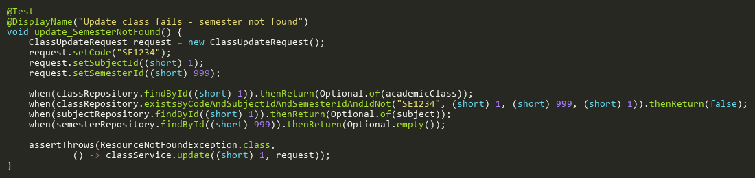

**Figure: update_SemesterNotFound**  
*Reference: Sheet "CLS_update", Test Case TC05*

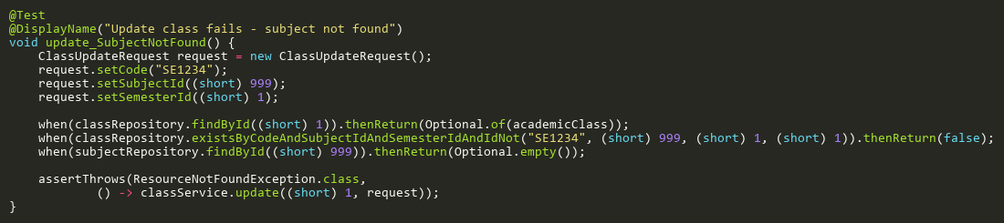

**Figure: update_SubjectNotFound**  
*Reference: Sheet "CLS_update", Test Case TC04*

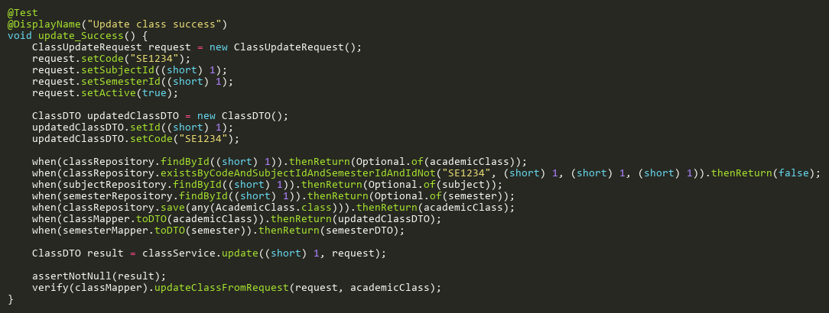

**Figure: update_Success**  
*Reference: Sheet "CLS_update", Test Case TC01*

# CsvParserServiceTest

## AdditionalCoverageTests

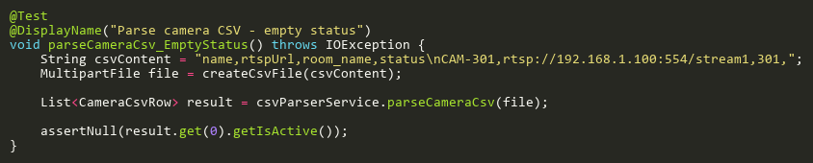

**Figure: parseCameraCsv_EmptyStatus**  
*Reference: Sheet "CPSS_statusCoverage", Test Case TC16*

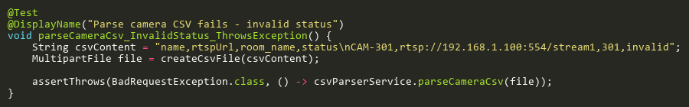

**Figure: parseCameraCsv_InvalidStatus_ThrowsException**  
*Reference: Sheet "CPSS_statusCoverage", Test Case TC08*

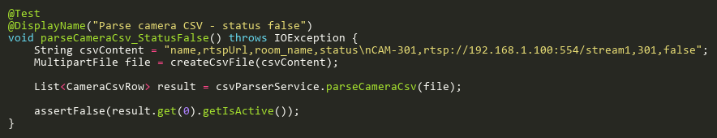

**Figure: parseCameraCsv_StatusFalse**  
*Reference: Sheet "CPSS_statusCoverage", Test Case TC07*

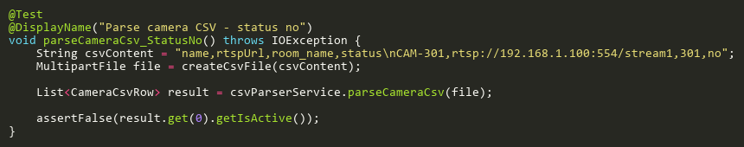

**Figure: parseCameraCsv_StatusNo**  
*Reference: Sheet "CPSS_statusCoverage", Test Case TC09*

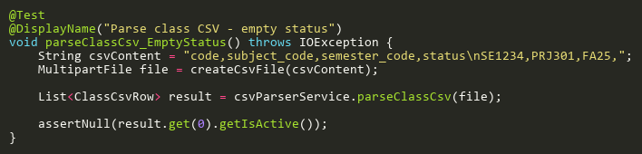

**Figure: parseClassCsv_EmptyStatus**  
*Reference: Sheet "CPSS_statusCoverage", Test Case TC17*

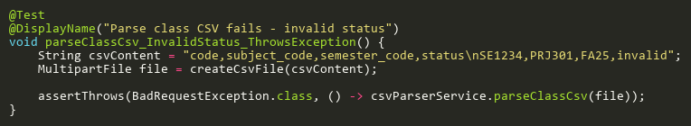

**Figure: parseClassCsv_InvalidStatus_ThrowsException**  
*Reference: Sheet "CPSS_statusCoverage", Test Case TC18*

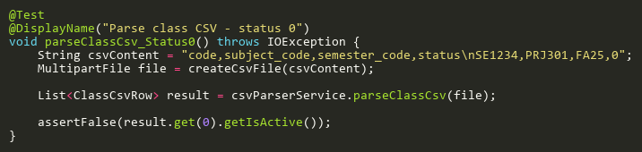

**Figure: parseClassCsv_Status0**  
*Reference: Sheet "CPSS_statusCoverage", Test Case TC10*

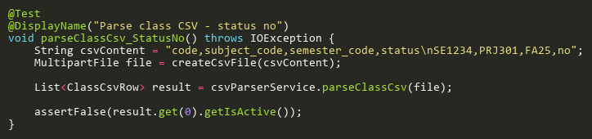

**Figure: parseClassCsv_StatusNo**  
*Reference: Sheet "CPSS_statusCoverage", Test Case TC11*

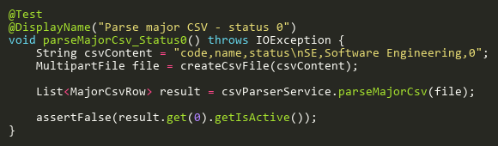

**Figure: parseMajorCsv_Status0**  
*Reference: Sheet "CPSS_statusCoverage", Test Case TC02*

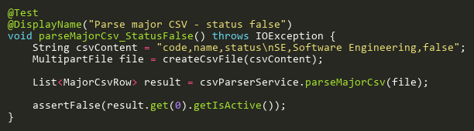

**Figure: parseMajorCsv_StatusFalse**  
*Reference: Sheet "CPSS_statusCoverage", Test Case TC01*

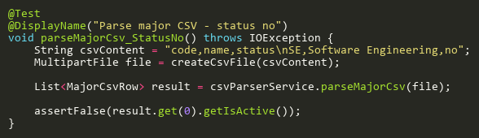

**Figure: parseMajorCsv_StatusNo**  
*Reference: Sheet "CPSS_statusCoverage", Test Case TC03*

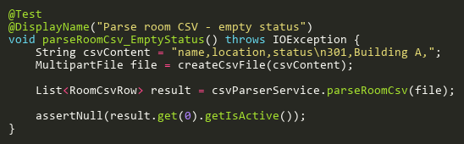

**Figure: parseRoomCsv_EmptyStatus**  
*Reference: Sheet "CPSS_statusCoverage", Test Case TC13*

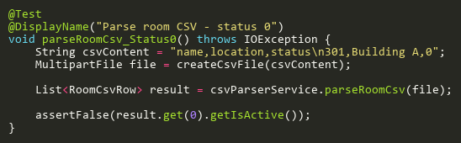

**Figure: parseRoomCsv_Status0**  
*Reference: Sheet "CPSS_statusCoverage", Test Case TC05*

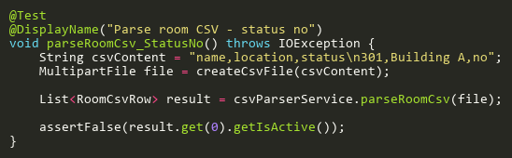

**Figure: parseRoomCsv_StatusNo**  
*Reference: Sheet "CPSS_statusCoverage", Test Case TC06*

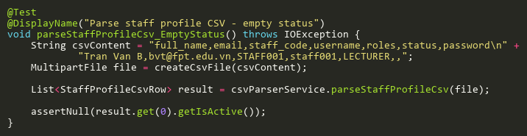

**Figure: parseStaffProfileCsv_EmptyStatus**  
*Reference: Sheet "CPSS_statusCoverage", Test Case TC20*

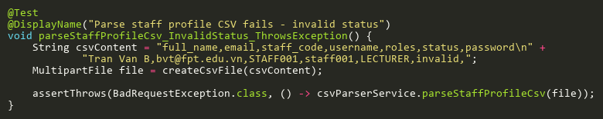

**Figure: parseStaffProfileCsv_InvalidStatus_ThrowsException**  
*Reference: Sheet "CPSS_statusCoverage", Test Case TC04*

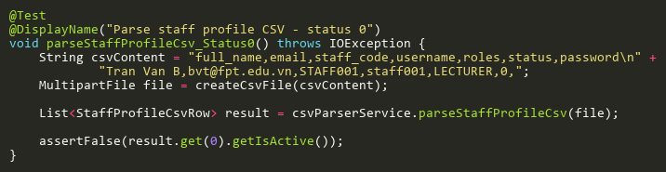

**Figure: parseStaffProfileCsv_Status0**  
*Reference: Sheet "CPSS_statusCoverage", Test Case TC23*

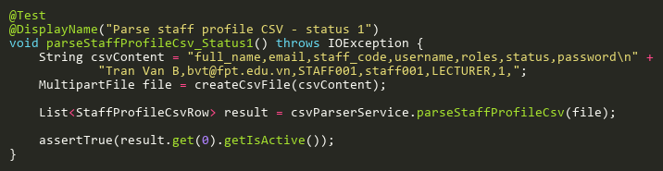

**Figure: parseStaffProfileCsv_Status1**  
*Reference: Sheet "CPSS_statusCoverage", Test Case TC24*

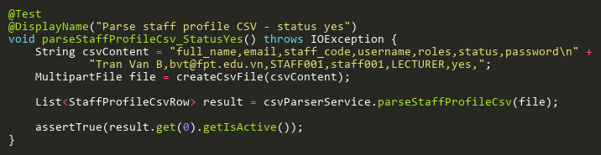

**Figure: parseStaffProfileCsv_StatusYes**  
*Reference: Sheet "CPSS_statusCoverage", Test Case TC25*

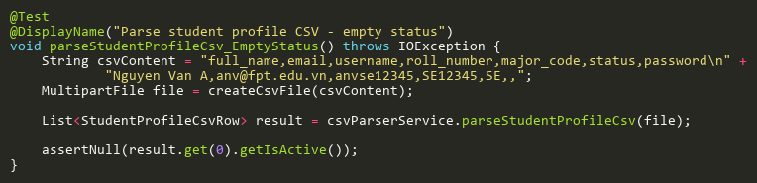

**Figure: parseStudentProfileCsv_EmptyStatus**  
*Reference: Sheet "CPSS_statusCoverage", Test Case TC19*

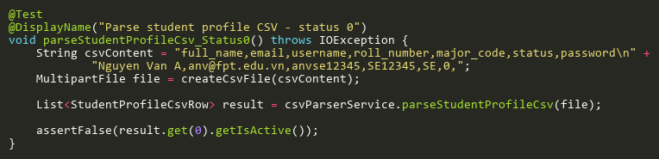

**Figure: parseStudentProfileCsv_Status0**  
*Reference: Sheet "CPSS_statusCoverage", Test Case TC21*

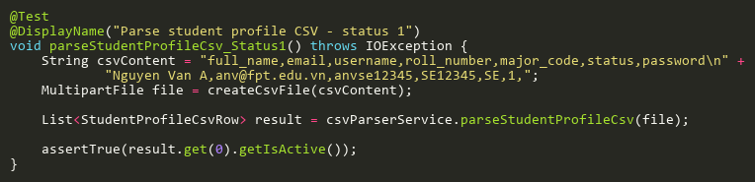

**Figure: parseStudentProfileCsv_Status1**  
*Reference: Sheet "CPSS_statusCoverage", Test Case TC26*

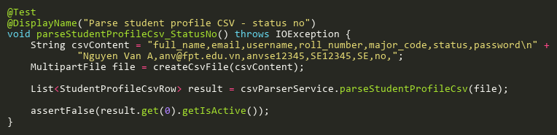

**Figure: parseStudentProfileCsv_StatusNo**  
*Reference: Sheet "CPSS_statusCoverage", Test Case TC22*

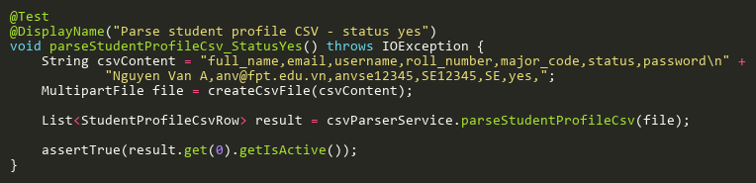

**Figure: parseStudentProfileCsv_StatusYes**  
*Reference: Sheet "CPSS_statusCoverage", Test Case TC27*

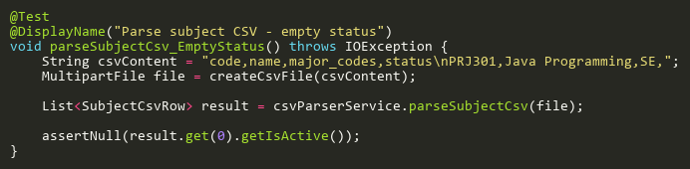

**Figure: parseSubjectCsv_EmptyStatus**  
*Reference: Sheet "CPSS_statusCoverage", Test Case TC12*

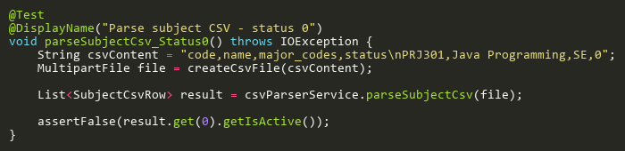

**Figure: parseSubjectCsv_Status0**  
*Reference: Sheet "CPSS_statusCoverage", Test Case TC14*

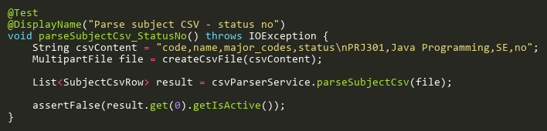

**Figure: parseSubjectCsv_StatusNo**  
*Reference: Sheet "CPSS_statusCoverage", Test Case TC15*

## FileValidationTests

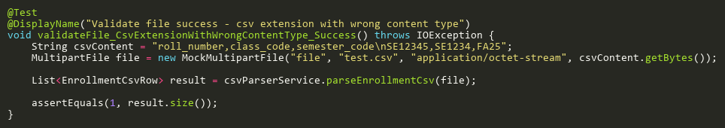

**Figure: validateFile_CsvExtensionWithWrongContentType_Success**  
*Reference: Sheet "CPSS_validateFile", Test Case TC05*

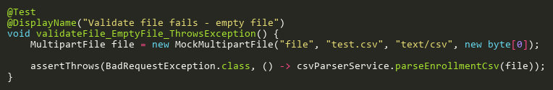

**Figure: validateFile_EmptyFile_ThrowsException**  
*Reference: Sheet "CPSS_validateFile", Test Case TC02*

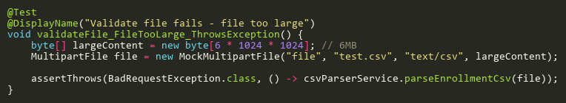

**Figure: validateFile_FileTooLarge_ThrowsException**  
*Reference: Sheet "CPSS_validateFile", Test Case TC03*

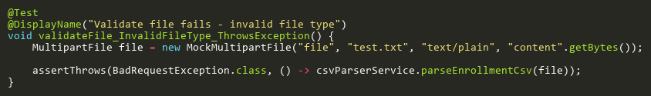

**Figure: validateFile_InvalidFileType_ThrowsException**  
*Reference: Sheet "CPSS_validateFile", Test Case TC04*

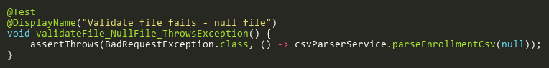

**Figure: validateFile_NullFile_ThrowsException**  
*Reference: Sheet "CPSS_validateFile", Test Case TC01*

## ParseBulkPhotoCsvTests

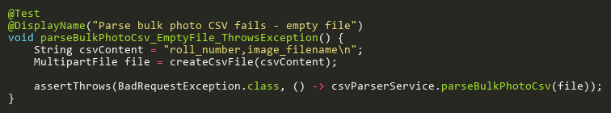

**Figure: parseBulkPhotoCsv_EmptyFile_ThrowsException**  
*Reference: Sheet "CPSS_parseBulkPhotoCsv", Test Case TC04*

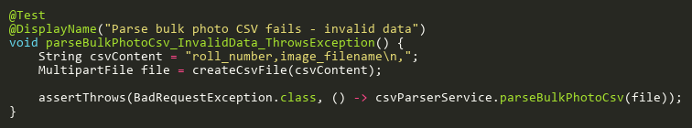

**Figure: parseBulkPhotoCsv_InvalidData_ThrowsException**  
*Reference: Sheet "CPSS_parseBulkPhotoCsv", Test Case TC05*

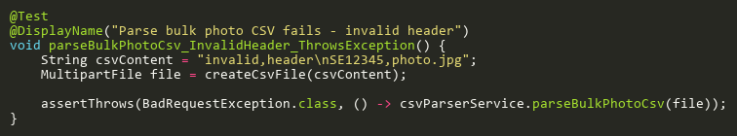

**Figure: parseBulkPhotoCsv_InvalidHeader_ThrowsException**  
*Reference: Sheet "CPSS_parseBulkPhotoCsv", Test Case TC02*

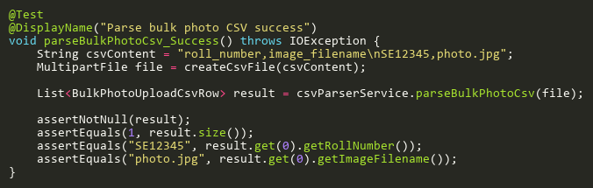

**Figure: parseBulkPhotoCsv_Success**  
*Reference: Sheet "CPSS_parseBulkPhotoCsv", Test Case TC01*

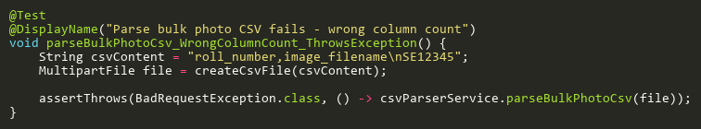

**Figure: parseBulkPhotoCsv_WrongColumnCount_ThrowsException**  
*Reference: Sheet "CPSS_parseBulkPhotoCsv", Test Case TC03*

## ParseCameraCsvTests

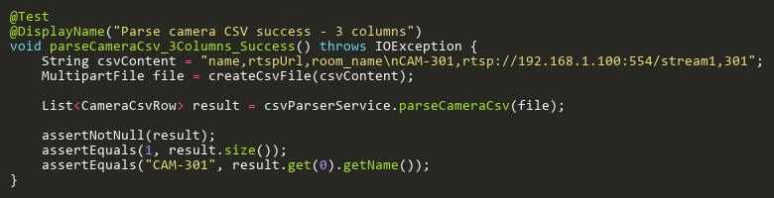

**Figure: parseCameraCsv_3Columns_Success**  
*Reference: Sheet "CPSS_parseCameraCsv", Test Case TC01*

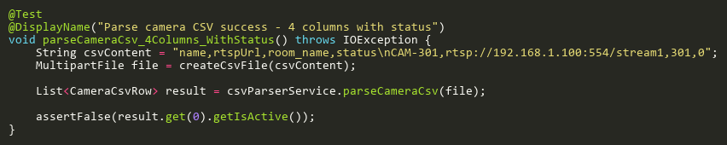

**Figure: parseCameraCsv_4Columns_WithStatus**  
*Reference: Sheet "CPSS_parseCameraCsv", Test Case TC02*

## ParseClassCsvTests

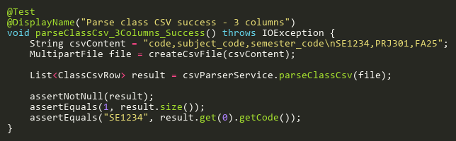

**Figure: parseClassCsv_3Columns_Success**  
*Reference: Sheet "CPSS_parseClassCsv", Test Case TC01*

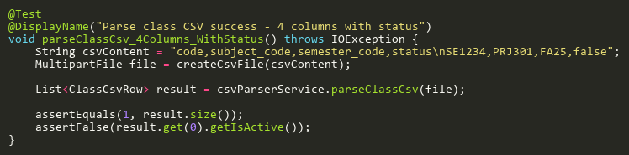

**Figure: parseClassCsv_4Columns_WithStatus**  
*Reference: Sheet "CPSS_parseClassCsv", Test Case TC02*

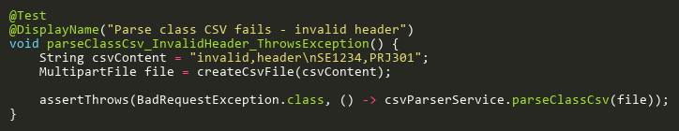

**Figure: parseClassCsv_InvalidHeader_ThrowsException**  
*Reference: Sheet "CPSS_parseClassCsv", Test Case TC03*

## ParseEnrollmentCsvTests

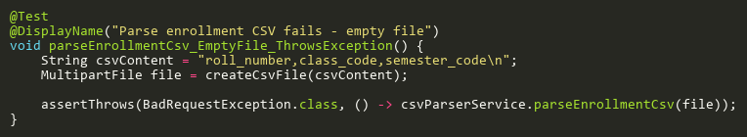

**Figure: parseEnrollmentCsv_EmptyFile_ThrowsException**  
*Reference: Sheet "CPSS_parseEnrollmentCsv", Test Case TC03*

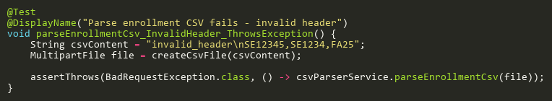

**Figure: parseEnrollmentCsv_InvalidHeader_ThrowsException**  
*Reference: Sheet "CPSS_parseEnrollmentCsv", Test Case TC02*

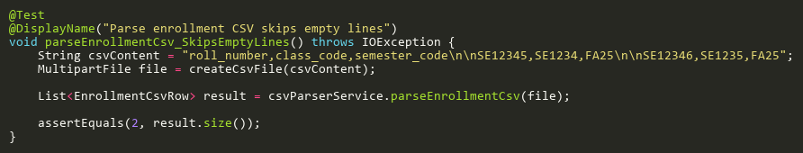

**Figure: parseEnrollmentCsv_SkipsEmptyLines**  
*Reference: Sheet "CPSS_parseEnrollmentCsv", Test Case TC05*

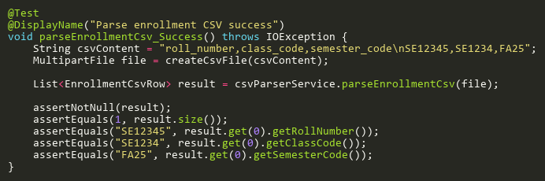

**Figure: parseEnrollmentCsv_Success**  
*Reference: Sheet "CPSS_parseEnrollmentCsv", Test Case TC01*

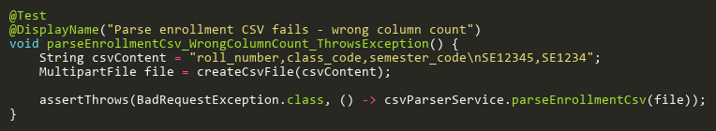

**Figure: parseEnrollmentCsv_WrongColumnCount_ThrowsException**  
*Reference: Sheet "CPSS_parseEnrollmentCsv", Test Case TC04*

## ParseExamSlotParticipantCsvTests

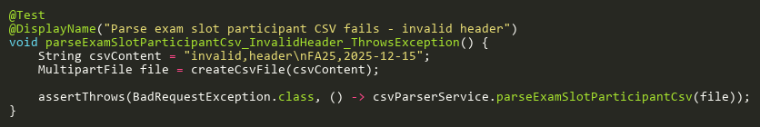

**Figure: parseExamSlotParticipantCsv_InvalidHeader_ThrowsException**  
*Reference: Sheet "CPSS_parseExamSlotCsv", Test Case TC02*

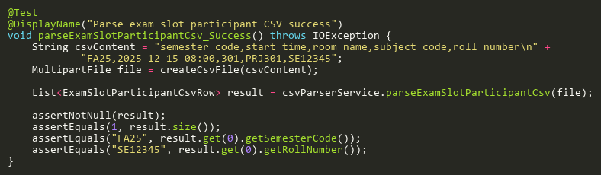

**Figure: parseExamSlotParticipantCsv_Success**  
*Reference: Sheet "CPSS_parseExamSlotCsv", Test Case TC01*

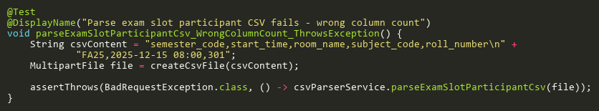

**Figure: parseExamSlotParticipantCsv_WrongColumnCount_ThrowsException**  
*Reference: Sheet "CPSS_parseExamSlotCsv", Test Case TC03*

## ParseMajorCsvTests

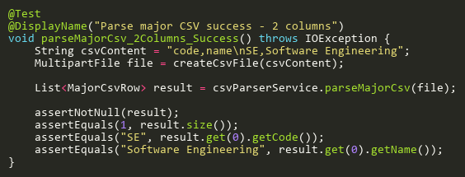

**Figure: parseMajorCsv_2Columns_Success**  
*Reference: Sheet "CPSS_parseMajorCsv", Test Case TC01*

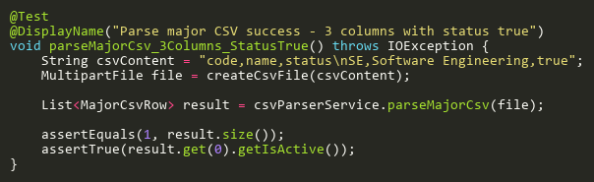

**Figure: parseMajorCsv_3Columns_StatusTrue**  
*Reference: Sheet "CPSS_parseMajorCsv", Test Case TC02*

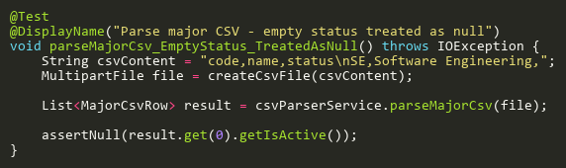

**Figure: parseMajorCsv_EmptyStatus_TreatedAsNull**  
*Reference: Sheet "CPSS_parseMajorCsv", Test Case TC06*

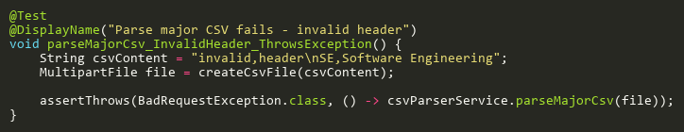

**Figure: parseMajorCsv_InvalidHeader_ThrowsException**  
*Reference: Sheet "CPSS_parseMajorCsv", Test Case TC07*

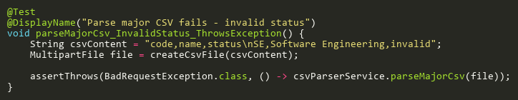

**Figure: parseMajorCsv_InvalidStatus_ThrowsException**  
*Reference: Sheet "CPSS_parseMajorCsv", Test Case TC05*

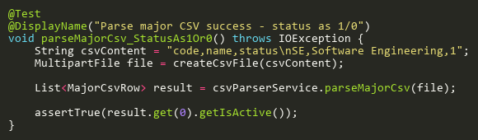

**Figure: parseMajorCsv_StatusAs1Or0**  
*Reference: Sheet "CPSS_parseMajorCsv", Test Case TC03*

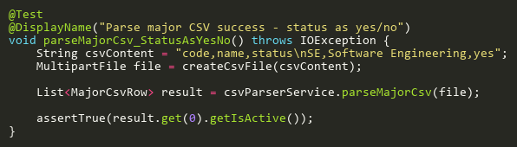

**Figure: parseMajorCsv_StatusAsYesNo**  
*Reference: Sheet "CPSS_parseMajorCsv", Test Case TC04*

## ParseRoomCsvTests

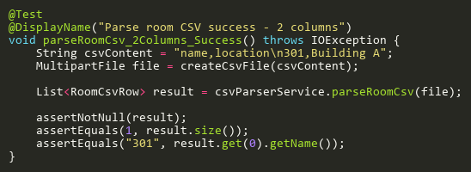

**Figure: parseRoomCsv_2Columns_Success**  
*Reference: Sheet "CPSS_parseRoomCsv", Test Case TC01*

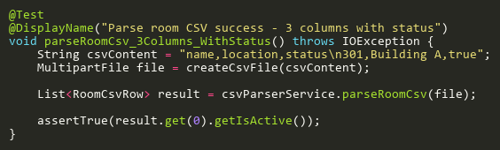

**Figure: parseRoomCsv_3Columns_WithStatus**  
*Reference: Sheet "CPSS_parseRoomCsv", Test Case TC02*

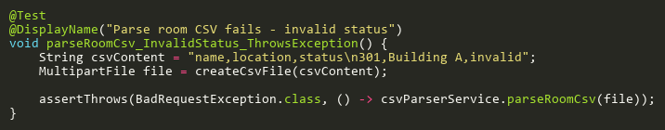

**Figure: parseRoomCsv_InvalidStatus_ThrowsException**  
*Reference: Sheet "CPSS_parseRoomCsv", Test Case TC03*

## ParseSemesterCsvTests

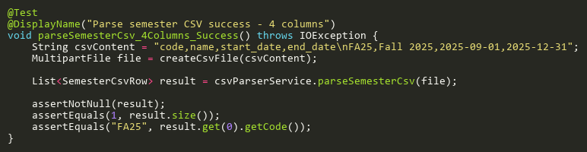

**Figure: parseSemesterCsv_4Columns_Success**  
*Reference: Sheet "CPSS_parseSemesterCsv", Test Case TC01*

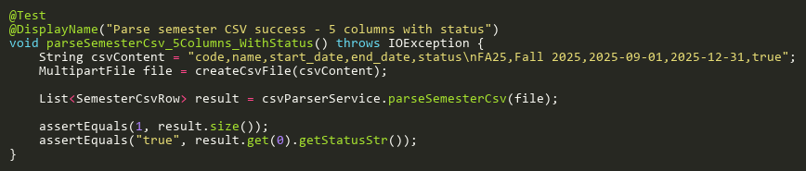

**Figure: parseSemesterCsv_5Columns_WithStatus**  
*Reference: Sheet "CPSS_parseSemesterCsv", Test Case TC02*

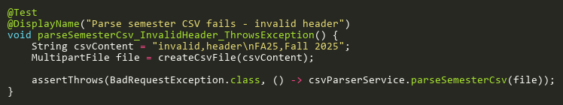

**Figure: parseSemesterCsv_InvalidHeader_ThrowsException**  
*Reference: Sheet "CPSS_parseSemesterCsv", Test Case TC03*

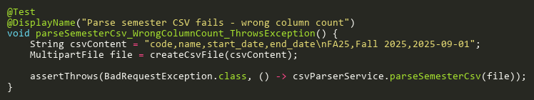

**Figure: parseSemesterCsv_WrongColumnCount_ThrowsException**  
*Reference: Sheet "CPSS_parseSemesterCsv", Test Case TC04*

## ParseStaffProfileCsvTests

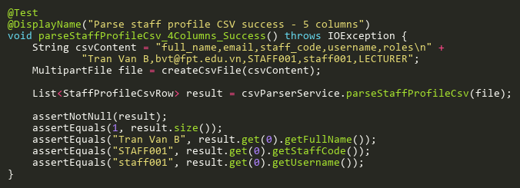

**Figure: parseStaffProfileCsv_4Columns_Success**  
*Reference: Sheet "CPSS_parseStaffCsv", Test Case TC01*

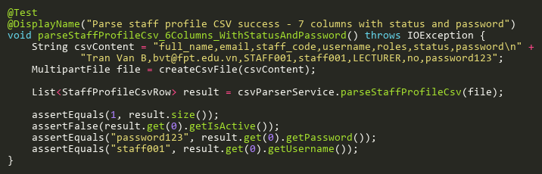

**Figure: parseStaffProfileCsv_6Columns_WithStatusAndPassword**  
*Reference: Sheet "CPSS_parseStaffCsv", Test Case TC02*

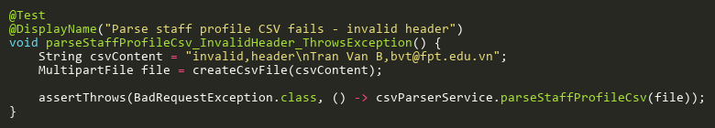

**Figure: parseStaffProfileCsv_InvalidHeader_ThrowsException**  
*Reference: Sheet "CPSS_parseStaffCsv", Test Case TC03*

## ParseStudentProfileCsvTests

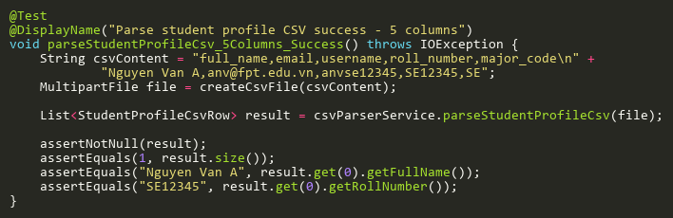

**Figure: parseStudentProfileCsv_5Columns_Success**  
*Reference: Sheet "CPSS_parseStudentCsv", Test Case TC01*

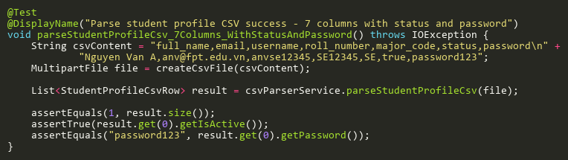

**Figure: parseStudentProfileCsv_7Columns_WithStatusAndPassword**  
*Reference: Sheet "CPSS_parseStudentCsv", Test Case TC02*

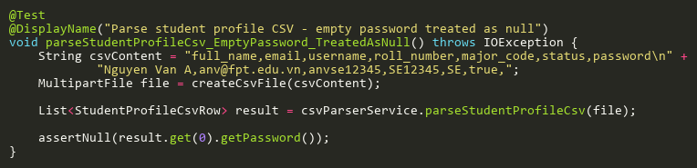

**Figure: parseStudentProfileCsv_EmptyPassword_TreatedAsNull**  
*Reference: Sheet "CPSS_parseStudentCsv", Test Case TC03*

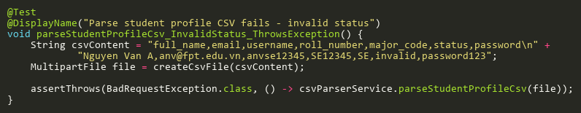

**Figure: parseStudentProfileCsv_InvalidStatus_ThrowsException**  
*Reference: Sheet "CPSS_parseStudentCsv", Test Case TC04*

## ParseSubjectCsvTests

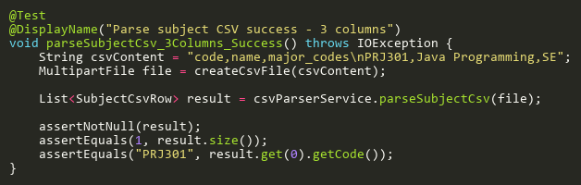

**Figure: parseSubjectCsv_3Columns_Success**  
*Reference: Sheet "CPSS_parseSubjectCsv", Test Case TC01*

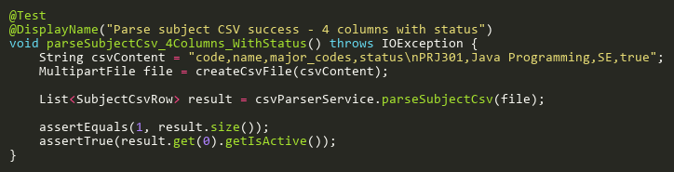

**Figure: parseSubjectCsv_4Columns_WithStatus**  
*Reference: Sheet "CPSS_parseSubjectCsv", Test Case TC02*

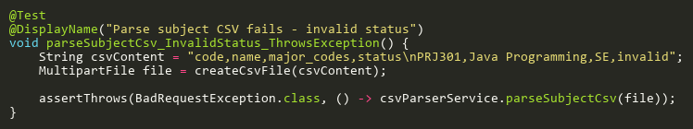

**Figure: parseSubjectCsv_InvalidStatus_ThrowsException**  
*Reference: Sheet "CPSS_parseSubjectCsv", Test Case TC04*

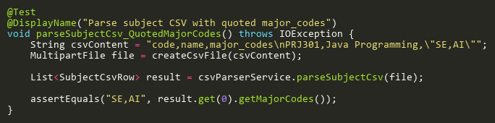

**Figure: parseSubjectCsv_QuotedMajorCodes**  
*Reference: Sheet "CPSS_parseSubjectCsv", Test Case TC03*

## ValidateRowTests

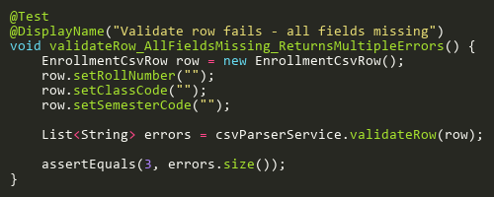

**Figure: validateRow_AllFieldsMissing_ReturnsMultipleErrors**  
*Reference: Sheet "CPSS_validateRow", Test Case TC03*

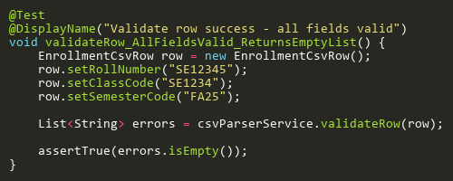

**Figure: validateRow_AllFieldsValid_ReturnsEmptyList**  
*Reference: Sheet "CPSS_validateRow", Test Case TC01*

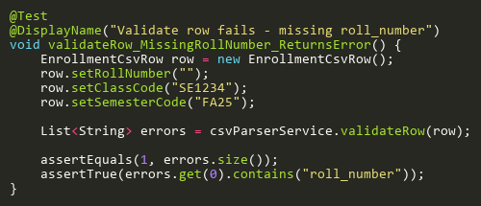

**Figure: validateRow_MissingRollNumber_ReturnsError**  
*Reference: Sheet "CPSS_validateRow", Test Case TC02*

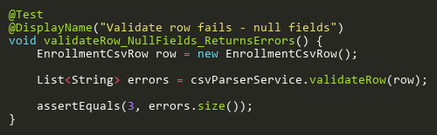

**Figure: validateRow_NullFields_ReturnsErrors**  
*Reference: Sheet "CPSS_validateRow", Test Case TC04*

# EnrollmentServiceTest

## CountByClassIdTests

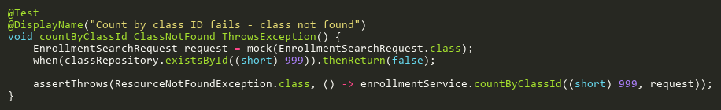

**Figure: countByClassId_ClassNotFound_ThrowsException**  
*Reference: Sheet "ES_countByClassId", Test Case TC03*

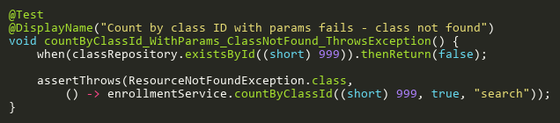

**Figure: countByClassId_WithParams_ClassNotFound_ThrowsException**  
*Reference: Sheet "ES_countByClassId", Test Case TC04*

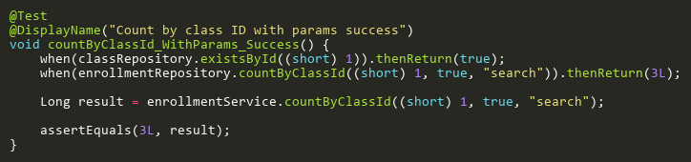

**Figure: countByClassId_WithParams_Success**  
*Reference: Sheet "ES_countByClassId", Test Case TC02*

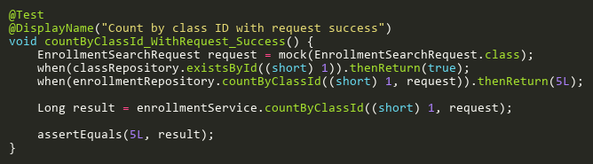

**Figure: countByClassId_WithRequest_Success**  
*Reference: Sheet "ES_countByClassId", Test Case TC01*

## CreateTests

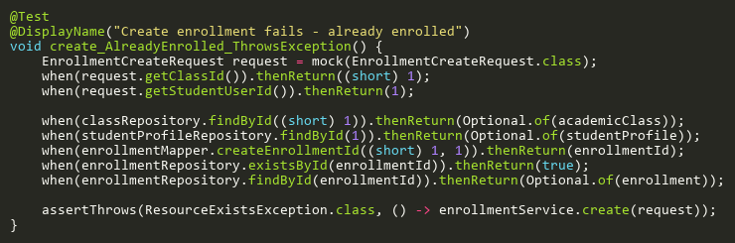

**Figure: create_AlreadyEnrolled_ThrowsException**  
*Reference: Sheet "ES_create", Test Case TC08*

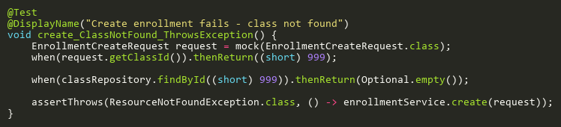

**Figure: create_ClassNotFound_ThrowsException**  
*Reference: Sheet "ES_create", Test Case TC02*

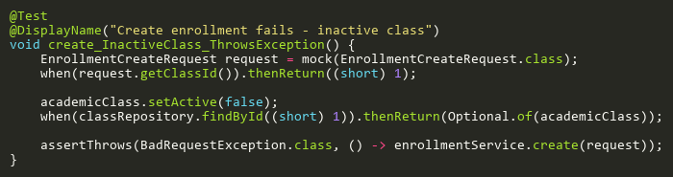

**Figure: create_InactiveClass_ThrowsException**  
*Reference: Sheet "ES_create", Test Case TC03*

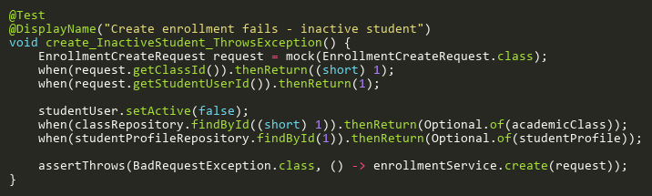

**Figure: create_InactiveStudent_ThrowsException**  
*Reference: Sheet "ES_create", Test Case TC05*

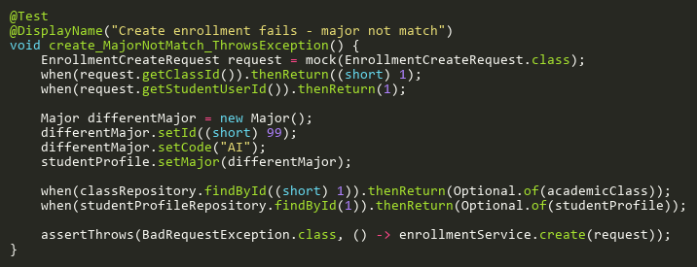

**Figure: create_MajorNotMatch_ThrowsException**  
*Reference: Sheet "ES_create", Test Case TC06*

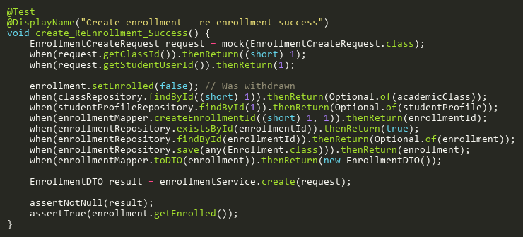

**Figure: create_ReEnrollment_Success**  
*Reference: Sheet "ES_create", Test Case TC09*

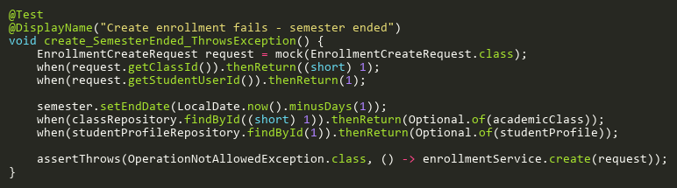

**Figure: create_SemesterEnded_ThrowsException**  
*Reference: Sheet "ES_create", Test Case TC07*

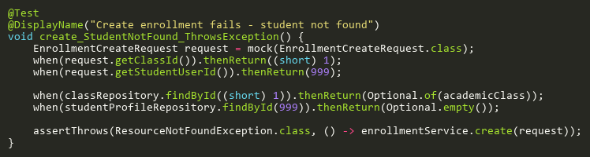

**Figure: create_StudentNotFound_ThrowsException**  
*Reference: Sheet "ES_create", Test Case TC04*

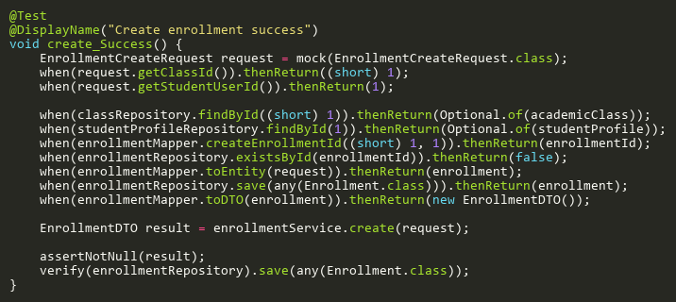

**Figure: create_Success**  
*Reference: Sheet "ES_create", Test Case TC01*

## DeleteTests

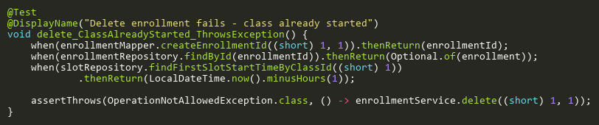

**Figure: delete_ClassAlreadyStarted_ThrowsException**  
*Reference: Sheet "ES_delete", Test Case TC04*

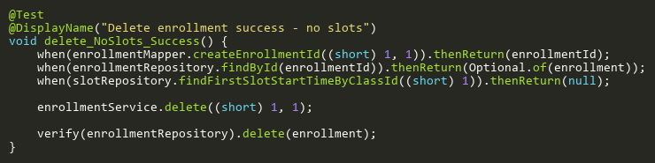

**Figure: delete_NoSlots_Success**  
*Reference: Sheet "ES_delete", Test Case TC01*

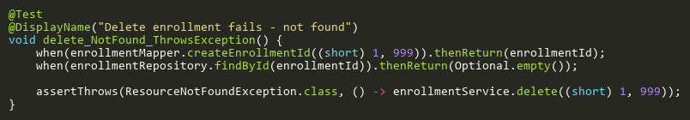

**Figure: delete_NotFound_ThrowsException**  
*Reference: Sheet "ES_delete", Test Case TC03*

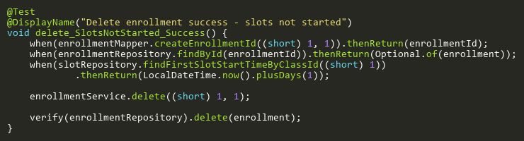

**Figure: delete_SlotsNotStarted_Success**  
*Reference: Sheet "ES_delete", Test Case TC02*

## FindByClassIdTests

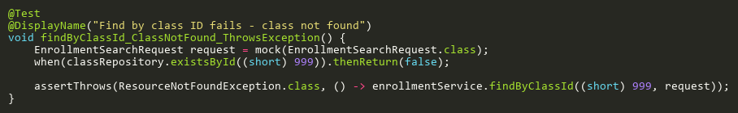

**Figure: findByClassId_ClassNotFound_ThrowsException**  
*Reference: Sheet "ES_findByClassId", Test Case TC02*

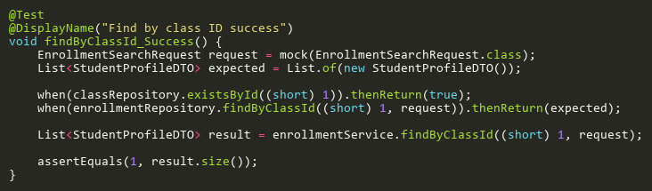

**Figure: findByClassId_Success**  
*Reference: Sheet "ES_findByClassId", Test Case TC01*

## UpdateTests

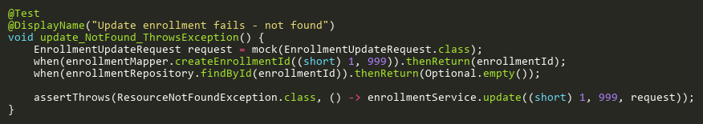

**Figure: update_NotFound_ThrowsException**  
*Reference: Sheet "ES_update", Test Case TC02*

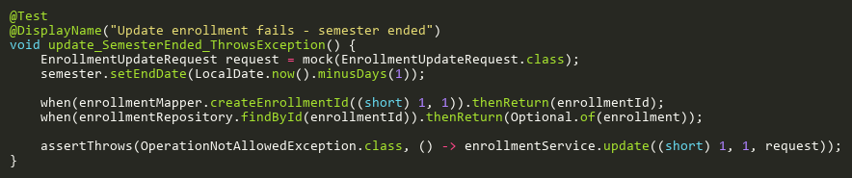

**Figure: update_SemesterEnded_ThrowsException**  
*Reference: Sheet "ES_update", Test Case TC03*

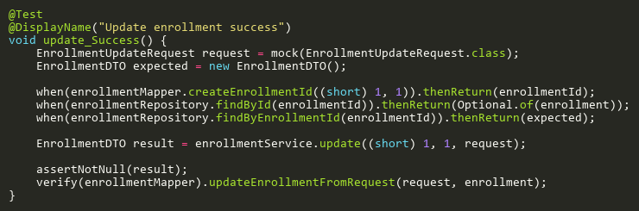

**Figure: update_Success**  
*Reference: Sheet "ES_update", Test Case TC01*

# EvidenceStorageServiceTest

## DeleteEvidenceTests

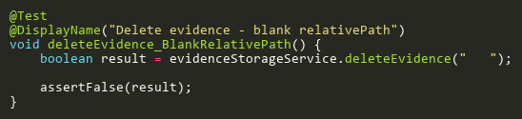

**Figure: deleteEvidence_BlankRelativePath**  
*Reference: Sheet "ESST_deleteEvidence", Test Case TC03*

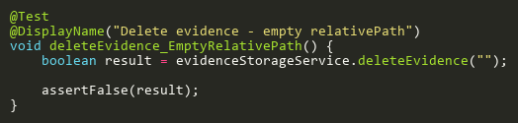

**Figure: deleteEvidence_EmptyRelativePath**  
*Reference: Sheet "ESST_deleteEvidence", Test Case TC05*

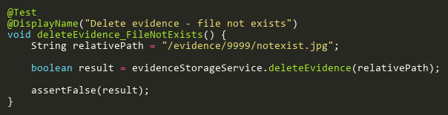

**Figure: deleteEvidence_FileNotExists**  
*Reference: Sheet "ESST_deleteEvidence", Test Case TC04*

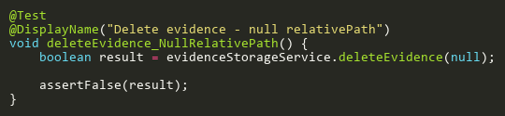

**Figure: deleteEvidence_NullRelativePath**  
*Reference: Sheet "ESST_deleteEvidence", Test Case TC02*

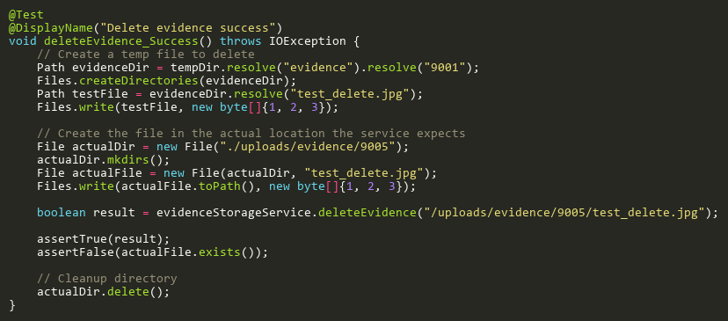

**Figure: deleteEvidence_Success**  
*Reference: Sheet "ESST_deleteEvidence", Test Case TC01*

## DownloadAndSaveEvidenceTests

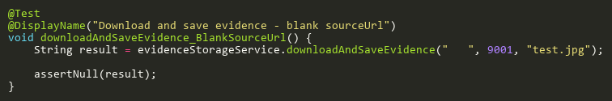

**Figure: downloadAndSaveEvidence_BlankSourceUrl**  
*Reference: Sheet "ESST_downloadAndSave", Test Case TC03*

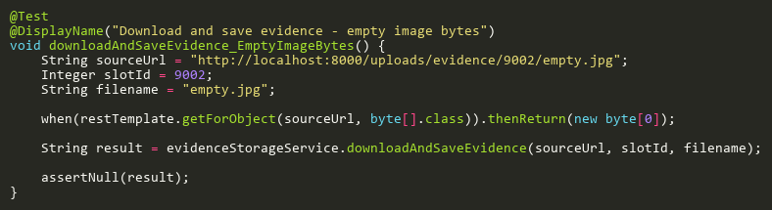

**Figure: downloadAndSaveEvidence_EmptyImageBytes**  
*Reference: Sheet "ESST_downloadAndSave", Test Case TC04*

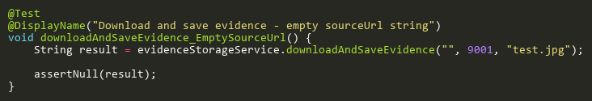

**Figure: downloadAndSaveEvidence_EmptySourceUrl**  
*Reference: Sheet "ESST_downloadAndSave", Test Case TC07*

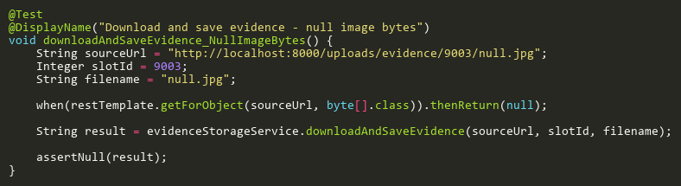

**Figure: downloadAndSaveEvidence_NullImageBytes**  
*Reference: Sheet "ESST_downloadAndSave", Test Case TC05*

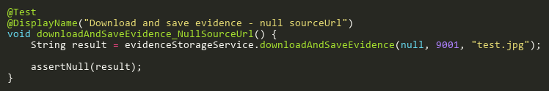

**Figure: downloadAndSaveEvidence_NullSourceUrl**  
*Reference: Sheet "ESST_downloadAndSave", Test Case TC02*

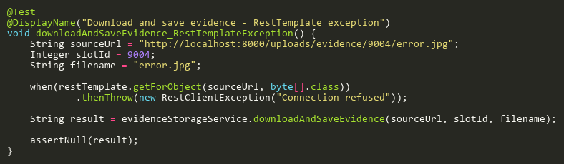

**Figure: downloadAndSaveEvidence_RestTemplateException**  
*Reference: Sheet "ESST_downloadAndSave", Test Case TC06*

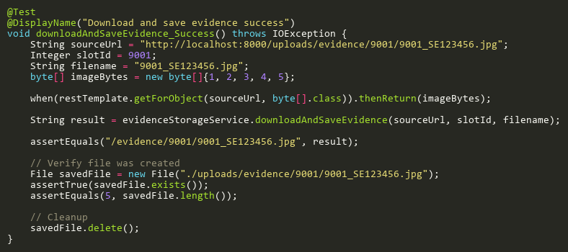

**Figure: downloadAndSaveEvidence_Success**  
*Reference: Sheet "ESST_downloadAndSave", Test Case TC01*

## ExtractFilenameFromUrlTests

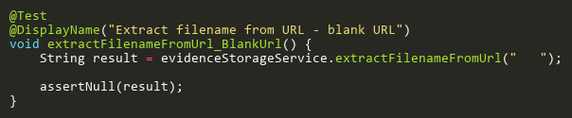

**Figure: extractFilenameFromUrl_BlankUrl**  
*Reference: Sheet "ESST_extractFilename", Test Case TC03*

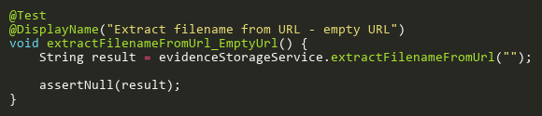

**Figure: extractFilenameFromUrl_EmptyUrl**  
*Reference: Sheet "ESST_extractFilename", Test Case TC07*

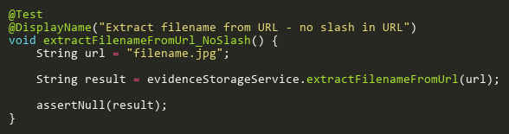

**Figure: extractFilenameFromUrl_NoSlash**  
*Reference: Sheet "ESST_extractFilename", Test Case TC05*

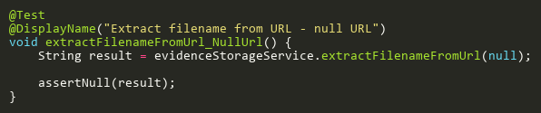

**Figure: extractFilenameFromUrl_NullUrl**  
*Reference: Sheet "ESST_extractFilename", Test Case TC02*

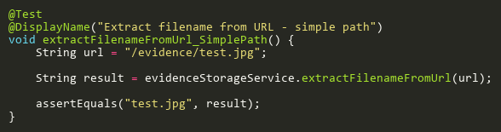

**Figure: extractFilenameFromUrl_SimplePath**  
*Reference: Sheet "ESST_extractFilename", Test Case TC06*

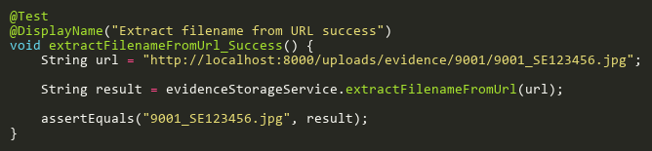

**Figure: extractFilenameFromUrl_Success**  
*Reference: Sheet "ESST_extractFilename", Test Case TC01*

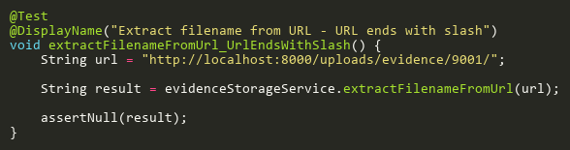

**Figure: extractFilenameFromUrl_UrlEndsWithSlash**  
*Reference: Sheet "ESST_extractFilename", Test Case TC04*

# ExamAttendanceReportServiceTest

## GetExamAttendanceReportForUserTests

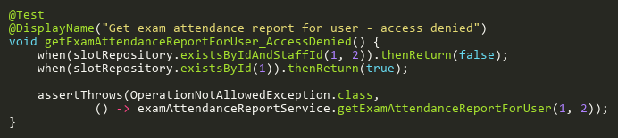

**Figure: getExamAttendanceReportForUser_AccessDenied**  
*Reference: Sheet "EARST_getReportForUser", Test Case TC07*

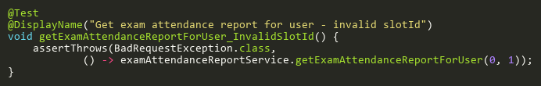

**Figure: getExamAttendanceReportForUser_InvalidSlotId**  
*Reference: Sheet "EARST_getReportForUser", Test Case TC03*

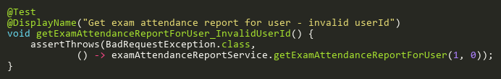

**Figure: getExamAttendanceReportForUser_InvalidUserId**  
*Reference: Sheet "EARST_getReportForUser", Test Case TC05*

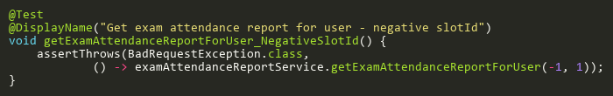

**Figure: getExamAttendanceReportForUser_NegativeSlotId**  
*Reference: Sheet "EARST_getReportForUser", Test Case TC08*

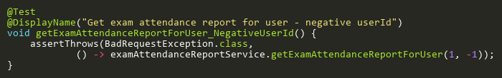

**Figure: getExamAttendanceReportForUser_NegativeUserId**  
*Reference: Sheet "EARST_getReportForUser", Test Case TC09*

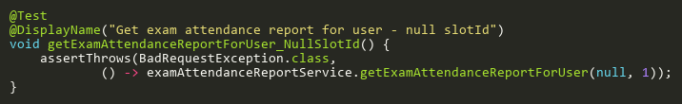

**Figure: getExamAttendanceReportForUser_NullSlotId**  
*Reference: Sheet "EARST_getReportForUser", Test Case TC02*

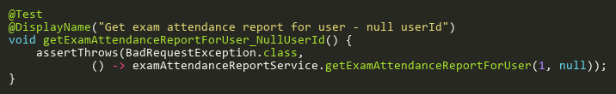

**Figure: getExamAttendanceReportForUser_NullUserId**  
*Reference: Sheet "EARST_getReportForUser", Test Case TC04*

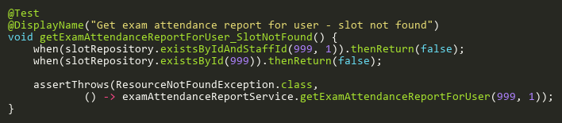

**Figure: getExamAttendanceReportForUser_SlotNotFound**  
*Reference: Sheet "EARST_getReportForUser", Test Case TC06*

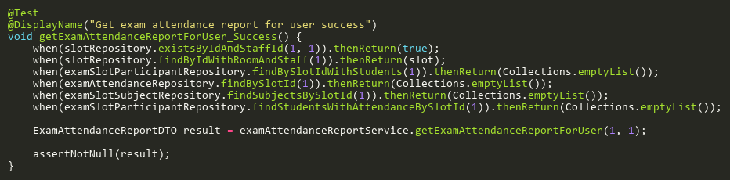

**Figure: getExamAttendanceReportForUser_Success**  
*Reference: Sheet "EARST_getReportForUser", Test Case TC01*

# ExamAttendanceServiceTest

## ApplyRescanReviewFlagsTests

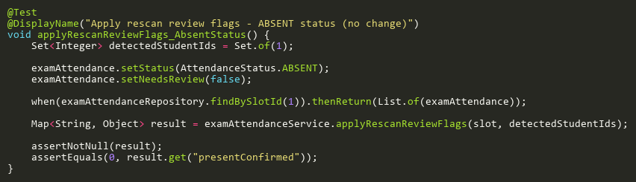

**Figure: applyRescanReviewFlags_AbsentStatus**  
*Reference: Sheet "EAST_applyRescanFlags", Test Case TC05*

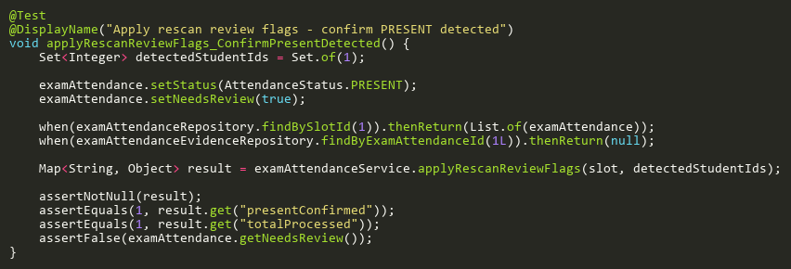

**Figure: applyRescanReviewFlags_ConfirmPresentDetected**  
*Reference: Sheet "EAST_applyRescanFlags", Test Case TC01*

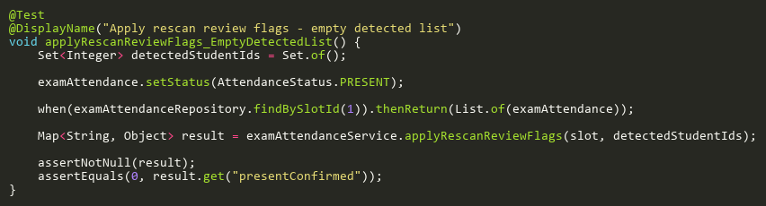

**Figure: applyRescanReviewFlags_EmptyDetectedList**  
*Reference: Sheet "EAST_applyRescanFlags", Test Case TC03*

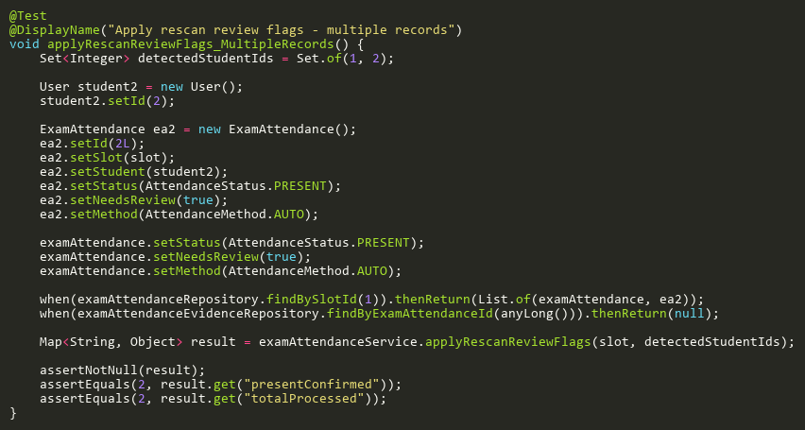

**Figure: applyRescanReviewFlags_MultipleRecords**  
*Reference: Sheet "EAST_applyRescanFlags", Test Case TC07*

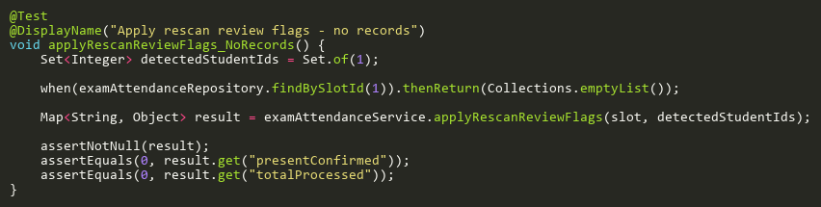

**Figure: applyRescanReviewFlags_NoRecords**  
*Reference: Sheet "EAST_applyRescanFlags", Test Case TC04*

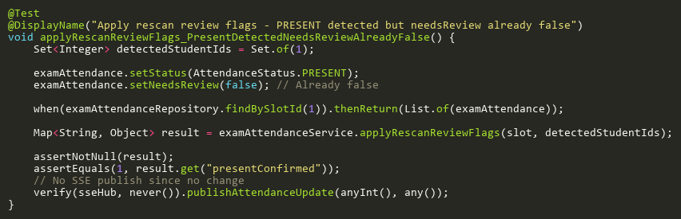

**Figure: applyRescanReviewFlags_PresentDetectedNeedsReviewAlreadyFalse**  
*Reference: Sheet "EAST_applyRescanFlags", Test Case TC06*

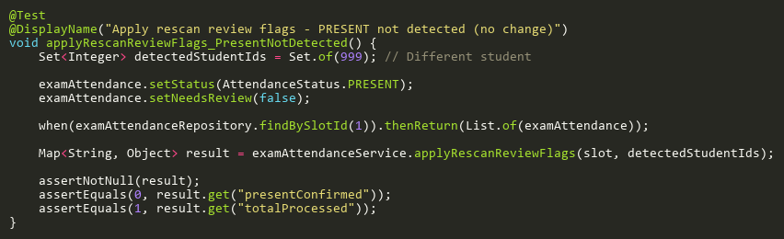

**Figure: applyRescanReviewFlags_PresentNotDetected**  
*Reference: Sheet "EAST_applyRescanFlags", Test Case TC02*

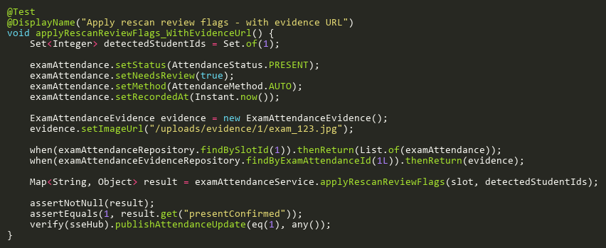

**Figure: applyRescanReviewFlags_WithEvidenceUrl**  
*Reference: Sheet "EAST_applyRescanFlags", Test Case TC08*

## FindByIdTests

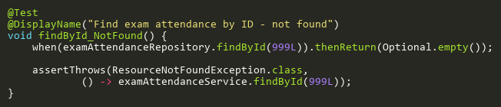

**Figure: findById_NotFound**  
*Reference: Sheet "EAST_findById", Test Case TC02*

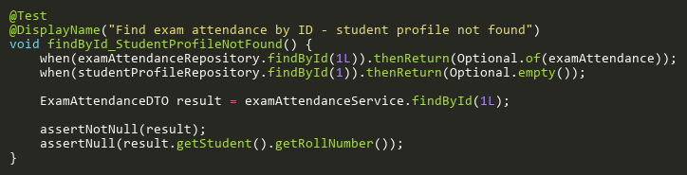

**Figure: findById_StudentProfileNotFound**  
*Reference: Sheet "EAST_findById", Test Case TC03*

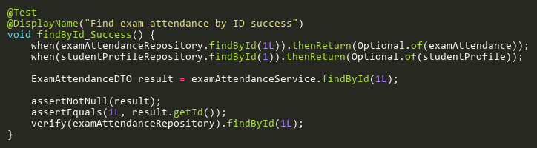

**Figure: findById_Success**  
*Reference: Sheet "EAST_findById", Test Case TC01*

## ProcessRecognitionResultsTests

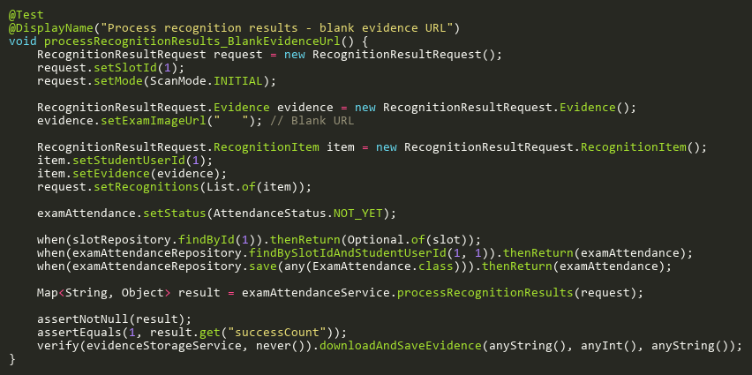

**Figure: processRecognitionResults_BlankEvidenceUrl**  
*Reference: Sheet "EAST_processRecognition", Test Case TC14*

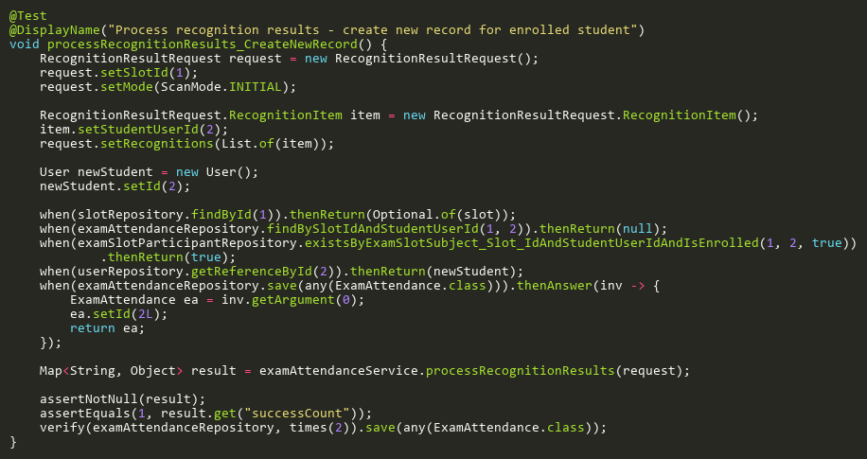

**Figure: processRecognitionResults_CreateNewRecord**  
*Reference: Sheet "EAST_processRecognition", Test Case TC05*

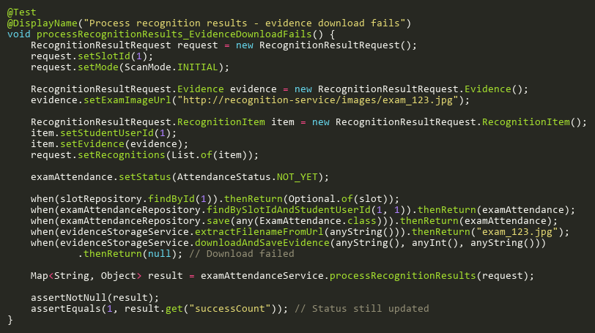

**Figure: processRecognitionResults_EvidenceDownloadFails**  
*Reference: Sheet "EAST_processRecognition", Test Case TC10*

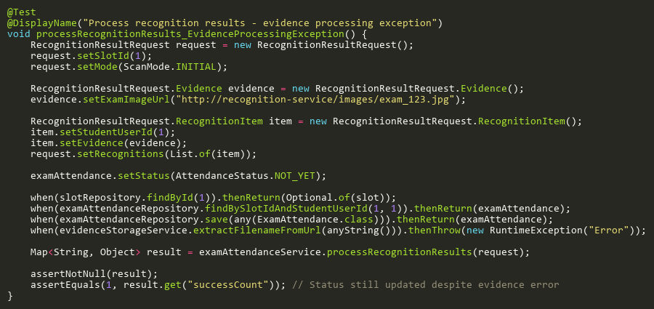

**Figure: processRecognitionResults_EvidenceProcessingException**  
*Reference: Sheet "EAST_processRecognition", Test Case TC13*

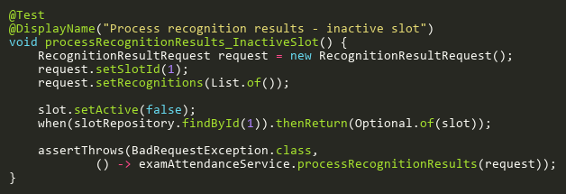

**Figure: processRecognitionResults_InactiveSlot**  
*Reference: Sheet "EAST_processRecognition", Test Case TC03*

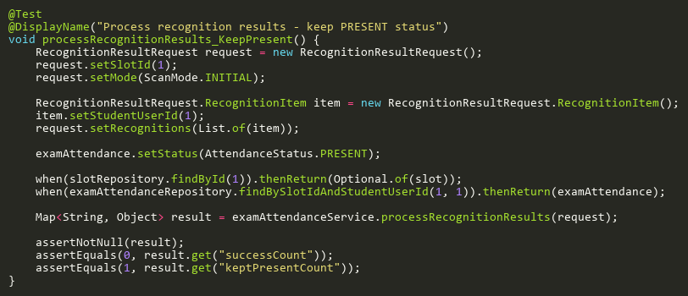

**Figure: processRecognitionResults_KeepPresent**  
*Reference: Sheet "EAST_processRecognition", Test Case TC07*

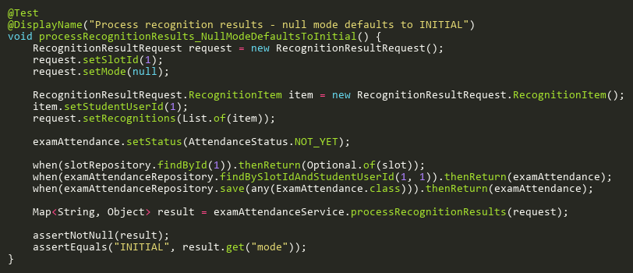

**Figure: processRecognitionResults_NullModeDefaultsToInitial**  
*Reference: Sheet "EAST_processRecognition", Test Case TC12*

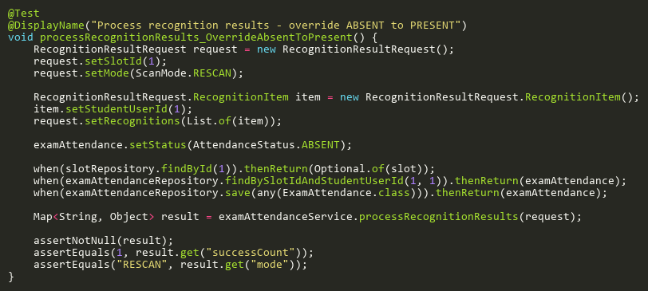

**Figure: processRecognitionResults_OverrideAbsentToPresent**  
*Reference: Sheet "EAST_processRecognition", Test Case TC06*

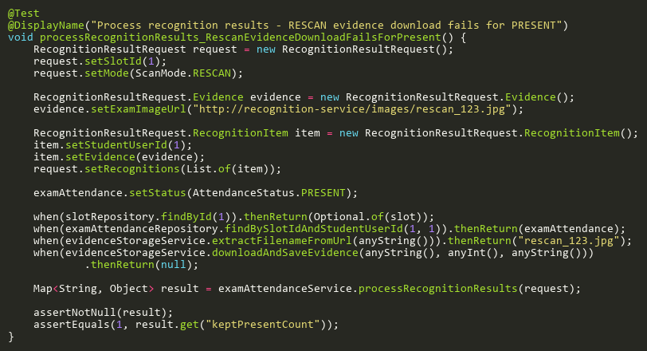

**Figure: processRecognitionResults_RescanEvidenceDownloadFailsForPresent**  
*Reference: Sheet "EAST_processRecognition", Test Case TC16*

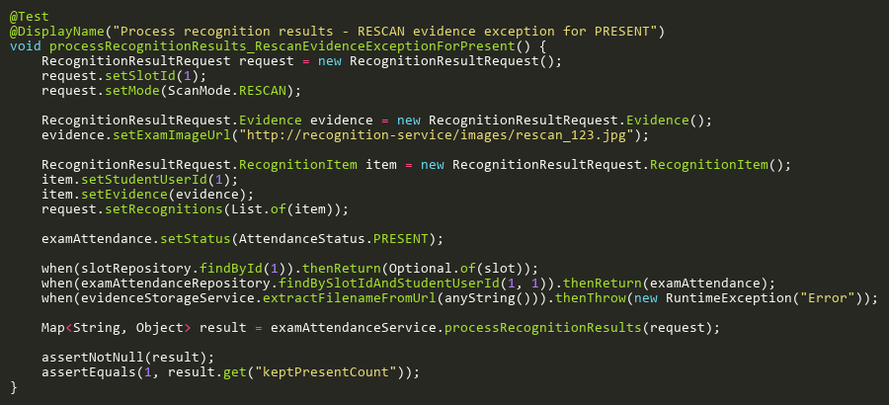

**Figure: processRecognitionResults_RescanEvidenceExceptionForPresent**  
*Reference: Sheet "EAST_processRecognition", Test Case TC15*

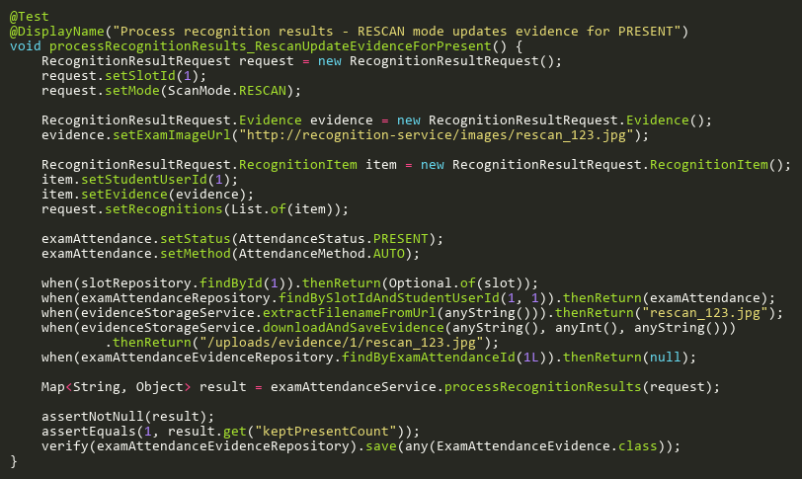

**Figure: processRecognitionResults_RescanUpdateEvidenceForPresent**  
*Reference: Sheet "EAST_processRecognition", Test Case TC11*

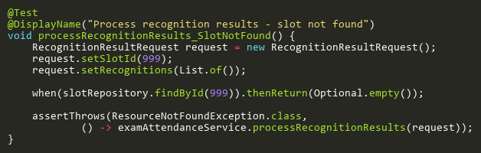

**Figure: processRecognitionResults_SlotNotFound**  
*Reference: Sheet "EAST_processRecognition", Test Case TC02*

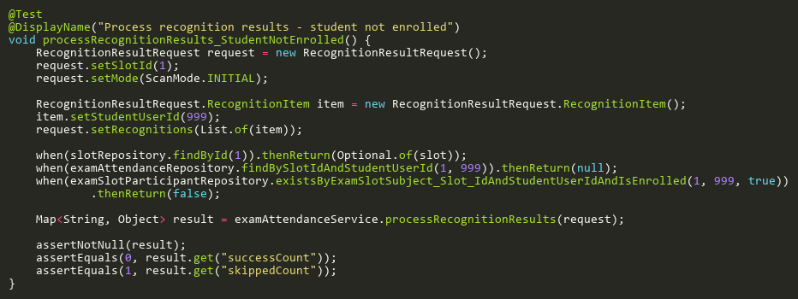

**Figure: processRecognitionResults_StudentNotEnrolled**  
*Reference: Sheet "EAST_processRecognition", Test Case TC04*

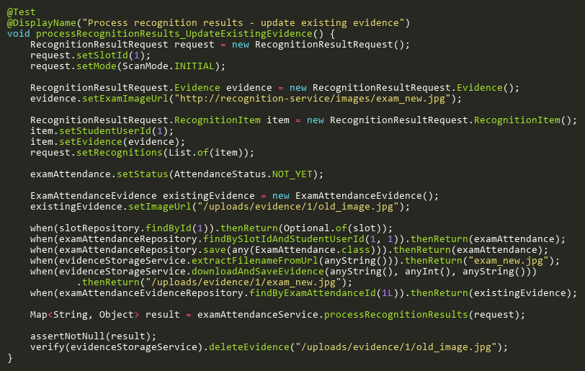

**Figure: processRecognitionResults_UpdateExistingEvidence**  
*Reference: Sheet "EAST_processRecognition", Test Case TC09*

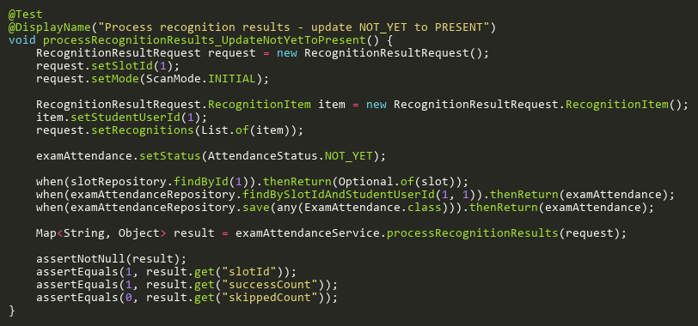

**Figure: processRecognitionResults_UpdateNotYetToPresent**  
*Reference: Sheet "EAST_processRecognition", Test Case TC01*

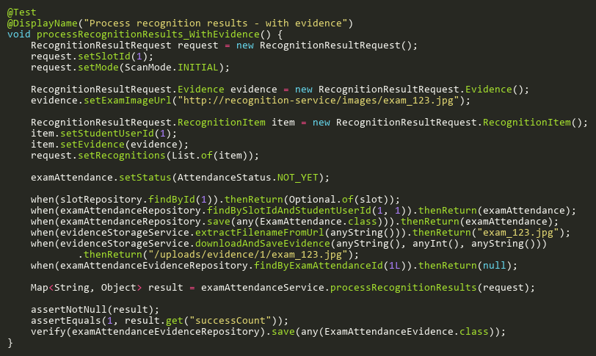

**Figure: processRecognitionResults_WithEvidence**  
*Reference: Sheet "EAST_processRecognition", Test Case TC08*

## UpdateStatusTests

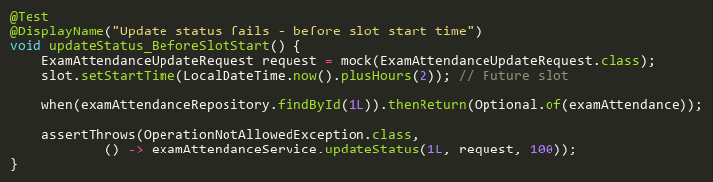

**Figure: updateStatus_BeforeSlotStart**  
*Reference: Sheet "EAST_updateStatus", Test Case TC05*

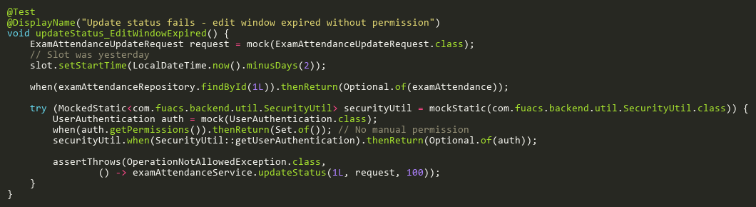

**Figure: updateStatus_EditWindowExpired**  
*Reference: Sheet "EAST_updateStatus", Test Case TC06*

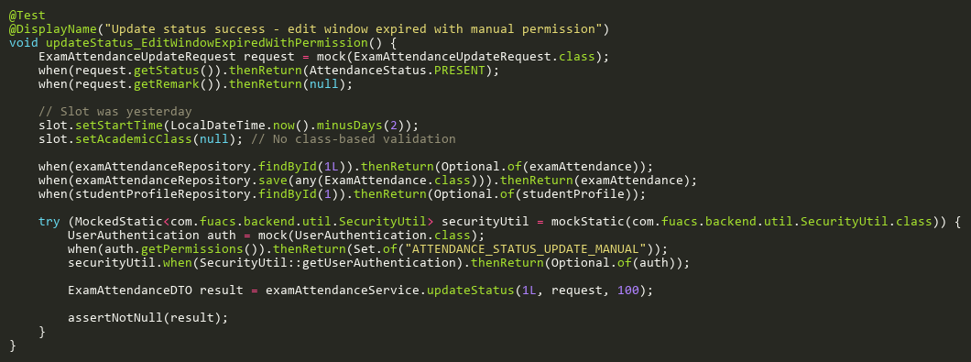

**Figure: updateStatus_EditWindowExpiredWithPermission**  
*Reference: Sheet "EAST_updateStatus", Test Case TC07*

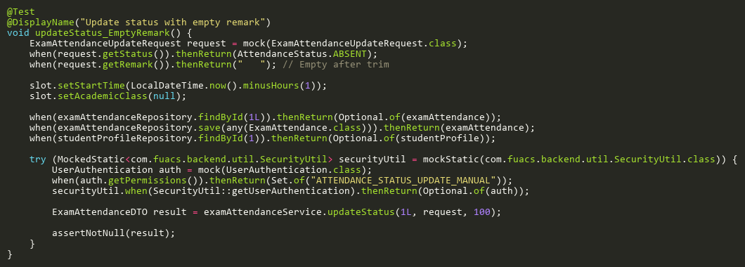

**Figure: updateStatus_EmptyRemark**  
*Reference: Sheet "EAST_updateStatus", Test Case TC10*

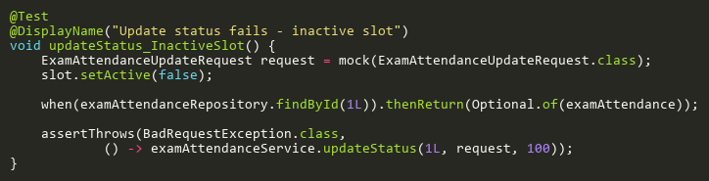

**Figure: updateStatus_InactiveSlot**  
*Reference: Sheet "EAST_updateStatus", Test Case TC03*

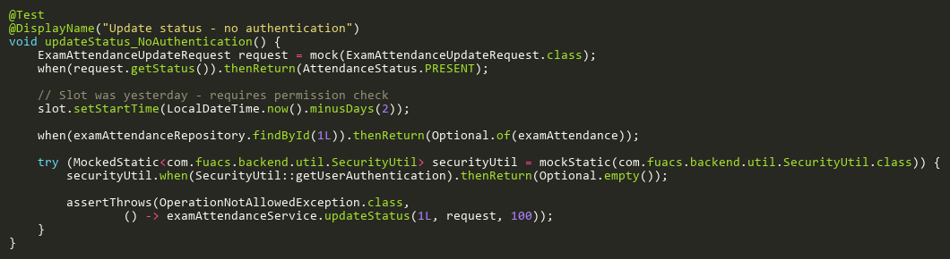

**Figure: updateStatus_NoAuthentication**  
*Reference: Sheet "EAST_updateStatus", Test Case TC11*

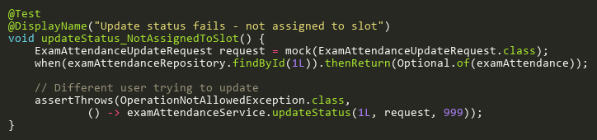

**Figure: updateStatus_NotAssignedToSlot**  
*Reference: Sheet "EAST_updateStatus", Test Case TC04*

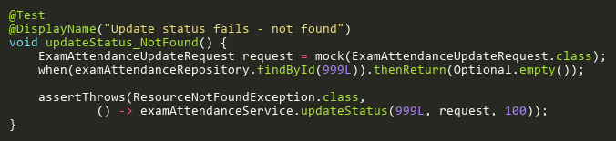

**Figure: updateStatus_NotFound**  
*Reference: Sheet "EAST_updateStatus", Test Case TC02*

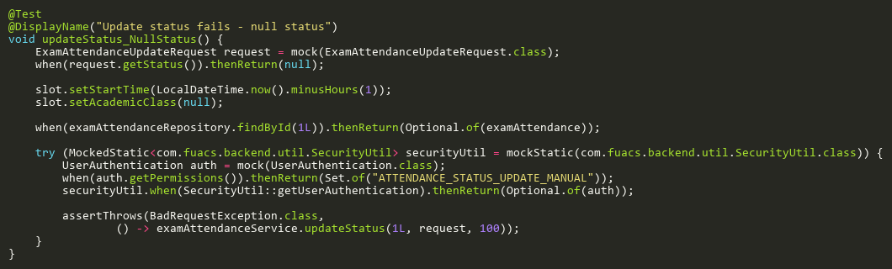

**Figure: updateStatus_NullStatus**  
*Reference: Sheet "EAST_updateStatus", Test Case TC09*

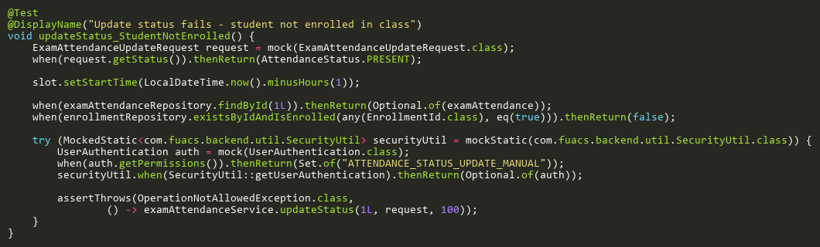

**Figure: updateStatus_StudentNotEnrolled**  
*Reference: Sheet "EAST_updateStatus", Test Case TC08*

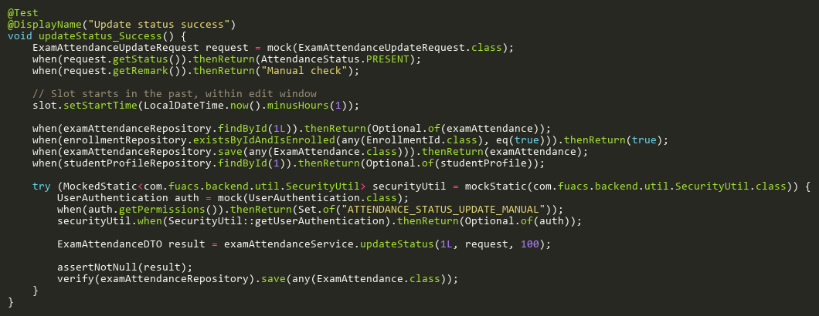

**Figure: updateStatus_Success**  
*Reference: Sheet "EAST_updateStatus", Test Case TC01*

# ExamSlotServiceTest

## AddParticipantTests

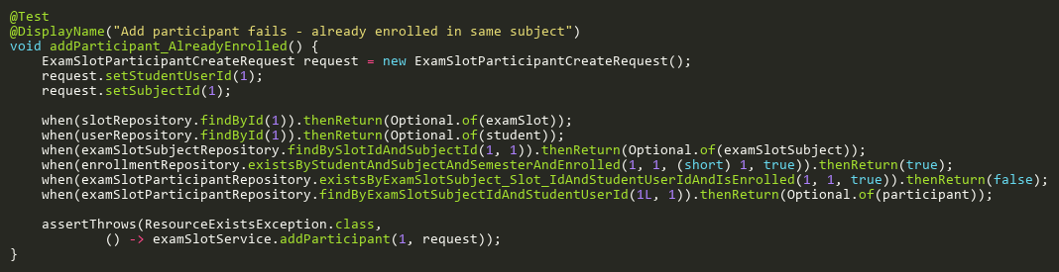

**Figure: addParticipant_AlreadyEnrolled**  
*Reference: Sheet "EXSS_addParticipant", Test Case TC12*

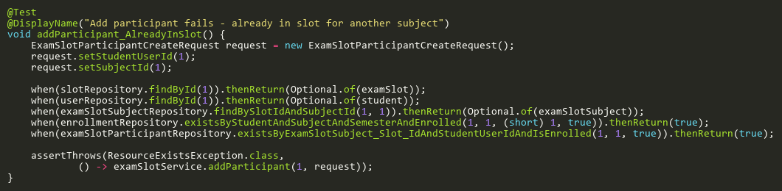

**Figure: addParticipant_AlreadyInSlot**  
*Reference: Sheet "EXSS_addParticipant", Test Case TC11*

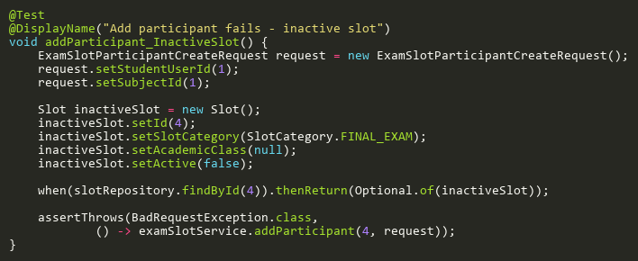

**Figure: addParticipant_InactiveSlot**  
*Reference: Sheet "EXSS_addParticipant", Test Case TC04*

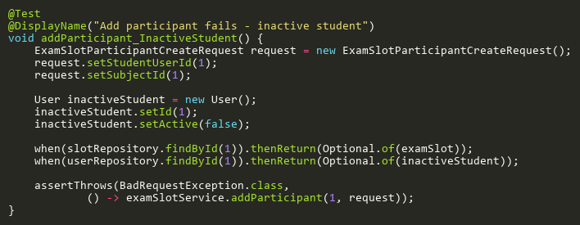

**Figure: addParticipant_InactiveStudent**  
*Reference: Sheet "EXSS_addParticipant", Test Case TC07*

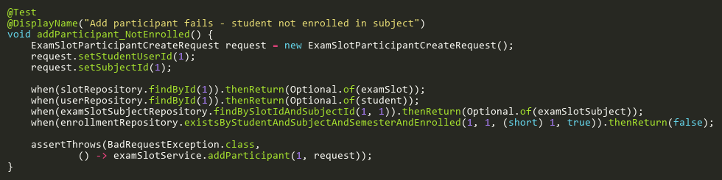

**Figure: addParticipant_NotEnrolled**  
*Reference: Sheet "EXSS_addParticipant", Test Case TC10*

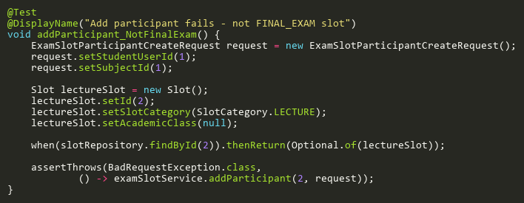

**Figure: addParticipant_NotFinalExam**  
*Reference: Sheet "EXSS_addParticipant", Test Case TC03*

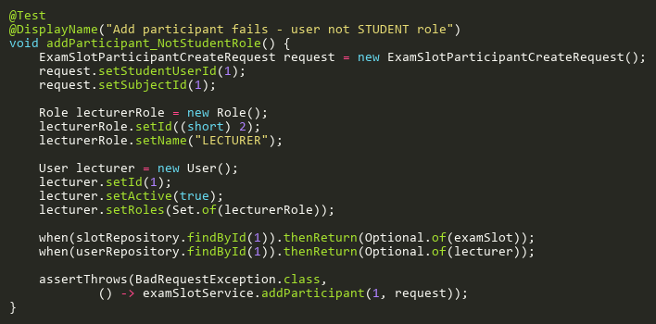

**Figure: addParticipant_NotStudentRole**  
*Reference: Sheet "EXSS_addParticipant", Test Case TC08*

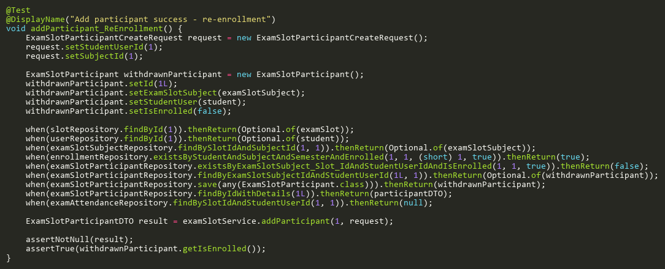

**Figure: addParticipant_ReEnrollment**  
*Reference: Sheet "EXSS_addParticipant", Test Case TC13*

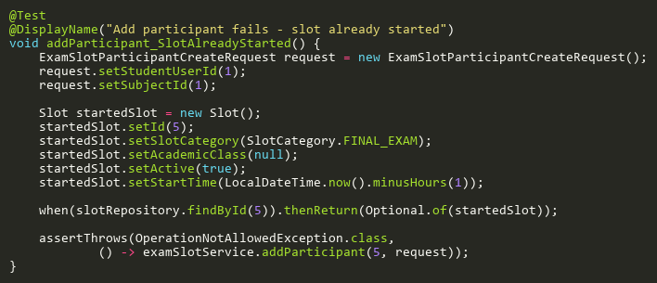

**Figure: addParticipant_SlotAlreadyStarted**  
*Reference: Sheet "EXSS_addParticipant", Test Case TC05*

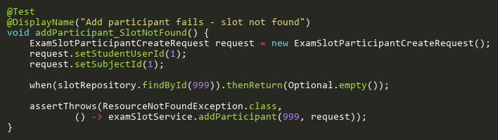

**Figure: addParticipant_SlotNotFound**  
*Reference: Sheet "EXSS_addParticipant", Test Case TC02*

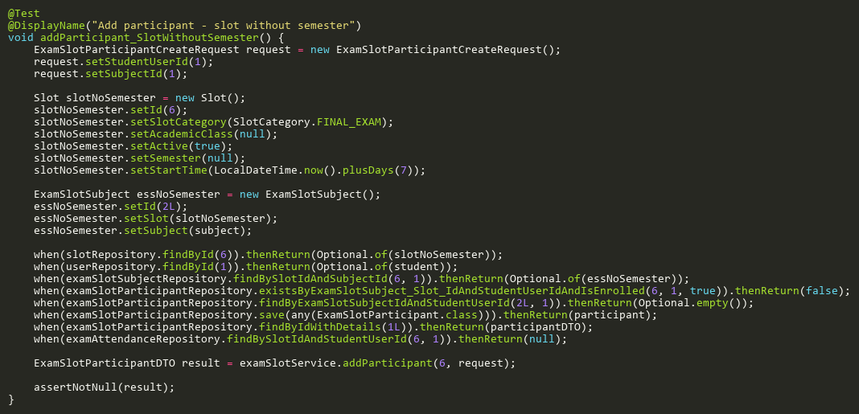

**Figure: addParticipant_SlotWithoutSemester**  
*Reference: Sheet "EXSS_addParticipant", Test Case TC14*

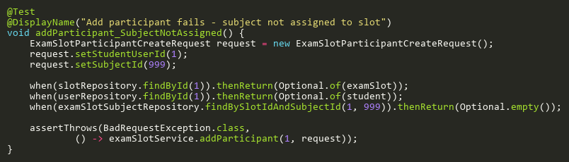

**Figure: addParticipant_SubjectNotAssigned**  
*Reference: Sheet "EXSS_addParticipant", Test Case TC09*

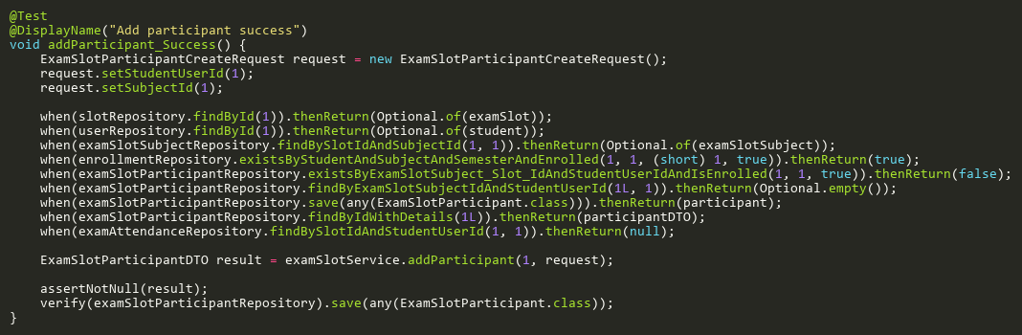

**Figure: addParticipant_Success**  
*Reference: Sheet "EXSS_addParticipant", Test Case TC01*

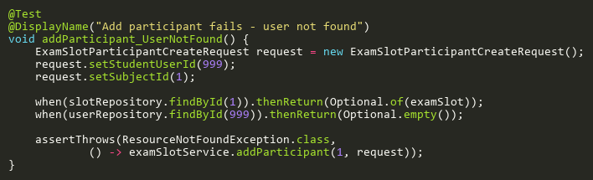

**Figure: addParticipant_UserNotFound**  
*Reference: Sheet "EXSS_addParticipant", Test Case TC06*

## AssignSubjectsToSlotTests

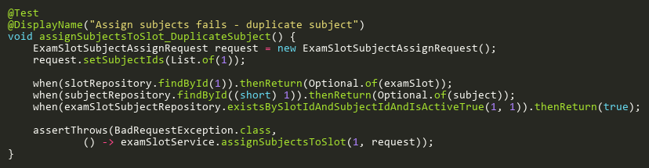

**Figure: assignSubjectsToSlot_DuplicateSubject**  
*Reference: Sheet "EXSS_assignSubjects", Test Case TC08*

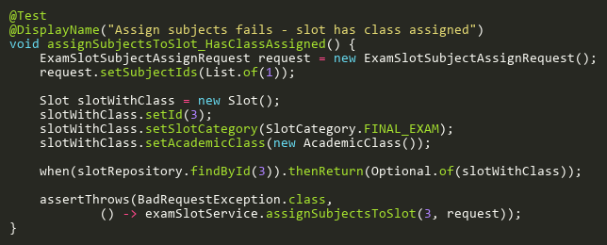

**Figure: assignSubjectsToSlot_HasClassAssigned**  
*Reference: Sheet "EXSS_assignSubjects", Test Case TC04*

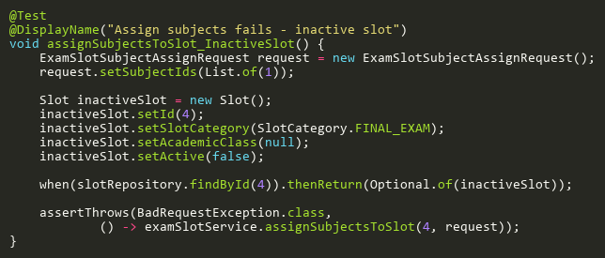

**Figure: assignSubjectsToSlot_InactiveSlot**  
*Reference: Sheet "EXSS_assignSubjects", Test Case TC05*

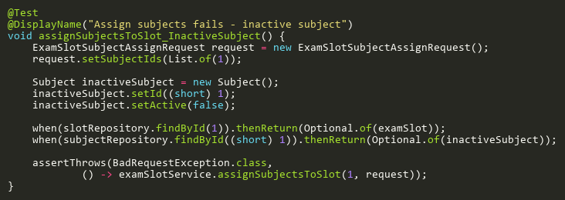

**Figure: assignSubjectsToSlot_InactiveSubject**  
*Reference: Sheet "EXSS_assignSubjects", Test Case TC07*

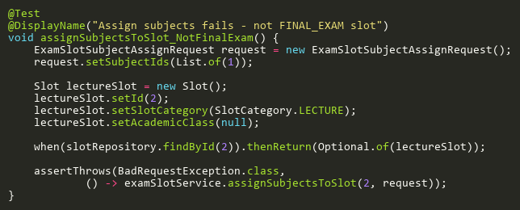

**Figure: assignSubjectsToSlot_NotFinalExam**  
*Reference: Sheet "EXSS_assignSubjects", Test Case TC03*

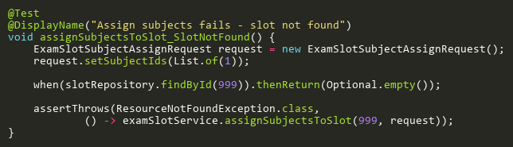

**Figure: assignSubjectsToSlot_SlotNotFound**  
*Reference: Sheet "EXSS_assignSubjects", Test Case TC02*

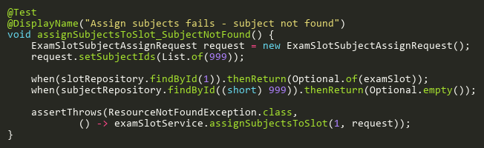

**Figure: assignSubjectsToSlot_SubjectNotFound**  
*Reference: Sheet "EXSS_assignSubjects", Test Case TC06*

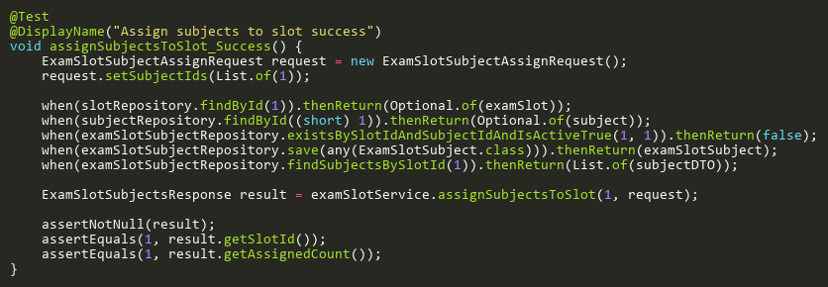

**Figure: assignSubjectsToSlot_Success**  
*Reference: Sheet "EXSS_assignSubjects", Test Case TC01*

## GetParticipantByIdTests

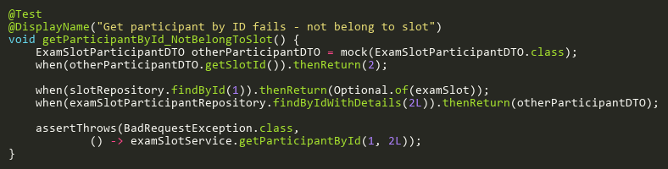

**Figure: getParticipantById_NotBelongToSlot**  
*Reference: Sheet "EXSS_getParticipantById", Test Case TC04*

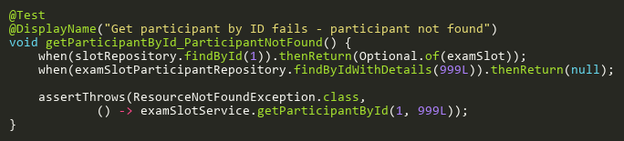

**Figure: getParticipantById_ParticipantNotFound**  
*Reference: Sheet "EXSS_getParticipantById", Test Case TC03*

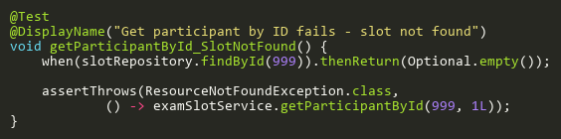

**Figure: getParticipantById_SlotNotFound**  
*Reference: Sheet "EXSS_getParticipantById", Test Case TC02*

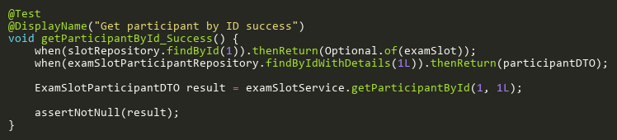

**Figure: getParticipantById_Success**  
*Reference: Sheet "EXSS_getParticipantById", Test Case TC01*

## RemoveParticipantTests

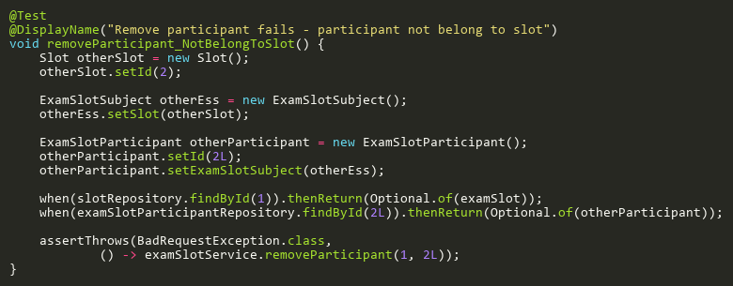

**Figure: removeParticipant_NotBelongToSlot**  
*Reference: Sheet "EXSS_removeParticipant", Test Case TC05*

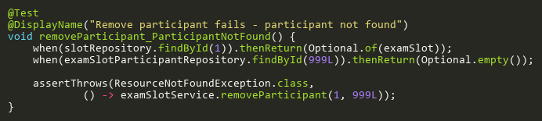

**Figure: removeParticipant_ParticipantNotFound**  
*Reference: Sheet "EXSS_removeParticipant", Test Case TC04*

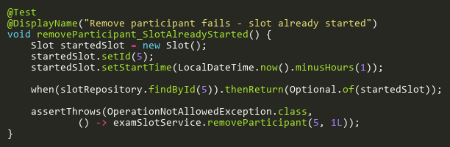

**Figure: removeParticipant_SlotAlreadyStarted**  
*Reference: Sheet "EXSS_removeParticipant", Test Case TC03*

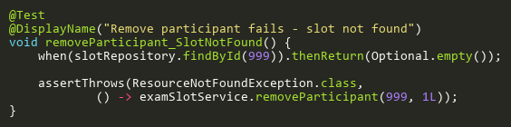

**Figure: removeParticipant_SlotNotFound**  
*Reference: Sheet "EXSS_removeParticipant", Test Case TC02*

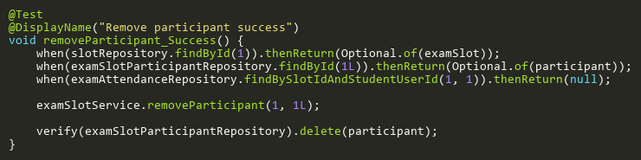

**Figure: removeParticipant_Success**  
*Reference: Sheet "EXSS_removeParticipant", Test Case TC01*

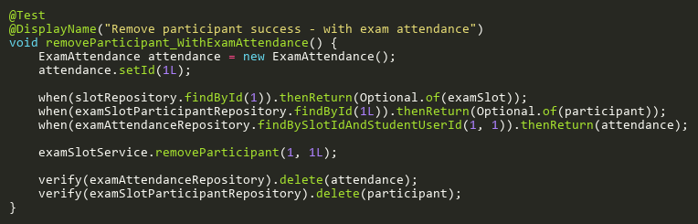

**Figure: removeParticipant_WithExamAttendance**  
*Reference: Sheet "EXSS_removeParticipant", Test Case TC06*

## RemoveSubjectFromSlotTests

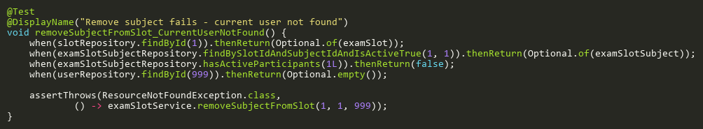

**Figure: removeSubjectFromSlot_CurrentUserNotFound**  
*Reference: Sheet "EXSS_removeSubject", Test Case TC06*

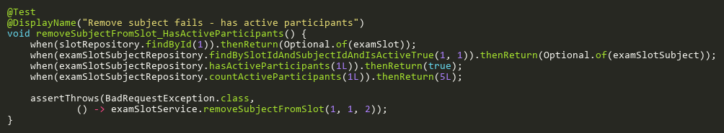

**Figure: removeSubjectFromSlot_HasActiveParticipants**  
*Reference: Sheet "EXSS_removeSubject", Test Case TC05*

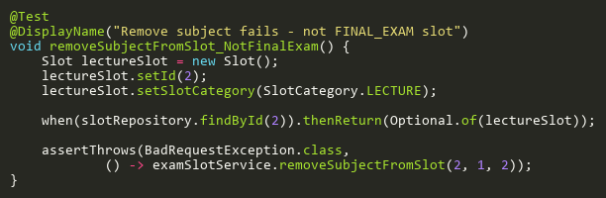

**Figure: removeSubjectFromSlot_NotFinalExam**  
*Reference: Sheet "EXSS_removeSubject", Test Case TC03*

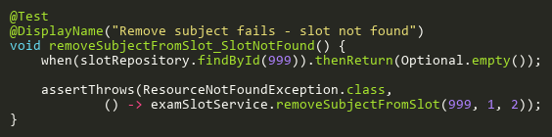

**Figure: removeSubjectFromSlot_SlotNotFound**  
*Reference: Sheet "EXSS_removeSubject", Test Case TC02*

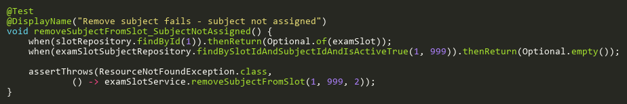

**Figure: removeSubjectFromSlot_SubjectNotAssigned**  
*Reference: Sheet "EXSS_removeSubject", Test Case TC04*

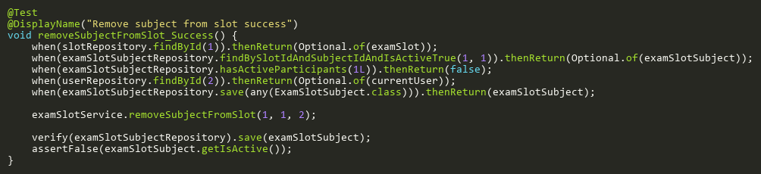

**Figure: removeSubjectFromSlot_Success**  
*Reference: Sheet "EXSS_removeSubject", Test Case TC01*

## UpdateParticipantTests

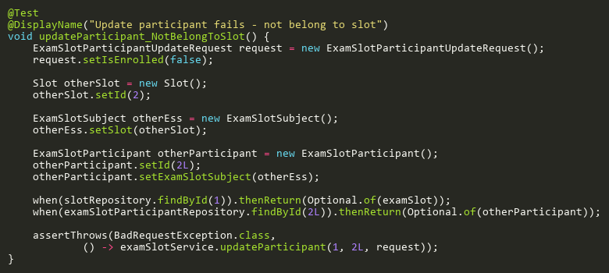

**Figure: updateParticipant_NotBelongToSlot**  
*Reference: Sheet "EXSS_updateParticipant", Test Case TC04*

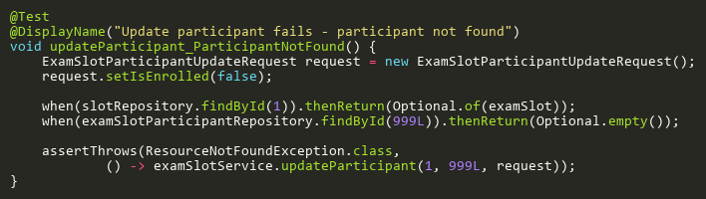

**Figure: updateParticipant_ParticipantNotFound**  
*Reference: Sheet "EXSS_updateParticipant", Test Case TC03*

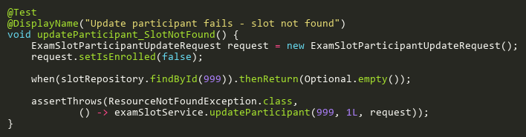

**Figure: updateParticipant_SlotNotFound**  
*Reference: Sheet "EXSS_updateParticipant", Test Case TC02*

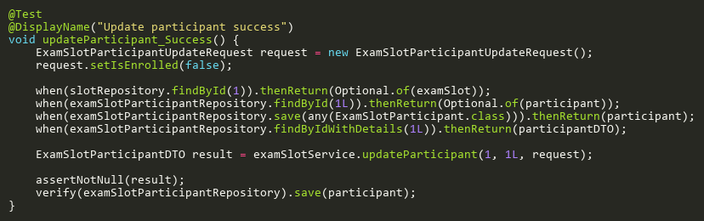

**Figure: updateParticipant_Success**  
*Reference: Sheet "EXSS_updateParticipant", Test Case TC01*

# ExcelServiceTest

## ImportStudentsTests

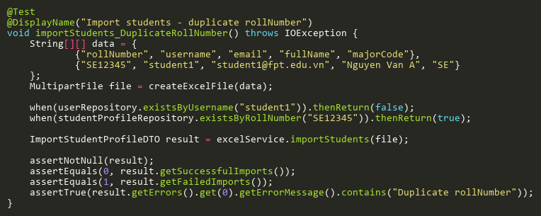

**Figure: importStudents_DuplicateRollNumber**  
*Reference: Sheet "EXCST_importStudents", Test Case TC06*

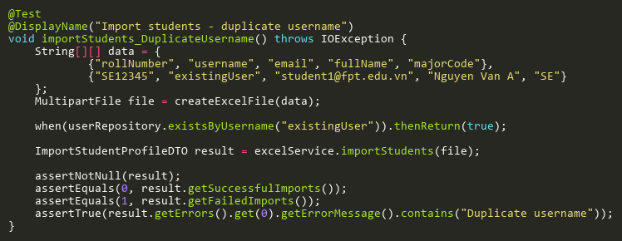

**Figure: importStudents_DuplicateUsername**  
*Reference: Sheet "EXCST_importStudents", Test Case TC05*

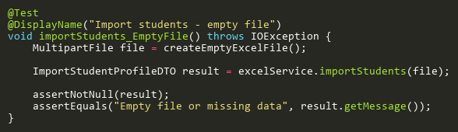

**Figure: importStudents_EmptyFile**  
*Reference: Sheet "EXCST_importStudents", Test Case TC02*

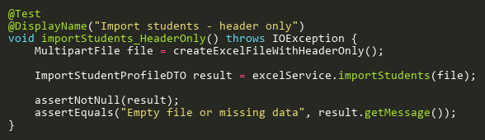

**Figure: importStudents_HeaderOnly**  
*Reference: Sheet "EXCST_importStudents", Test Case TC03*

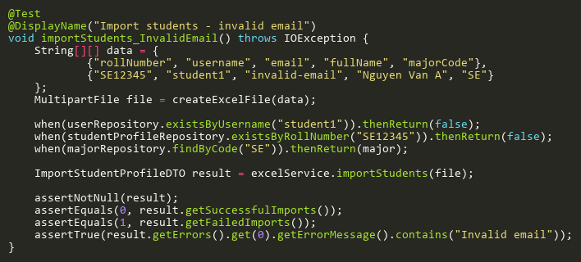

**Figure: importStudents_InvalidEmail**  
*Reference: Sheet "EXCST_importStudents", Test Case TC08*

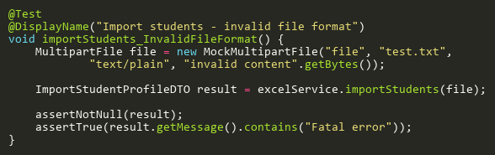

**Figure: importStudents_InvalidFileFormat**  
*Reference: Sheet "EXCST_importStudents", Test Case TC10*

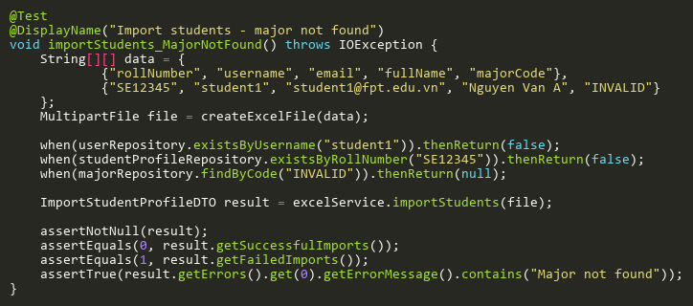

**Figure: importStudents_MajorNotFound**  
*Reference: Sheet "EXCST_importStudents", Test Case TC07*

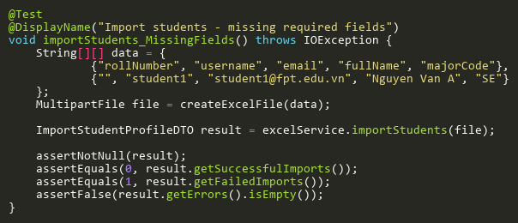

**Figure: importStudents_MissingFields**  
*Reference: Sheet "EXCST_importStudents", Test Case TC04*

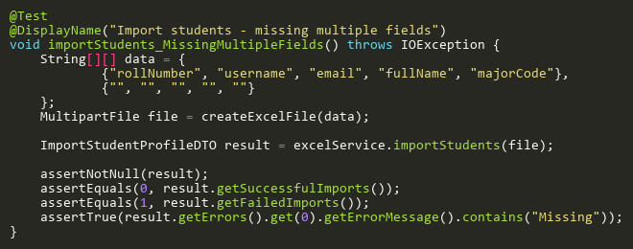

**Figure: importStudents_MissingMultipleFields**  
*Reference: Sheet "EXCST_importStudents", Test Case TC12*

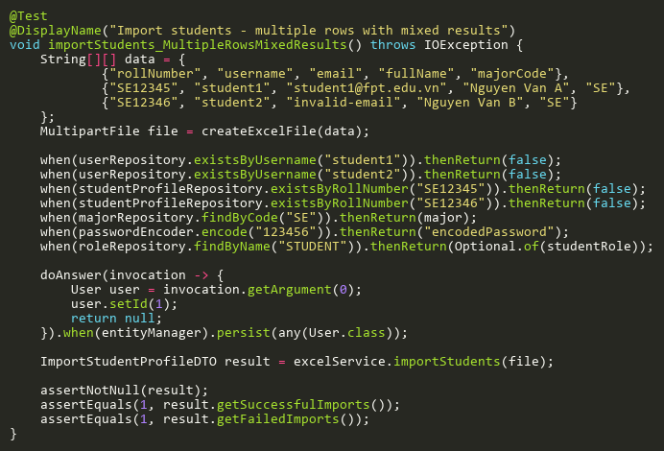

**Figure: importStudents_MultipleRowsMixedResults**  
*Reference: Sheet "EXCST_importStudents", Test Case TC09*

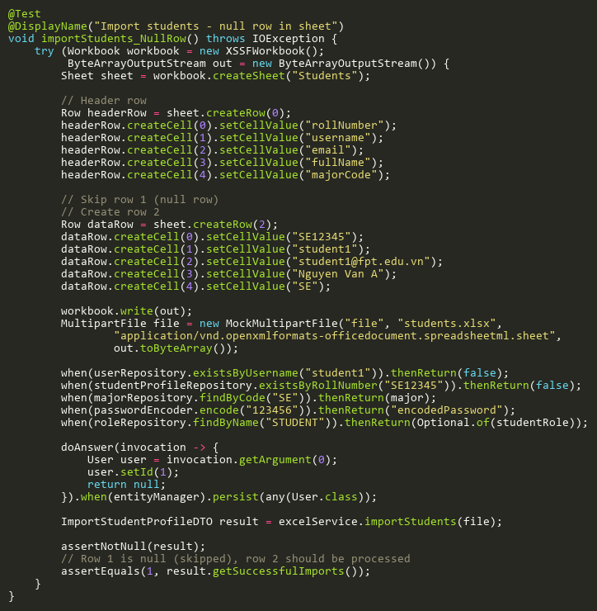

**Figure: importStudents_NullRow**  
*Reference: Sheet "EXCST_importStudents", Test Case TC11*

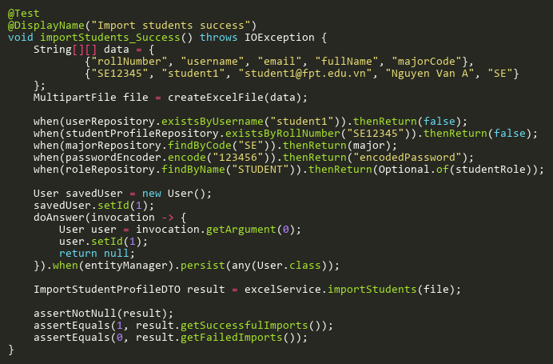

**Figure: importStudents_Success**  
*Reference: Sheet "EXCST_importStudents", Test Case TC01*

# FaceEmbeddingServiceTest

## GenerateAndSaveEmbeddingTests

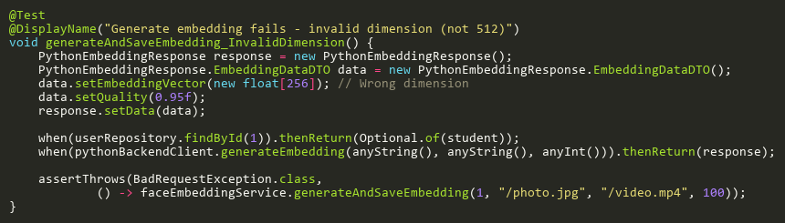

**Figure: generateAndSaveEmbedding_InvalidDimension**  
*Reference: Sheet "FEST_generateAndSave", Test Case TC06*

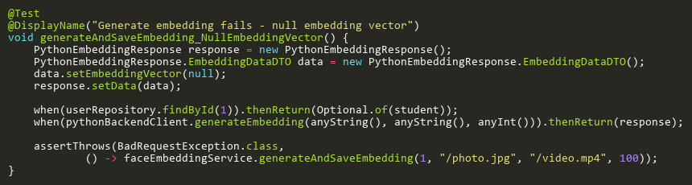

**Figure: generateAndSaveEmbedding_NullEmbeddingVector**  
*Reference: Sheet "FEST_generateAndSave", Test Case TC05*

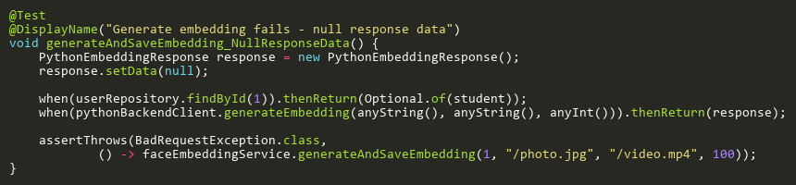

**Figure: generateAndSaveEmbedding_NullResponseData**  
*Reference: Sheet "FEST_generateAndSave", Test Case TC04*

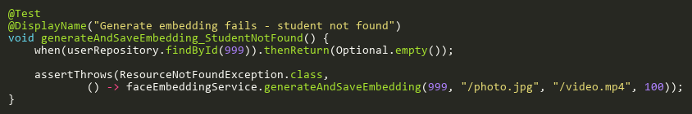

**Figure: generateAndSaveEmbedding_StudentNotFound**  
*Reference: Sheet "FEST_generateAndSave", Test Case TC03*

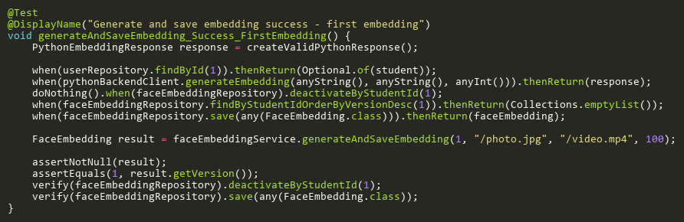

**Figure: generateAndSaveEmbedding_Success_FirstEmbedding**  
*Reference: Sheet "FEST_generateAndSave", Test Case TC01*

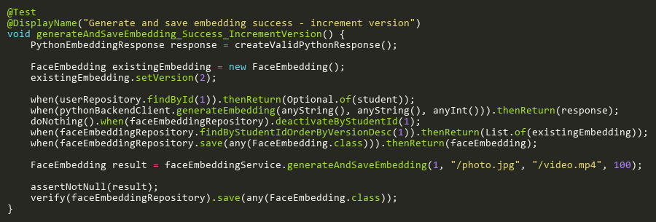

**Figure: generateAndSaveEmbedding_Success_IncrementVersion**  
*Reference: Sheet "FEST_generateAndSave", Test Case TC02*

## HasActiveEmbeddingTests

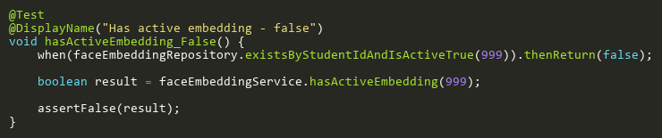

**Figure: hasActiveEmbedding_False**  
*Reference: Sheet "FEST_hasActiveEmbedding", Test Case TC02*

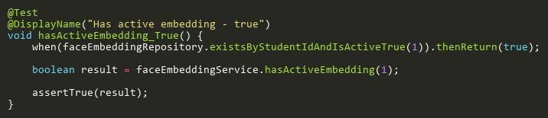

**Figure: hasActiveEmbedding_True**  
*Reference: Sheet "FEST_hasActiveEmbedding", Test Case TC01*

## SaveEmbeddingTests

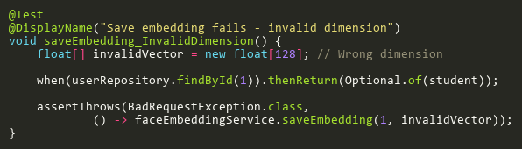

**Figure: saveEmbedding_InvalidDimension**  
*Reference: Sheet "FEST_saveEmbedding", Test Case TC04*

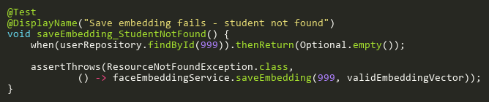

**Figure: saveEmbedding_StudentNotFound**  
*Reference: Sheet "FEST_saveEmbedding", Test Case TC03*

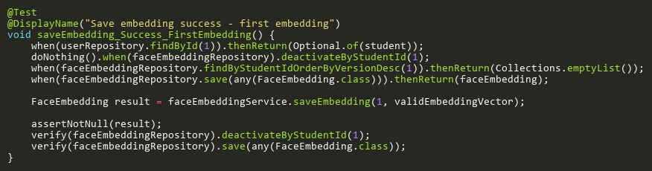

**Figure: saveEmbedding_Success_FirstEmbedding**  
*Reference: Sheet "FEST_saveEmbedding", Test Case TC01*

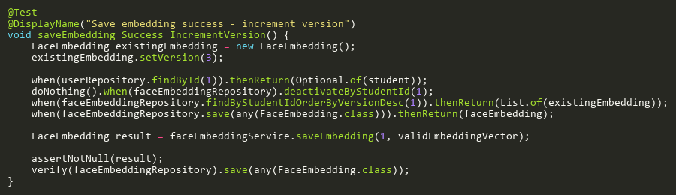

**Figure: saveEmbedding_Success_IncrementVersion**  
*Reference: Sheet "FEST_saveEmbedding", Test Case TC02*

# LecturerServiceTest

## GetLecturerSemestersWithClassesByUserIdTests

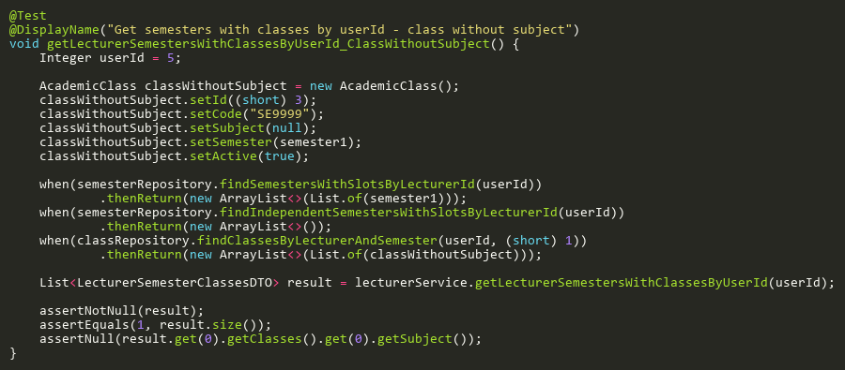

**Figure: getLecturerSemestersWithClassesByUserId_ClassWithoutSubject**  
*Reference: Sheet "LST_getSemestersByUserId", Test Case TC06*

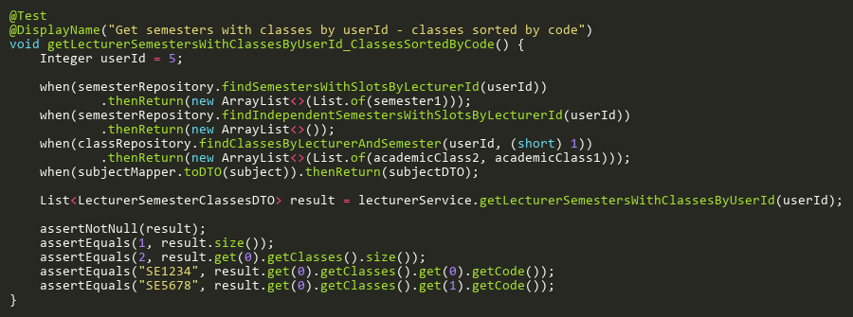

**Figure: getLecturerSemestersWithClassesByUserId_ClassesSortedByCode**  
*Reference: Sheet "LST_getSemestersByUserId", Test Case TC04*

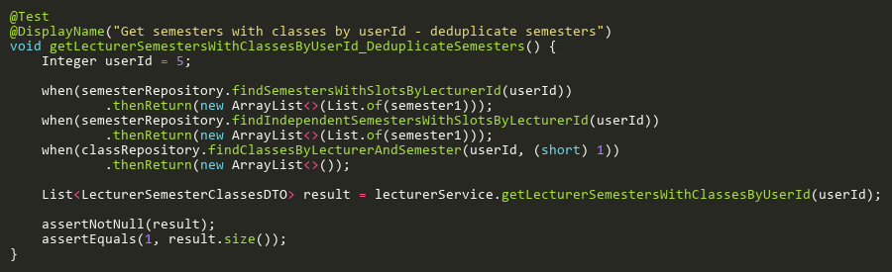

**Figure: getLecturerSemestersWithClassesByUserId_DeduplicateSemesters**  
*Reference: Sheet "LST_getSemestersByUserId", Test Case TC05*

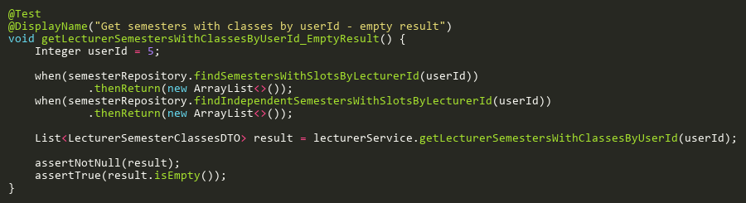

**Figure: getLecturerSemestersWithClassesByUserId_EmptyResult**  
*Reference: Sheet "LST_getSemestersByUserId", Test Case TC02*

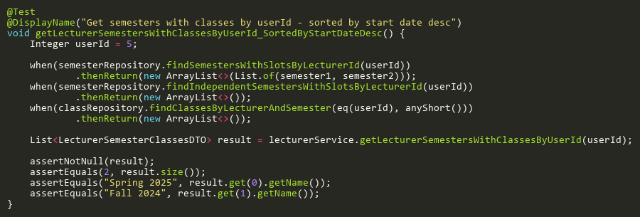

**Figure: getLecturerSemestersWithClassesByUserId_SortedByStartDateDesc**  
*Reference: Sheet "LST_getSemestersByUserId", Test Case TC03*

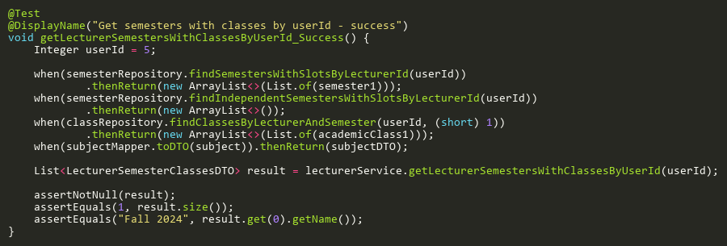

**Figure: getLecturerSemestersWithClassesByUserId_Success**  
*Reference: Sheet "LST_getSemestersByUserId", Test Case TC01*

## GetLecturerSemestersWithClassesTests

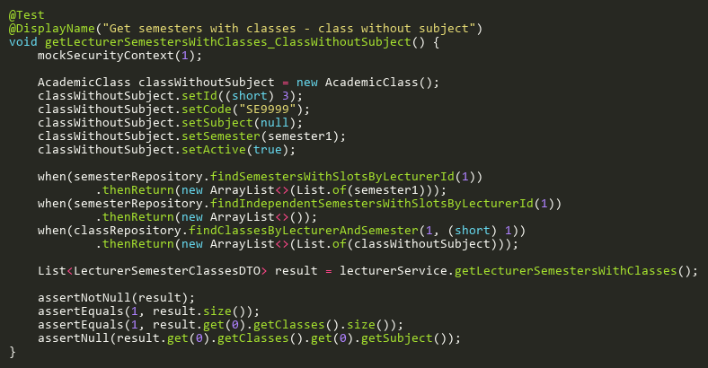

**Figure: getLecturerSemestersWithClasses_ClassWithoutSubject**  
*Reference: Sheet "LST_getSemestersClasses", Test Case TC06*

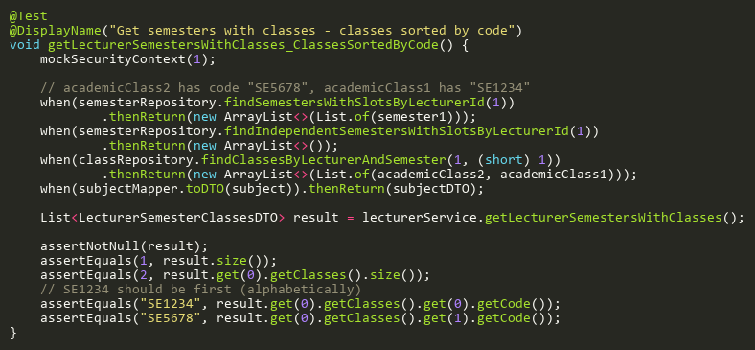

**Figure: getLecturerSemestersWithClasses_ClassesSortedByCode**  
*Reference: Sheet "LST_getSemestersClasses", Test Case TC05*

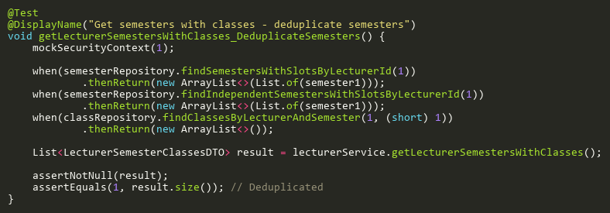

**Figure: getLecturerSemestersWithClasses_DeduplicateSemesters**  
*Reference: Sheet "LST_getSemestersClasses", Test Case TC07*

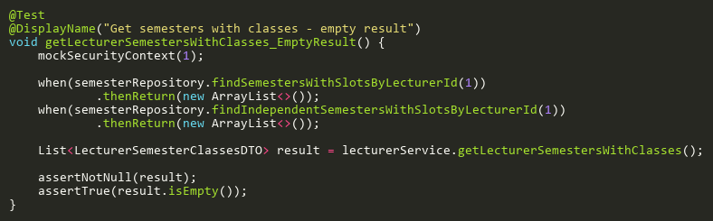

**Figure: getLecturerSemestersWithClasses_EmptyResult**  
*Reference: Sheet "LST_getSemestersClasses", Test Case TC03*

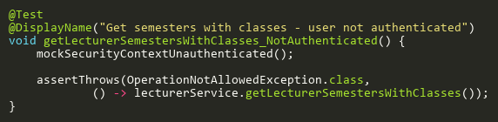

**Figure: getLecturerSemestersWithClasses_NotAuthenticated**  
*Reference: Sheet "LST_getSemestersClasses", Test Case TC02*

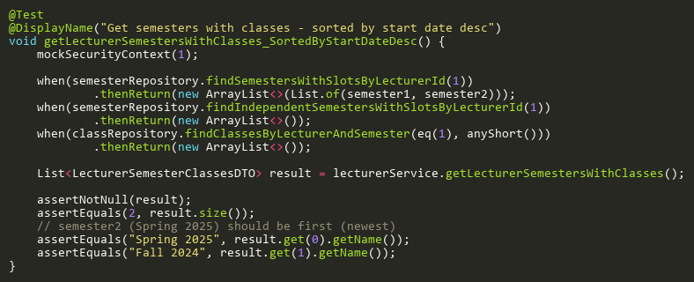

**Figure: getLecturerSemestersWithClasses_SortedByStartDateDesc**  
*Reference: Sheet "LST_getSemestersClasses", Test Case TC04*

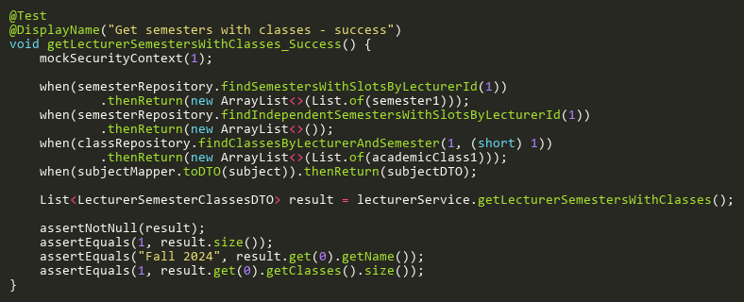

**Figure: getLecturerSemestersWithClasses_Success**  
*Reference: Sheet "LST_getSemestersClasses", Test Case TC01*

# MajorServiceTest

## CreateTests

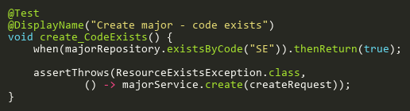

**Figure: create_CodeExists**  
*Reference: Sheet "MJST_create", Test Case TC02*

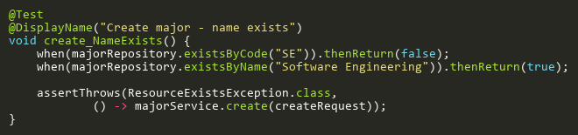

**Figure: create_NameExists**  
*Reference: Sheet "MJST_create", Test Case TC03*

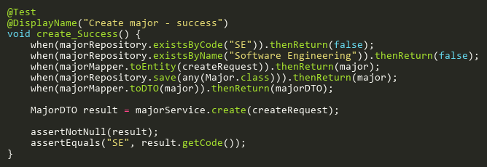

**Figure: create_Success**  
*Reference: Sheet "MJST_create", Test Case TC01*

## DeleteTests

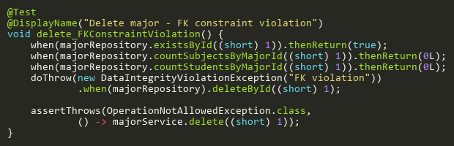

**Figure: delete_FKConstraintViolation**  
*Reference: Sheet "MJST_delete", Test Case TC05*

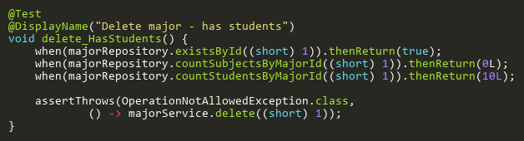

**Figure: delete_HasStudents**  
*Reference: Sheet "MJST_delete", Test Case TC04*

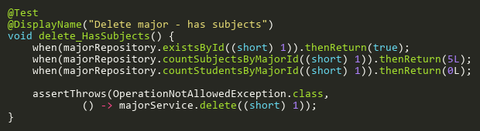

**Figure: delete_HasSubjects**  
*Reference: Sheet "MJST_delete", Test Case TC03*

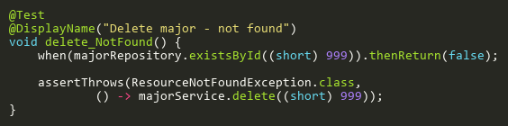

**Figure: delete_NotFound**  
*Reference: Sheet "MJST_delete", Test Case TC02*

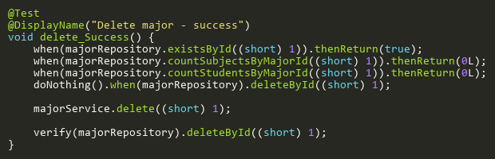

**Figure: delete_Success**  
*Reference: Sheet "MJST_delete", Test Case TC01*

## FindByIdTests

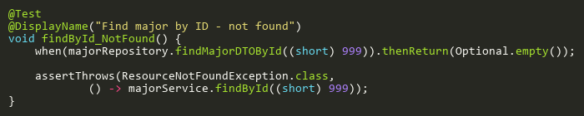

**Figure: findById_NotFound**  
*Reference: Sheet "MJST_findById", Test Case TC02*

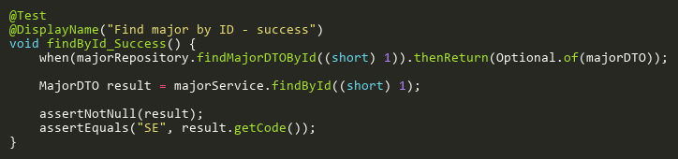

**Figure: findById_Success**  
*Reference: Sheet "MJST_findById", Test Case TC01*

## SearchTests

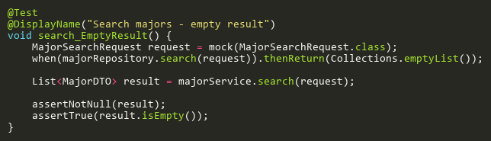

**Figure: search_EmptyResult**  
*Reference: Sheet "MJST_search", Test Case TC02*

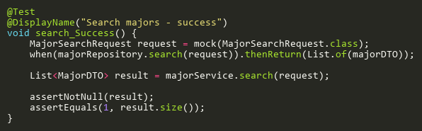

**Figure: search_Success**  
*Reference: Sheet "MJST_search", Test Case TC01*

## UpdateTests

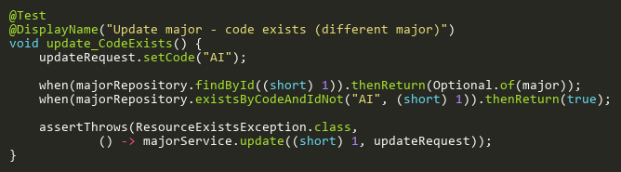

**Figure: update_CodeExists**  
*Reference: Sheet "MJST_update", Test Case TC03*

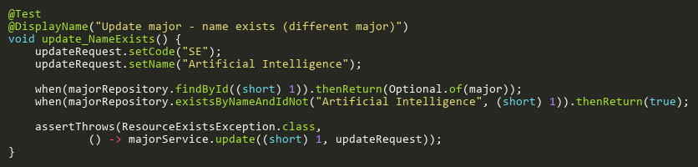

**Figure: update_NameExists**  
*Reference: Sheet "MJST_update", Test Case TC04*

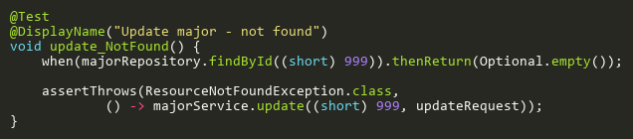

**Figure: update_NotFound**  
*Reference: Sheet "MJST_update", Test Case TC02*

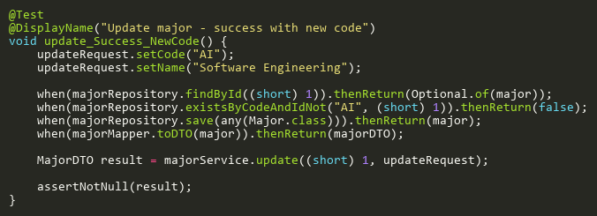

**Figure: update_Success_NewCode**  
*Reference: Sheet "MJST_update", Test Case TC05*

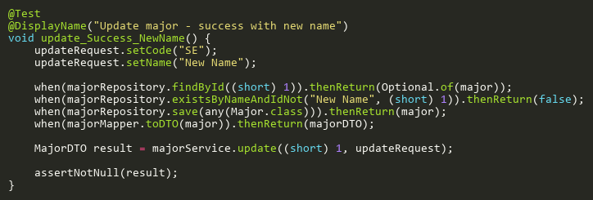

**Figure: update_Success_NewName**  
*Reference: Sheet "MJST_update", Test Case TC06*

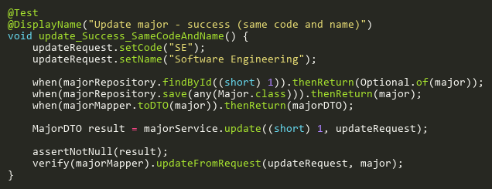

**Figure: update_Success_SameCodeAndName**  
*Reference: Sheet "MJST_update", Test Case TC01*

# NotificationServiceTest

## NotifyExamAttendanceFinalizedTests

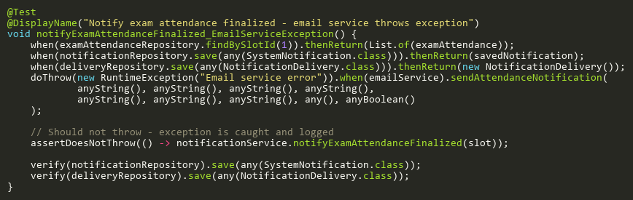

**Figure: notifyExamAttendanceFinalized_EmailServiceException**  
*Reference: Sheet "NST_notifyExam", Test Case TC05*

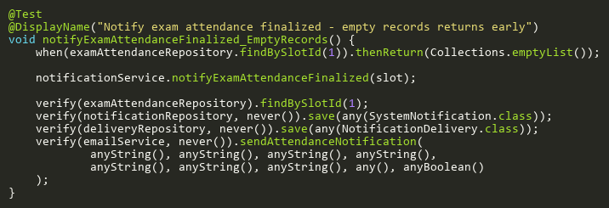

**Figure: notifyExamAttendanceFinalized_EmptyRecords**  
*Reference: Sheet "NST_notifyExam", Test Case TC02*

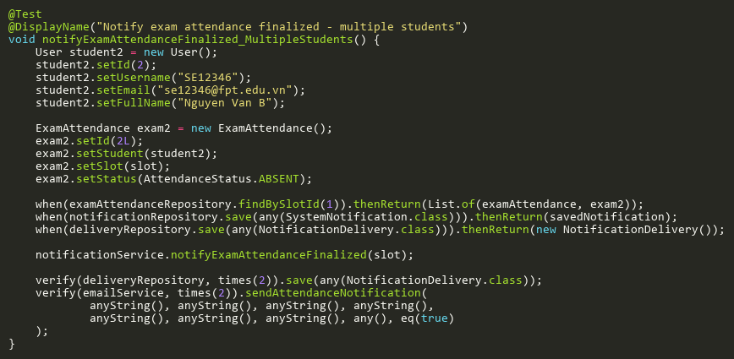

**Figure: notifyExamAttendanceFinalized_MultipleStudents**  
*Reference: Sheet "NST_notifyExam", Test Case TC03*

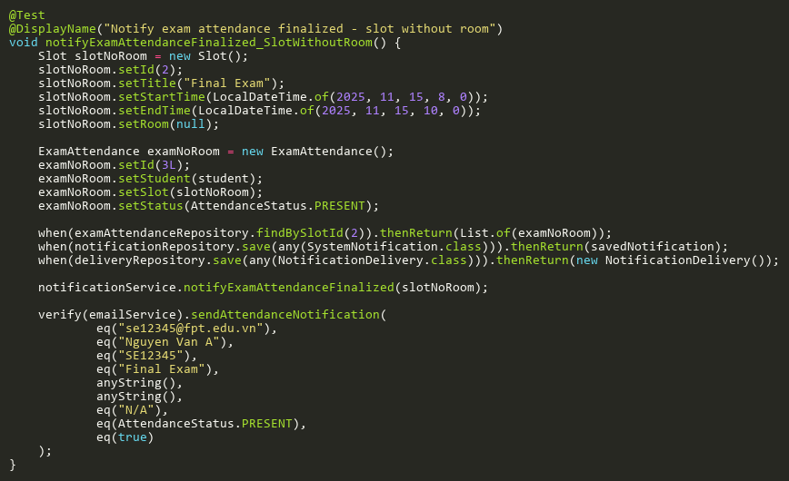

**Figure: notifyExamAttendanceFinalized_SlotWithoutRoom**  
*Reference: Sheet "NST_notifyExam", Test Case TC04*

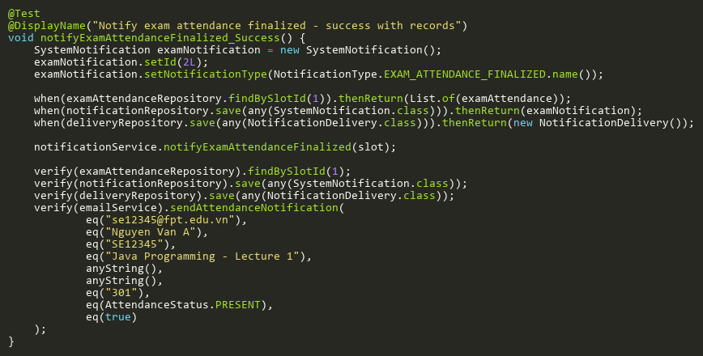

**Figure: notifyExamAttendanceFinalized_Success**  
*Reference: Sheet "NST_notifyExam", Test Case TC01*

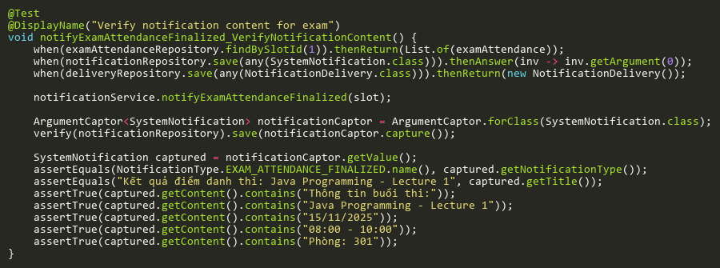

**Figure: notifyExamAttendanceFinalized_VerifyNotificationContent**  
*Reference: Sheet "NST_notifyExam", Test Case TC06*

## NotifyLectureAttendanceFinalizedTests

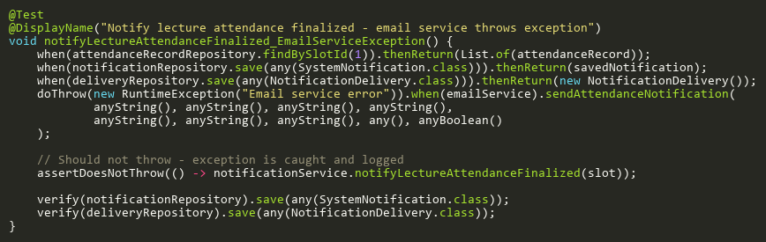

**Figure: notifyLectureAttendanceFinalized_EmailServiceException**  
*Reference: Sheet "NST_notifyLecture", Test Case TC05*

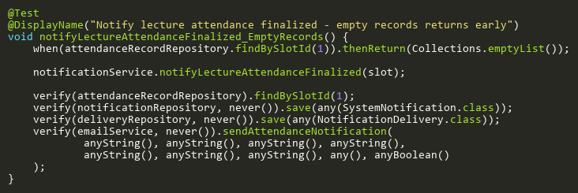

**Figure: notifyLectureAttendanceFinalized_EmptyRecords**  
*Reference: Sheet "NST_notifyLecture", Test Case TC02*

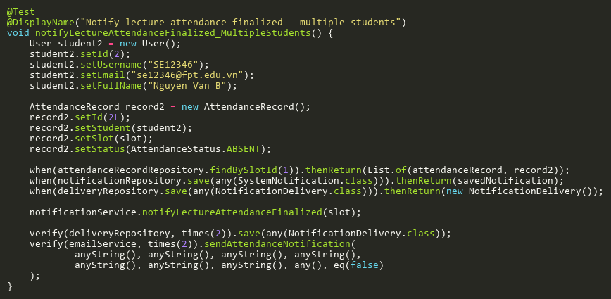

**Figure: notifyLectureAttendanceFinalized_MultipleStudents**  
*Reference: Sheet "NST_notifyLecture", Test Case TC03*

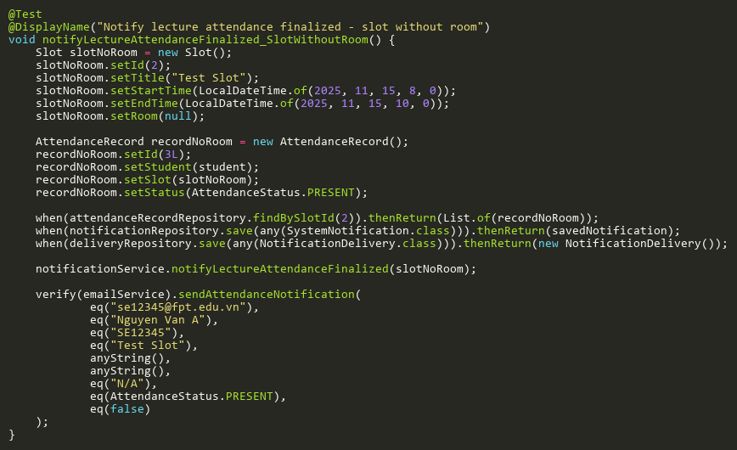

**Figure: notifyLectureAttendanceFinalized_SlotWithoutRoom**  
*Reference: Sheet "NST_notifyLecture", Test Case TC04*

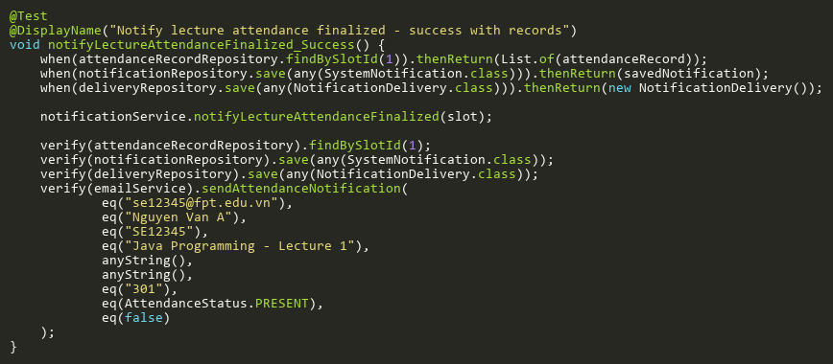

**Figure: notifyLectureAttendanceFinalized_Success**  
*Reference: Sheet "NST_notifyLecture", Test Case TC01*

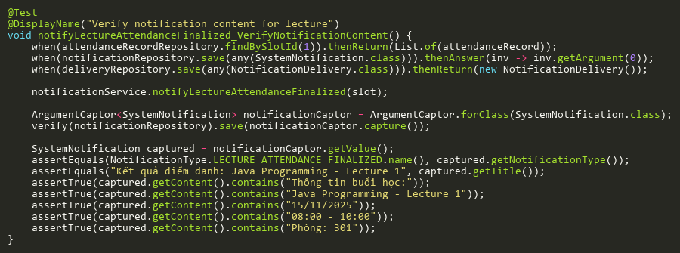

**Figure: notifyLectureAttendanceFinalized_VerifyNotificationContent**  
*Reference: Sheet "NST_notifyLecture", Test Case TC06*

# PythonBackendClientTest

## CheckHealthTests

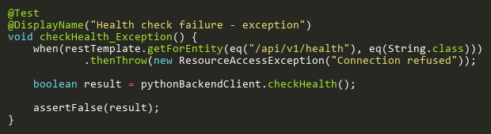

**Figure: checkHealth_Exception**  
*Reference: Sheet "PBCT_checkHealth", Test Case TC02*

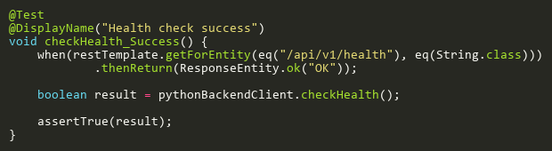

**Figure: checkHealth_Success**  
*Reference: Sheet "PBCT_checkHealth", Test Case TC01*

## GenerateEmbeddingPathTests

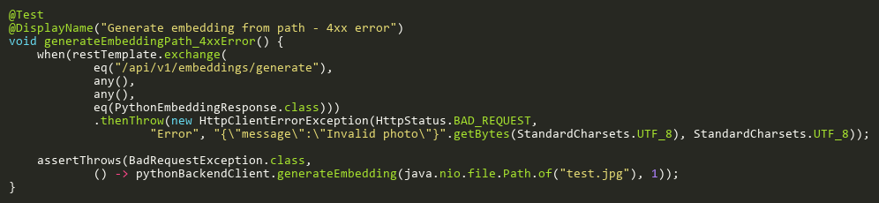

**Figure: generateEmbeddingPath_4xxError**  
*Reference: Sheet "PBCT_genEmbedPath", Test Case TC03*

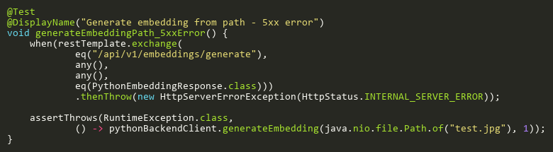

**Figure: generateEmbeddingPath_5xxError**  
*Reference: Sheet "PBCT_genEmbedPath", Test Case TC04*

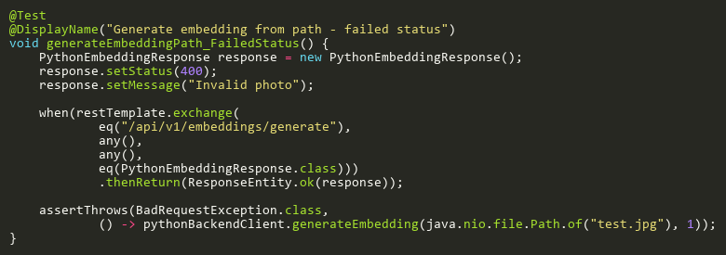

**Figure: generateEmbeddingPath_FailedStatus**  
*Reference: Sheet "PBCT_genEmbedPath", Test Case TC02*

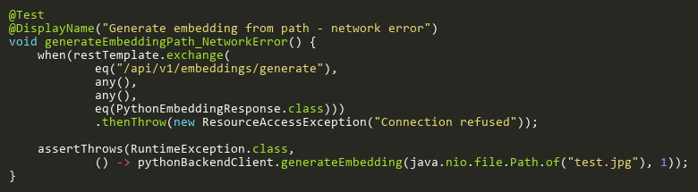

**Figure: generateEmbeddingPath_NetworkError**  
*Reference: Sheet "PBCT_genEmbedPath", Test Case TC05*

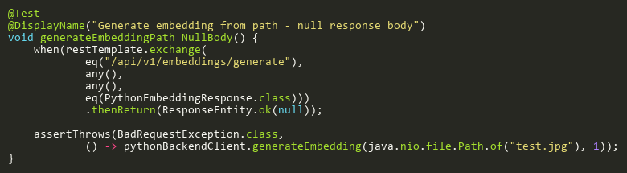

**Figure: generateEmbeddingPath_NullBody**  
*Reference: Sheet "PBCT_genEmbedPath", Test Case TC06*

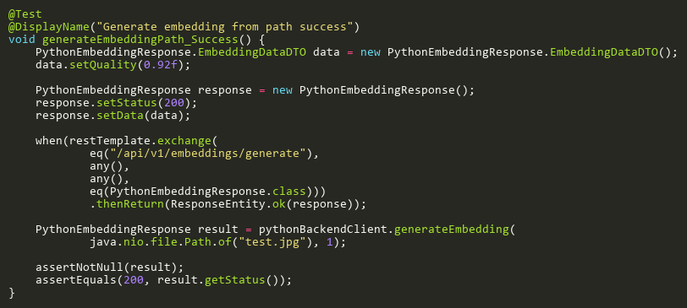

**Figure: generateEmbeddingPath_Success**  
*Reference: Sheet "PBCT_genEmbedPath", Test Case TC01*

## GenerateEmbeddingUrlTests

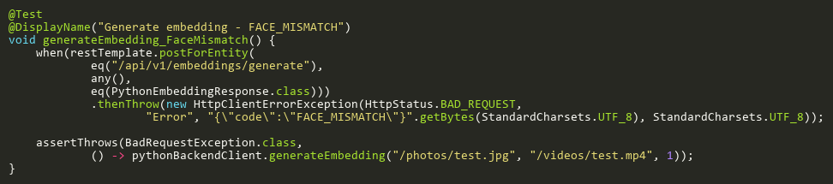

**Figure: generateEmbedding_FaceMismatch**  
*Reference: Sheet "PBCT_genEmbedURL", Test Case TC04*

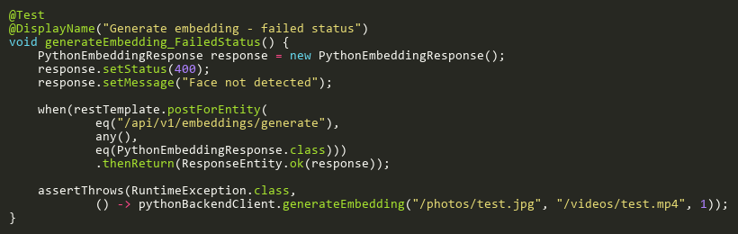

**Figure: generateEmbedding_FailedStatus**  
*Reference: Sheet "PBCT_genEmbedURL", Test Case TC02*

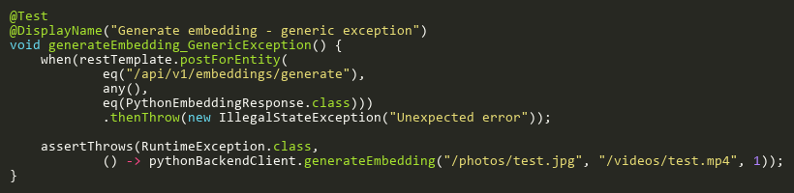

**Figure: generateEmbedding_GenericException**  
*Reference: Sheet "PBCT_genEmbedURL", Test Case TC07*

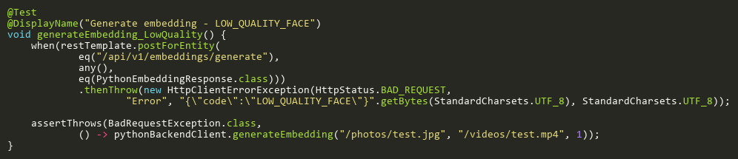

**Figure: generateEmbedding_LowQuality**  
*Reference: Sheet "PBCT_genEmbedURL", Test Case TC05*

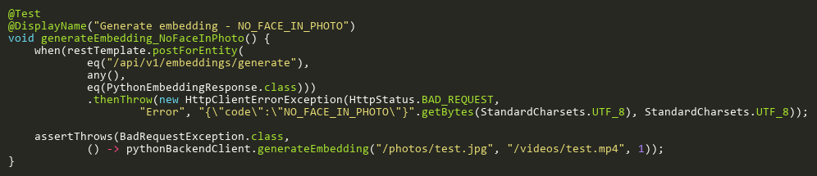

**Figure: generateEmbedding_NoFaceInPhoto**  
*Reference: Sheet "PBCT_genEmbedURL", Test Case TC03*

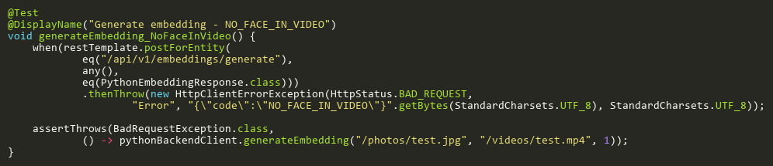

**Figure: generateEmbedding_NoFaceInVideo**  
*Reference: Sheet "PBCT_genEmbedURL", Test Case TC09*

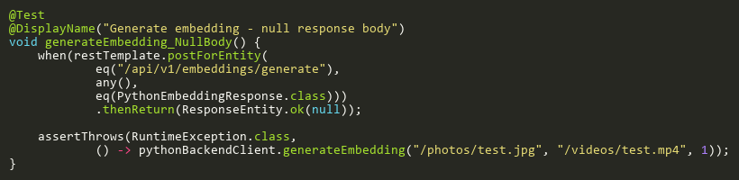

**Figure: generateEmbedding_NullBody**  
*Reference: Sheet "PBCT_genEmbedURL", Test Case TC08*

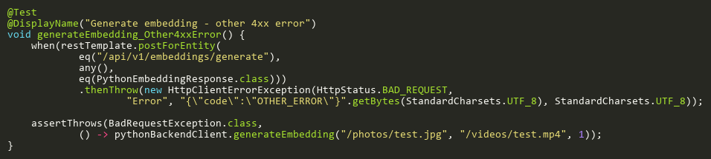

**Figure: generateEmbedding_Other4xxError**  
*Reference: Sheet "PBCT_genEmbedURL", Test Case TC06*

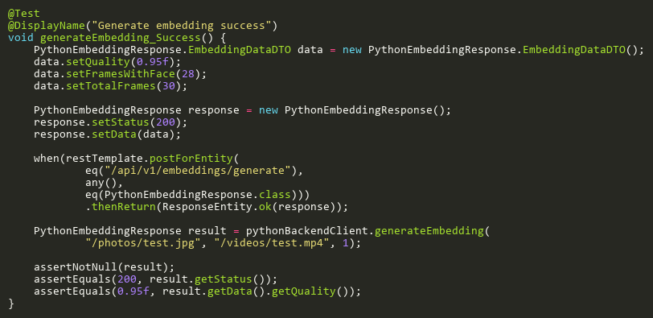

**Figure: generateEmbedding_Success**  
*Reference: Sheet "PBCT_genEmbedURL", Test Case TC01*

## StartRecognitionSessionTests

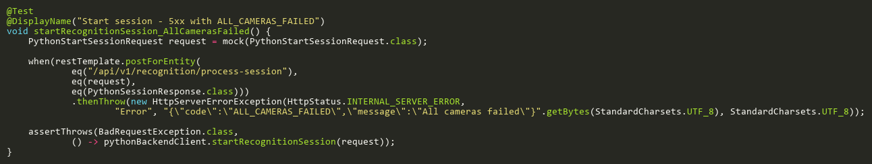

**Figure: startRecognitionSession_AllCamerasFailed**  
*Reference: Sheet "PBCT_startSession", Test Case TC07*

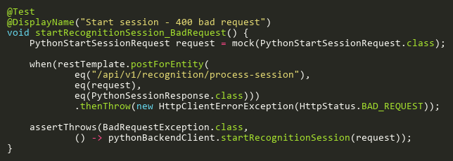

**Figure: startRecognitionSession_BadRequest**  
*Reference: Sheet "PBCT_startSession", Test Case TC04*

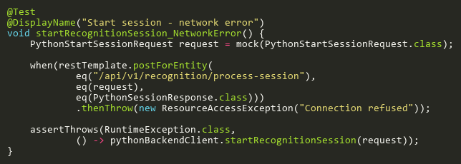

**Figure: startRecognitionSession_NetworkError**  
*Reference: Sheet "PBCT_startSession", Test Case TC08*

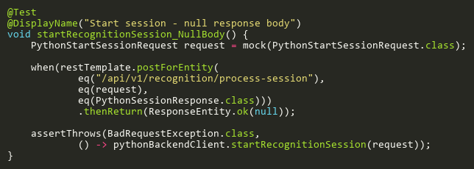

**Figure: startRecognitionSession_NullBody**  
*Reference: Sheet "PBCT_startSession", Test Case TC09*

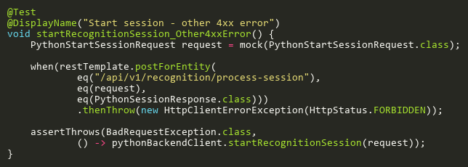

**Figure: startRecognitionSession_Other4xxError**  
*Reference: Sheet "PBCT_startSession", Test Case TC05*

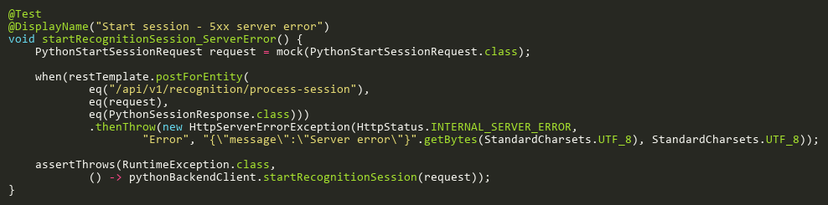

**Figure: startRecognitionSession_ServerError**  
*Reference: Sheet "PBCT_startSession", Test Case TC06*

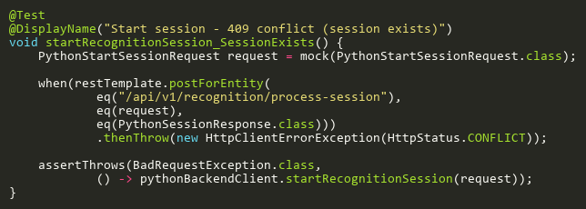

**Figure: startRecognitionSession_SessionExists**  
*Reference: Sheet "PBCT_startSession", Test Case TC03*

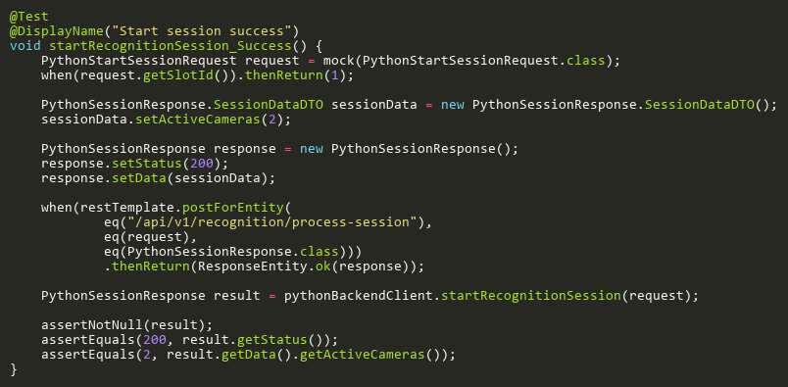

**Figure: startRecognitionSession_Success**  
*Reference: Sheet "PBCT_startSession", Test Case TC01*

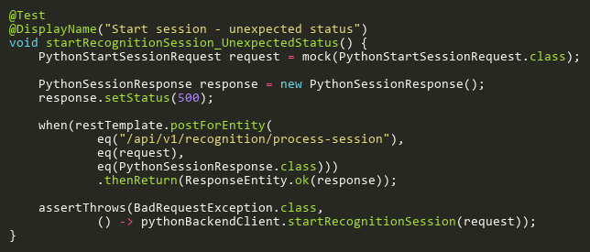

**Figure: startRecognitionSession_UnexpectedStatus**  
*Reference: Sheet "PBCT_startSession", Test Case TC02*

## StopRecognitionSessionTests

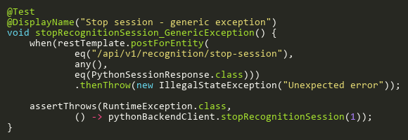

**Figure: stopRecognitionSession_GenericException**  
*Reference: Sheet "PBCT_stopSession", Test Case TC07*

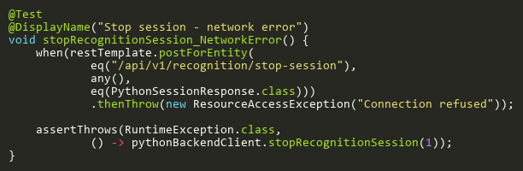

**Figure: stopRecognitionSession_NetworkError**  
*Reference: Sheet "PBCT_stopSession", Test Case TC06*

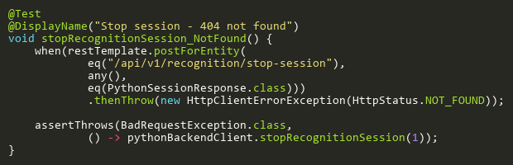

**Figure: stopRecognitionSession_NotFound**  
*Reference: Sheet "PBCT_stopSession", Test Case TC03*

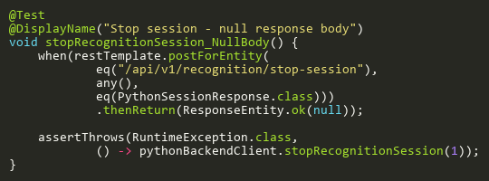

**Figure: stopRecognitionSession_NullBody**  
*Reference: Sheet "PBCT_stopSession", Test Case TC08*

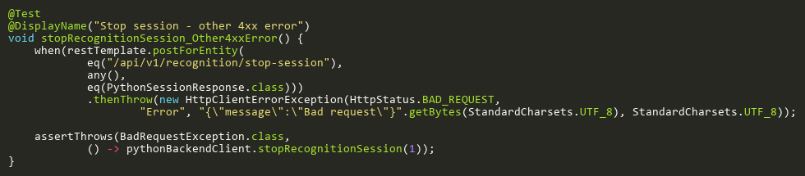

**Figure: stopRecognitionSession_Other4xxError**  
*Reference: Sheet "PBCT_stopSession", Test Case TC04*

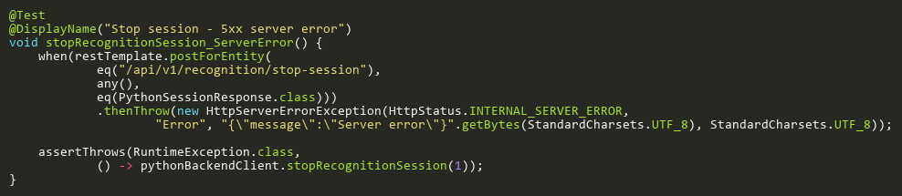

**Figure: stopRecognitionSession_ServerError**  
*Reference: Sheet "PBCT_stopSession", Test Case TC05*

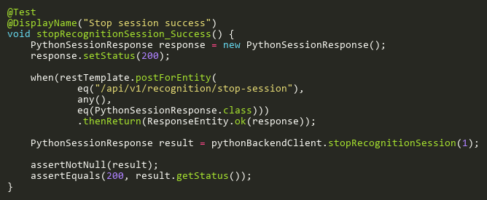

**Figure: stopRecognitionSession_Success**  
*Reference: Sheet "PBCT_stopSession", Test Case TC01*

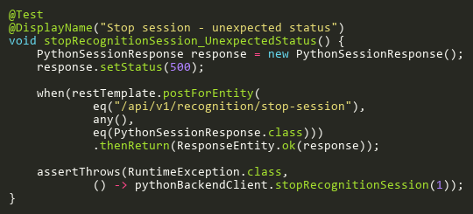

**Figure: stopRecognitionSession_UnexpectedStatus**  
*Reference: Sheet "PBCT_stopSession", Test Case TC02*

## TestCameraConnectionTests

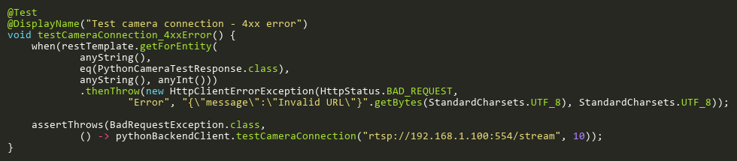

**Figure: testCameraConnection_4xxError**  
*Reference: Sheet "PBCT_testCamera", Test Case TC04*

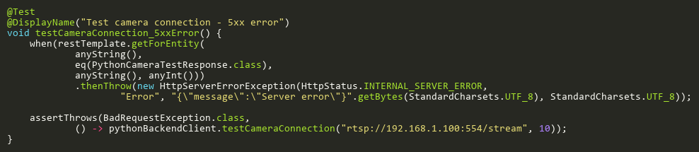

**Figure: testCameraConnection_5xxError**  
*Reference: Sheet "PBCT_testCamera", Test Case TC05*

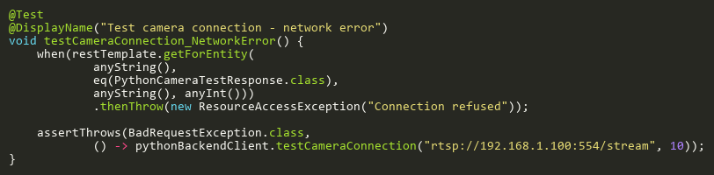

**Figure: testCameraConnection_NetworkError**  
*Reference: Sheet "PBCT_testCamera", Test Case TC06*

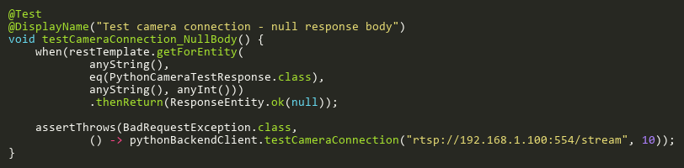

**Figure: testCameraConnection_NullBody**  
*Reference: Sheet "PBCT_testCamera", Test Case TC07*

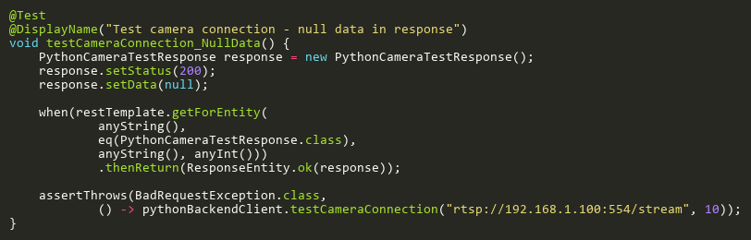

**Figure: testCameraConnection_NullData**  
*Reference: Sheet "PBCT_testCamera", Test Case TC08*

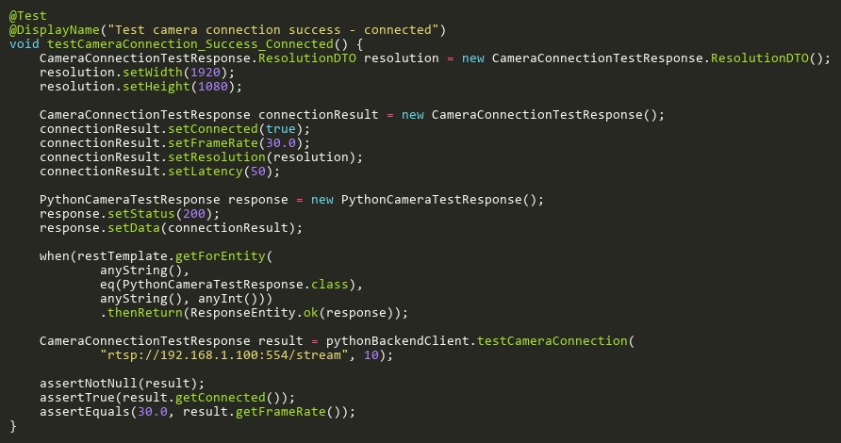

**Figure: testCameraConnection_Success_Connected**  
*Reference: Sheet "PBCT_testCamera", Test Case TC01*

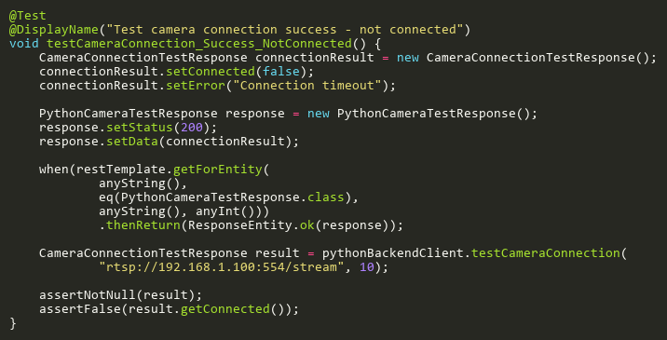

**Figure: testCameraConnection_Success_NotConnected**  
*Reference: Sheet "PBCT_testCamera", Test Case TC02*

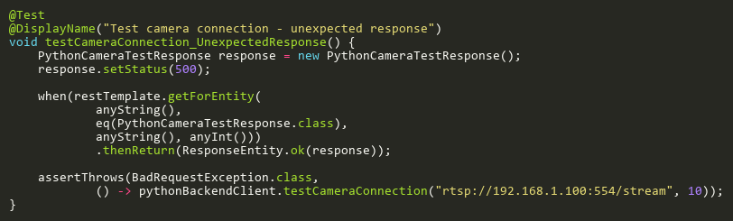

**Figure: testCameraConnection_UnexpectedResponse**  
*Reference: Sheet "PBCT_testCamera", Test Case TC03*

# RoomServiceTest

## CountByStaffIdTests

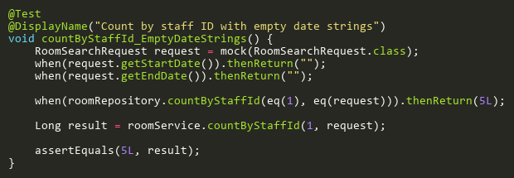

**Figure: countByStaffId_EmptyDateStrings**  
*Reference: Sheet "RMST_countByStaffId", Test Case TC05*

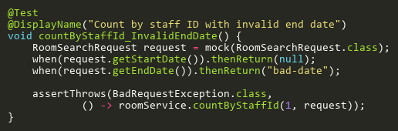

**Figure: countByStaffId_InvalidEndDate**  
*Reference: Sheet "RMST_countByStaffId", Test Case TC04*

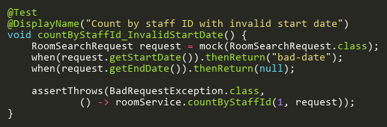

**Figure: countByStaffId_InvalidStartDate**  
*Reference: Sheet "RMST_countByStaffId", Test Case TC03*

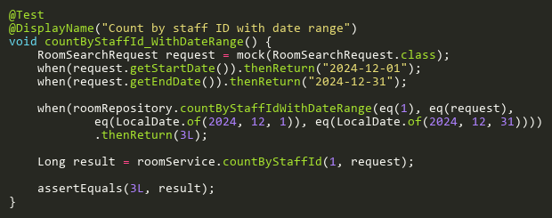

**Figure: countByStaffId_WithDateRange**  
*Reference: Sheet "RMST_countByStaffId", Test Case TC02*

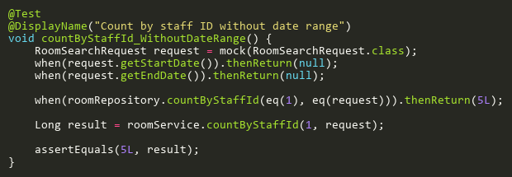

**Figure: countByStaffId_WithoutDateRange**  
*Reference: Sheet "RMST_countByStaffId", Test Case TC01*

## CreateTests

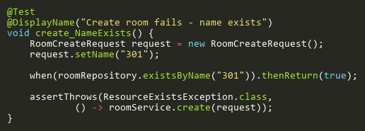

**Figure: create_NameExists**  
*Reference: Sheet "RMST_create", Test Case TC02*

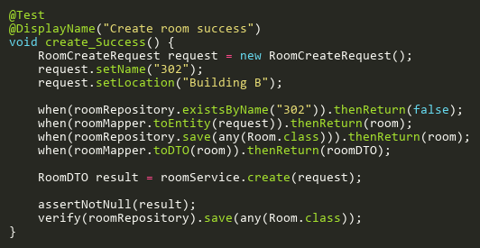

**Figure: create_Success**  
*Reference: Sheet "RMST_create", Test Case TC01*

## DeleteTests

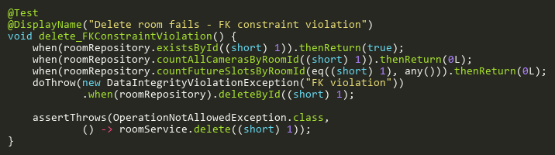

**Figure: delete_FKConstraintViolation**  
*Reference: Sheet "RMST_delete", Test Case TC05*

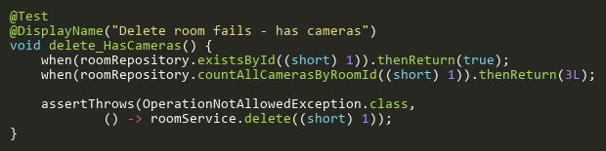

**Figure: delete_HasCameras**  
*Reference: Sheet "RMST_delete", Test Case TC03*

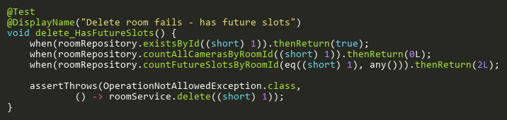

**Figure: delete_HasFutureSlots**  
*Reference: Sheet "RMST_delete", Test Case TC04*

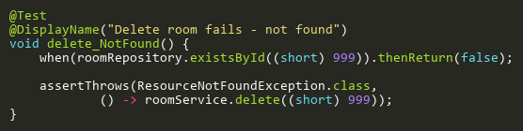

**Figure: delete_NotFound**  
*Reference: Sheet "RMST_delete", Test Case TC02*

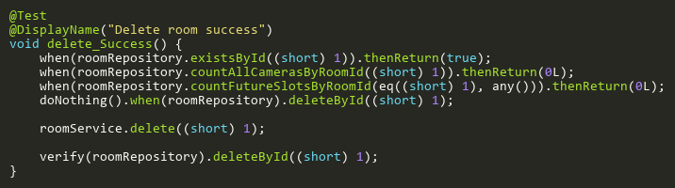

**Figure: delete_Success**  
*Reference: Sheet "RMST_delete", Test Case TC01*

## SearchByStaffIdTests

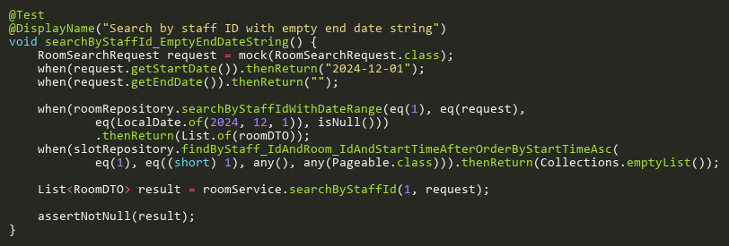

**Figure: searchByStaffId_EmptyEndDateString**  
*Reference: Sheet "RMST_searchByStaffId", Test Case TC08*

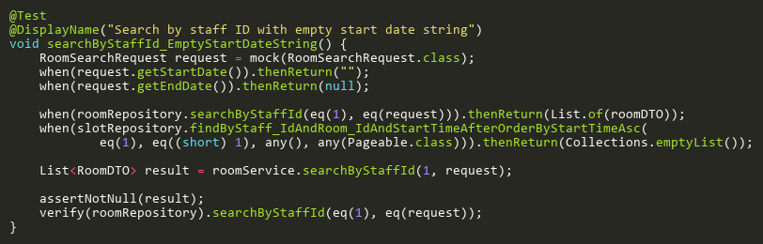

**Figure: searchByStaffId_EmptyStartDateString**  
*Reference: Sheet "RMST_searchByStaffId", Test Case TC07*

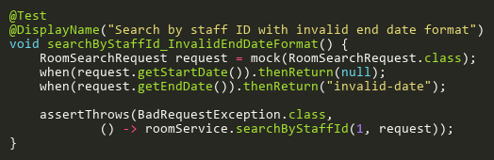

**Figure: searchByStaffId_InvalidEndDateFormat**  
*Reference: Sheet "RMST_searchByStaffId", Test Case TC05*

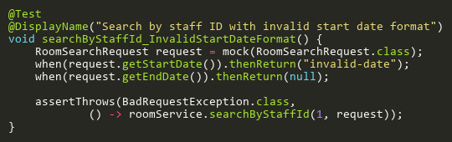

**Figure: searchByStaffId_InvalidStartDateFormat**  
*Reference: Sheet "RMST_searchByStaffId", Test Case TC04*

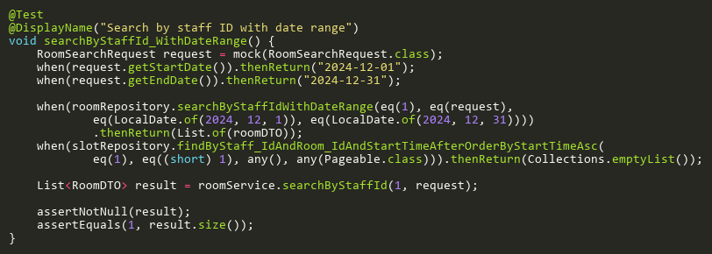

**Figure: searchByStaffId_WithDateRange**  
*Reference: Sheet "RMST_searchByStaffId", Test Case TC02*

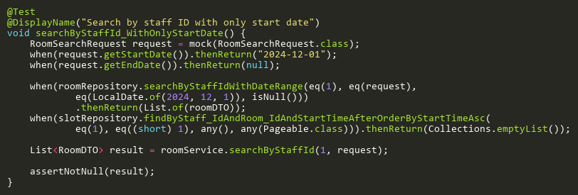

**Figure: searchByStaffId_WithOnlyStartDate**  
*Reference: Sheet "RMST_searchByStaffId", Test Case TC03*

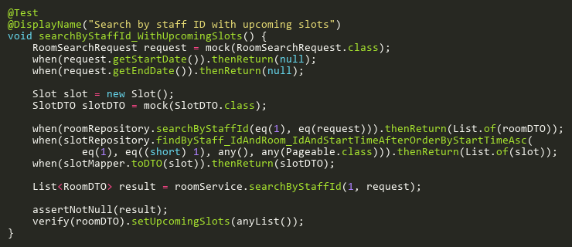

**Figure: searchByStaffId_WithUpcomingSlots**  
*Reference: Sheet "RMST_searchByStaffId", Test Case TC06*

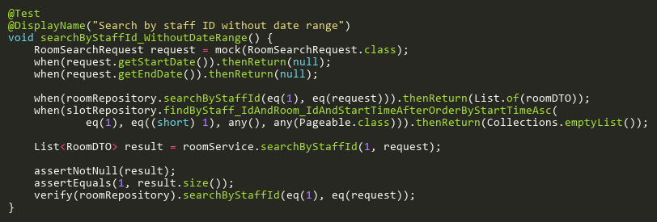

**Figure: searchByStaffId_WithoutDateRange**  
*Reference: Sheet "RMST_searchByStaffId", Test Case TC01*

## UpdateTests

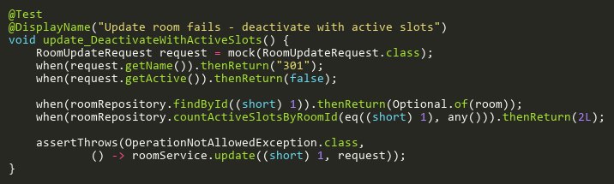

**Figure: update_DeactivateWithActiveSlots**  
*Reference: Sheet "RMST_update", Test Case TC05*

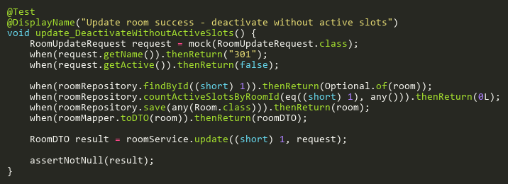

**Figure: update_DeactivateWithoutActiveSlots**  
*Reference: Sheet "RMST_update", Test Case TC06*

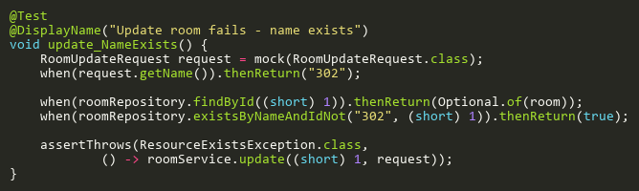

**Figure: update_NameExists**  
*Reference: Sheet "RMST_update", Test Case TC04*

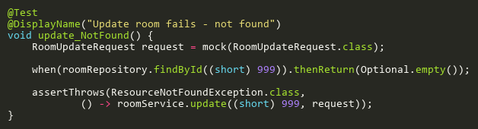

**Figure: update_NotFound**  
*Reference: Sheet "RMST_update", Test Case TC03*

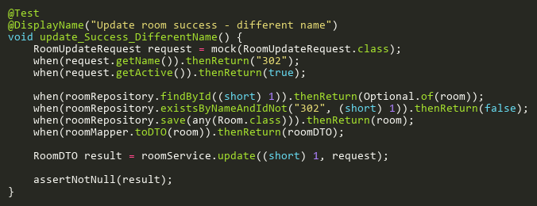

**Figure: update_Success_DifferentName**  
*Reference: Sheet "RMST_update", Test Case TC02*

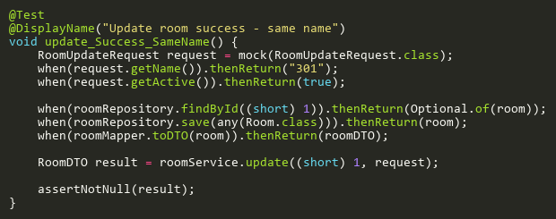

**Figure: update_Success_SameName**  
*Reference: Sheet "RMST_update", Test Case TC01*

# SemesterServiceTest

## CreateTests

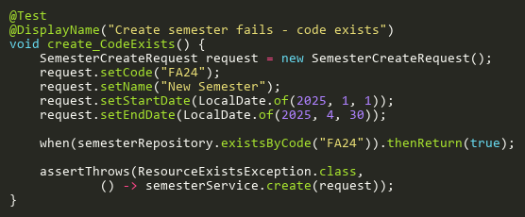

**Figure: create_CodeExists**  
*Reference: Sheet "SMST_create", Test Case TC03*

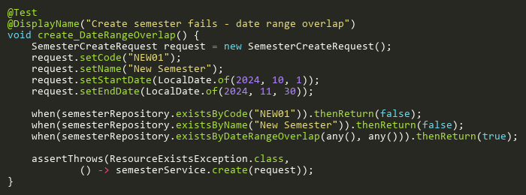

**Figure: create_DateRangeOverlap**  
*Reference: Sheet "SMST_create", Test Case TC05*

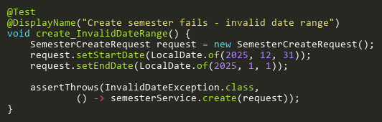

**Figure: create_InvalidDateRange**  
*Reference: Sheet "SMST_create", Test Case TC02*

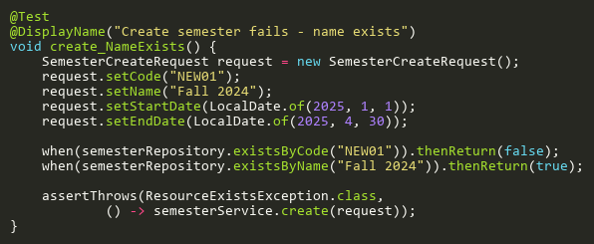

**Figure: create_NameExists**  
*Reference: Sheet "SMST_create", Test Case TC04*

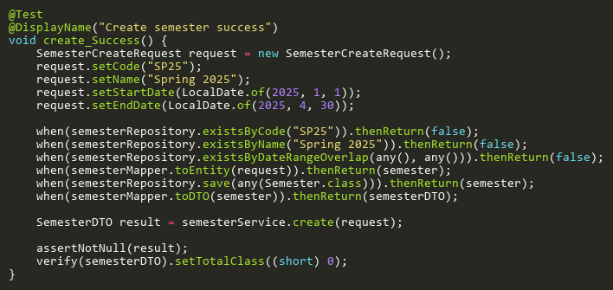

**Figure: create_Success**  
*Reference: Sheet "SMST_create", Test Case TC01*

## DeleteTests

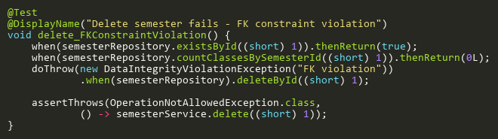

**Figure: delete_FKConstraintViolation**  
*Reference: Sheet "SMST_delete", Test Case TC04*

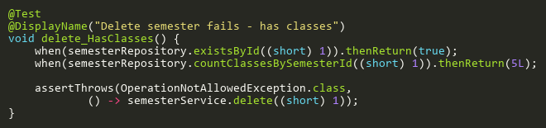

**Figure: delete_HasClasses**  
*Reference: Sheet "SMST_delete", Test Case TC03*

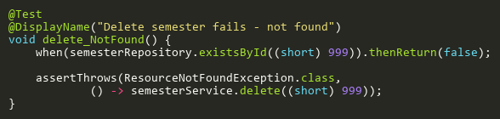

**Figure: delete_NotFound**  
*Reference: Sheet "SMST_delete", Test Case TC02*

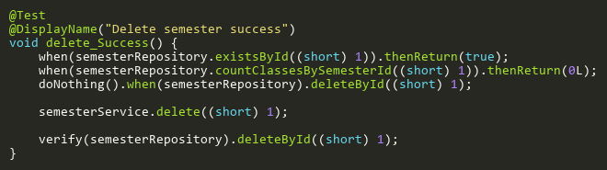

**Figure: delete_Success**  
*Reference: Sheet "SMST_delete", Test Case TC01*

## UpdateTests

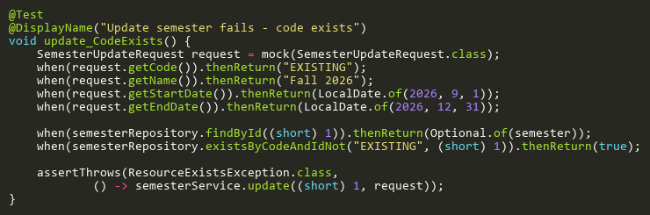

**Figure: update_CodeExists**  
*Reference: Sheet "SMST_update", Test Case TC07*

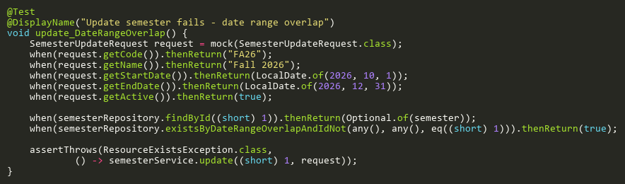

**Figure: update_DateRangeOverlap**  
*Reference: Sheet "SMST_update", Test Case TC09*

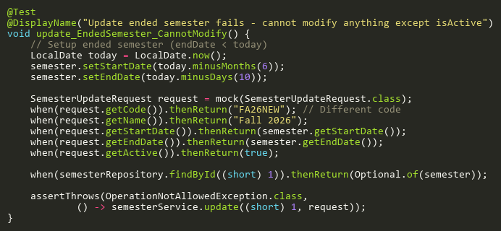

**Figure: update_EndedSemester_CannotModify**  
*Reference: Sheet "SMST_update", Test Case TC10*

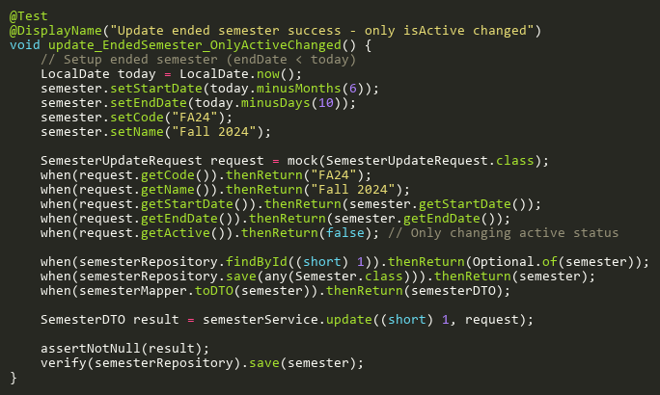

**Figure: update_EndedSemester_OnlyActiveChanged**  
*Reference: Sheet "SMST_update", Test Case TC11*

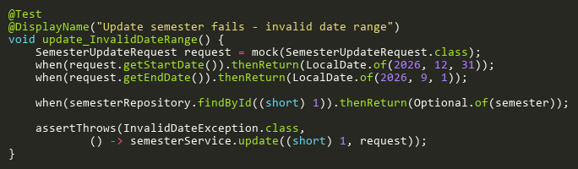

**Figure: update_InvalidDateRange**  
*Reference: Sheet "SMST_update", Test Case TC06*

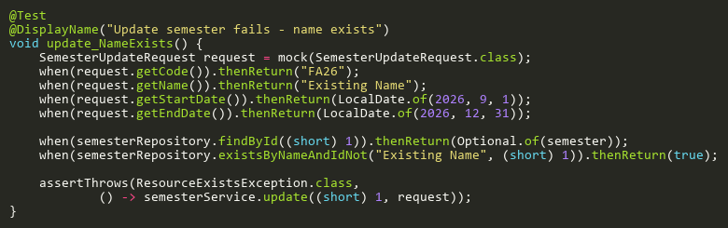

**Figure: update_NameExists**  
*Reference: Sheet "SMST_update", Test Case TC08*

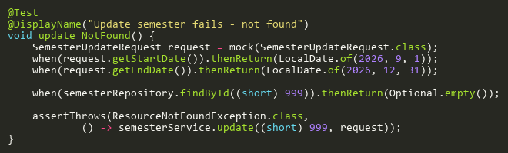

**Figure: update_NotFound**  
*Reference: Sheet "SMST_update", Test Case TC05*

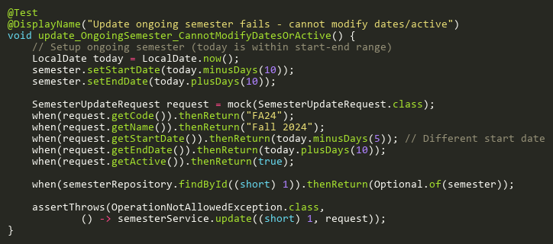

**Figure: update_OngoingSemester_CannotModifyDatesOrActive**  
*Reference: Sheet "SMST_update", Test Case TC12*

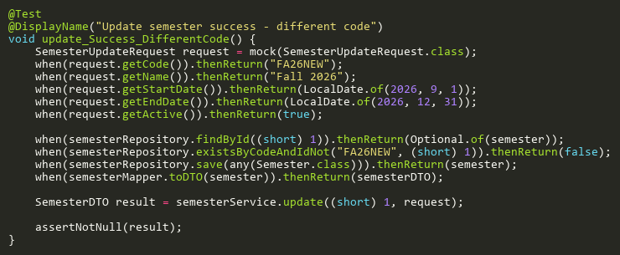

**Figure: update_Success_DifferentCode**  
*Reference: Sheet "SMST_update", Test Case TC02*

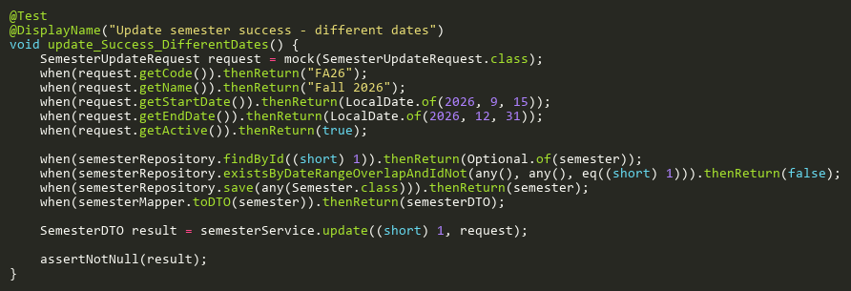

**Figure: update_Success_DifferentDates**  
*Reference: Sheet "SMST_update", Test Case TC04*

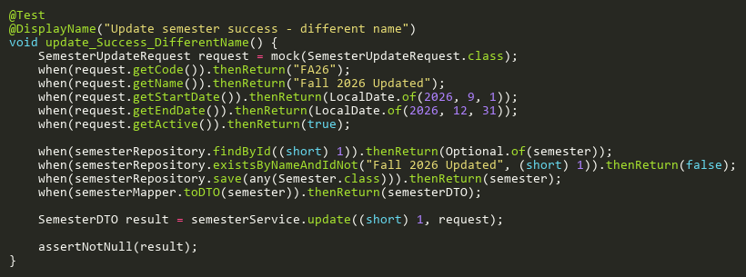

**Figure: update_Success_DifferentName**  
*Reference: Sheet "SMST_update", Test Case TC03*

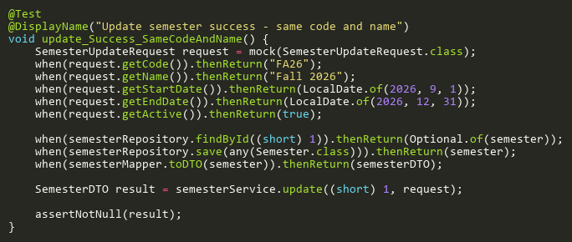

**Figure: update_Success_SameCodeAndName**  
*Reference: Sheet "SMST_update", Test Case TC01*

# SlotServiceTest

## CreateAdditionalTests

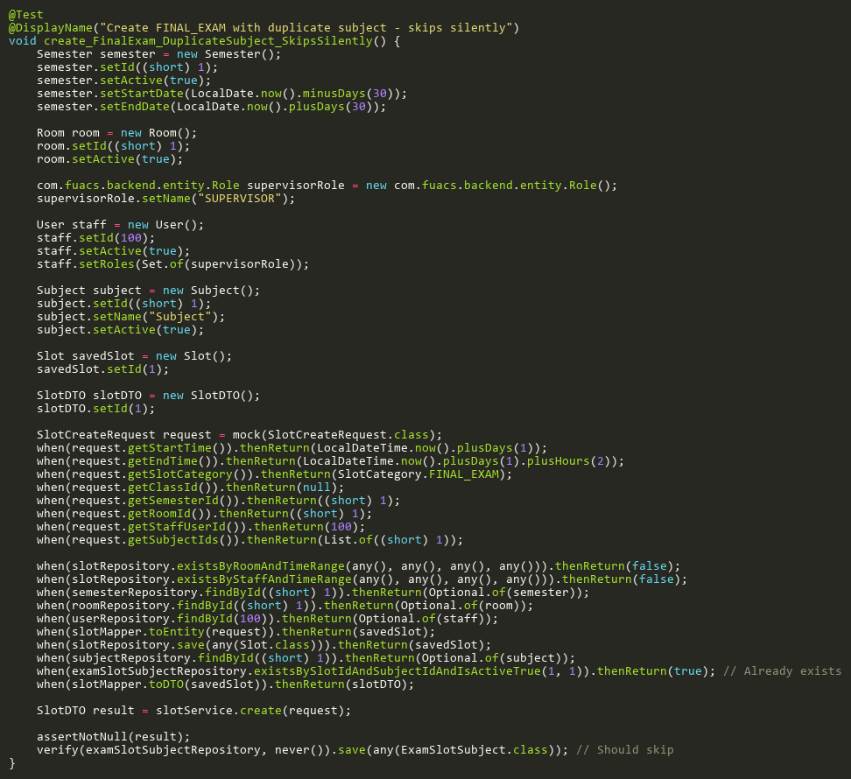

**Figure: create_FinalExam_DuplicateSubject_SkipsSilently**  
*Reference: Sheet "SLST_create", Test Case TC21*

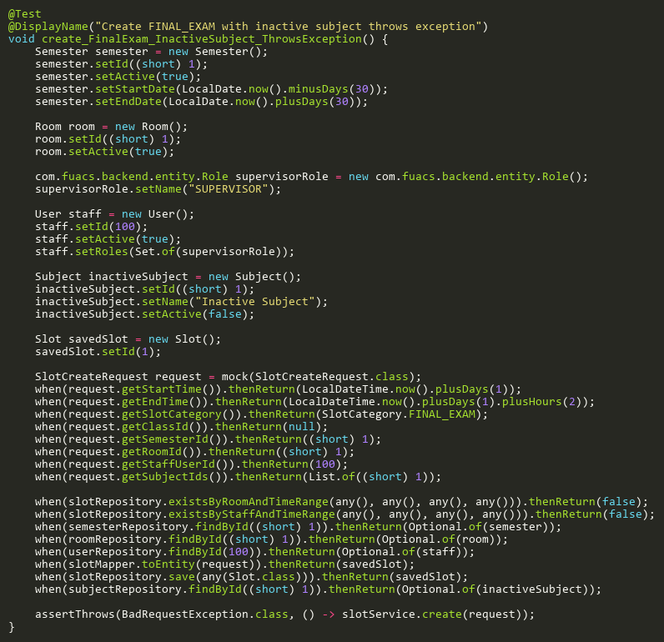

**Figure: create_FinalExam_InactiveSubject_ThrowsException**  
*Reference: Sheet "SLST_create", Test Case TC17*

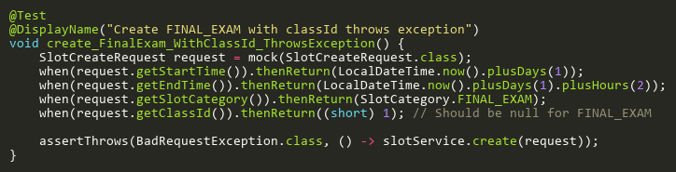

**Figure: create_FinalExam_WithClassId_ThrowsException**  
*Reference: Sheet "SLST_create", Test Case TC22*

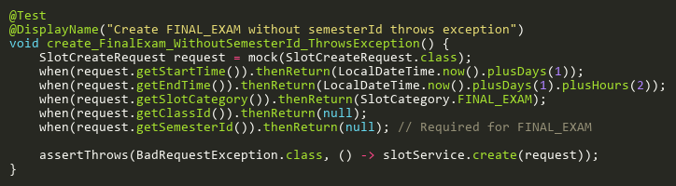

**Figure: create_FinalExam_WithoutSemesterId_ThrowsException**  
*Reference: Sheet "SLST_create", Test Case TC23*

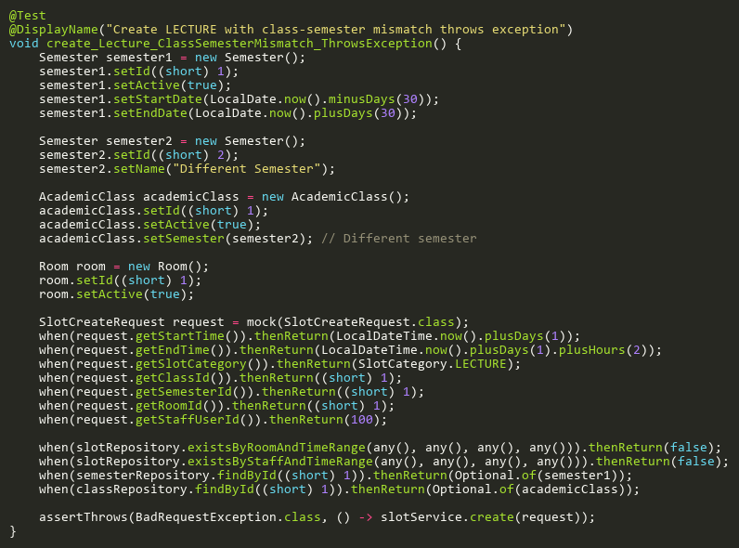

**Figure: create_Lecture_ClassSemesterMismatch_ThrowsException**  
*Reference: Sheet "SLST_create", Test Case TC24*

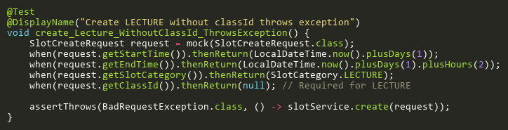

**Figure: create_Lecture_WithoutClassId_ThrowsException**  
*Reference: Sheet "SLST_create", Test Case TC25*

## CreateInitialAttendanceRecordsTests

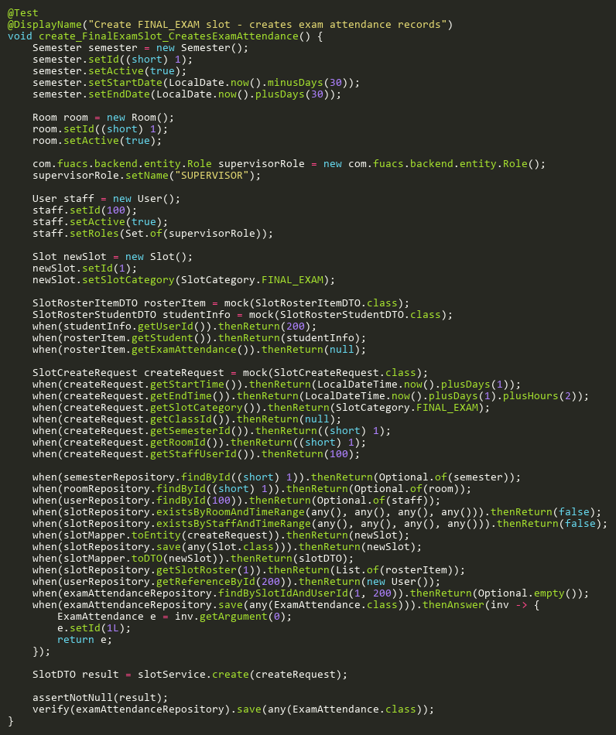

**Figure: create_FinalExamSlot_CreatesExamAttendance**  
*Reference: Sheet "SLST_create", Test Case TC19*

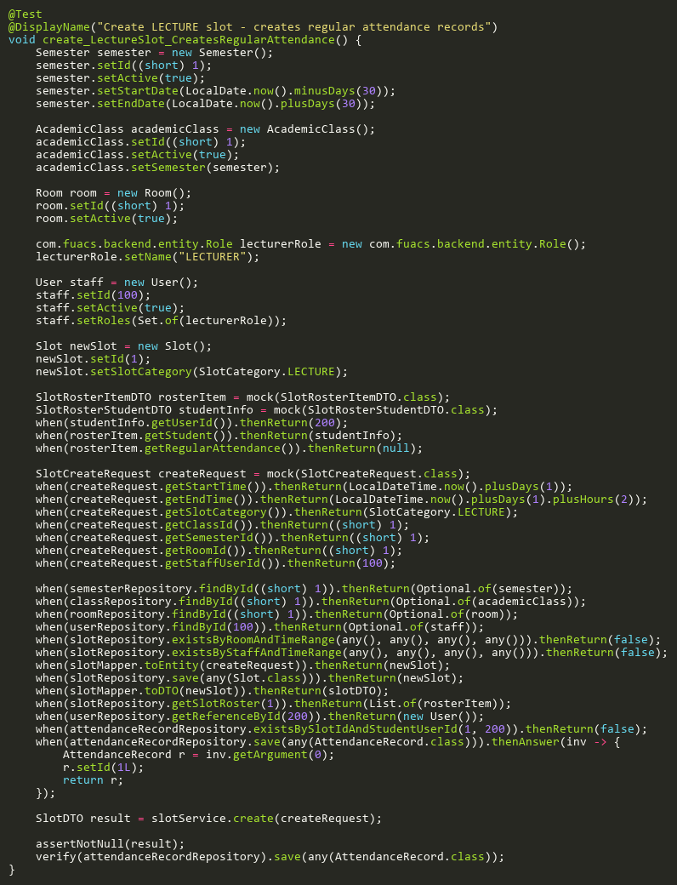

**Figure: create_LectureSlot_CreatesRegularAttendance**  
*Reference: Sheet "SLST_create", Test Case TC18*

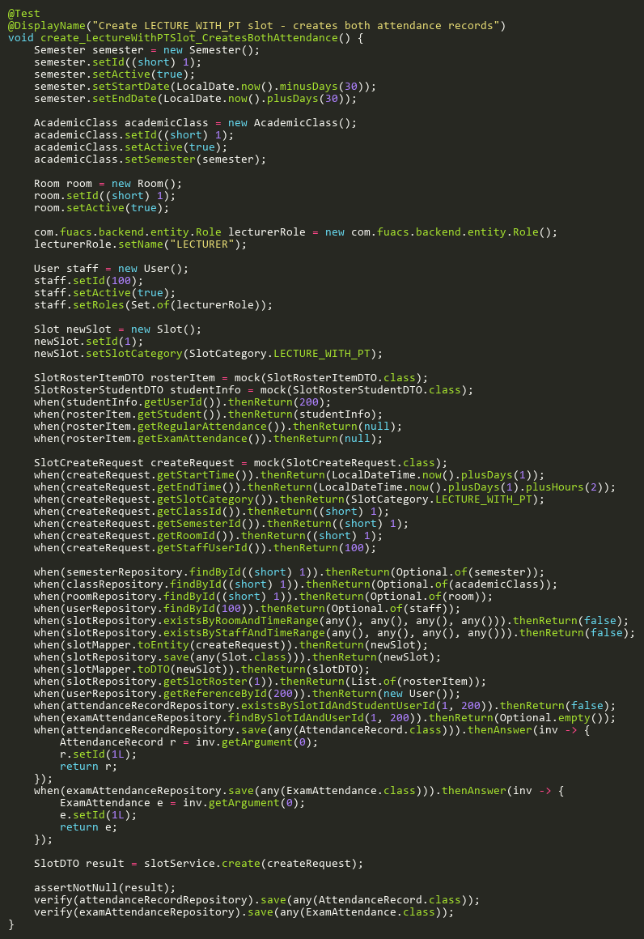

**Figure: create_LectureWithPTSlot_CreatesBothAttendance**  
*Reference: Sheet "SLST_create", Test Case TC20*

## CreateTests

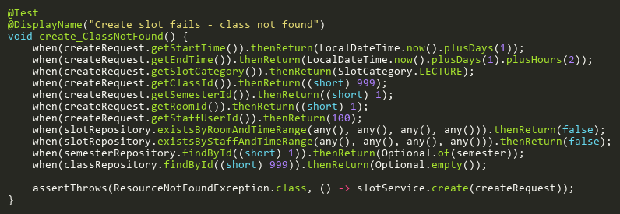

**Figure: create_ClassNotFound**  
*Reference: Sheet "SLST_create", Test Case TC11*

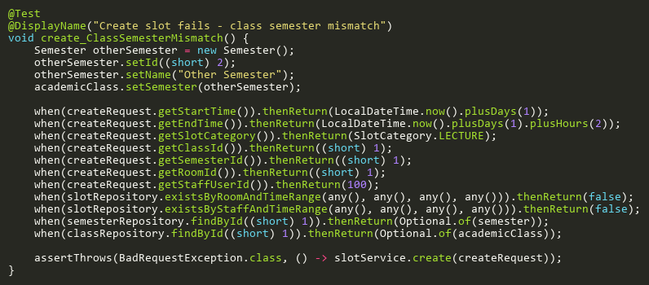

**Figure: create_ClassSemesterMismatch**  
*Reference: Sheet "SLST_create", Test Case TC13*

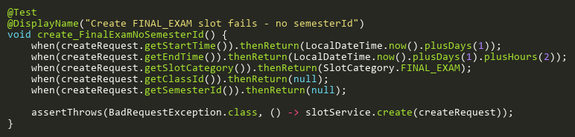

**Figure: create_FinalExamNoSemesterId**  
*Reference: Sheet "SLST_create", Test Case TC04*

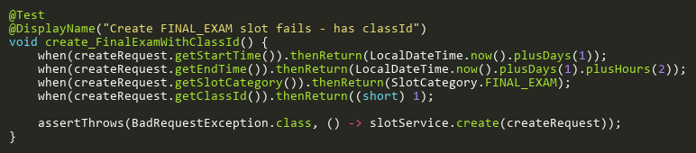

**Figure: create_FinalExamWithClassId**  
*Reference: Sheet "SLST_create", Test Case TC03*

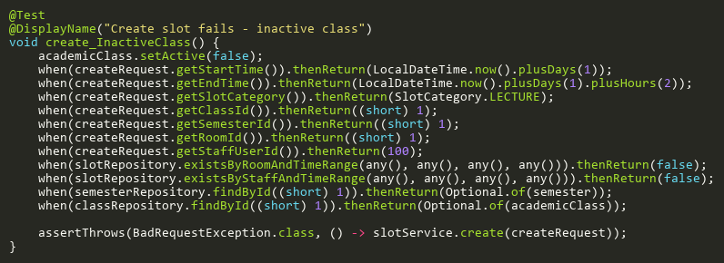

**Figure: create_InactiveClass**  
*Reference: Sheet "SLST_create", Test Case TC12*

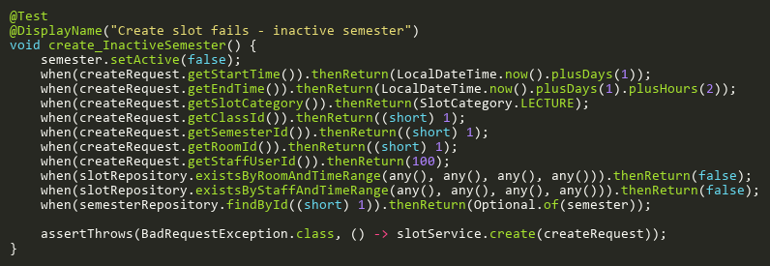

**Figure: create_InactiveSemester**  
*Reference: Sheet "SLST_create", Test Case TC09*

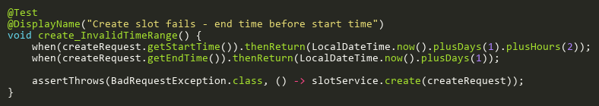

**Figure: create_InvalidTimeRange**  
*Reference: Sheet "SLST_create", Test Case TC02*

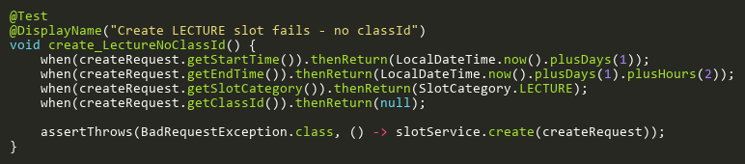

**Figure: create_LectureNoClassId**  
*Reference: Sheet "SLST_create", Test Case TC05*

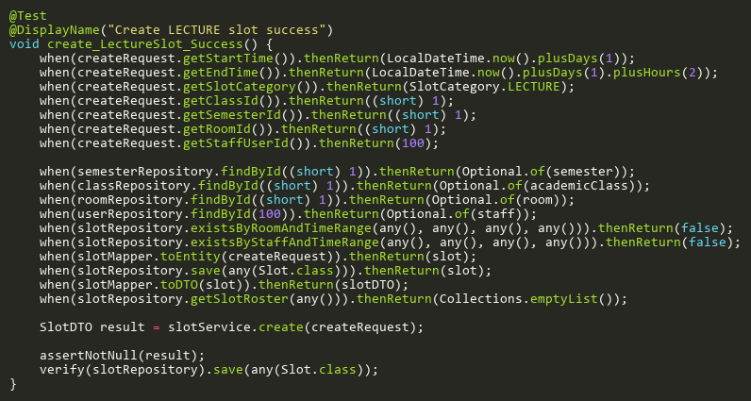

**Figure: create_LectureSlot_Success**  
*Reference: Sheet "SLST_create", Test Case TC01*

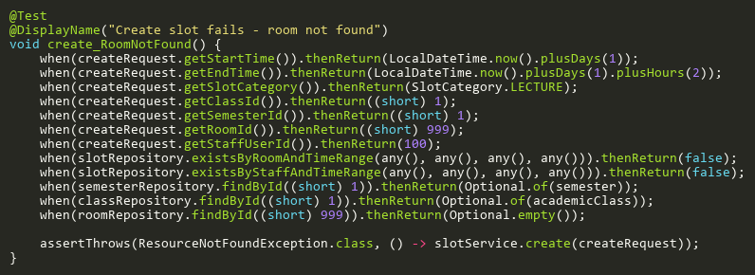

**Figure: create_RoomNotFound**  
*Reference: Sheet "SLST_create", Test Case TC14*

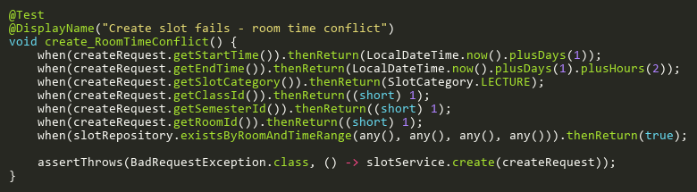

**Figure: create_RoomTimeConflict**  
*Reference: Sheet "SLST_create", Test Case TC06*

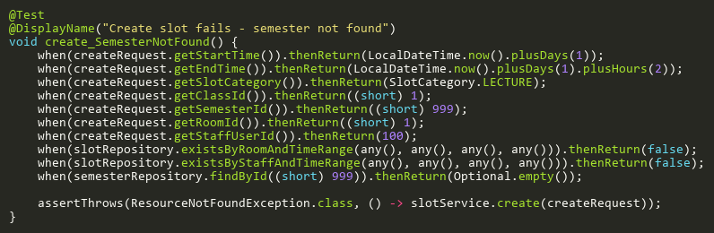

**Figure: create_SemesterNotFound**  
*Reference: Sheet "SLST_create", Test Case TC08*

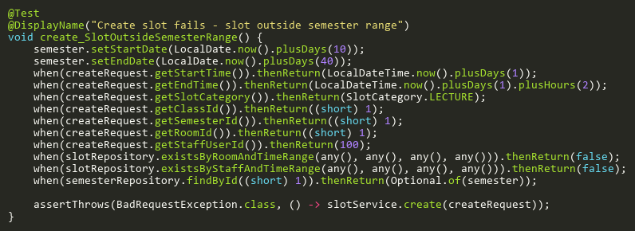

**Figure: create_SlotOutsideSemesterRange**  
*Reference: Sheet "SLST_create", Test Case TC10*

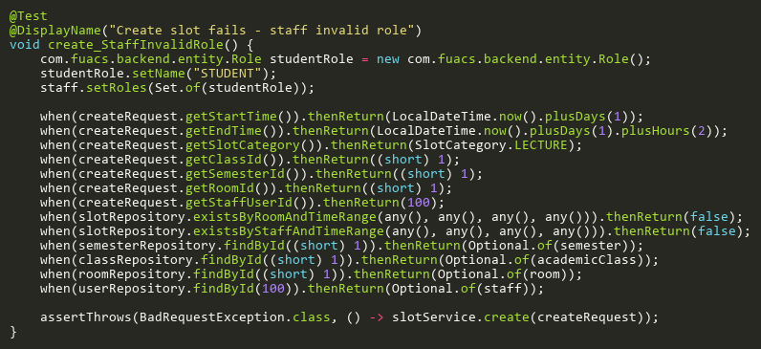

**Figure: create_StaffInvalidRole**  
*Reference: Sheet "SLST_create", Test Case TC16*

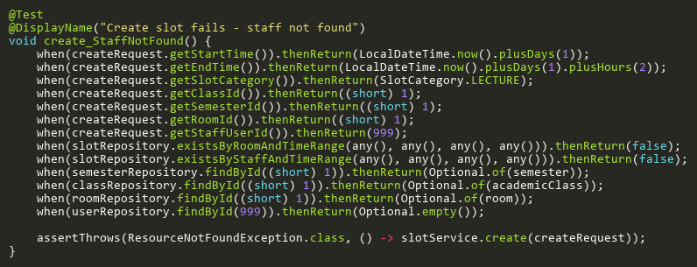

**Figure: create_StaffNotFound**  
*Reference: Sheet "SLST_create", Test Case TC15*

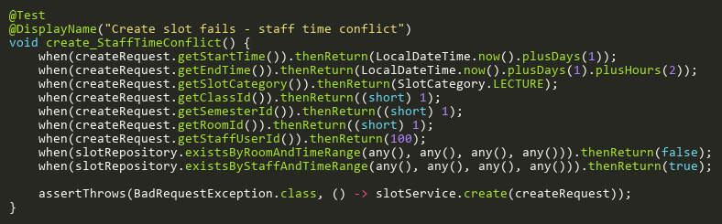

**Figure: create_StaffTimeConflict**  
*Reference: Sheet "SLST_create", Test Case TC07*

## DeleteAdditionalTests

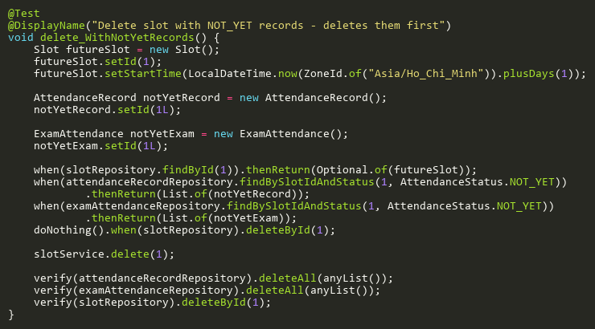

**Figure: delete_WithNotYetRecords**  
*Reference: Sheet "SLST_delete", Test Case TC05*

## DeleteTests

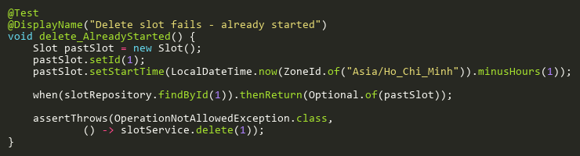

**Figure: delete_AlreadyStarted**  
*Reference: Sheet "SLST_delete", Test Case TC03*

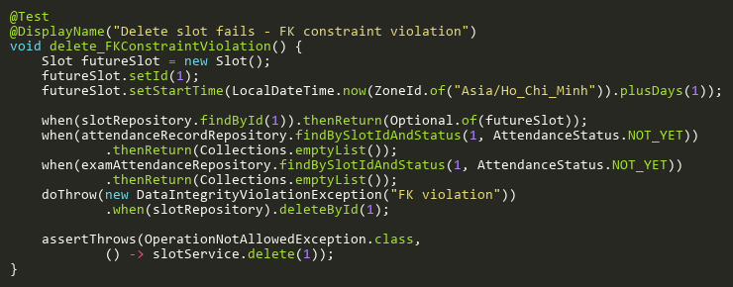

**Figure: delete_FKConstraintViolation**  
*Reference: Sheet "SLST_delete", Test Case TC04*

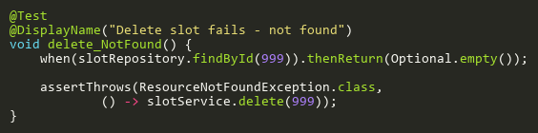

**Figure: delete_NotFound**  
*Reference: Sheet "SLST_delete", Test Case TC02*

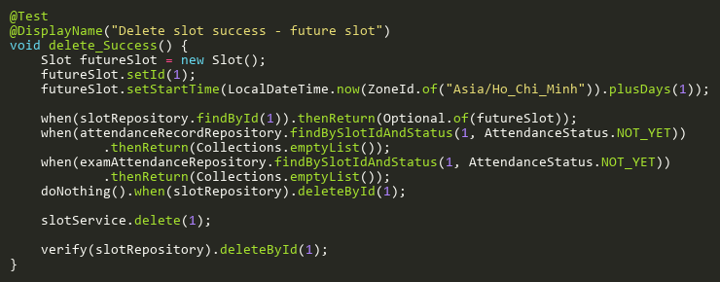

**Figure: delete_Success**  
*Reference: Sheet "SLST_delete", Test Case TC01*

## EnsureAttendanceRecordsExistTests

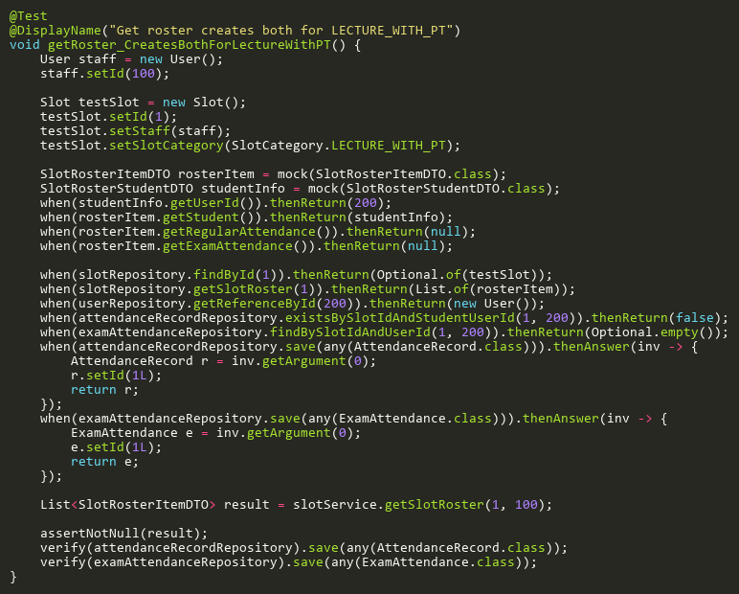

**Figure: getRoster_CreatesBothForLectureWithPT**  
*Reference: Sheet "SLST_ensureRecords", Test Case TC03*

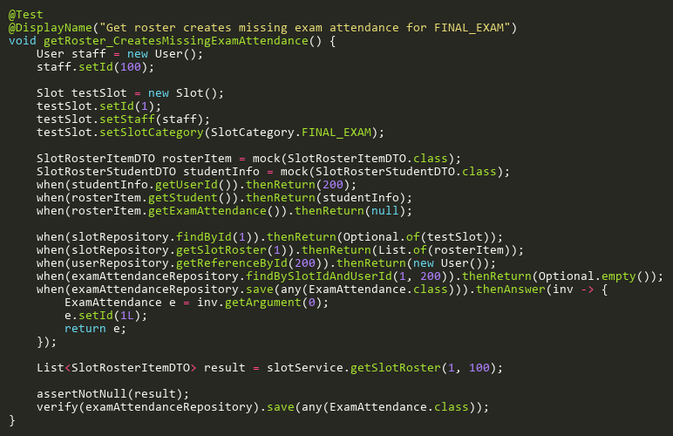

**Figure: getRoster_CreatesMissingExamAttendance**  
*Reference: Sheet "SLST_ensureRecords", Test Case TC02*

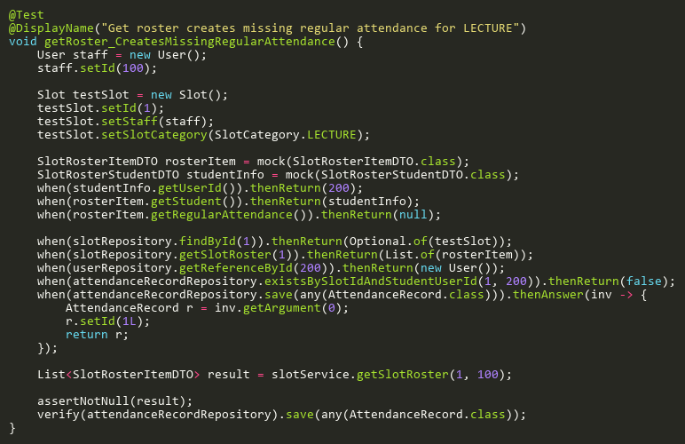

**Figure: getRoster_CreatesMissingRegularAttendance**  
*Reference: Sheet "SLST_ensureRecords", Test Case TC01*

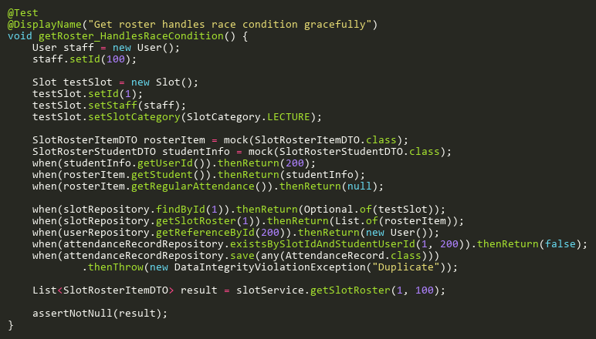

**Figure: getRoster_HandlesRaceCondition**  
*Reference: Sheet "SLST_ensureRecords", Test Case TC05*

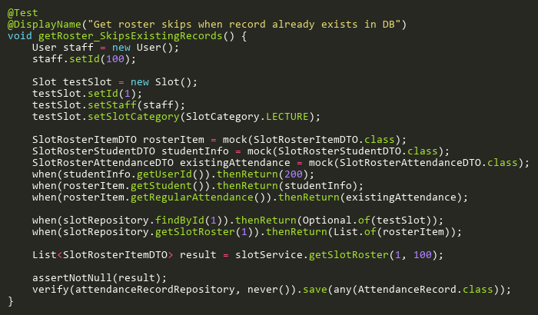

**Figure: getRoster_SkipsExistingRecords**  
*Reference: Sheet "SLST_ensureRecords", Test Case TC04*

## HasAttendanceRecordsTests

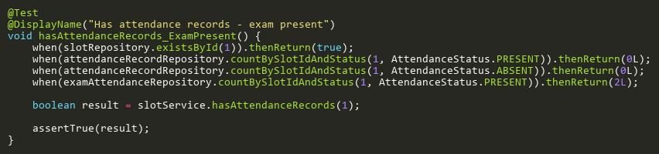

**Figure: hasAttendanceRecords_ExamPresent**  
*Reference: Sheet "SLST_hasRecords", Test Case TC03*

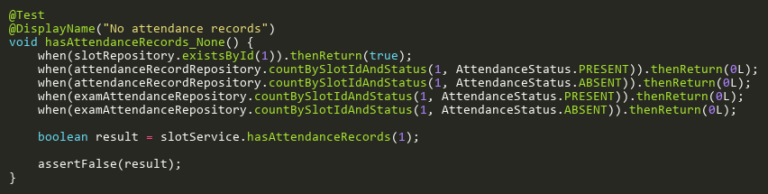

**Figure: hasAttendanceRecords_None**  
*Reference: Sheet "SLST_hasRecords", Test Case TC04*

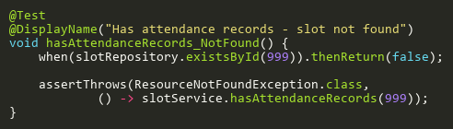

**Figure: hasAttendanceRecords_NotFound**  
*Reference: Sheet "SLST_hasRecords", Test Case TC05*

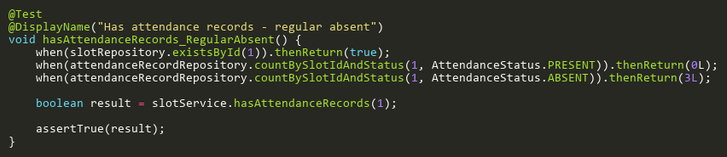

**Figure: hasAttendanceRecords_RegularAbsent**  
*Reference: Sheet "SLST_hasRecords", Test Case TC02*

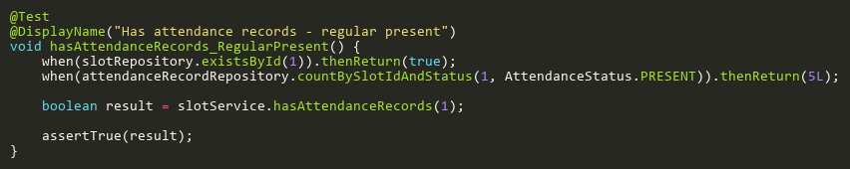

**Figure: hasAttendanceRecords_RegularPresent**  
*Reference: Sheet "SLST_hasRecords", Test Case TC01*

## IsValidCategoryTransitionTests

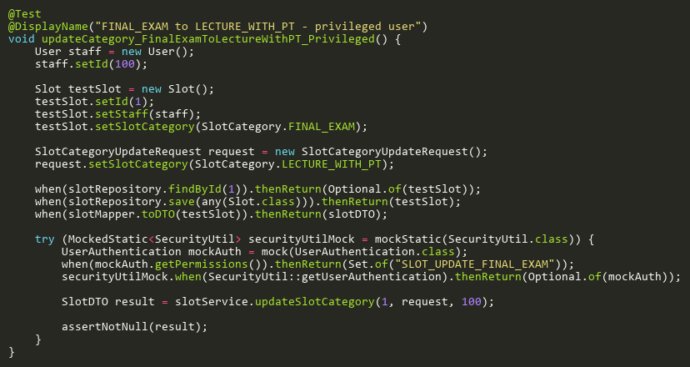

**Figure: updateCategory_FinalExamToLectureWithPT_Privileged**  
*Reference: Sheet "SLST_updateCategory", Test Case TC09*

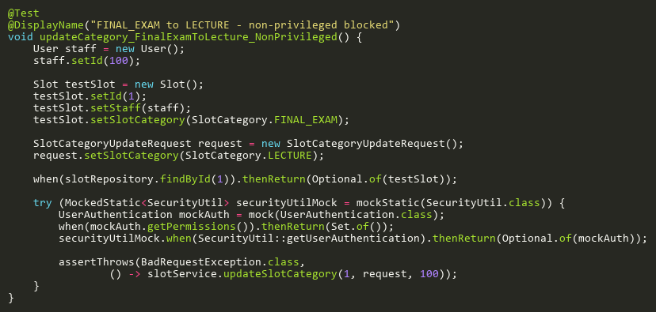

**Figure: updateCategory_FinalExamToLecture_NonPrivileged**  
*Reference: Sheet "SLST_updateCategory", Test Case TC12*

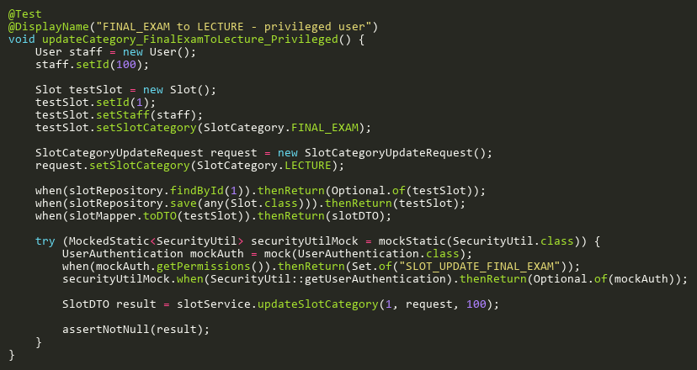

**Figure: updateCategory_FinalExamToLecture_Privileged**  
*Reference: Sheet "SLST_updateCategory", Test Case TC10*

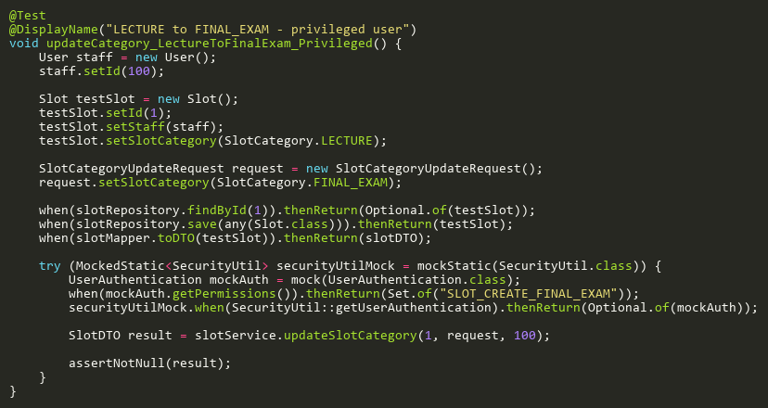

**Figure: updateCategory_LectureToFinalExam_Privileged**  
*Reference: Sheet "SLST_updateCategory", Test Case TC11*

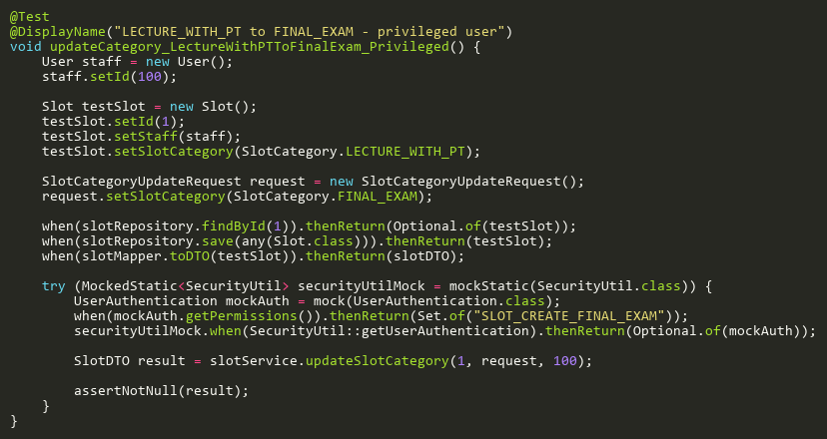

**Figure: updateCategory_LectureWithPTToFinalExam_Privileged**  
*Reference: Sheet "SLST_updateCategory", Test Case TC07*

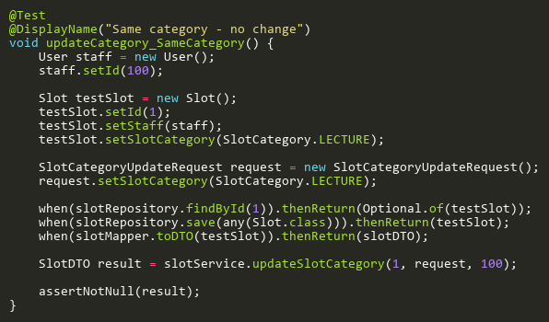

**Figure: updateCategory_SameCategory**  
*Reference: Sheet "SLST_updateCategory", Test Case TC08*

## ProcessNotYetResolutionTests

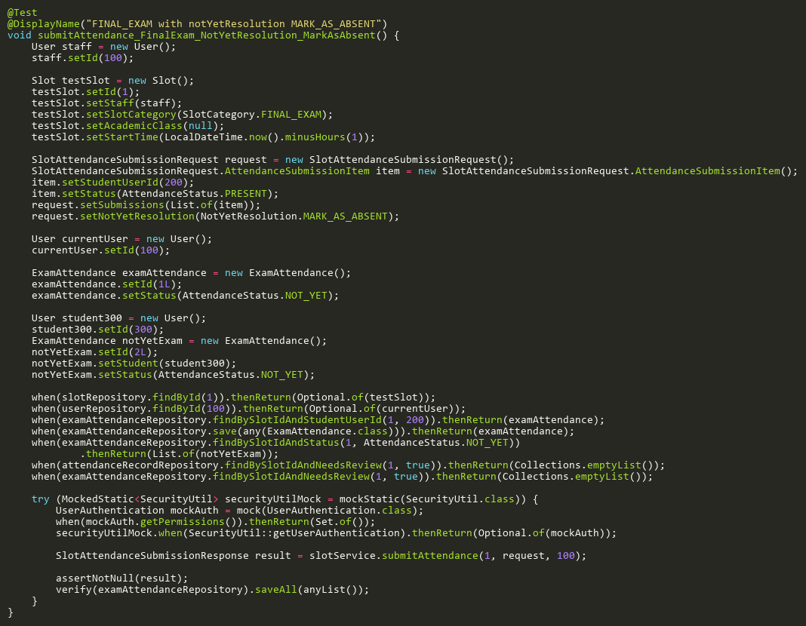

**Figure: submitAttendance_FinalExam_NotYetResolution_MarkAsAbsent**  
*Reference: Sheet "SLST_submitAtt", Test Case TC18*

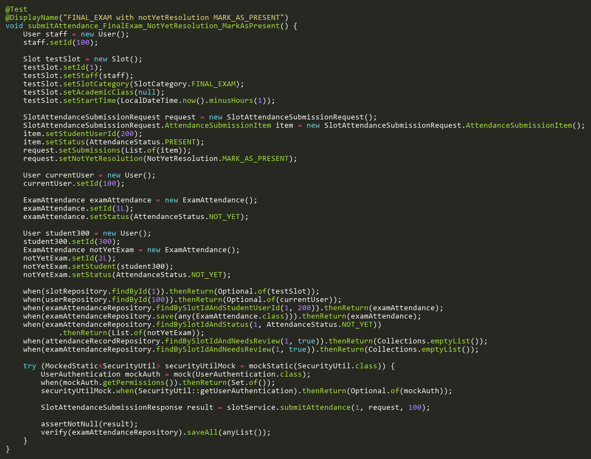

**Figure: submitAttendance_FinalExam_NotYetResolution_MarkAsPresent**  
*Reference: Sheet "SLST_submitAtt", Test Case TC21*

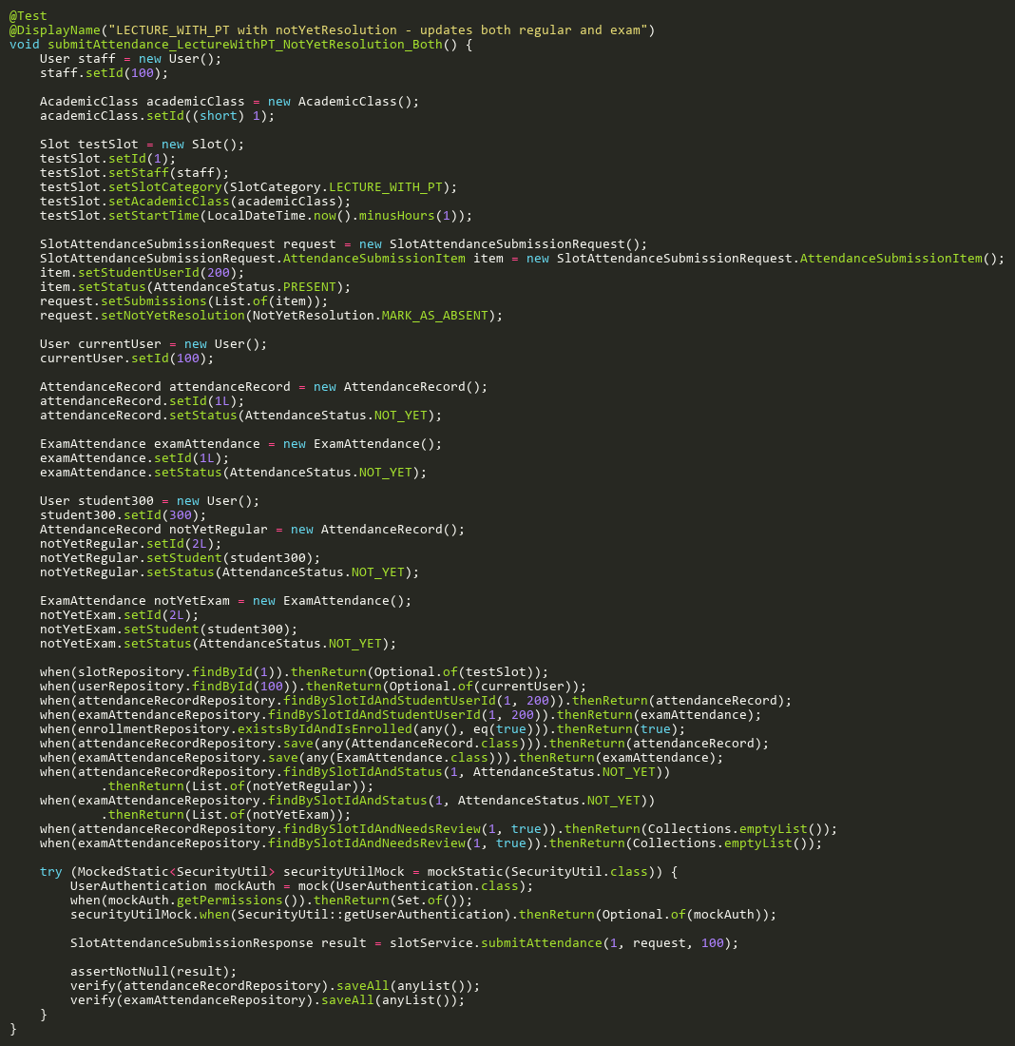

**Figure: submitAttendance_LectureWithPT_NotYetResolution_Both**  
*Reference: Sheet "SLST_submitAtt", Test Case TC22*

## ProcessSingleSubmissionBranchTests

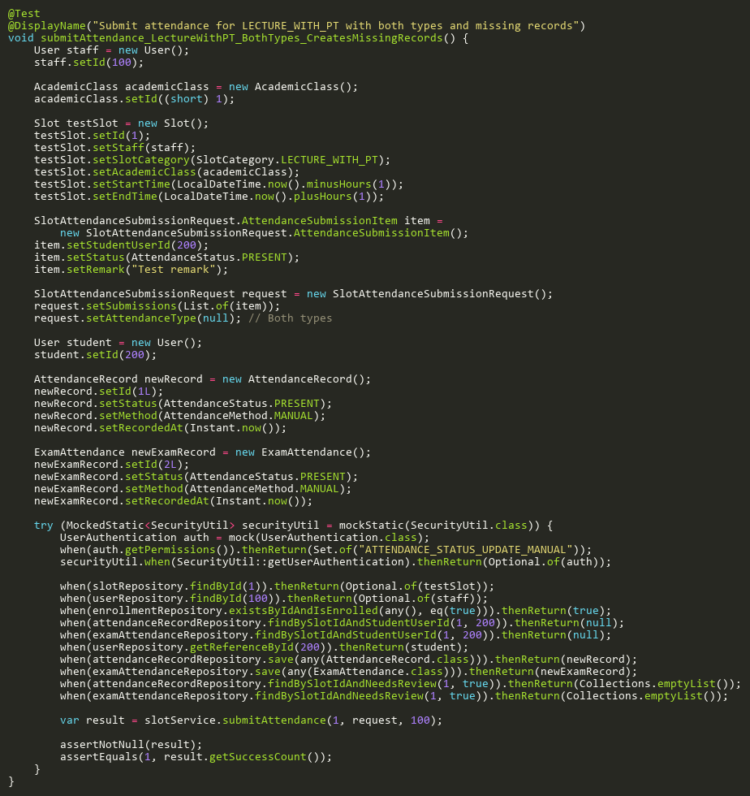

**Figure: submitAttendance_LectureWithPT_BothTypes_CreatesMissingRecords**  
*Reference: Sheet "SLST_submitAtt", Test Case TC17*

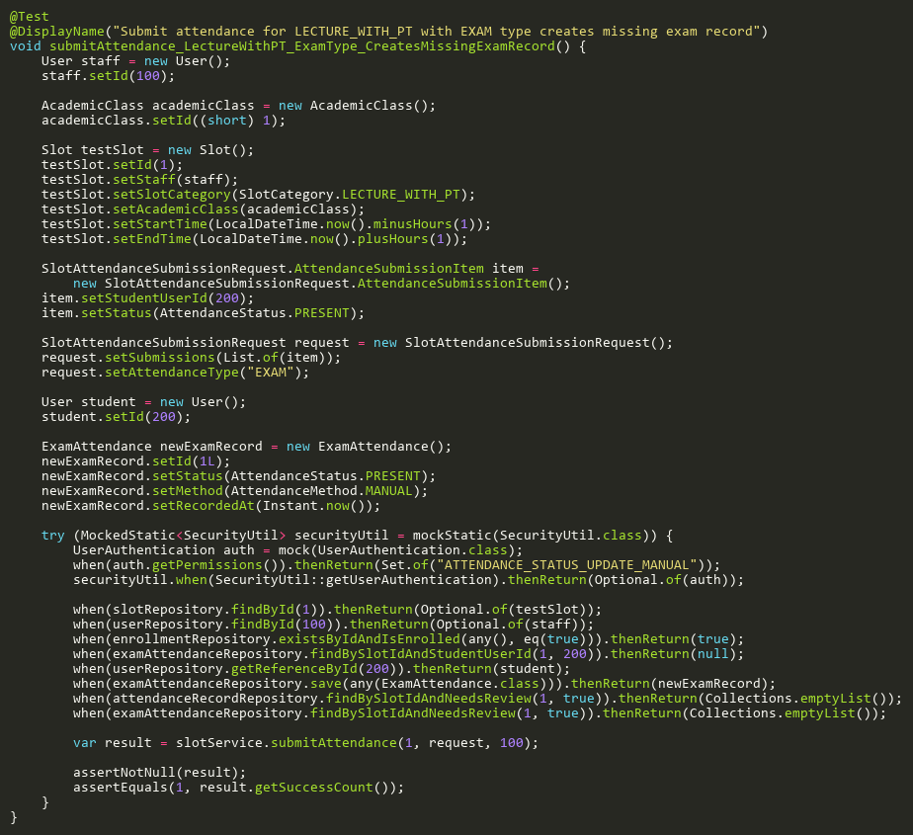

**Figure: submitAttendance_LectureWithPT_ExamType_CreatesMissingExamRecord**  
*Reference: Sheet "SLST_submitAtt", Test Case TC29*

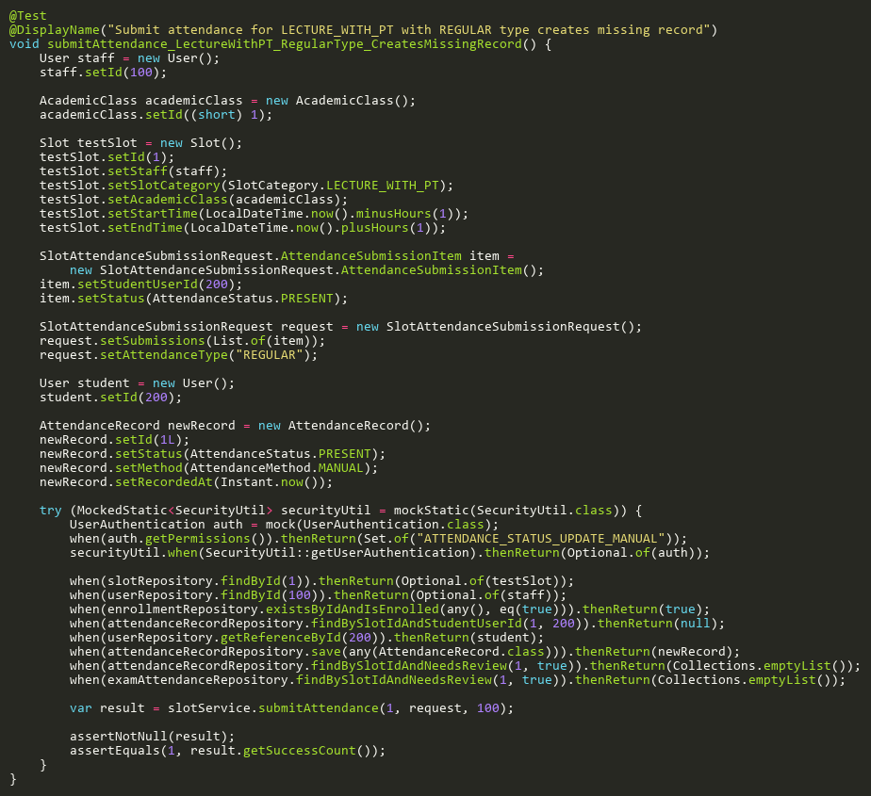

**Figure: submitAttendance_LectureWithPT_RegularType_CreatesMissingRecord**  
*Reference: Sheet "SLST_submitAtt", Test Case TC28*

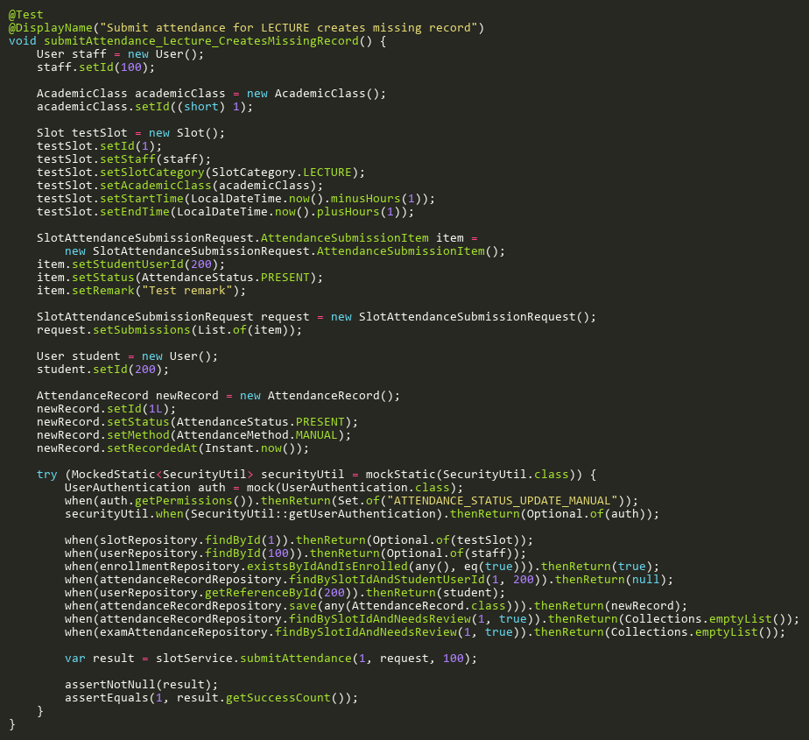

**Figure: submitAttendance_Lecture_CreatesMissingRecord**  
*Reference: Sheet "SLST_submitAtt", Test Case TC26*

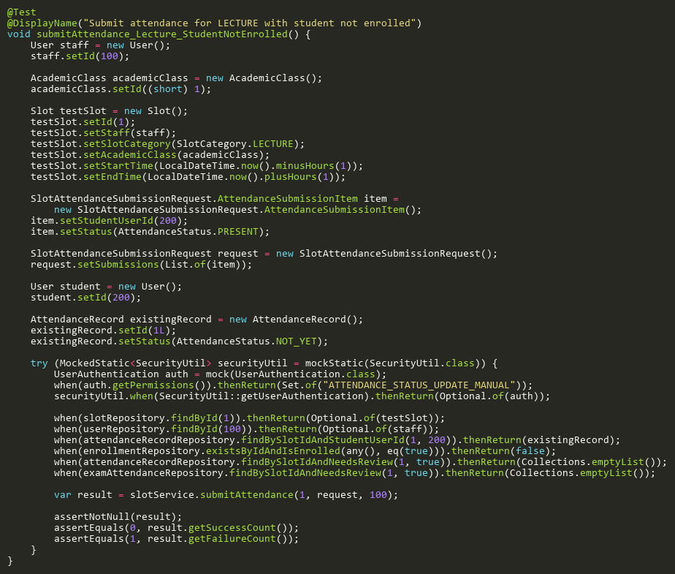

**Figure: submitAttendance_Lecture_StudentNotEnrolled**  
*Reference: Sheet "SLST_submitAtt", Test Case TC27*

## RescanExamTests

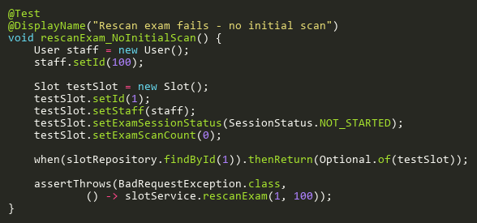

**Figure: rescanExam_NoInitialScan**  
*Reference: Sheet "SLST_rescanExam", Test Case TC03*

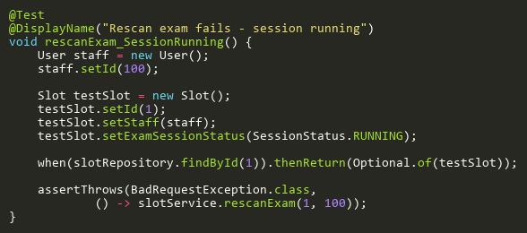

**Figure: rescanExam_SessionRunning**  
*Reference: Sheet "SLST_rescanExam", Test Case TC02*

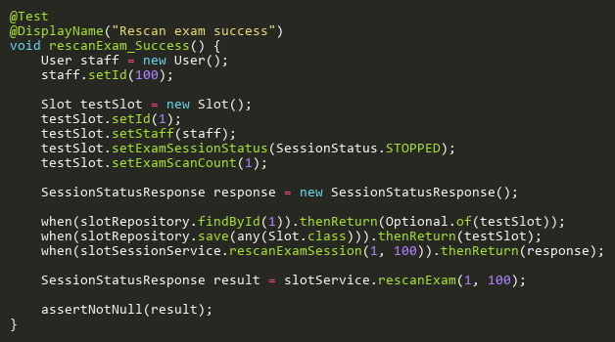

**Figure: rescanExam_Success**  
*Reference: Sheet "SLST_rescanExam", Test Case TC01*

## SearchByStudentIdTests

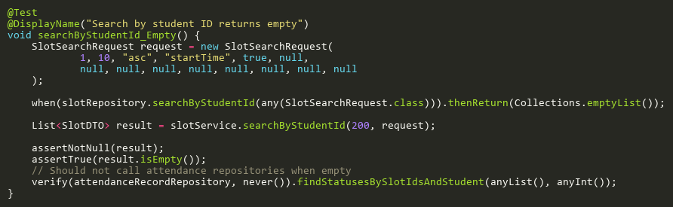

**Figure: searchByStudentId_Empty**  
*Reference: Sheet "SLST_searchStudent", Test Case TC03*

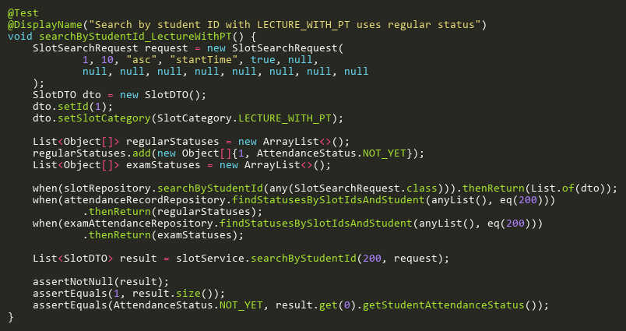

**Figure: searchByStudentId_LectureWithPT**  
*Reference: Sheet "SLST_searchStudent", Test Case TC05*

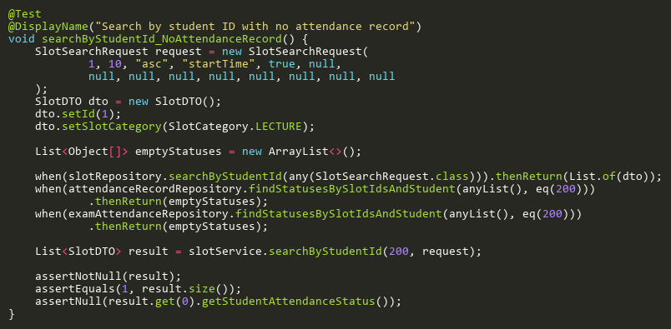

**Figure: searchByStudentId_NoAttendanceRecord**  
*Reference: Sheet "SLST_searchStudent", Test Case TC04*

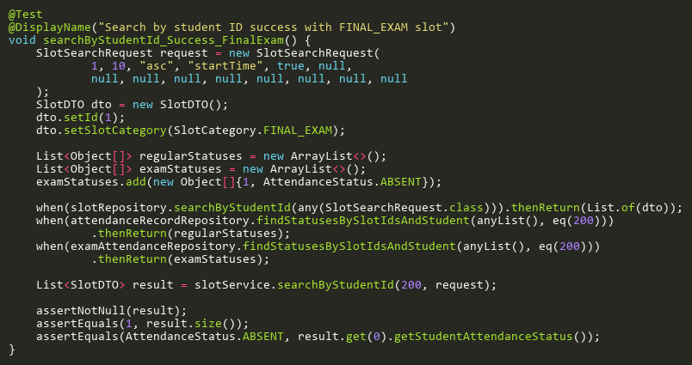

**Figure: searchByStudentId_Success_FinalExam**  
*Reference: Sheet "SLST_searchStudent", Test Case TC02*

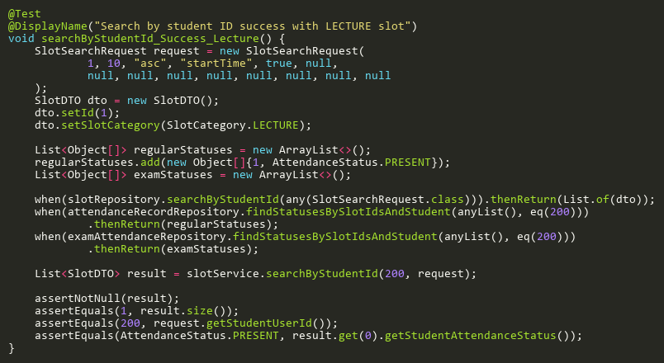

**Figure: searchByStudentId_Success_Lecture**  
*Reference: Sheet "SLST_searchStudent", Test Case TC01*

## StartAttendanceSessionTests

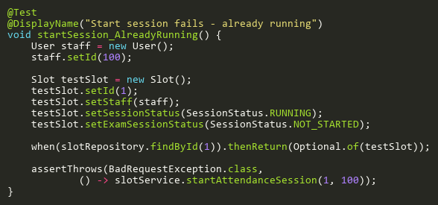

**Figure: startSession_AlreadyRunning**  
*Reference: Sheet "SLST_startSession", Test Case TC05*

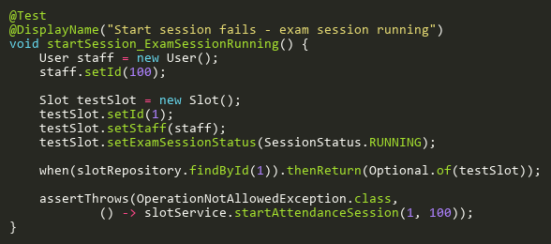

**Figure: startSession_ExamSessionRunning**  
*Reference: Sheet "SLST_startSession", Test Case TC04*

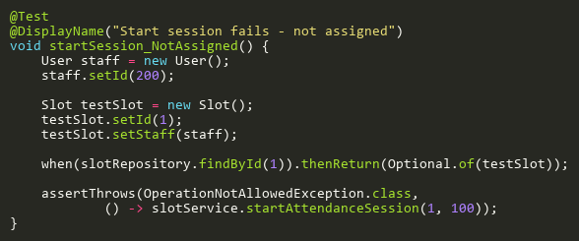

**Figure: startSession_NotAssigned**  
*Reference: Sheet "SLST_startSession", Test Case TC03*

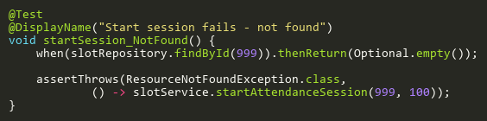

**Figure: startSession_NotFound**  
*Reference: Sheet "SLST_startSession", Test Case TC02*

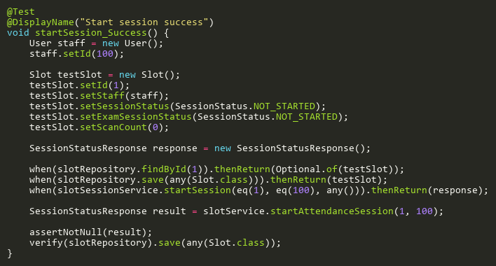

**Figure: startSession_Success**  
*Reference: Sheet "SLST_startSession", Test Case TC01*

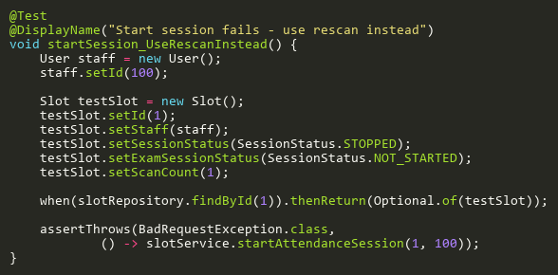

**Figure: startSession_UseRescanInstead**  
*Reference: Sheet "SLST_startSession", Test Case TC06*

## StartExamSessionTests

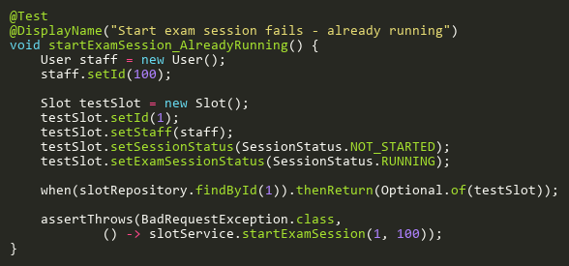

**Figure: startExamSession_AlreadyRunning**  
*Reference: Sheet "SLST_startExam", Test Case TC03*

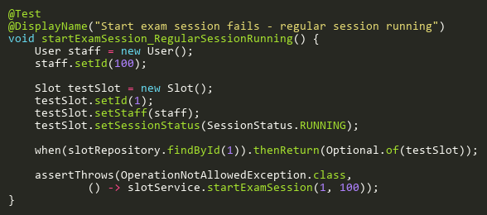

**Figure: startExamSession_RegularSessionRunning**  
*Reference: Sheet "SLST_startExam", Test Case TC02*

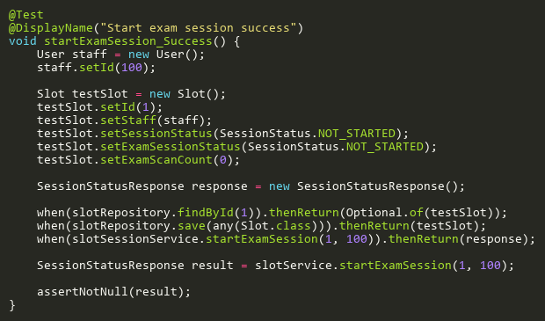

**Figure: startExamSession_Success**  
*Reference: Sheet "SLST_startExam", Test Case TC01*

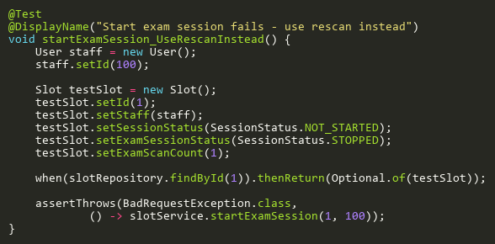

**Figure: startExamSession_UseRescanInstead**  
*Reference: Sheet "SLST_startExam", Test Case TC04*

## StopAttendanceSessionTests

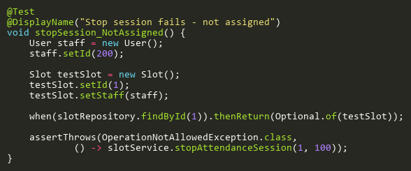

**Figure: stopSession_NotAssigned**  
*Reference: Sheet "SLST_stopSession", Test Case TC02*

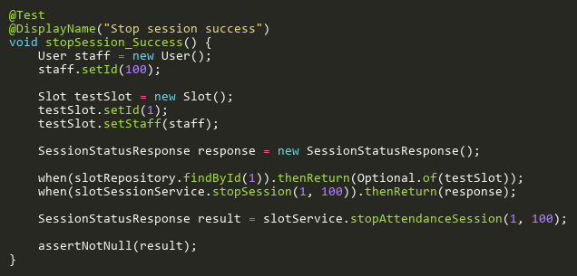

**Figure: stopSession_Success**  
*Reference: Sheet "SLST_stopSession", Test Case TC01*

## StopExamSessionTests

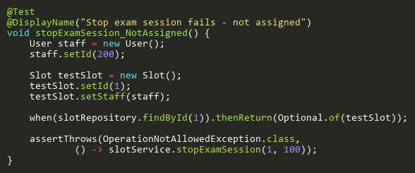

**Figure: stopExamSession_NotAssigned**  
*Reference: Sheet "SLST_stopExam", Test Case TC02*

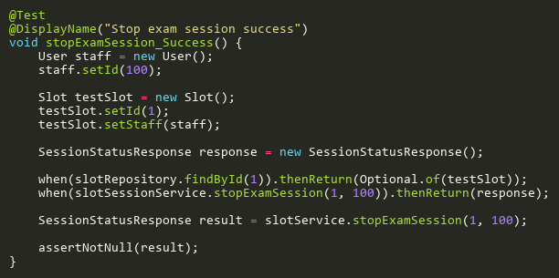

**Figure: stopExamSession_Success**  
*Reference: Sheet "SLST_stopExam", Test Case TC01*

## SubmitAttendanceAdditionalTests

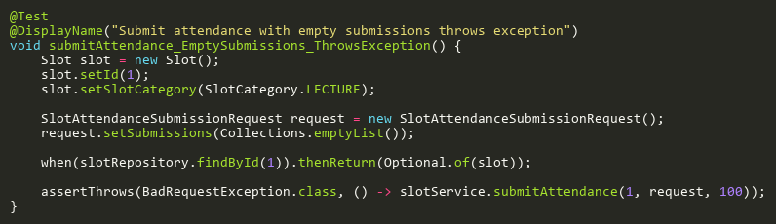

**Figure: submitAttendance_EmptySubmissions_ThrowsException**  
*Reference: Sheet "SLST_submitAtt", Test Case TC24*

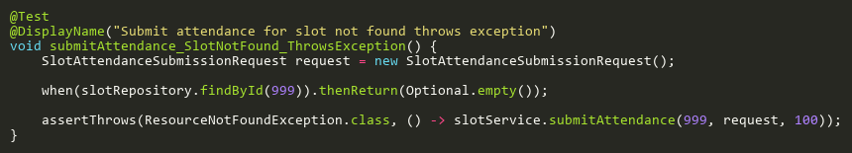

**Figure: submitAttendance_SlotNotFound_ThrowsException**  
*Reference: Sheet "SLST_submitAtt", Test Case TC25*

## SubmitAttendanceTests

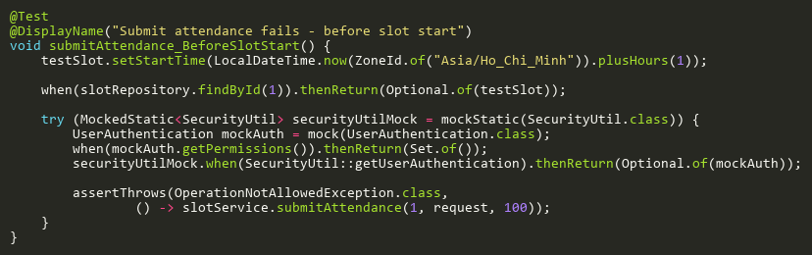

**Figure: submitAttendance_BeforeSlotStart**  
*Reference: Sheet "SLST_submitAtt", Test Case TC05*

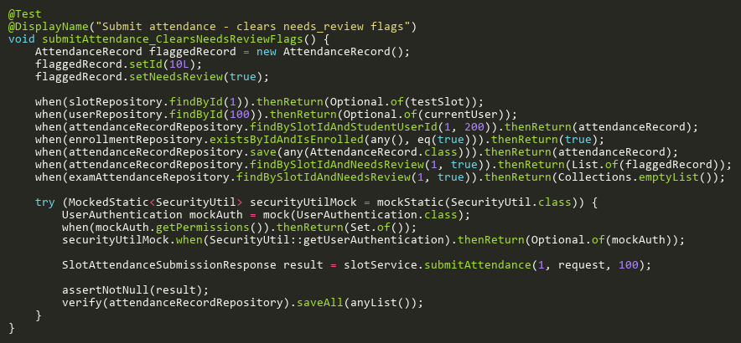

**Figure: submitAttendance_ClearsNeedsReviewFlags**  
*Reference: Sheet "SLST_submitAtt", Test Case TC07*

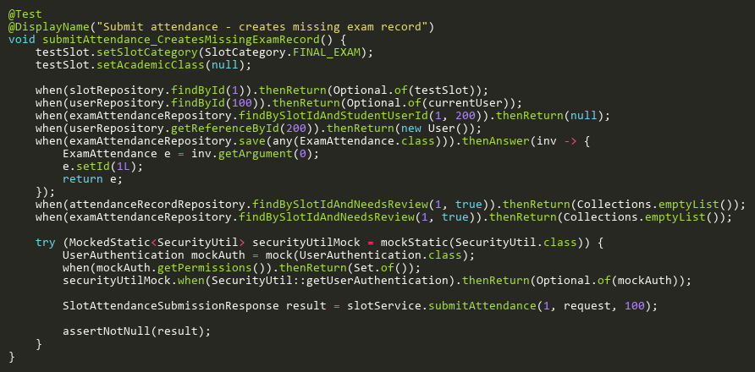

**Figure: submitAttendance_CreatesMissingExamRecord**  
*Reference: Sheet "SLST_submitAtt", Test Case TC16*

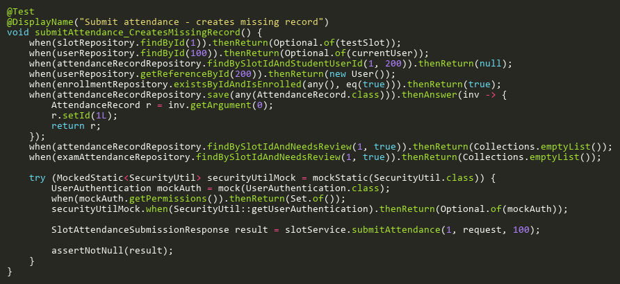

**Figure: submitAttendance_CreatesMissingRecord**  
*Reference: Sheet "SLST_submitAtt", Test Case TC10*

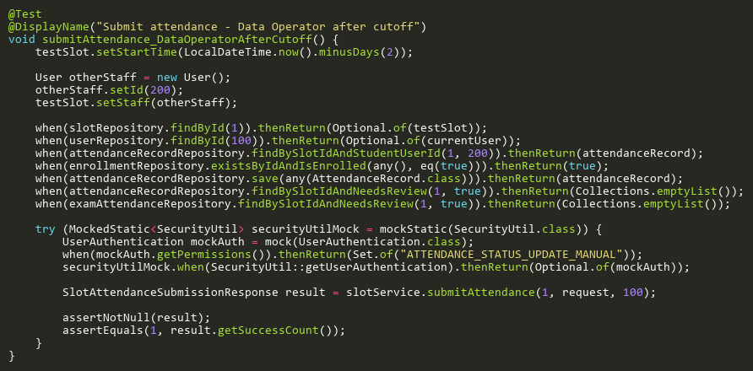

**Figure: submitAttendance_DataOperatorAfterCutoff**  
*Reference: Sheet "SLST_submitAtt", Test Case TC19*

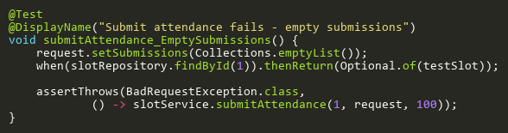

**Figure: submitAttendance_EmptySubmissions**  
*Reference: Sheet "SLST_submitAtt", Test Case TC03*

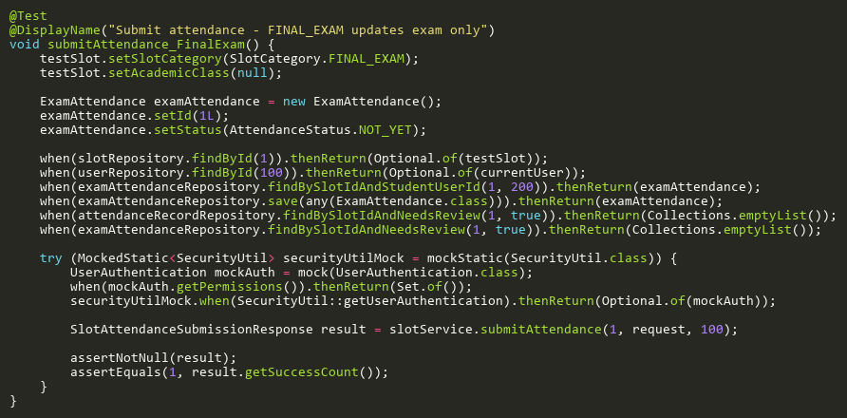

**Figure: submitAttendance_FinalExam**  
*Reference: Sheet "SLST_submitAtt", Test Case TC09*

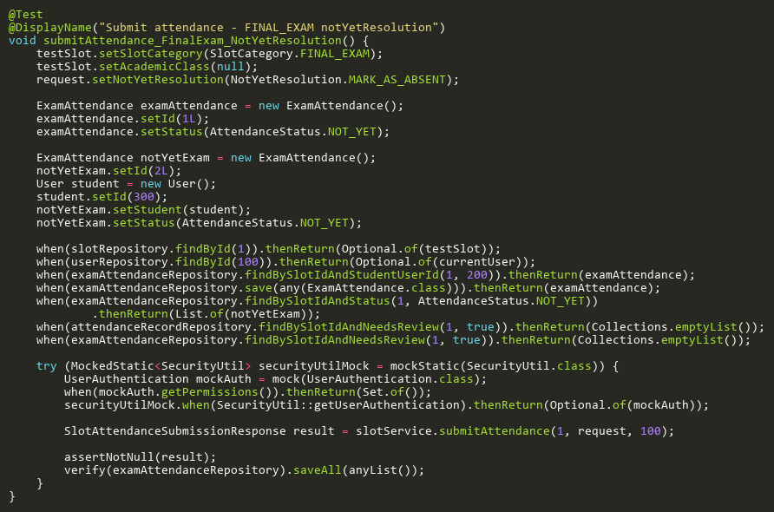

**Figure: submitAttendance_FinalExam_NotYetResolution**  
*Reference: Sheet "SLST_submitAtt", Test Case TC20*

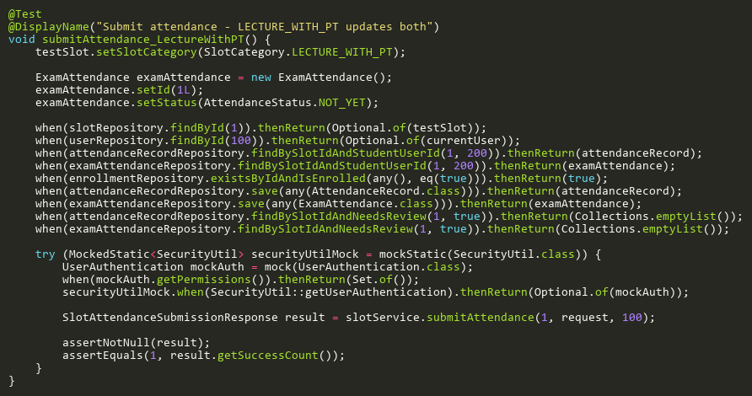

**Figure: submitAttendance_LectureWithPT**  
*Reference: Sheet "SLST_submitAtt", Test Case TC08*

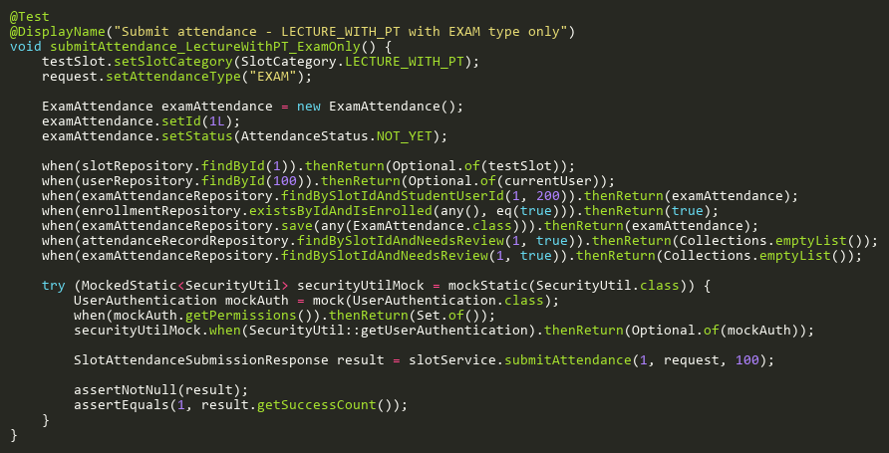

**Figure: submitAttendance_LectureWithPT_ExamOnly**  
*Reference: Sheet "SLST_submitAtt", Test Case TC13*

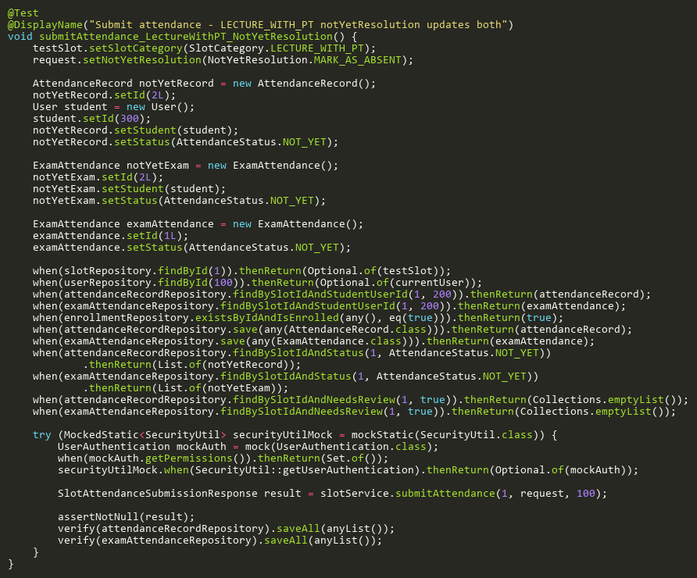

**Figure: submitAttendance_LectureWithPT_NotYetResolution**  
*Reference: Sheet "SLST_submitAtt", Test Case TC15*

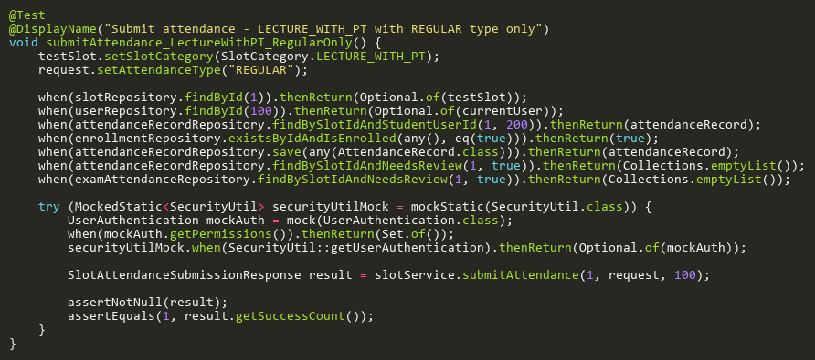

**Figure: submitAttendance_LectureWithPT_RegularOnly**  
*Reference: Sheet "SLST_submitAtt", Test Case TC12*

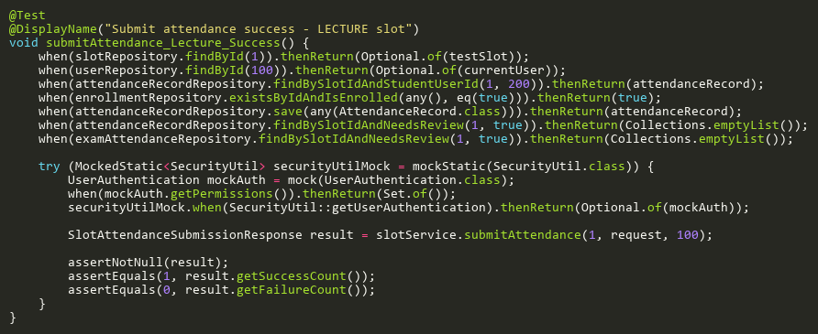

**Figure: submitAttendance_Lecture_Success**  
*Reference: Sheet "SLST_submitAtt", Test Case TC01*

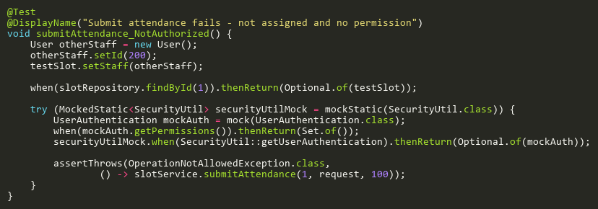

**Figure: submitAttendance_NotAuthorized**  
*Reference: Sheet "SLST_submitAtt", Test Case TC04*

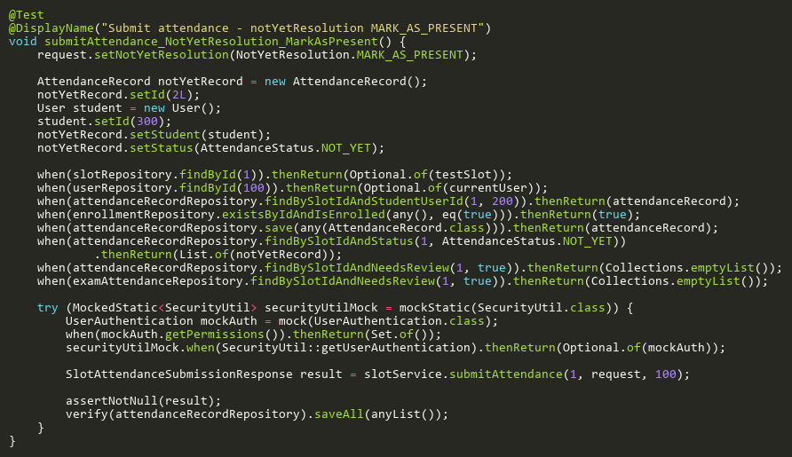

**Figure: submitAttendance_NotYetResolution_MarkAsPresent**  
*Reference: Sheet "SLST_submitAtt", Test Case TC14*

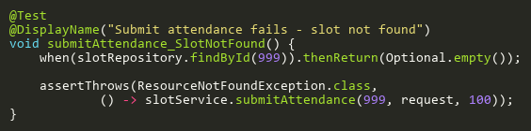

**Figure: submitAttendance_SlotNotFound**  
*Reference: Sheet "SLST_submitAtt", Test Case TC02*

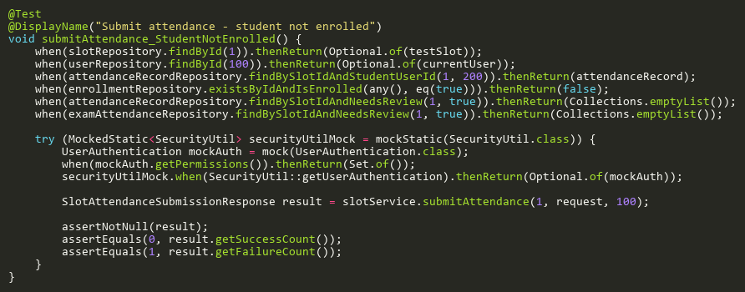

**Figure: submitAttendance_StudentNotEnrolled**  
*Reference: Sheet "SLST_submitAtt", Test Case TC11*

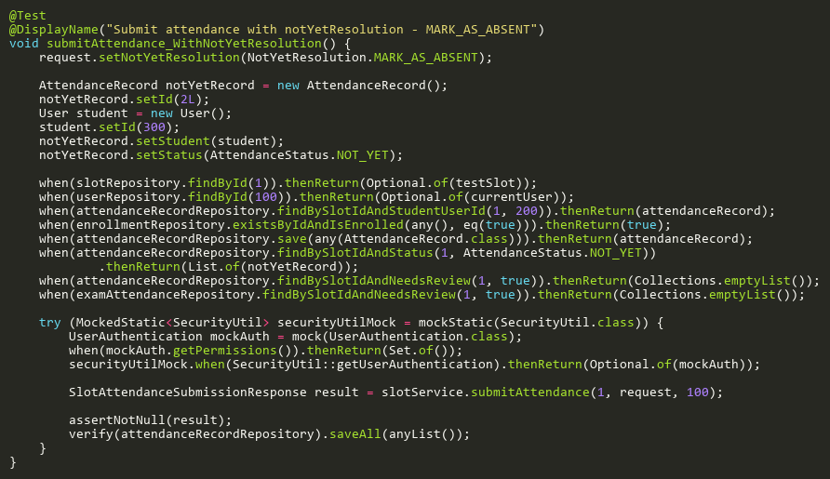

**Figure: submitAttendance_WithNotYetResolution**  
*Reference: Sheet "SLST_submitAtt", Test Case TC06*

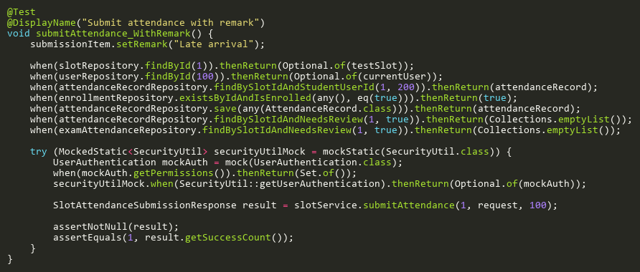

**Figure: submitAttendance_WithRemark**  
*Reference: Sheet "SLST_submitAtt", Test Case TC23*

## TriggerRescanTests

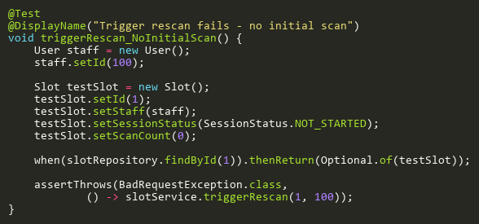

**Figure: triggerRescan_NoInitialScan**  
*Reference: Sheet "SLST_triggerRescan", Test Case TC04*

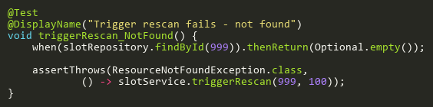

**Figure: triggerRescan_NotFound**  
*Reference: Sheet "SLST_triggerRescan", Test Case TC02*

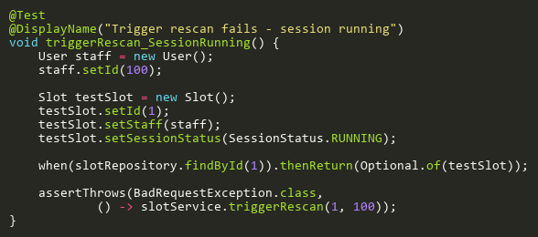

**Figure: triggerRescan_SessionRunning**  
*Reference: Sheet "SLST_triggerRescan", Test Case TC03*

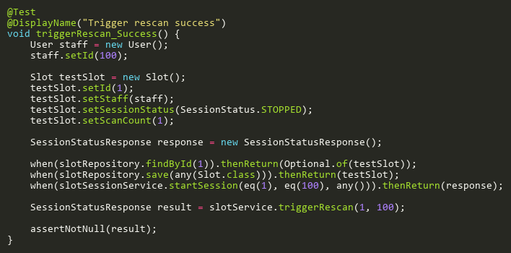

**Figure: triggerRescan_Success**  
*Reference: Sheet "SLST_triggerRescan", Test Case TC01*

## UpdateAdditionalTests

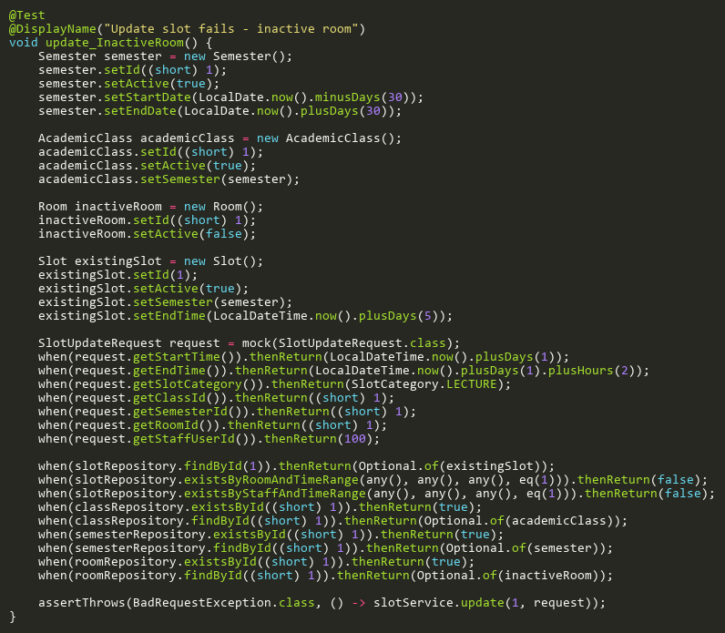

**Figure: update_InactiveRoom**  
*Reference: Sheet "SLST_update", Test Case TC18*

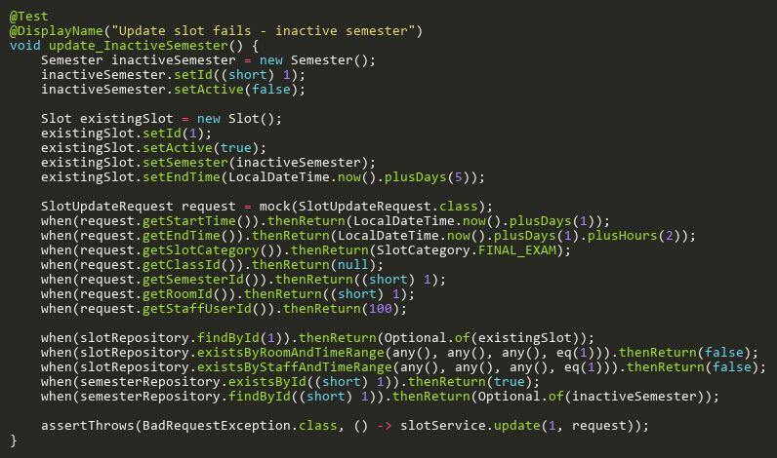

**Figure: update_InactiveSemester**  
*Reference: Sheet "SLST_update", Test Case TC14*

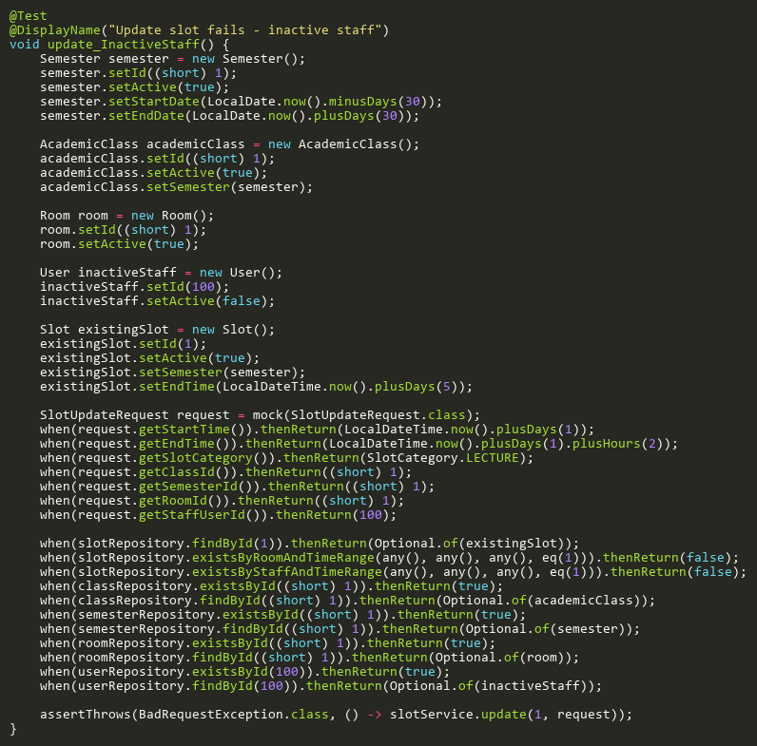

**Figure: update_InactiveStaff**  
*Reference: Sheet "SLST_update", Test Case TC19*

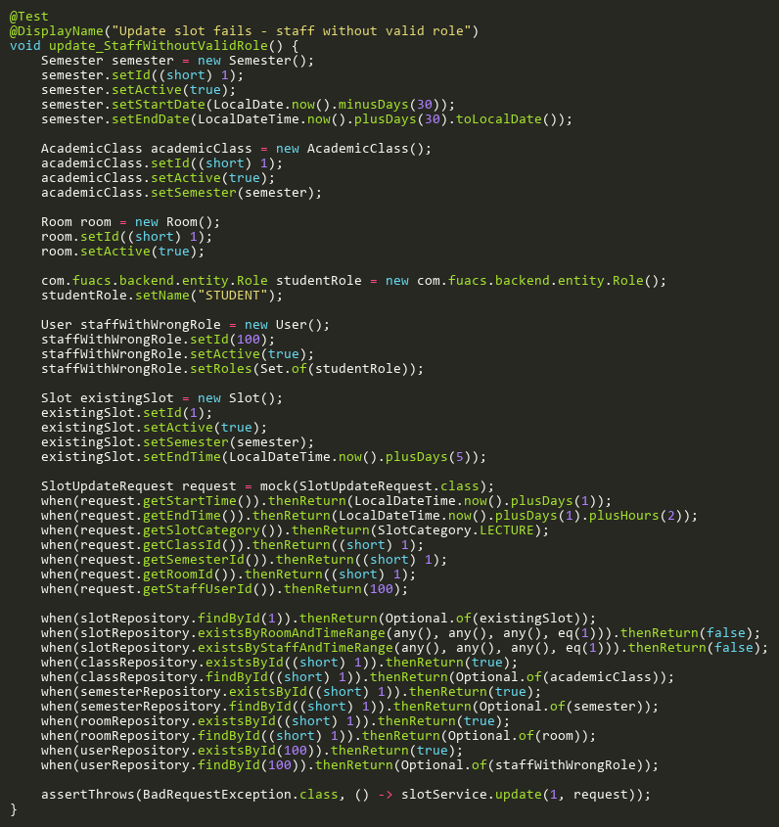

**Figure: update_StaffWithoutValidRole**  
*Reference: Sheet "SLST_update", Test Case TC20*

## UpdateBranchCoverageTests

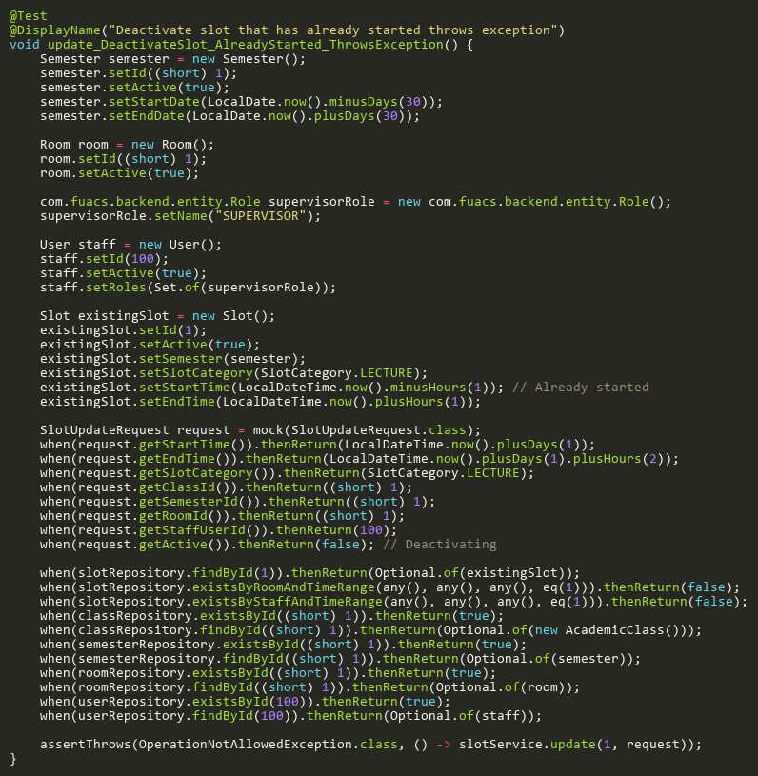

**Figure: update_DeactivateSlot_AlreadyStarted_ThrowsException**  
*Reference: Sheet "SLST_update", Test Case TC15*

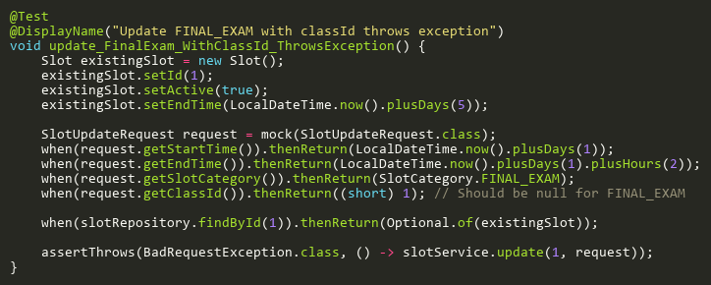

**Figure: update_FinalExam_WithClassId_ThrowsException**  
*Reference: Sheet "SLST_update", Test Case TC16*

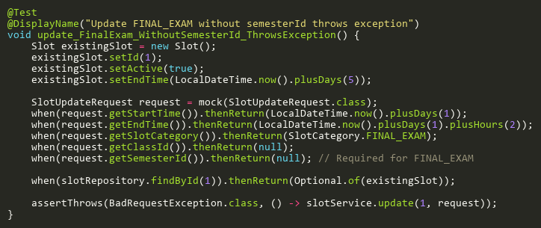

**Figure: update_FinalExam_WithoutSemesterId_ThrowsException**  
*Reference: Sheet "SLST_update", Test Case TC17*

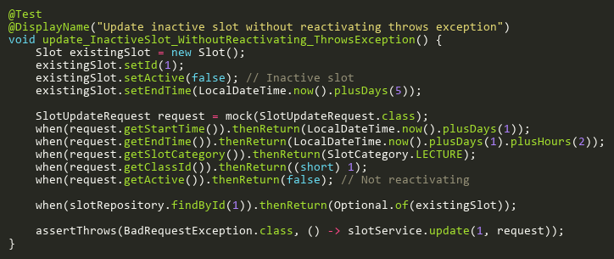

**Figure: update_InactiveSlot_WithoutReactivating_ThrowsException**  
*Reference: Sheet "SLST_update", Test Case TC12*

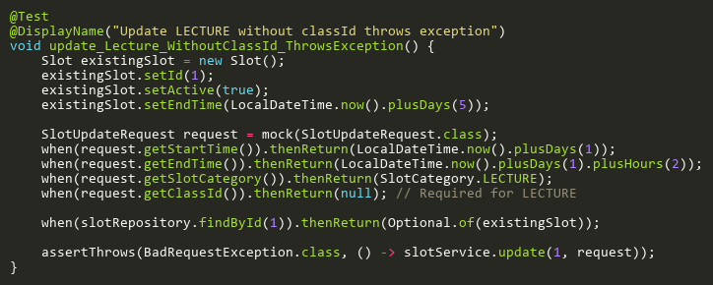

**Figure: update_Lecture_WithoutClassId_ThrowsException**  
*Reference: Sheet "SLST_update", Test Case TC21*

## UpdateSlotCategoryTests

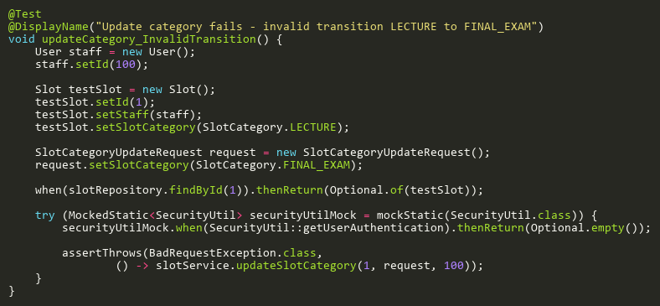

**Figure: updateCategory_InvalidTransition**  
*Reference: Sheet "SLST_updateCategory", Test Case TC05*

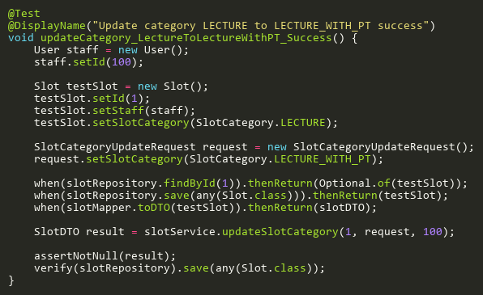

**Figure: updateCategory_LectureToLectureWithPT_Success**  
*Reference: Sheet "SLST_updateCategory", Test Case TC01*

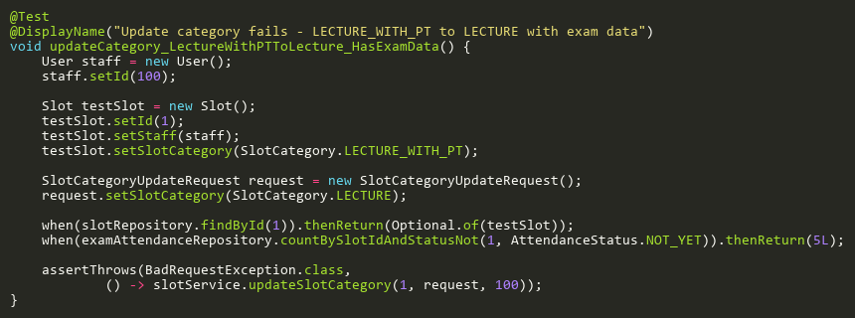

**Figure: updateCategory_LectureWithPTToLecture_HasExamData**  
*Reference: Sheet "SLST_updateCategory", Test Case TC06*

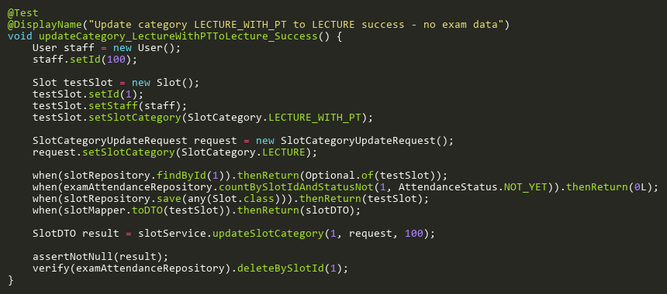

**Figure: updateCategory_LectureWithPTToLecture_Success**  
*Reference: Sheet "SLST_updateCategory", Test Case TC02*

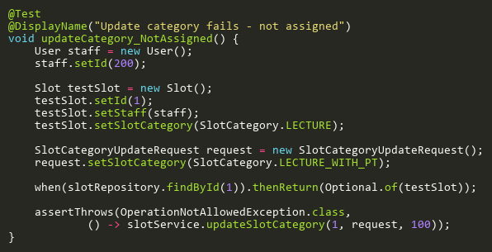

**Figure: updateCategory_NotAssigned**  
*Reference: Sheet "SLST_updateCategory", Test Case TC03*

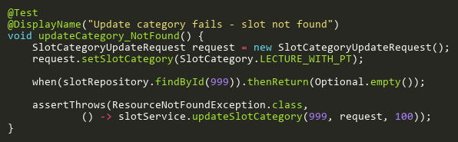

**Figure: updateCategory_NotFound**  
*Reference: Sheet "SLST_updateCategory", Test Case TC04*

## UpdateTests

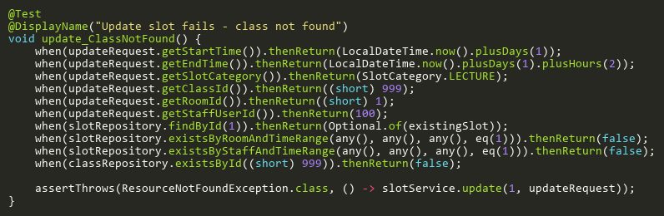

**Figure: update_ClassNotFound**  
*Reference: Sheet "SLST_update", Test Case TC07*

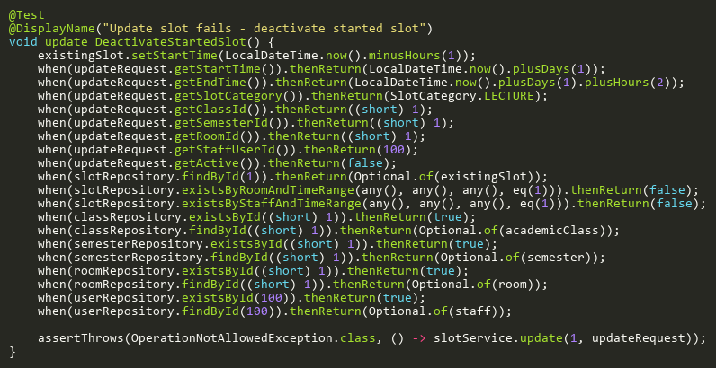

**Figure: update_DeactivateStartedSlot**  
*Reference: Sheet "SLST_update", Test Case TC10*

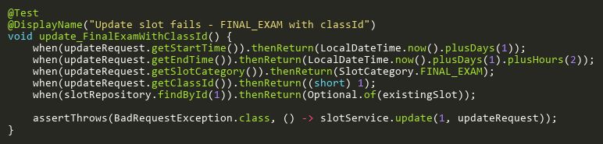

**Figure: update_FinalExamWithClassId**  
*Reference: Sheet "SLST_update", Test Case TC03*

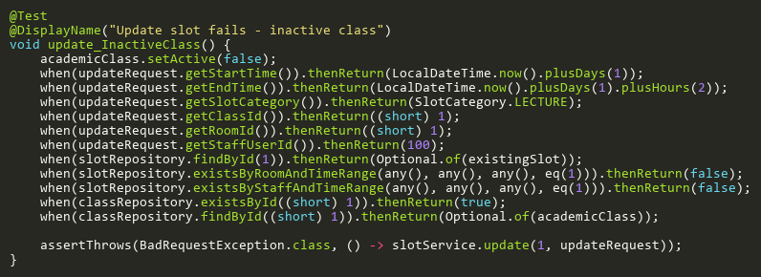

**Figure: update_InactiveClass**  
*Reference: Sheet "SLST_update", Test Case TC08*

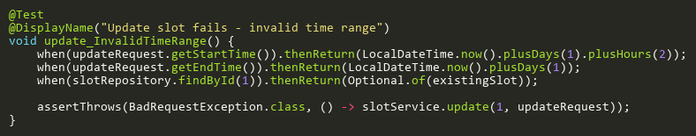

**Figure: update_InvalidTimeRange**  
*Reference: Sheet "SLST_update", Test Case TC02*

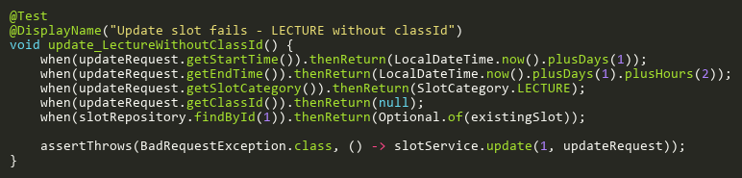

**Figure: update_LectureWithoutClassId**  
*Reference: Sheet "SLST_update", Test Case TC04*

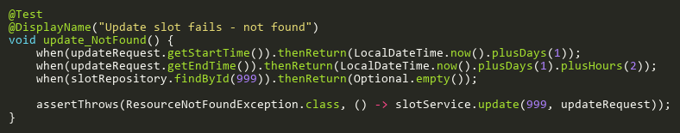

**Figure: update_NotFound**  
*Reference: Sheet "SLST_update", Test Case TC01*

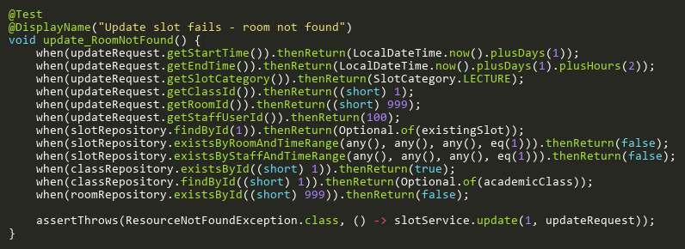

**Figure: update_RoomNotFound**  
*Reference: Sheet "SLST_update", Test Case TC09*

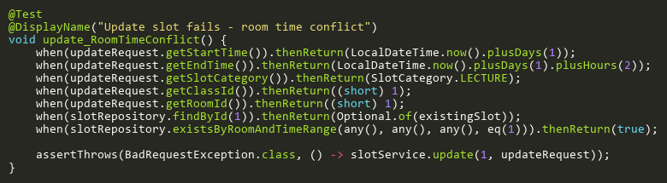

**Figure: update_RoomTimeConflict**  
*Reference: Sheet "SLST_update", Test Case TC05*

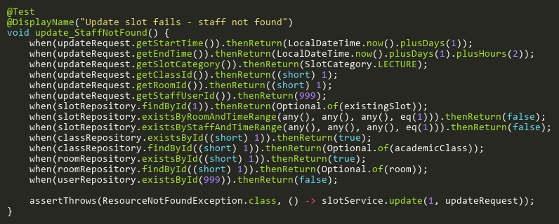

**Figure: update_StaffNotFound**  
*Reference: Sheet "SLST_update", Test Case TC13*

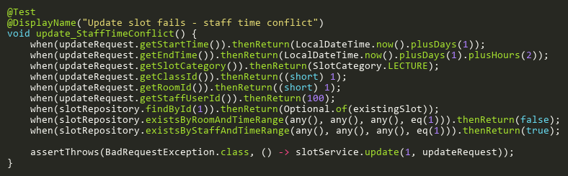

**Figure: update_StaffTimeConflict**  
*Reference: Sheet "SLST_update", Test Case TC06*

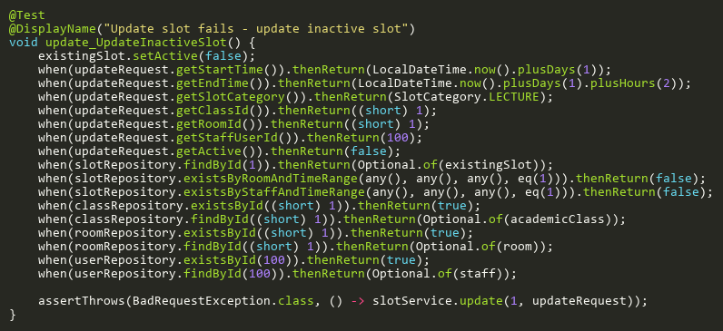

**Figure: update_UpdateInactiveSlot**  
*Reference: Sheet "SLST_update", Test Case TC11*

# SlotSessionServiceTest

## RescanExamSessionTests

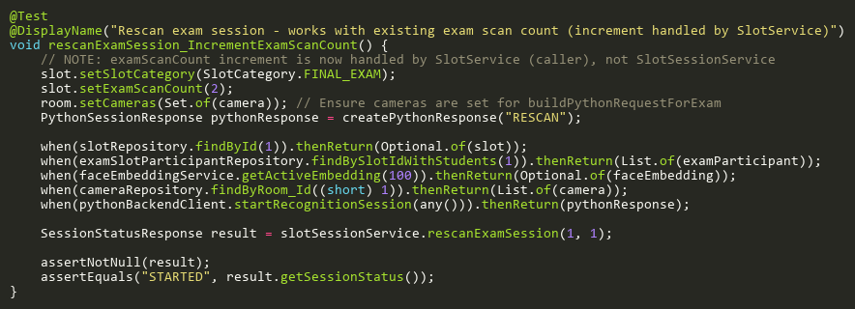

**Figure: rescanExamSession_IncrementExamScanCount**  
*Reference: Sheet "SSST_rescanExamSession", Test Case TC06*

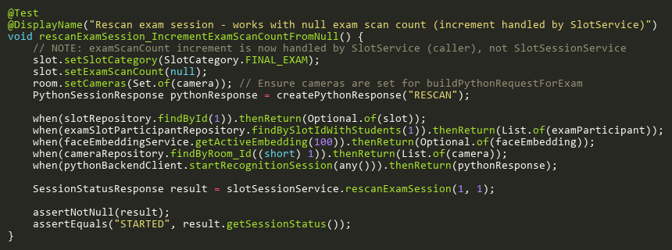

**Figure: rescanExamSession_IncrementExamScanCountFromNull**  
*Reference: Sheet "SSST_rescanExamSession", Test Case TC07*

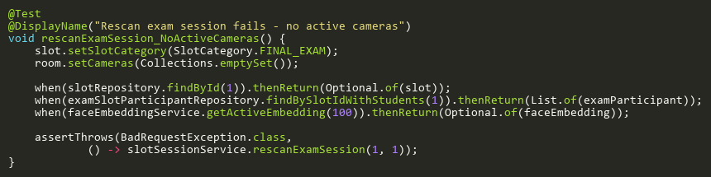

**Figure: rescanExamSession_NoActiveCameras**  
*Reference: Sheet "SSST_rescanExamSession", Test Case TC04*

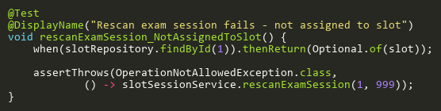

**Figure: rescanExamSession_NotAssignedToSlot**  
*Reference: Sheet "SSST_rescanExamSession", Test Case TC03*

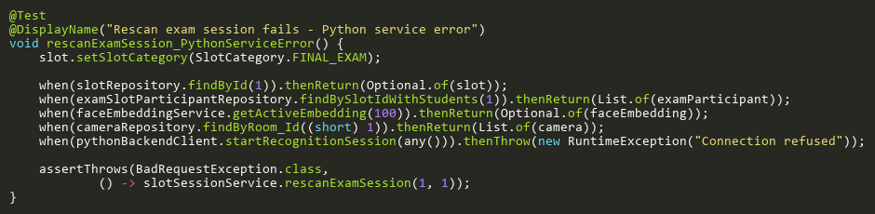

**Figure: rescanExamSession_PythonServiceError**  
*Reference: Sheet "SSST_rescanExamSession", Test Case TC05*

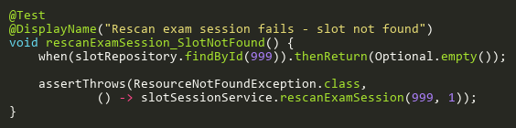

**Figure: rescanExamSession_SlotNotFound**  
*Reference: Sheet "SSST_rescanExamSession", Test Case TC02*

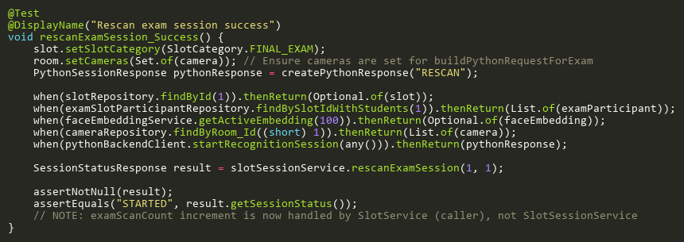

**Figure: rescanExamSession_Success**  
*Reference: Sheet "SSST_rescanExamSession", Test Case TC01*

## StartExamSessionTests

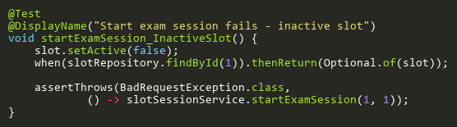

**Figure: startExamSession_InactiveSlot**  
*Reference: Sheet "SSST_startExamSession", Test Case TC04*

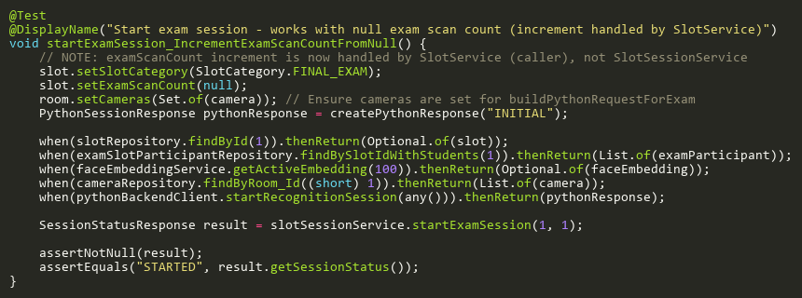

**Figure: startExamSession_IncrementExamScanCountFromNull**  
*Reference: Sheet "SSST_startExamSession", Test Case TC09*

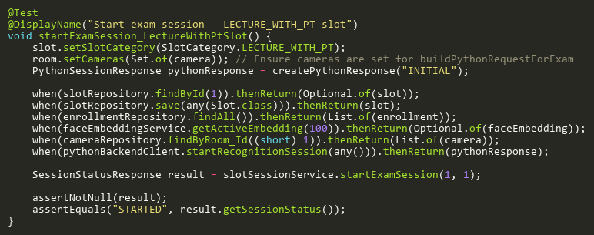

**Figure: startExamSession_LectureWithPtSlot**  
*Reference: Sheet "SSST_startExamSession", Test Case TC10*

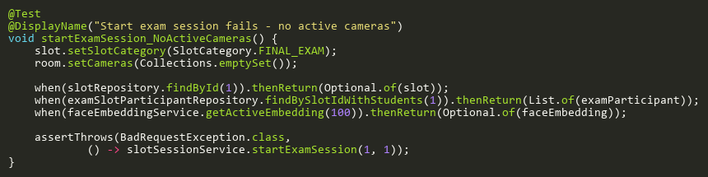

**Figure: startExamSession_NoActiveCameras**  
*Reference: Sheet "SSST_startExamSession", Test Case TC07*

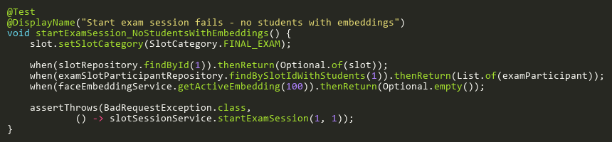

**Figure: startExamSession_NoStudentsWithEmbeddings**  
*Reference: Sheet "SSST_startExamSession", Test Case TC06*

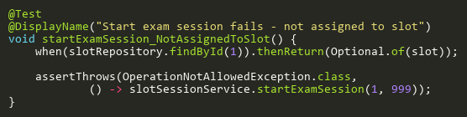

**Figure: startExamSession_NotAssignedToSlot**  
*Reference: Sheet "SSST_startExamSession", Test Case TC03*

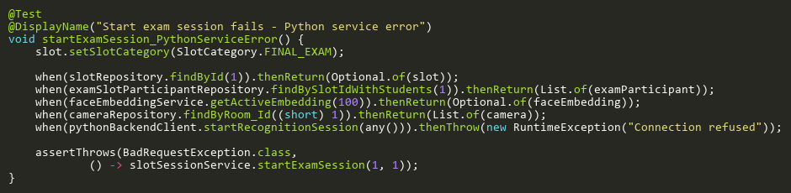

**Figure: startExamSession_PythonServiceError**  
*Reference: Sheet "SSST_startExamSession", Test Case TC08*

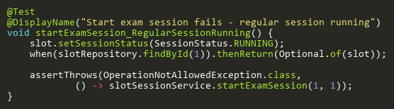

**Figure: startExamSession_RegularSessionRunning**  
*Reference: Sheet "SSST_startExamSession", Test Case TC05*

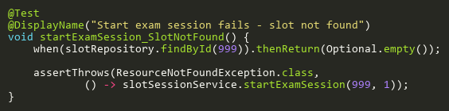

**Figure: startExamSession_SlotNotFound**  
*Reference: Sheet "SSST_startExamSession", Test Case TC02*

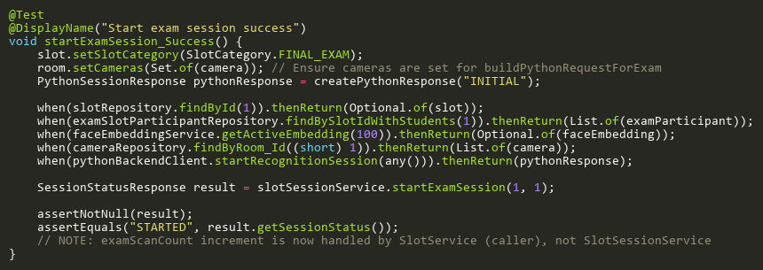

**Figure: startExamSession_Success**  
*Reference: Sheet "SSST_startExamSession", Test Case TC01*

## StartSessionTests

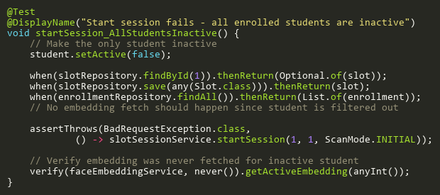

**Figure: startSession_AllStudentsInactive**  
*Reference: Sheet "SSST_startSession", Test Case TC14*

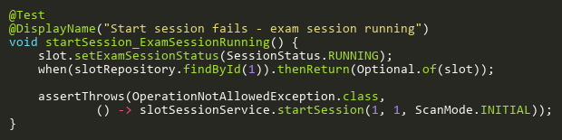

**Figure: startSession_ExamSessionRunning**  
*Reference: Sheet "SSST_startSession", Test Case TC06*

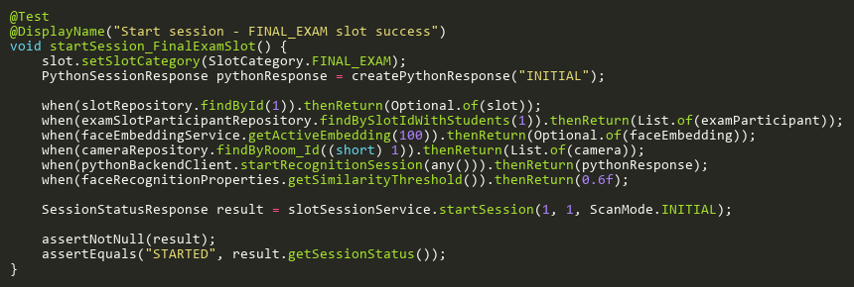

**Figure: startSession_FinalExamSlot**  
*Reference: Sheet "SSST_startSession", Test Case TC11*

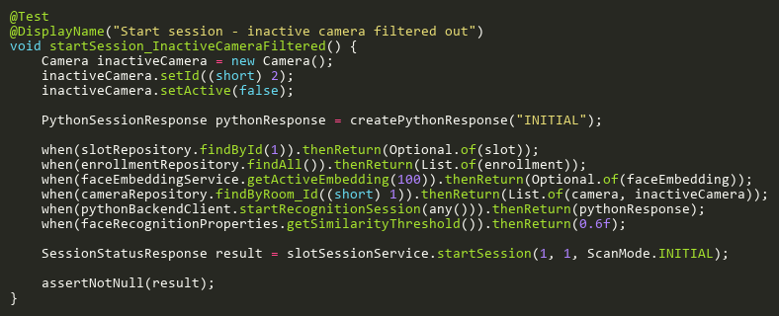

**Figure: startSession_InactiveCameraFiltered**  
*Reference: Sheet "SSST_startSession", Test Case TC12*

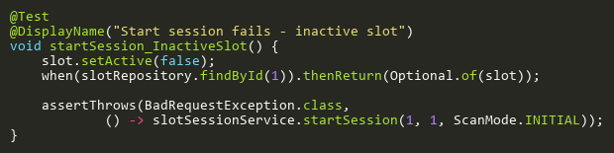

**Figure: startSession_InactiveSlot**  
*Reference: Sheet "SSST_startSession", Test Case TC05*

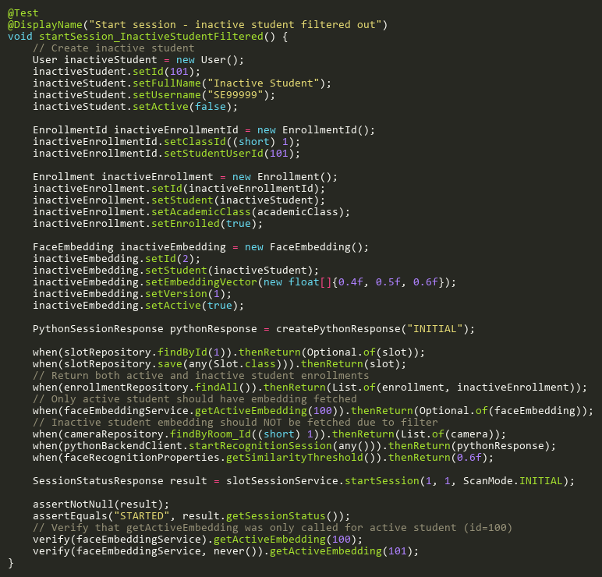

**Figure: startSession_InactiveStudentFiltered**  
*Reference: Sheet "SSST_startSession", Test Case TC13*

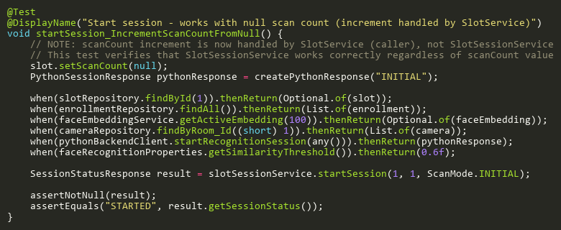

**Figure: startSession_IncrementScanCountFromNull**  
*Reference: Sheet "SSST_startSession", Test Case TC09*

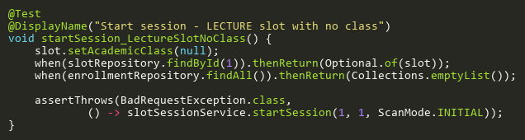

**Figure: startSession_LectureSlotNoClass**  
*Reference: Sheet "SSST_startSession", Test Case TC10*

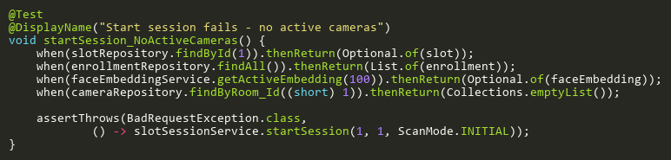

**Figure: startSession_NoActiveCameras**  
*Reference: Sheet "SSST_startSession", Test Case TC08*

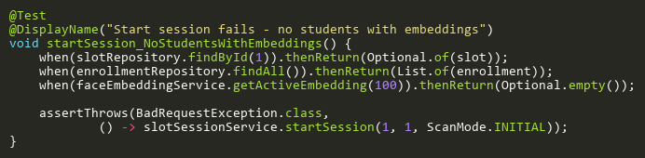

**Figure: startSession_NoStudentsWithEmbeddings**  
*Reference: Sheet "SSST_startSession", Test Case TC07*

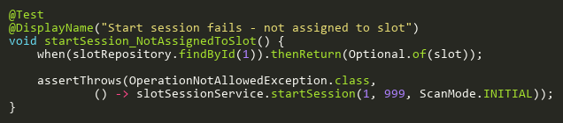

**Figure: startSession_NotAssignedToSlot**  
*Reference: Sheet "SSST_startSession", Test Case TC04*

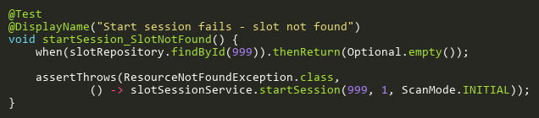

**Figure: startSession_SlotNotFound**  
*Reference: Sheet "SSST_startSession", Test Case TC03*

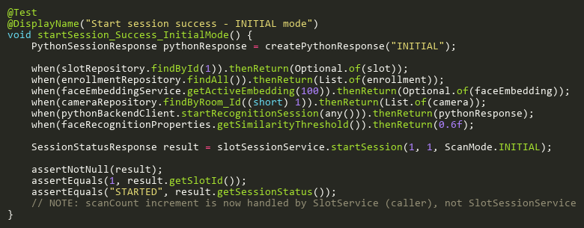

**Figure: startSession_Success_InitialMode**  
*Reference: Sheet "SSST_startSession", Test Case TC01*

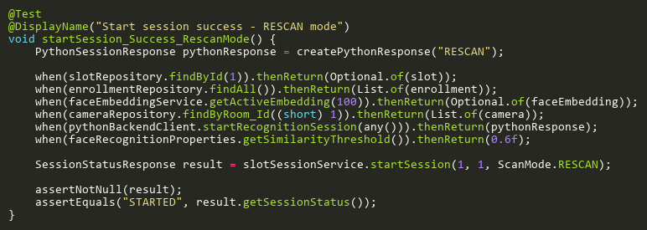

**Figure: startSession_Success_RescanMode**  
*Reference: Sheet "SSST_startSession", Test Case TC02*

## StopExamSessionTests

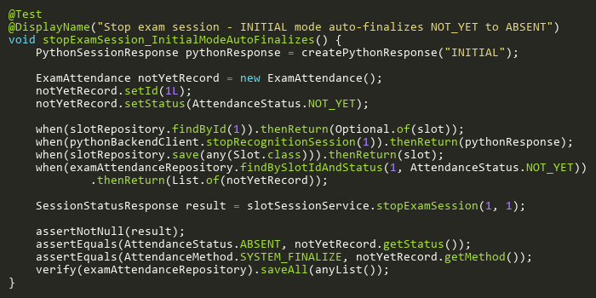

**Figure: stopExamSession_InitialModeAutoFinalizes**  
*Reference: Sheet "SSST_stopExamSession", Test Case TC06*

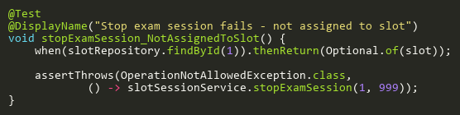

**Figure: stopExamSession_NotAssignedToSlot**  
*Reference: Sheet "SSST_stopExamSession", Test Case TC03*

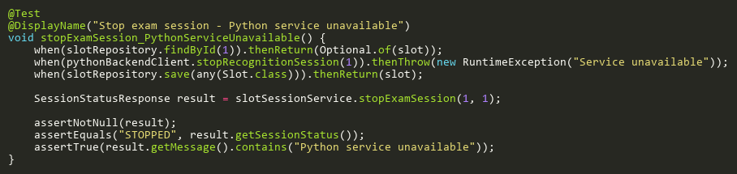

**Figure: stopExamSession_PythonServiceUnavailable**  
*Reference: Sheet "SSST_stopExamSession", Test Case TC04*

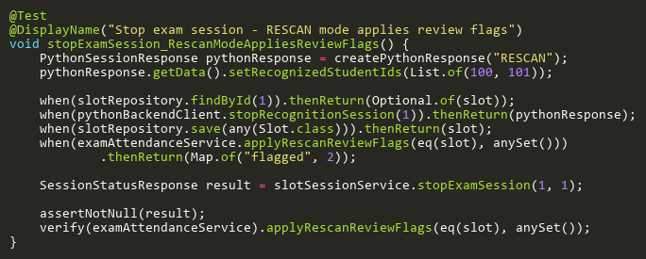

**Figure: stopExamSession_RescanModeAppliesReviewFlags**  
*Reference: Sheet "SSST_stopExamSession", Test Case TC05*

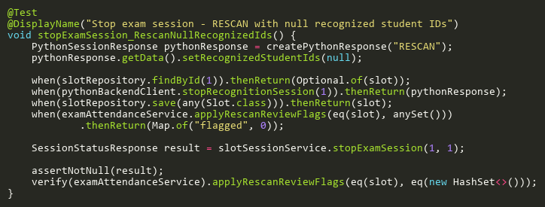

**Figure: stopExamSession_RescanNullRecognizedIds**  
*Reference: Sheet "SSST_stopExamSession", Test Case TC07*

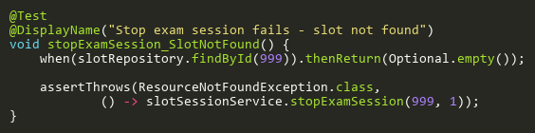

**Figure: stopExamSession_SlotNotFound**  
*Reference: Sheet "SSST_stopExamSession", Test Case TC02*

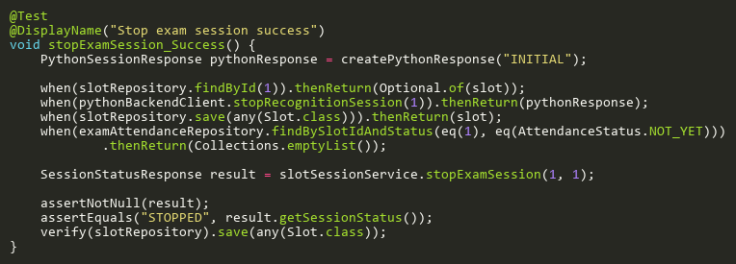

**Figure: stopExamSession_Success**  
*Reference: Sheet "SSST_stopExamSession", Test Case TC01*

## StopSessionTests

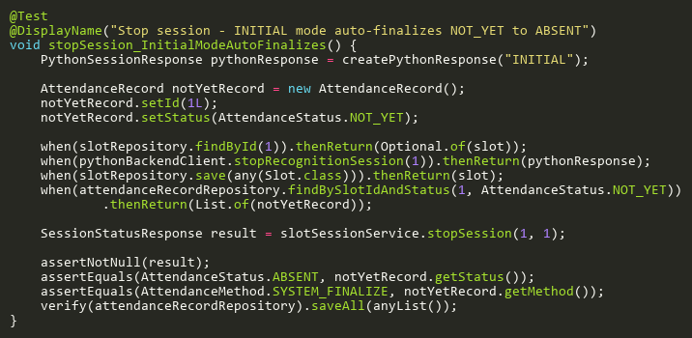

**Figure: stopSession_InitialModeAutoFinalizes**  
*Reference: Sheet "SSST_stopSession", Test Case TC06*

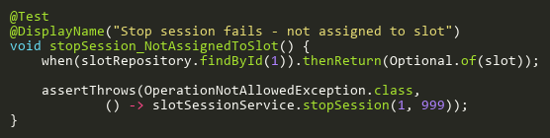

**Figure: stopSession_NotAssignedToSlot**  
*Reference: Sheet "SSST_stopSession", Test Case TC03*

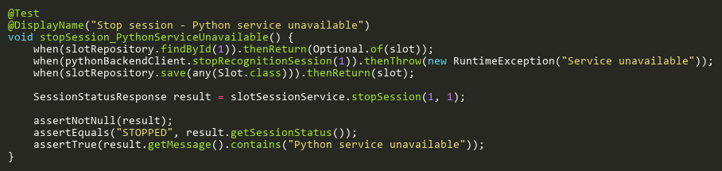

**Figure: stopSession_PythonServiceUnavailable**  
*Reference: Sheet "SSST_stopSession", Test Case TC04*

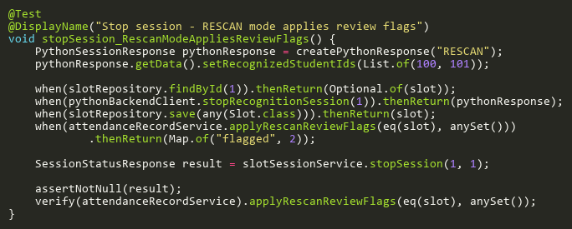

**Figure: stopSession_RescanModeAppliesReviewFlags**  
*Reference: Sheet "SSST_stopSession", Test Case TC05*

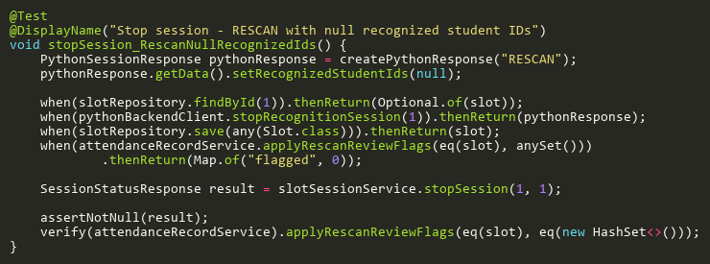

**Figure: stopSession_RescanNullRecognizedIds**  
*Reference: Sheet "SSST_stopSession", Test Case TC07*

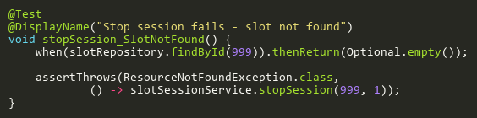

**Figure: stopSession_SlotNotFound**  
*Reference: Sheet "SSST_stopSession", Test Case TC02*

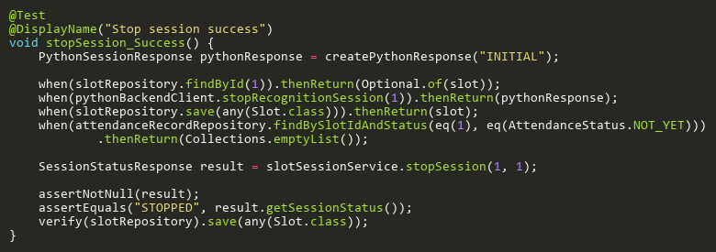

**Figure: stopSession_Success**  
*Reference: Sheet "SSST_stopSession", Test Case TC01*

# StaffProfileServiceTest

## CreateTests

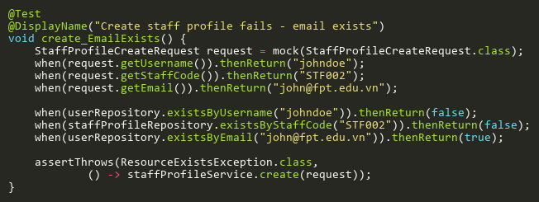

**Figure: create_EmailExists**  
*Reference: Sheet "SPST_create", Test Case TC05*

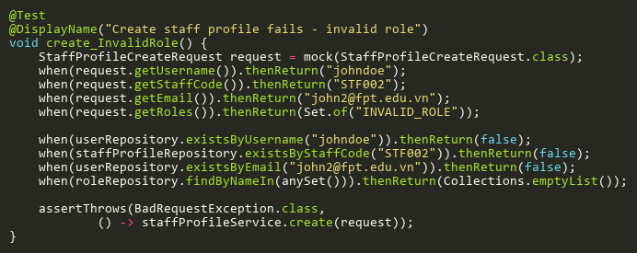

**Figure: create_InvalidRole**  
*Reference: Sheet "SPST_create", Test Case TC07*

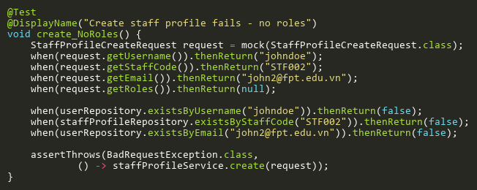

**Figure: create_NoRoles**  
*Reference: Sheet "SPST_create", Test Case TC06*

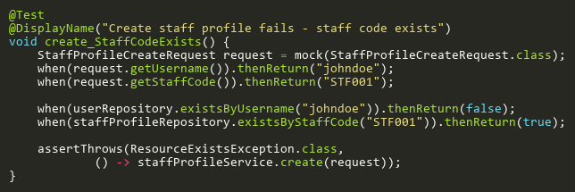

**Figure: create_StaffCodeExists**  
*Reference: Sheet "SPST_create", Test Case TC04*

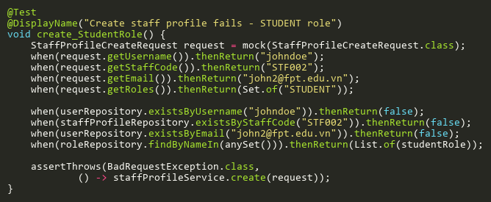

**Figure: create_StudentRole**  
*Reference: Sheet "SPST_create", Test Case TC08*

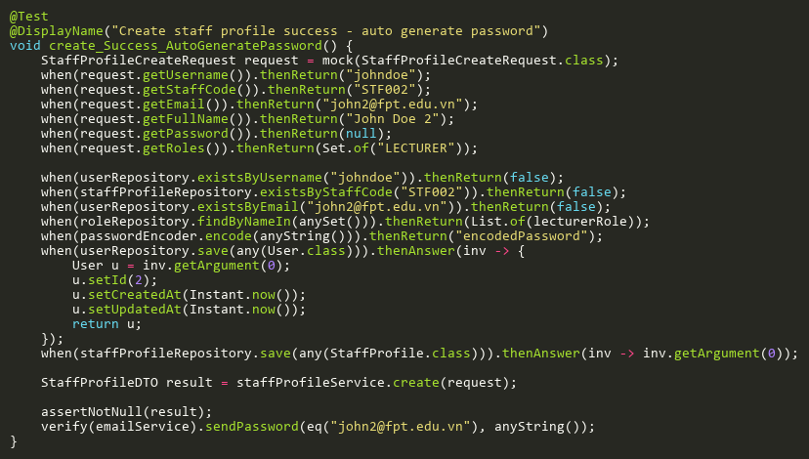

**Figure: create_Success_AutoGeneratePassword**  
*Reference: Sheet "SPST_create", Test Case TC02*

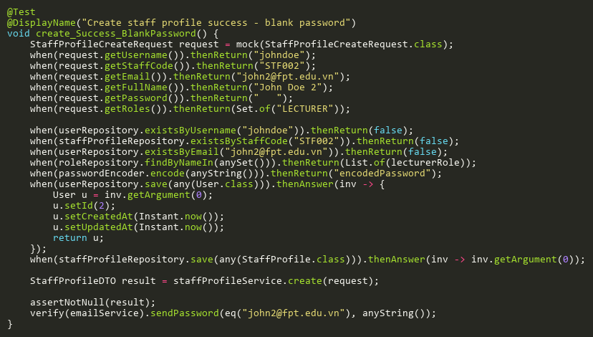

**Figure: create_Success_BlankPassword**  
*Reference: Sheet "SPST_create", Test Case TC09*

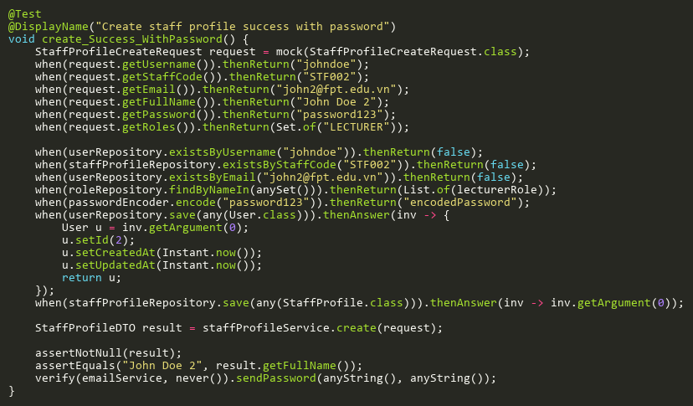

**Figure: create_Success_WithPassword**  
*Reference: Sheet "SPST_create", Test Case TC01*

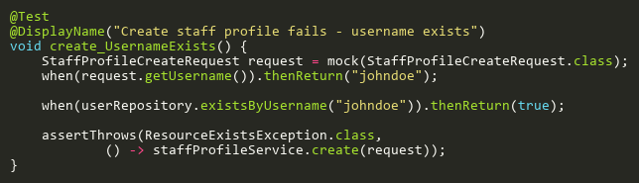

**Figure: create_UsernameExists**  
*Reference: Sheet "SPST_create", Test Case TC03*

## DeleteTests

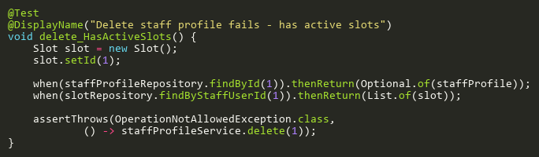

**Figure: delete_HasActiveSlots**  
*Reference: Sheet "SPST_delete", Test Case TC03*

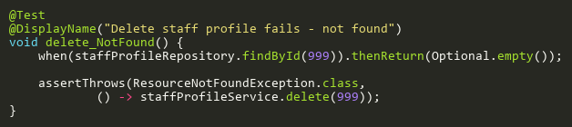

**Figure: delete_NotFound**  
*Reference: Sheet "SPST_delete", Test Case TC02*

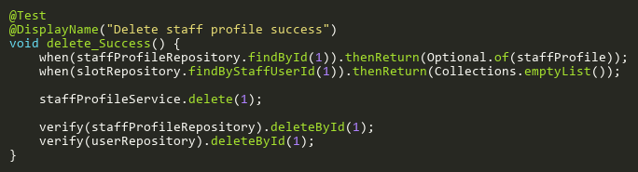

**Figure: delete_Success**  
*Reference: Sheet "SPST_delete", Test Case TC01*

## FindByIdTests

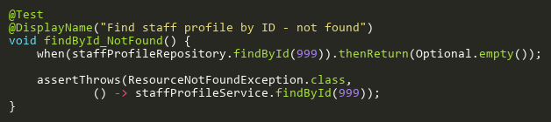

**Figure: findById_NotFound**  
*Reference: Sheet "SPST_findById", Test Case TC02*

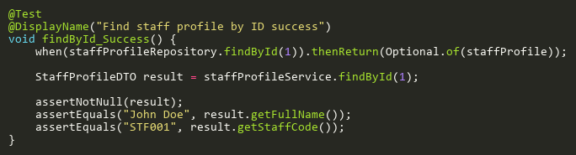

**Figure: findById_Success**  
*Reference: Sheet "SPST_findById", Test Case TC01*

## ImportFromCsvTests

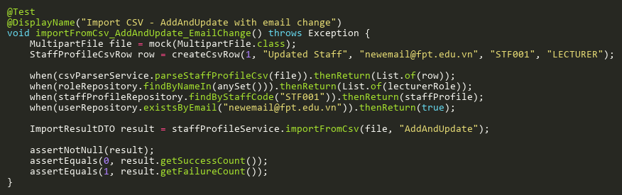

**Figure: importFromCsv_AddAndUpdate_EmailChange**  
*Reference: Sheet "SPST_importFromCsv", Test Case TC10*

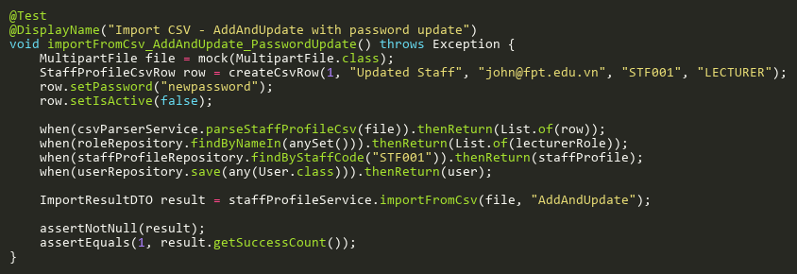

**Figure: importFromCsv_AddAndUpdate_PasswordUpdate**  
*Reference: Sheet "SPST_importFromCsv", Test Case TC12*

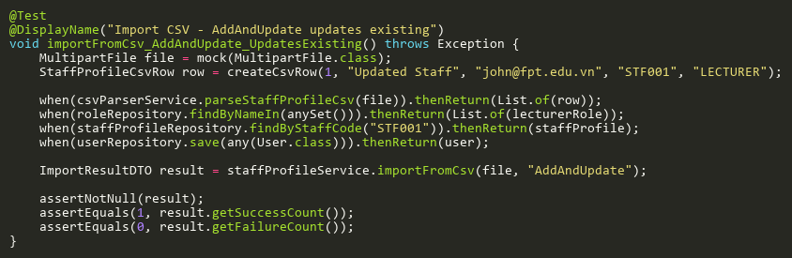

**Figure: importFromCsv_AddAndUpdate_UpdatesExisting**  
*Reference: Sheet "SPST_importFromCsv", Test Case TC05*

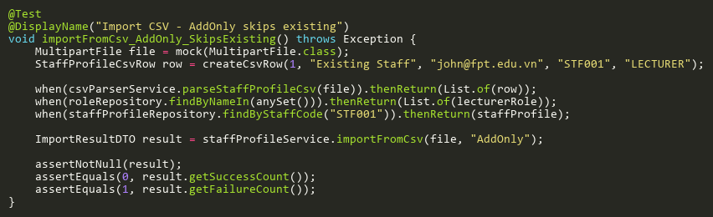

**Figure: importFromCsv_AddOnly_SkipsExisting**  
*Reference: Sheet "SPST_importFromCsv", Test Case TC04*

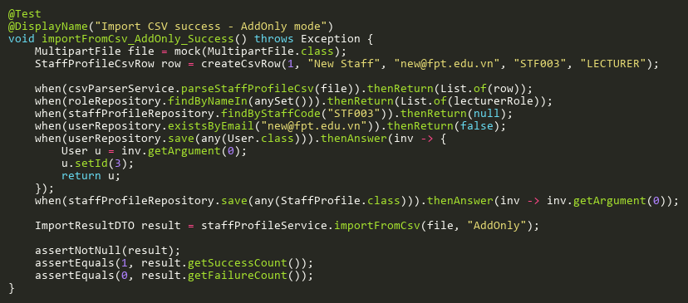

**Figure: importFromCsv_AddOnly_Success**  
*Reference: Sheet "SPST_importFromCsv", Test Case TC01*

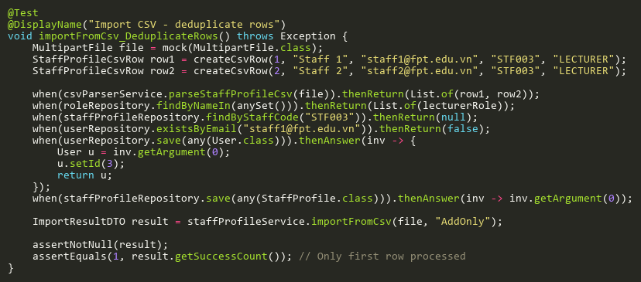

**Figure: importFromCsv_DeduplicateRows**  
*Reference: Sheet "SPST_importFromCsv", Test Case TC09*

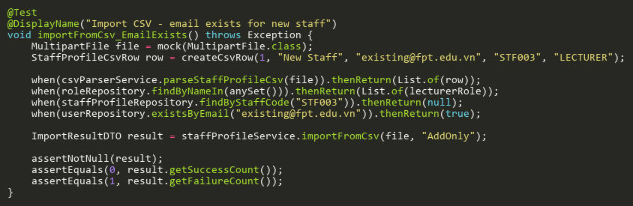

**Figure: importFromCsv_EmailExists**  
*Reference: Sheet "SPST_importFromCsv", Test Case TC06*

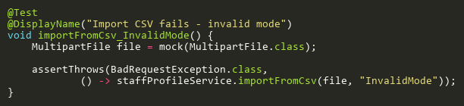

**Figure: importFromCsv_InvalidMode**  
*Reference: Sheet "SPST_importFromCsv", Test Case TC02*

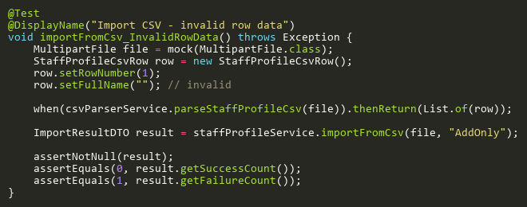

**Figure: importFromCsv_InvalidRowData**  
*Reference: Sheet "SPST_importFromCsv", Test Case TC07*

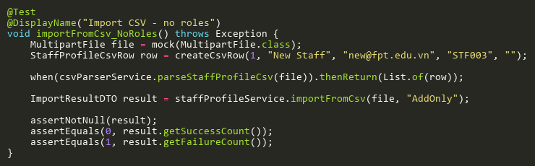

**Figure: importFromCsv_NoRoles**  
*Reference: Sheet "SPST_importFromCsv", Test Case TC08*

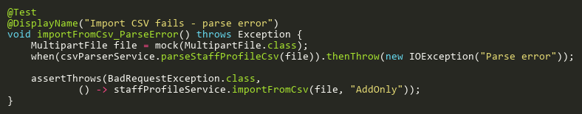

**Figure: importFromCsv_ParseError**  
*Reference: Sheet "SPST_importFromCsv", Test Case TC03*

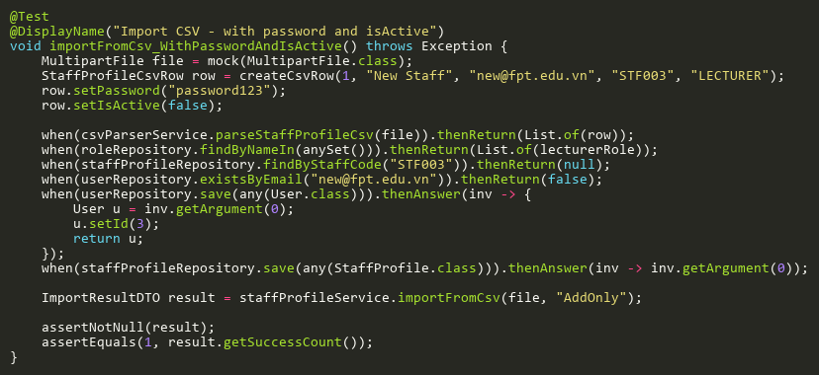

**Figure: importFromCsv_WithPasswordAndIsActive**  
*Reference: Sheet "SPST_importFromCsv", Test Case TC11*

## SearchTests

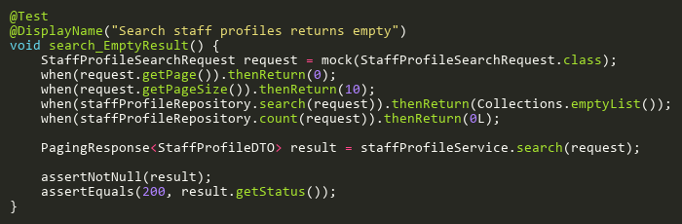

**Figure: search_EmptyResult**  
*Reference: Sheet "SPST_search", Test Case TC02*

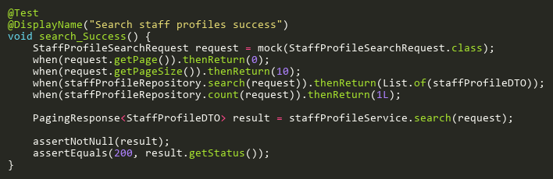

**Figure: search_Success**  
*Reference: Sheet "SPST_search", Test Case TC01*

## UpdateTests

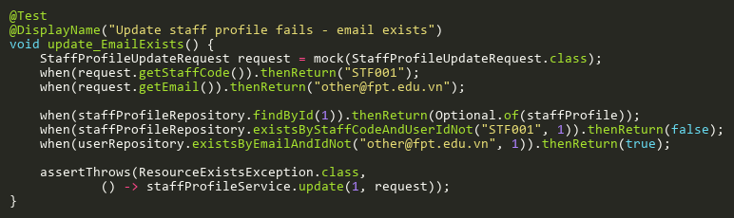

**Figure: update_EmailExists**  
*Reference: Sheet "SPST_update", Test Case TC04*

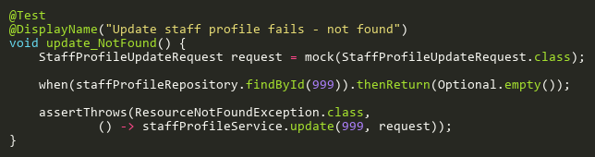

**Figure: update_NotFound**  
*Reference: Sheet "SPST_update", Test Case TC02*

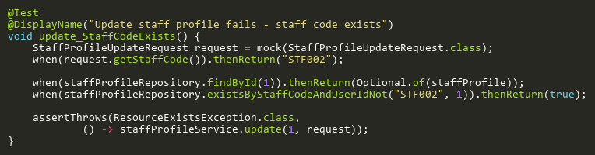

**Figure: update_StaffCodeExists**  
*Reference: Sheet "SPST_update", Test Case TC03*

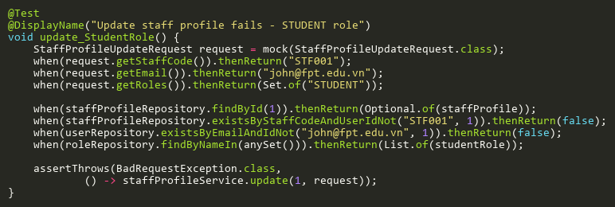

**Figure: update_StudentRole**  
*Reference: Sheet "SPST_update", Test Case TC05*

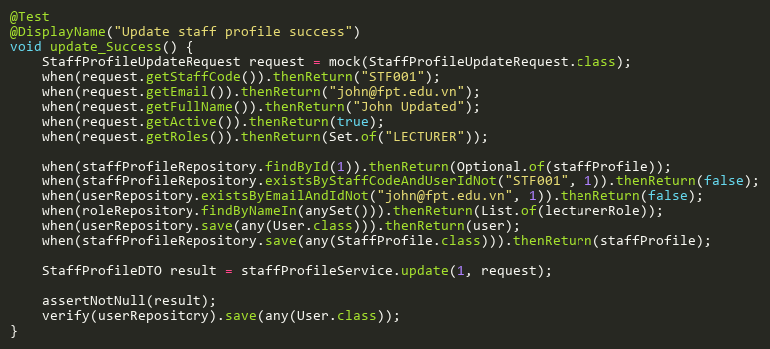

**Figure: update_Success**  
*Reference: Sheet "SPST_update", Test Case TC01*

# StudentPhotoServiceTest

## HasExistingPhotoTests

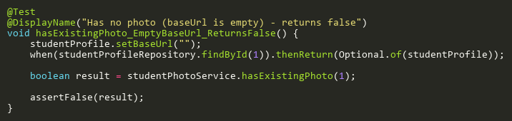

**Figure: hasExistingPhoto_EmptyBaseUrl_ReturnsFalse**  
*Reference: Sheet "SPHST_hasPhoto", Test Case TC03*

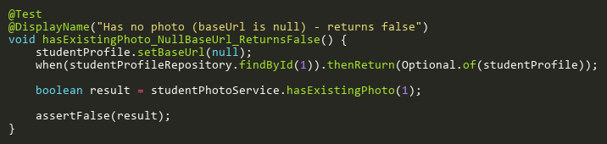

**Figure: hasExistingPhoto_NullBaseUrl_ReturnsFalse**  
*Reference: Sheet "SPHST_hasPhoto", Test Case TC02*

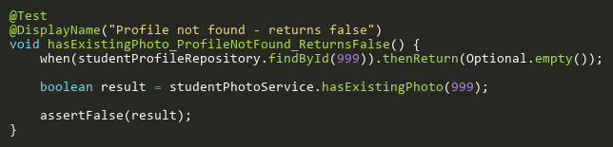

**Figure: hasExistingPhoto_ProfileNotFound_ReturnsFalse**  
*Reference: Sheet "SPHST_hasPhoto", Test Case TC04*

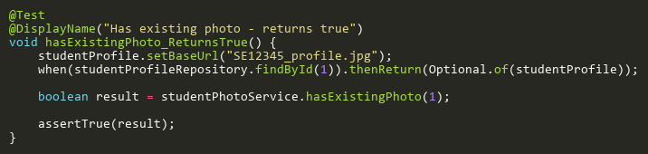

**Figure: hasExistingPhoto_ReturnsTrue**  
*Reference: Sheet "SPHST_hasPhoto", Test Case TC01*

## SavePhotoToUserFolderTests

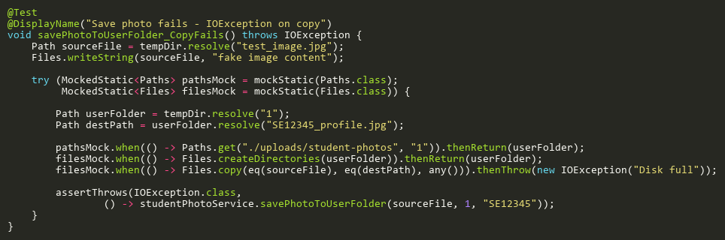

**Figure: savePhotoToUserFolder_CopyFails**  
*Reference: Sheet "SPHST_savePhoto", Test Case TC04*

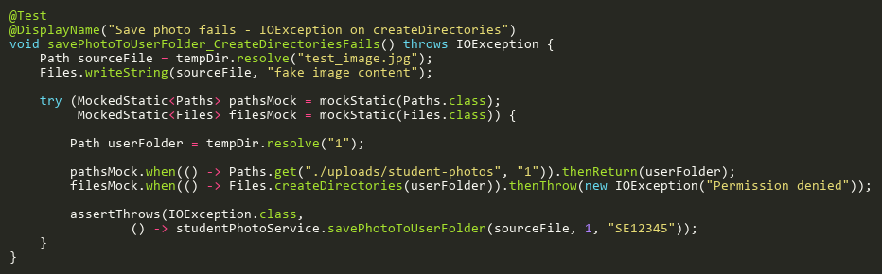

**Figure: savePhotoToUserFolder_CreateDirectoriesFails**  
*Reference: Sheet "SPHST_savePhoto", Test Case TC03*

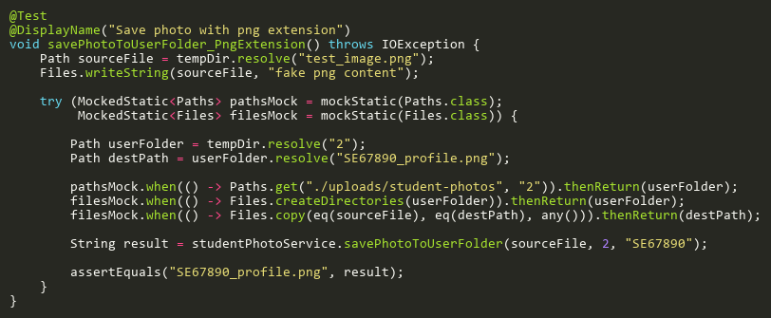

**Figure: savePhotoToUserFolder_PngExtension**  
*Reference: Sheet "SPHST_savePhoto", Test Case TC02*

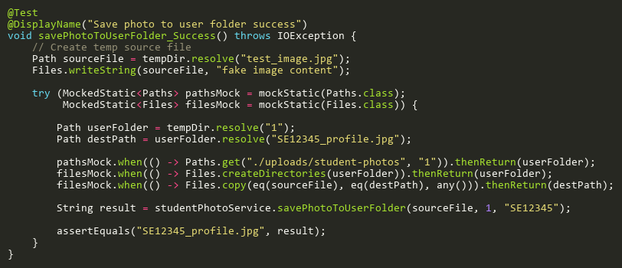

**Figure: savePhotoToUserFolder_Success**  
*Reference: Sheet "SPHST_savePhoto", Test Case TC01*

## UpdateStudentProfilePhotoTests

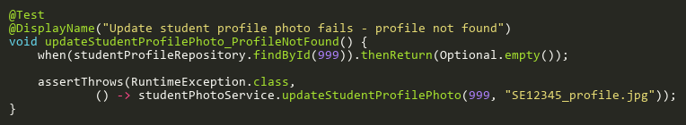

**Figure: updateStudentProfilePhoto_ProfileNotFound**  
*Reference: Sheet "SPHST_updatePhoto", Test Case TC02*

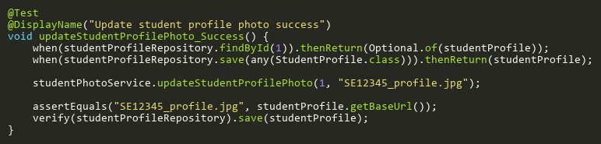

**Figure: updateStudentProfilePhoto_Success**  
*Reference: Sheet "SPHST_updatePhoto", Test Case TC01*

# StudentProfileServiceTest

## CreateTests

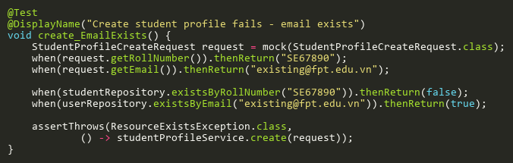

**Figure: create_EmailExists**  
*Reference: Sheet "STPST_create", Test Case TC03*

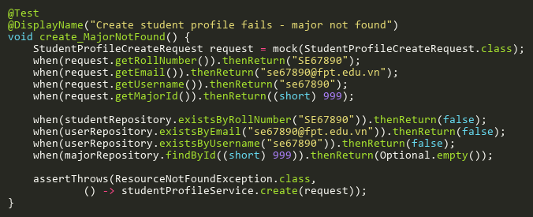

**Figure: create_MajorNotFound**  
*Reference: Sheet "STPST_create", Test Case TC05*

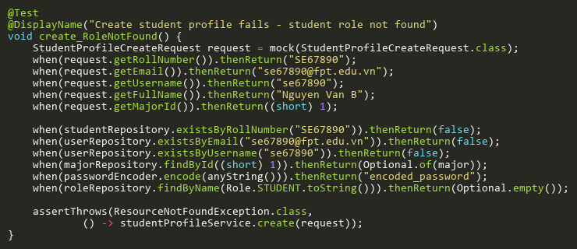

**Figure: create_RoleNotFound**  
*Reference: Sheet "STPST_create", Test Case TC06*

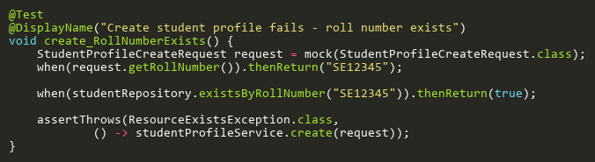

**Figure: create_RollNumberExists**  
*Reference: Sheet "STPST_create", Test Case TC02*

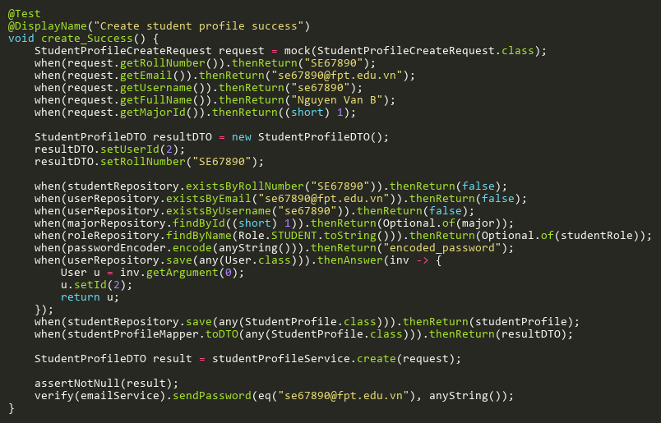

**Figure: create_Success**  
*Reference: Sheet "STPST_create", Test Case TC01*

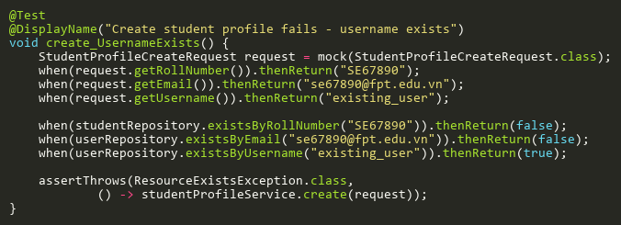

**Figure: create_UsernameExists**  
*Reference: Sheet "STPST_create", Test Case TC04*

## DeleteTests

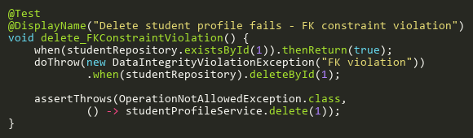

**Figure: delete_FKConstraintViolation**  
*Reference: Sheet "STPST_delete", Test Case TC03*

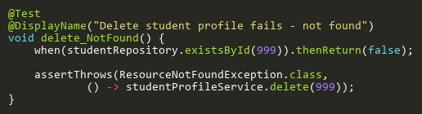

**Figure: delete_NotFound**  
*Reference: Sheet "STPST_delete", Test Case TC02*

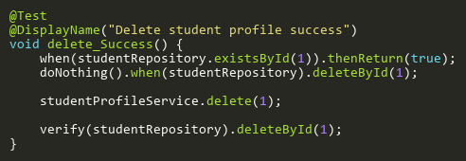

**Figure: delete_Success**  
*Reference: Sheet "STPST_delete", Test Case TC01*

## FindByIdTests

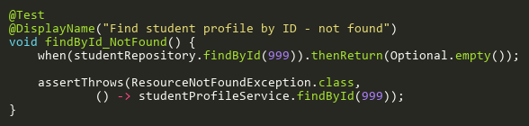

**Figure: findById_NotFound**  
*Reference: Sheet "STPST_findById", Test Case TC02*

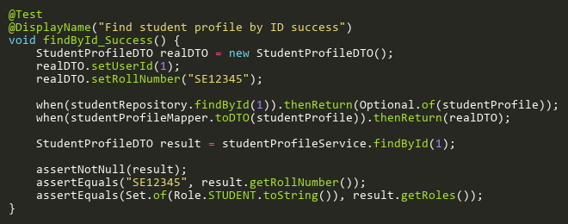

**Figure: findById_Success**  
*Reference: Sheet "STPST_findById", Test Case TC01*

## SearchBySemesterIdTests

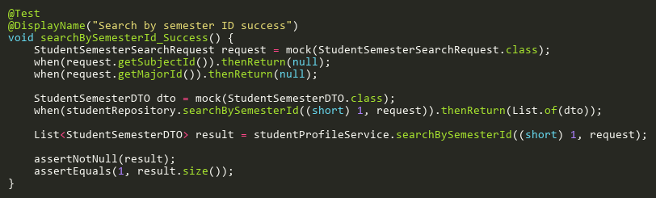

**Figure: searchBySemesterId_Success**  
*Reference: Sheet "STPST_searchBySem", Test Case TC01*

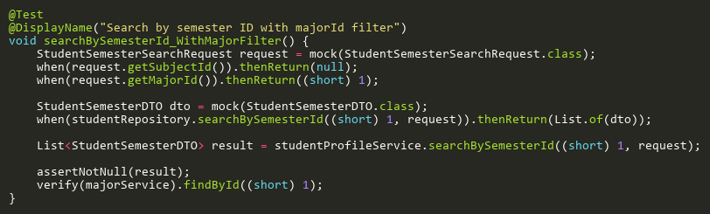

**Figure: searchBySemesterId_WithMajorFilter**  
*Reference: Sheet "STPST_searchBySem", Test Case TC02*

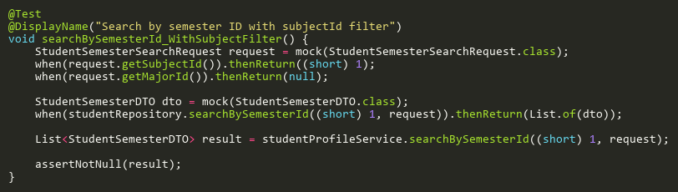

**Figure: searchBySemesterId_WithSubjectFilter**  
*Reference: Sheet "STPST_searchBySem", Test Case TC03*

## UpdateTests

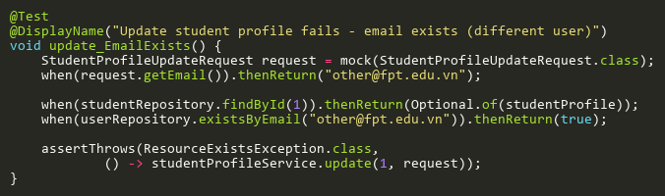

**Figure: update_EmailExists**  
*Reference: Sheet "STPST_update", Test Case TC03*

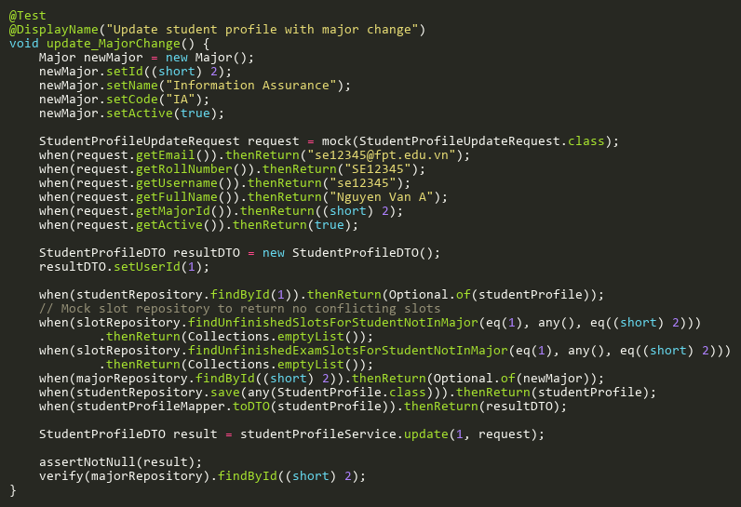

**Figure: update_MajorChange**  
*Reference: Sheet "STPST_update", Test Case TC06*

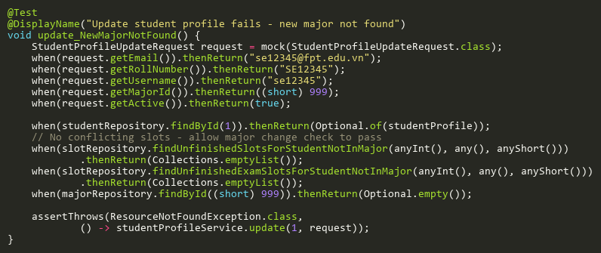

**Figure: update_NewMajorNotFound**  
*Reference: Sheet "STPST_update", Test Case TC07*

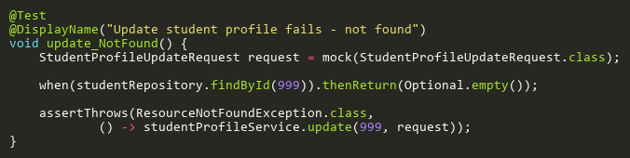

**Figure: update_NotFound**  
*Reference: Sheet "STPST_update", Test Case TC02*

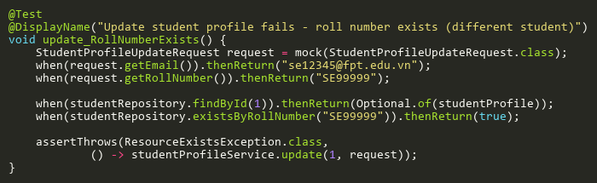

**Figure: update_RollNumberExists**  
*Reference: Sheet "STPST_update", Test Case TC04*

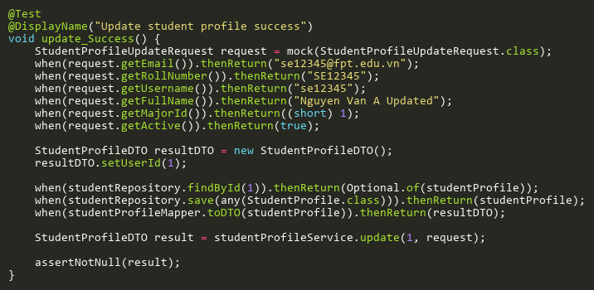

**Figure: update_Success**  
*Reference: Sheet "STPST_update", Test Case TC01*

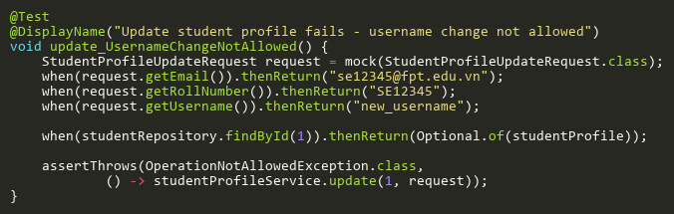

**Figure: update_UsernameChangeNotAllowed**  
*Reference: Sheet "STPST_update", Test Case TC05*

# SubjectServiceTest

## CreateTests

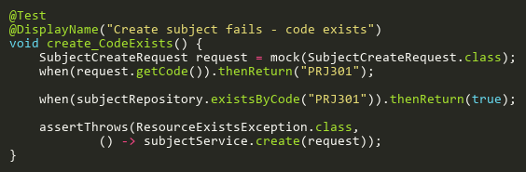

**Figure: create_CodeExists**  
*Reference: Sheet "SBST_create", Test Case TC02*

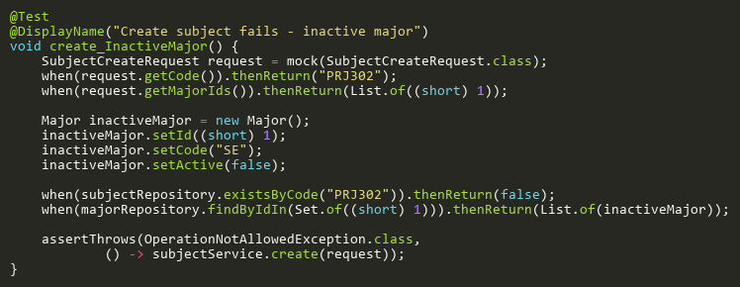

**Figure: create_InactiveMajor**  
*Reference: Sheet "SBST_create", Test Case TC06*

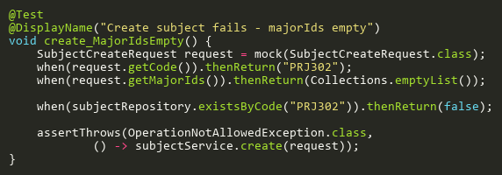

**Figure: create_MajorIdsEmpty**  
*Reference: Sheet "SBST_create", Test Case TC04*

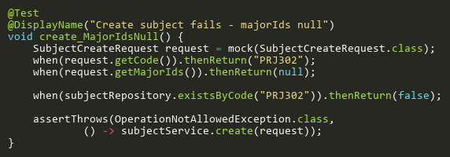

**Figure: create_MajorIdsNull**  
*Reference: Sheet "SBST_create", Test Case TC03*

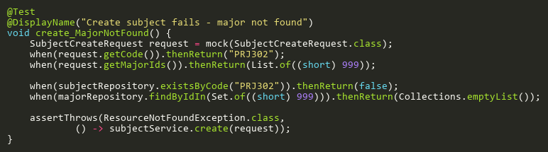

**Figure: create_MajorNotFound**  
*Reference: Sheet "SBST_create", Test Case TC05*

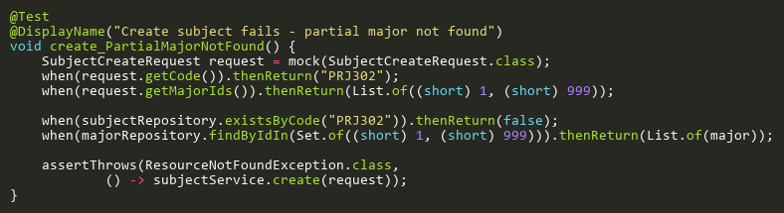

**Figure: create_PartialMajorNotFound**  
*Reference: Sheet "SBST_create", Test Case TC07*

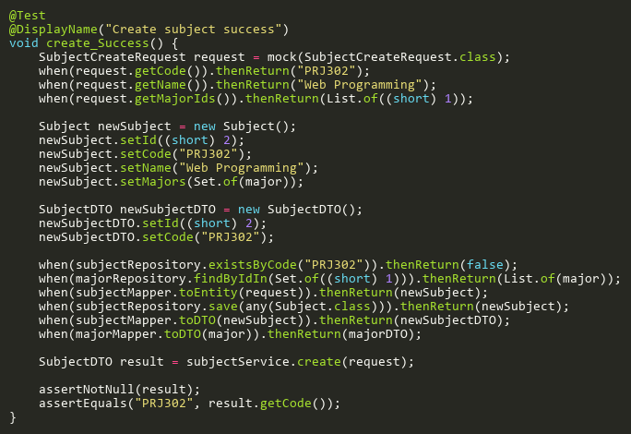

**Figure: create_Success**  
*Reference: Sheet "SBST_create", Test Case TC01*

## DeleteTests

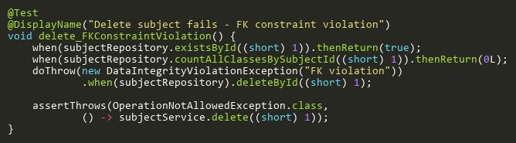

**Figure: delete_FKConstraintViolation**  
*Reference: Sheet "SBST_delete", Test Case TC04*

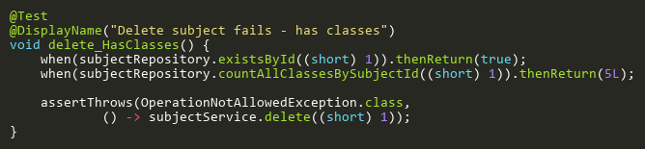

**Figure: delete_HasClasses**  
*Reference: Sheet "SBST_delete", Test Case TC03*

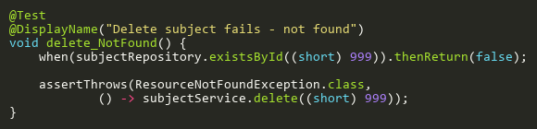

**Figure: delete_NotFound**  
*Reference: Sheet "SBST_delete", Test Case TC02*

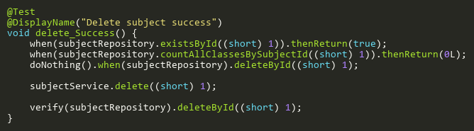

**Figure: delete_Success**  
*Reference: Sheet "SBST_delete", Test Case TC01*

## FindByIdTests

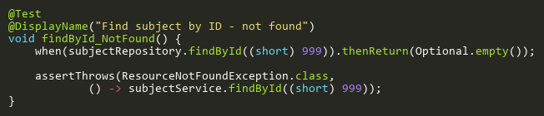

**Figure: findById_NotFound**  
*Reference: Sheet "SBST_findById", Test Case TC02*

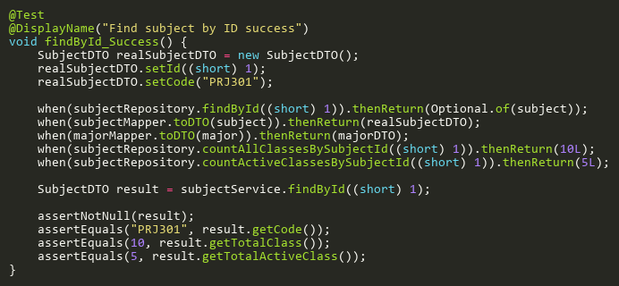

**Figure: findById_Success**  
*Reference: Sheet "SBST_findById", Test Case TC01*

## UpdateTests

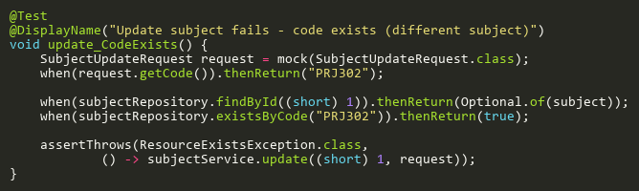

**Figure: update_CodeExists**  
*Reference: Sheet "SBST_update", Test Case TC03*

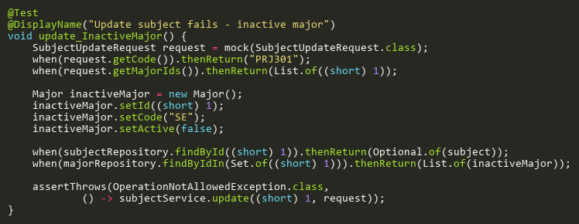

**Figure: update_InactiveMajor**  
*Reference: Sheet "SBST_update", Test Case TC07*

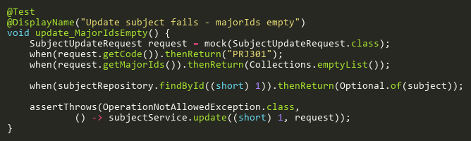

**Figure: update_MajorIdsEmpty**  
*Reference: Sheet "SBST_update", Test Case TC05*

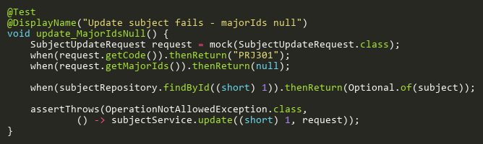

**Figure: update_MajorIdsNull**  
*Reference: Sheet "SBST_update", Test Case TC04*

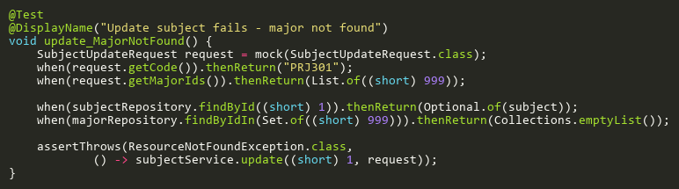

**Figure: update_MajorNotFound**  
*Reference: Sheet "SBST_update", Test Case TC06*

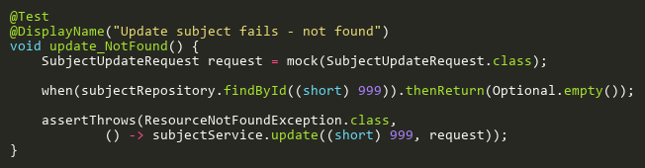

**Figure: update_NotFound**  
*Reference: Sheet "SBST_update", Test Case TC02*

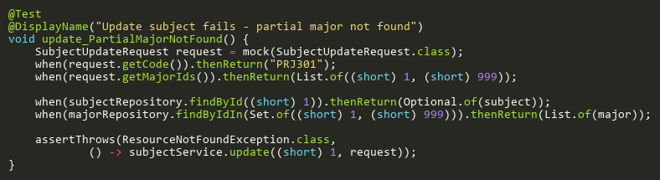

**Figure: update_PartialMajorNotFound**  
*Reference: Sheet "SBST_update", Test Case TC08*

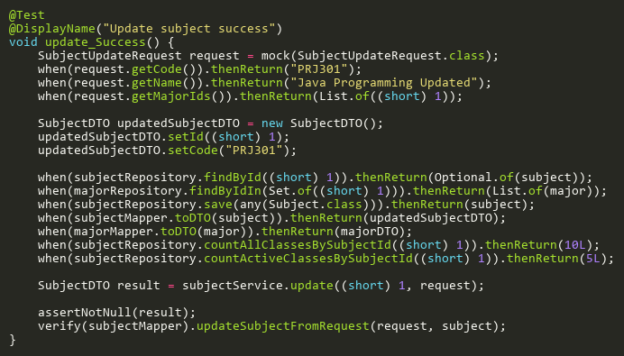

**Figure: update_Success**  
*Reference: Sheet "SBST_update", Test Case TC01*

# SupervisorDashboardServiceTest

## GetDashboardDataTests

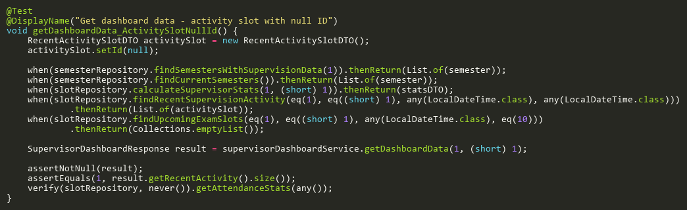

**Figure: getDashboardData_ActivitySlotNullId**  
*Reference: Sheet "SVDST_getDashboard", Test Case TC18*

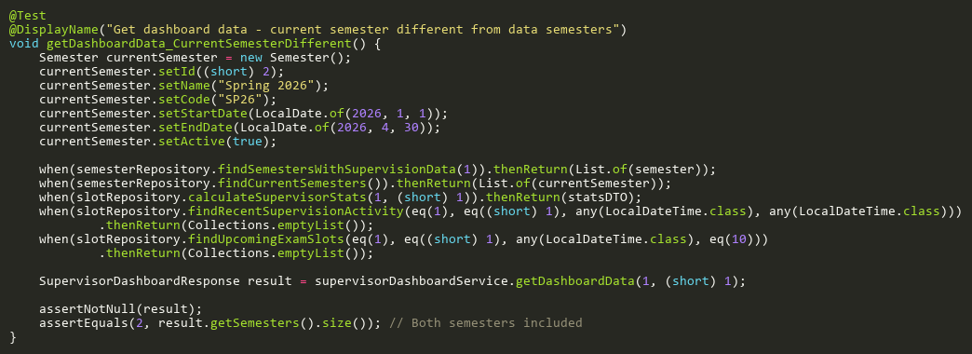

**Figure: getDashboardData_CurrentSemesterDifferent**  
*Reference: Sheet "SVDST_getDashboard", Test Case TC20*

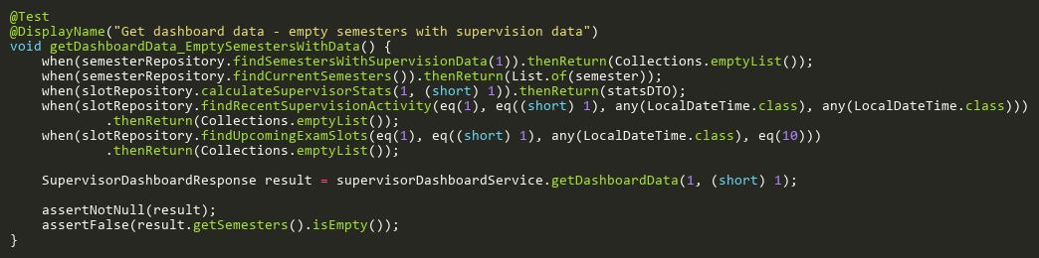

**Figure: getDashboardData_EmptySemestersWithData**  
*Reference: Sheet "SVDST_getDashboard", Test Case TC08*

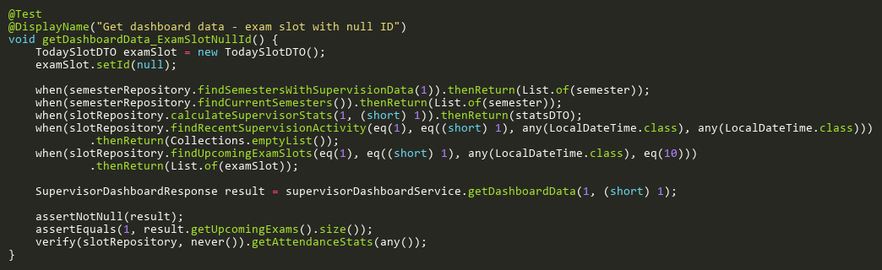

**Figure: getDashboardData_ExamSlotNullId**  
*Reference: Sheet "SVDST_getDashboard", Test Case TC19*

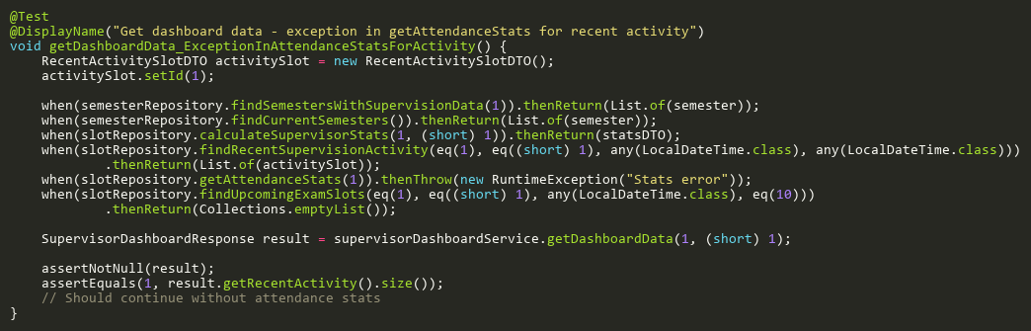

**Figure: getDashboardData_ExceptionInAttendanceStatsForActivity**  
*Reference: Sheet "SVDST_getDashboard", Test Case TC16*

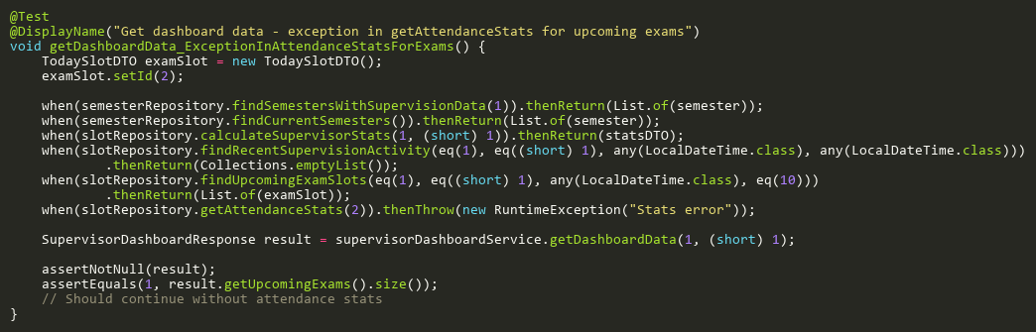

**Figure: getDashboardData_ExceptionInAttendanceStatsForExams**  
*Reference: Sheet "SVDST_getDashboard", Test Case TC17*

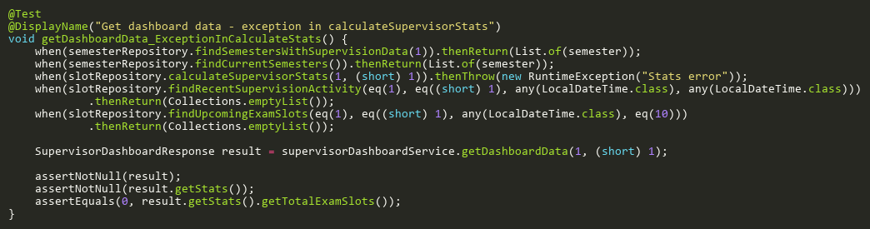

**Figure: getDashboardData_ExceptionInCalculateStats**  
*Reference: Sheet "SVDST_getDashboard", Test Case TC11*

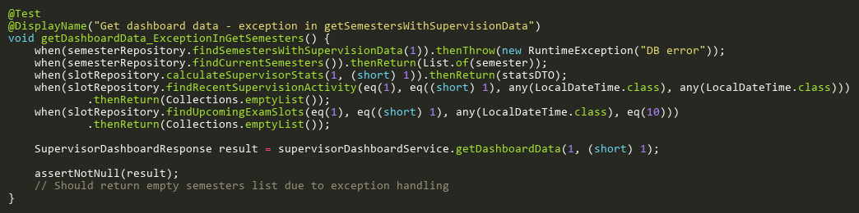

**Figure: getDashboardData_ExceptionInGetSemesters**  
*Reference: Sheet "SVDST_getDashboard", Test Case TC10*

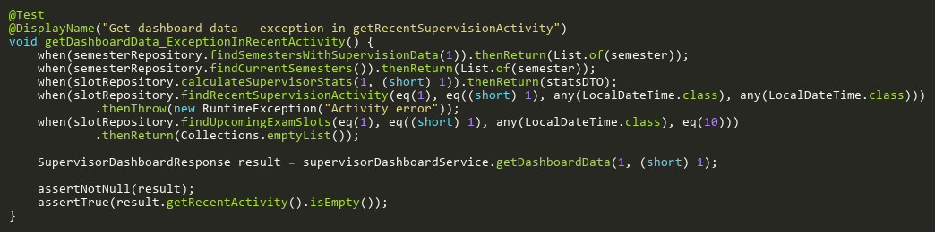

**Figure: getDashboardData_ExceptionInRecentActivity**  
*Reference: Sheet "SVDST_getDashboard", Test Case TC12*

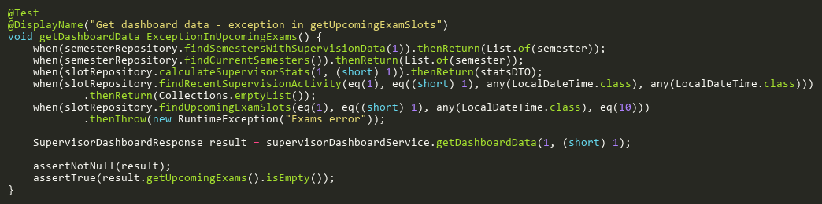

**Figure: getDashboardData_ExceptionInUpcomingExams**  
*Reference: Sheet "SVDST_getDashboard", Test Case TC13*

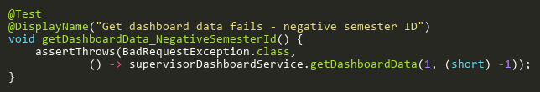

**Figure: getDashboardData_NegativeSemesterId**  
*Reference: Sheet "SVDST_getDashboard", Test Case TC07*

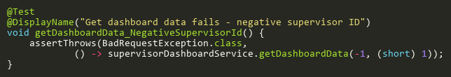

**Figure: getDashboardData_NegativeSupervisorId**  
*Reference: Sheet "SVDST_getDashboard", Test Case TC05*

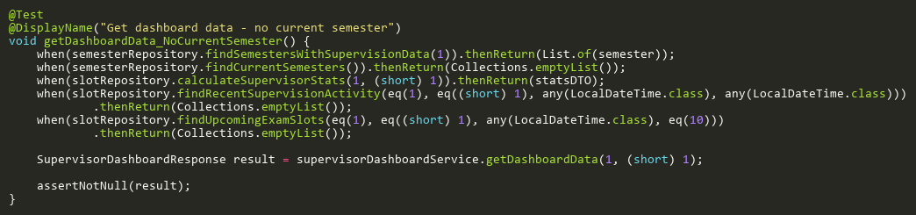

**Figure: getDashboardData_NoCurrentSemester**  
*Reference: Sheet "SVDST_getDashboard", Test Case TC09*

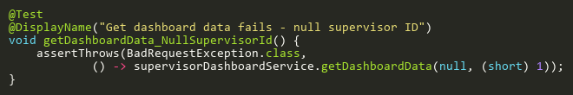

**Figure: getDashboardData_NullSupervisorId**  
*Reference: Sheet "SVDST_getDashboard", Test Case TC03*

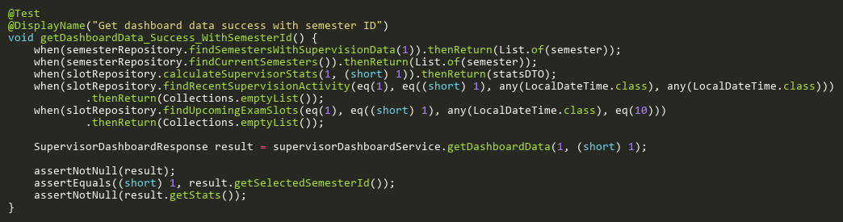

**Figure: getDashboardData_Success_WithSemesterId**  
*Reference: Sheet "SVDST_getDashboard", Test Case TC01*

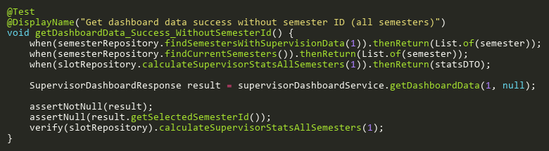

**Figure: getDashboardData_Success_WithoutSemesterId**  
*Reference: Sheet "SVDST_getDashboard", Test Case TC02*

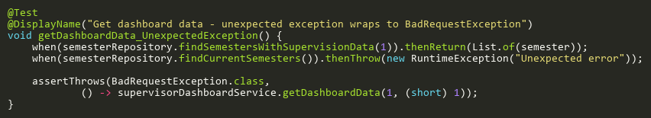

**Figure: getDashboardData_UnexpectedException**  
*Reference: Sheet "SVDST_getDashboard", Test Case TC21*

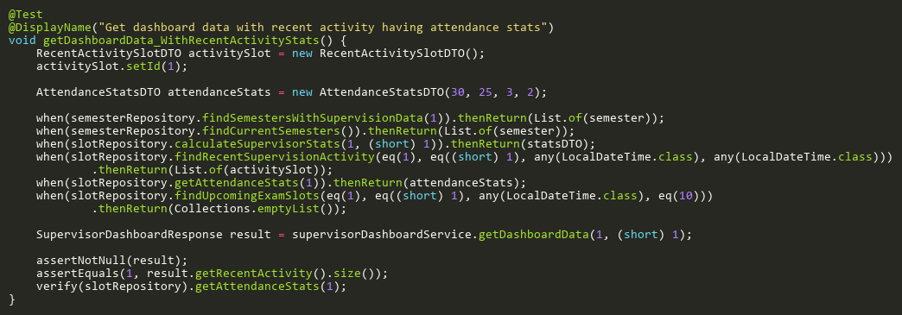

**Figure: getDashboardData_WithRecentActivityStats**  
*Reference: Sheet "SVDST_getDashboard", Test Case TC14*

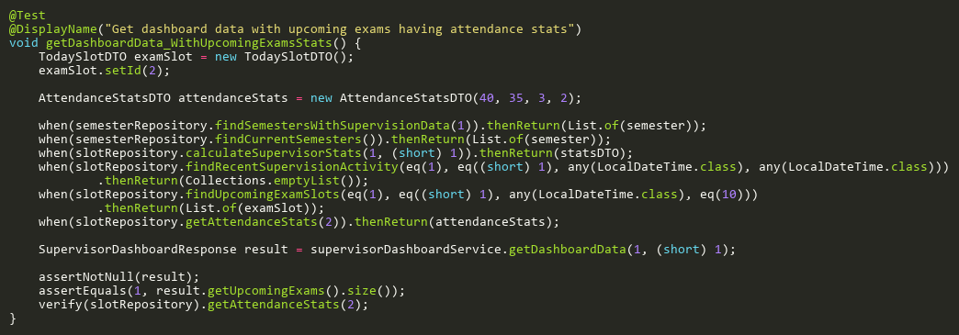

**Figure: getDashboardData_WithUpcomingExamsStats**  
*Reference: Sheet "SVDST_getDashboard", Test Case TC15*

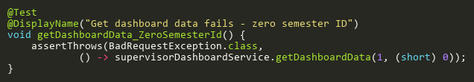

**Figure: getDashboardData_ZeroSemesterId**  
*Reference: Sheet "SVDST_getDashboard", Test Case TC06*

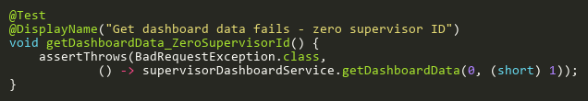

**Figure: getDashboardData_ZeroSupervisorId**  
*Reference: Sheet "SVDST_getDashboard", Test Case TC04*

# ZipFileServiceTest

## ExtractZipToTempTests

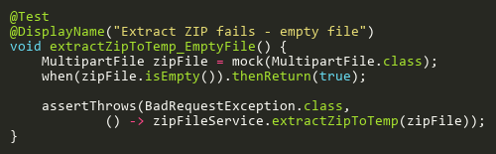

**Figure: extractZipToTemp_EmptyFile**  
*Reference: Sheet "ZFST_extractZip", Test Case TC03*

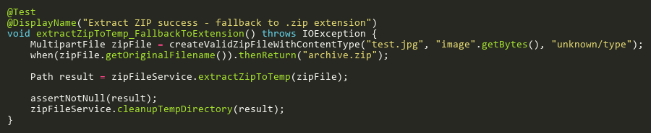

**Figure: extractZipToTemp_FallbackToExtension**  
*Reference: Sheet "ZFST_extractZip", Test Case TC09*

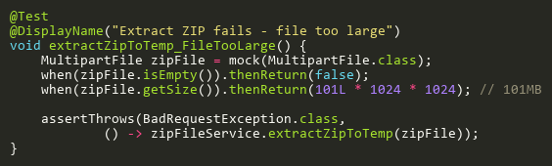

**Figure: extractZipToTemp_FileTooLarge**  
*Reference: Sheet "ZFST_extractZip", Test Case TC04*

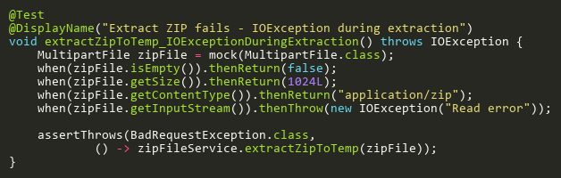

**Figure: extractZipToTemp_IOExceptionDuringExtraction**  
*Reference: Sheet "ZFST_extractZip", Test Case TC13*

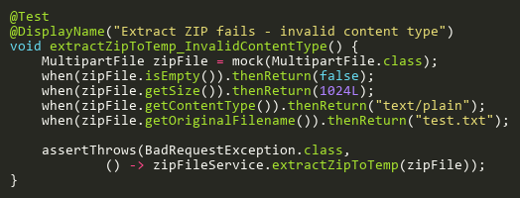

**Figure: extractZipToTemp_InvalidContentType**  
*Reference: Sheet "ZFST_extractZip", Test Case TC05*

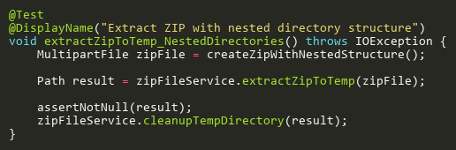

**Figure: extractZipToTemp_NestedDirectories**  
*Reference: Sheet "ZFST_extractZip", Test Case TC14*

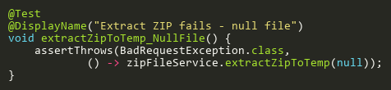

**Figure: extractZipToTemp_NullFile**  
*Reference: Sheet "ZFST_extractZip", Test Case TC02*

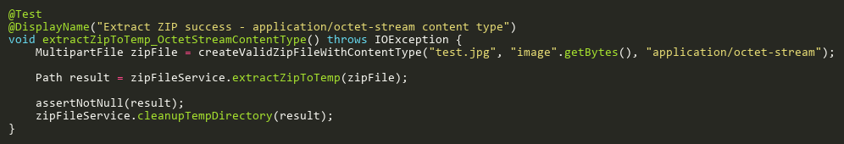

**Figure: extractZipToTemp_OctetStreamContentType**  
*Reference: Sheet "ZFST_extractZip", Test Case TC08*

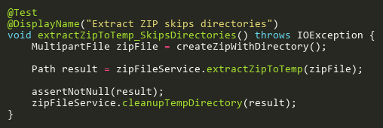

**Figure: extractZipToTemp_SkipsDirectories**  
*Reference: Sheet "ZFST_extractZip", Test Case TC10*

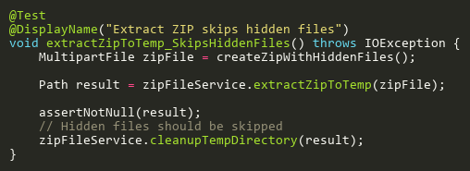

**Figure: extractZipToTemp_SkipsHiddenFiles**  
*Reference: Sheet "ZFST_extractZip", Test Case TC11*

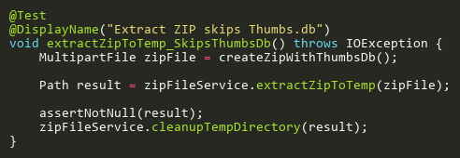

**Figure: extractZipToTemp_SkipsThumbsDb**  
*Reference: Sheet "ZFST_extractZip", Test Case TC12*

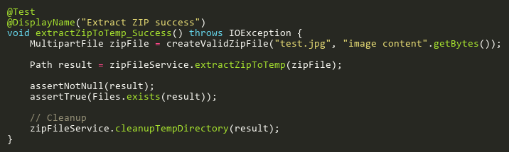

**Figure: extractZipToTemp_Success**  
*Reference: Sheet "ZFST_extractZip", Test Case TC01*

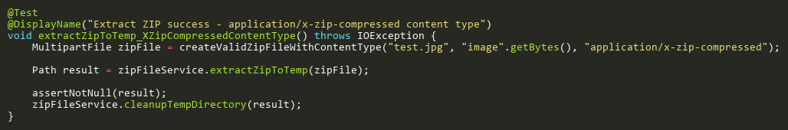

**Figure: extractZipToTemp_XZipCompressedContentType**  
*Reference: Sheet "ZFST_extractZip", Test Case TC06*

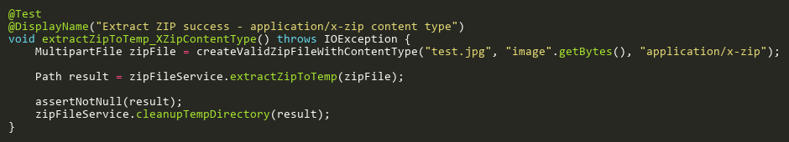

**Figure: extractZipToTemp_XZipContentType**  
*Reference: Sheet "ZFST_extractZip", Test Case TC07*

## IsImageFileTests

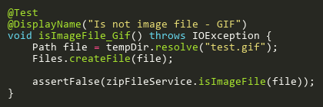

**Figure: isImageFile_Gif**  
*Reference: Sheet "ZFST_isImageFile", Test Case TC07*

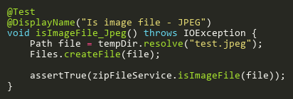

**Figure: isImageFile_Jpeg**  
*Reference: Sheet "ZFST_isImageFile", Test Case TC02*

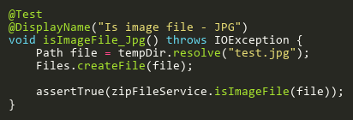

**Figure: isImageFile_Jpg**  
*Reference: Sheet "ZFST_isImageFile", Test Case TC01*

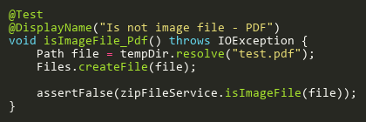

**Figure: isImageFile_Pdf**  
*Reference: Sheet "ZFST_isImageFile", Test Case TC06*

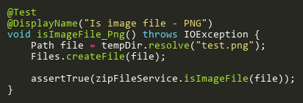

**Figure: isImageFile_Png**  
*Reference: Sheet "ZFST_isImageFile", Test Case TC03*

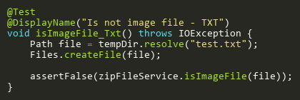

**Figure: isImageFile_Txt**  
*Reference: Sheet "ZFST_isImageFile", Test Case TC05*

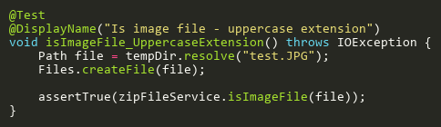

**Figure: isImageFile_UppercaseExtension**  
*Reference: Sheet "ZFST_isImageFile", Test Case TC04*